| **Gujarati Letter** | **Pronunciation** | **Transformation** | **Example Word** |
| --- | --- | --- | --- |
| ક | Ka | Single consonant | કાલ (Kal - yesterday) |
| ખ | Kha | Single consonant | ખુદ (Khud - self) |
| ગ | Ga | Single consonant | ગરમ (Garam - hot) |
| ઘ | Gha | Single consonant | ઘર (Ghar - home) |
| ઙ | Nga | Nasal consonant | અંગ (Ang - limb) |
| ચ | Cha | Single consonant | ચાંદ (Chaand - moon) |
| છ | Chha | Single consonant | છત્રી (Chhatri - umbrella) |
| જ | Ja | Single consonant | જવેલ (Javel - grain) |
| ઝ | Jha | Single consonant | ઝાડ (Jhaad - tree) |
| ટ | Ta | Single consonant | ટેબલ (Table - table) |
| ઠ | Tha | Single consonant | ઠંડુ (Thandu - cold) |
| ડ | Da | Single consonant | ડોલ (Dol - drum) |
| ઢ | Dha | Single consonant | ઢીંગલું (Dhinglu - doll) |
| ણ | Na (retroflex) | Nasal consonant | દાણો (Dano - grain) |
| ત | Ta | Single consonant | તાળું (Talu - lock) |
| થ | Tha | Single consonant | થાળો (Thalo - bag) |
| દ | Da | Single consonant | દાદા (Dada - grandfather) |
| ધ | Dha | Single consonant | ધન (Dhan - wealth) |
| ન | Na | Single consonant | નદી (Nadi - river) |
| પ | Pa | Single consonant | પરવું (Parvu - fly) |
| ફ | Pha | Single consonant | ફૂલ (Phool - flower) |
| બ | Ba | Single consonant | બાલ (Bal - child) |
| ભ | Bha | Single consonant | ભાત (Bhat - rice) |
| મ | Ma | Single consonant | માછલી (Machhli - fish) |
| ય | Ya | Single consonant | યશ (Yash - fame) |
| ર | Ra | Single consonant | રાજા (Raja - king) |
| લ | La | Single consonant | લોટ (Lot - flour) |
| વ | Va | Single consonant | વાવ (Vav - well) |
| શ | Sha | Single consonant | શાંત (Shaant - calm) |
| ષ | Sha (retroflex) | Single consonant | ષટ્કોણ (Shatkona - hexagon) |
| સ | Sa | Single consonant | સાગર (Sagar - ocean) |
| હ | Ha | Single consonant | હાથી (Haathi - elephant) |
| ક્ષ | Ksha | Consonant blend | ક્ષમતા (Kshamata - ability) |
| ત્ર | Tra | Consonant blend | ત્રાસ (Traas - fear) |
| જ્ઞ | Gnya | Consonant blend | જ્ઞાન (Gyaan - knowledge) |

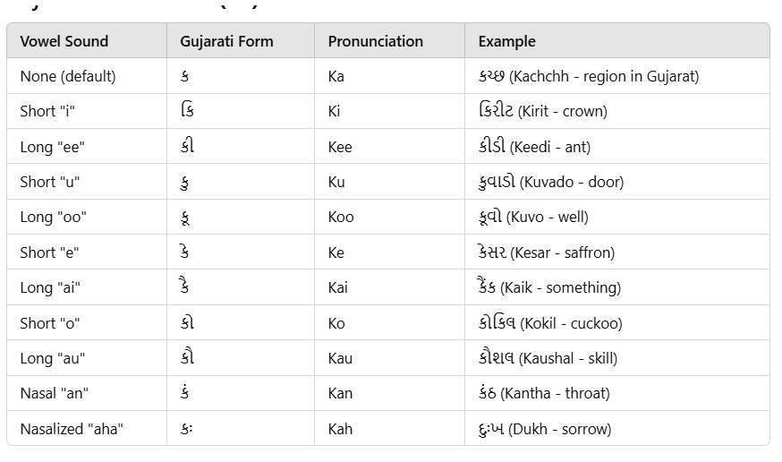

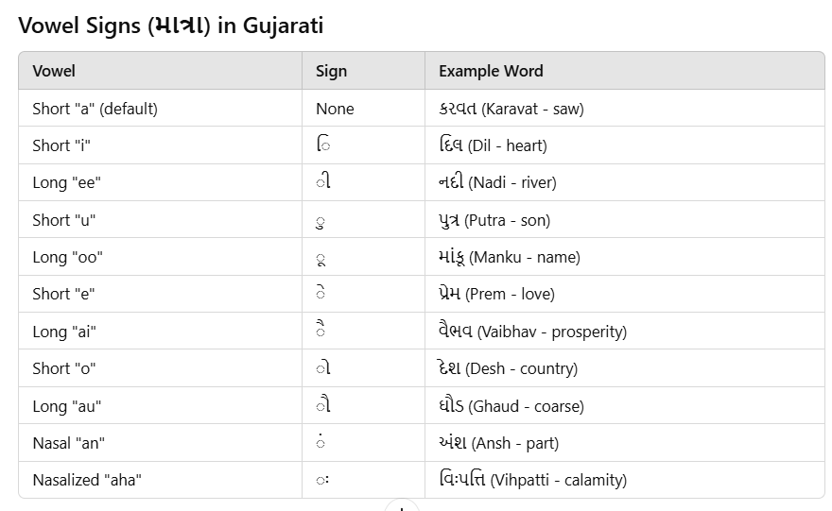

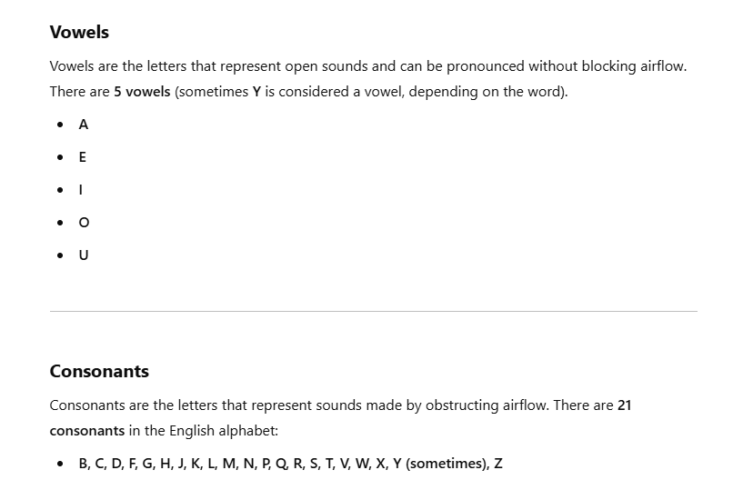

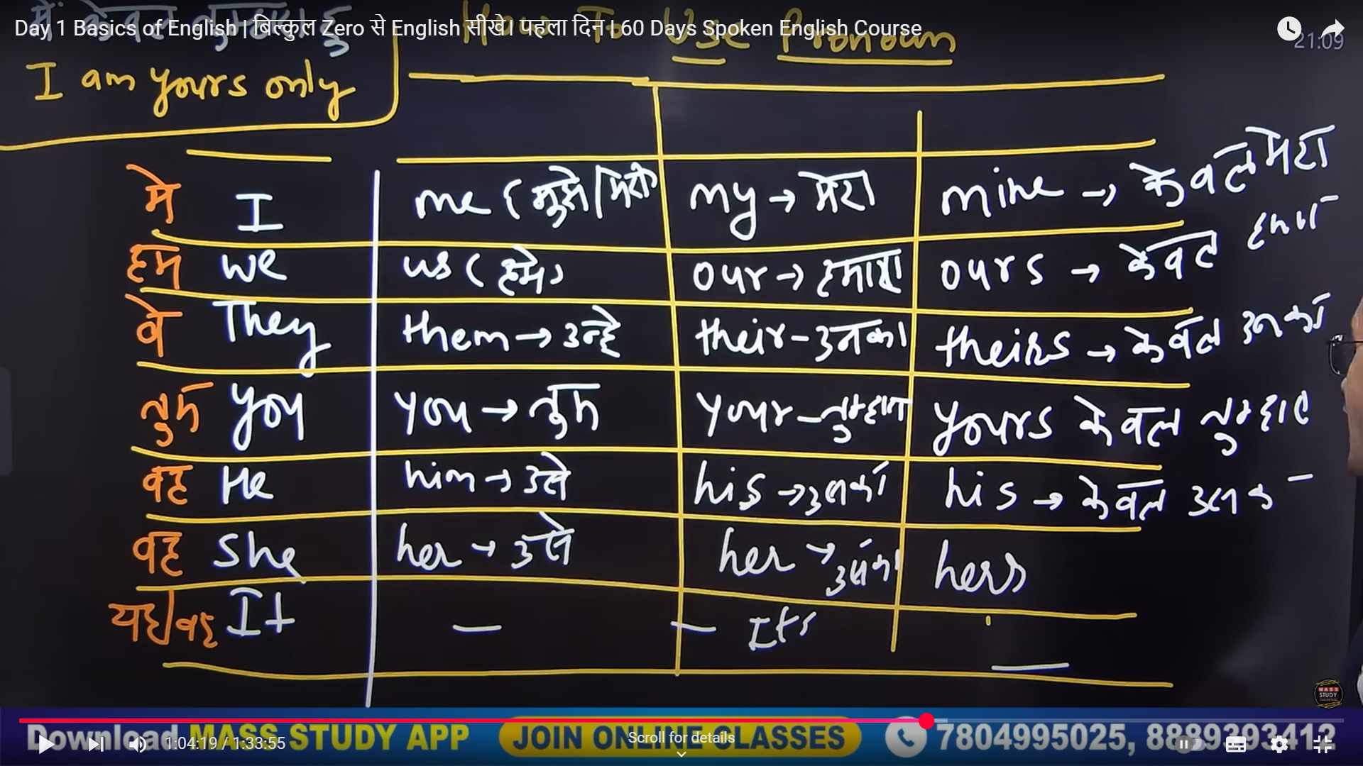

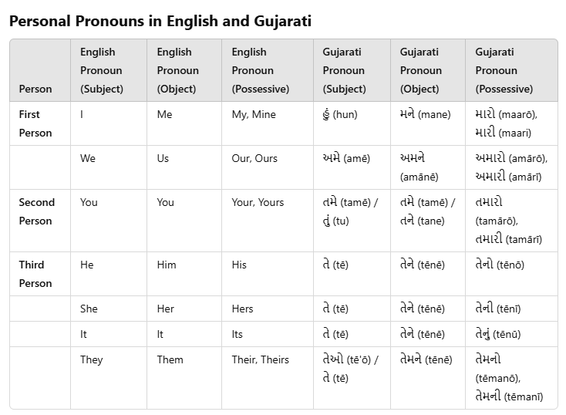

• One

• Two

• Three

• Four

• Five

• Six

• Seven

• Eight

• Nine

• Ten

• Eleven

• Twelve

• Thirteen

• Fourteen

• Fifteen

• Sixteen

• Seventeen

• Eighteen

• Nineteen

• Twenty

• One hundred one

• One hundred two

• One hundred three

• One hundred four

• One hundred five

• One hundred six

• One hundred seven

1,013. One thousand thirteen  
1,014. One thousand fourteen  
1,015. One thousand fifteen  
1,016. One thousand sixteen

100,001. One hundred thousand one  
100,002. One hundred thousand two  
100,003. One hundred thousand three  
100,004. One hundred thousand four  
100,005. One hundred thousand five  
100,006. One hundred thousand six  
100,007. One hundred thousand seven  
100,008. One hundred thousand eight

1,212. One thousand two hundred twelve

The number **100,000** in **English** is:

**One hundred thousand**.

The number **235,698** in **English** is:

**Two hundred thirty-five thousand six hundred ninety-eight**

The number **2,235,698** in **English** is:

**Two million, two hundred thirty-five thousand, six hundred ninety-eight**.

The number **5,854,455** in **English** is:

**Five million, eight hundred fifty-four thousand, four hundred fifty-five**.

The number **58,000,000** in **English** is:

**Fifty-eight million**.

