**Name: Virali Gada**

**Intern Id: 303**

**Tool Name:** Scp and Rsync in File transfer, Tunneling and Exfiltration.

**History:** Secure Copy (scp), a command-line utility for securely transferring files. SCP has its roots in the older, less secure Remote Copy Protocol (RCP) and was developed as part of the Secure Shell (SSH) suite in the 1990s. Rsync was first announced on June 19, 1996, by Andrew Tridgell and Paul Mackerras. It was designed as a faster and more efficient way to synchronize files compared to existing tools like rdist. Rsync achieves this by only transferring the changed portions of files, rather than the entire file each time. This efficiency has made it a standard Linux utility and it has been ported to various other operating systems, including Windows, macOS and much more.

**Description:** Both tools are used for securely transferring files over a network. SCP is known for its simplicity, while Rsync offers powerful synchronization capabilities.

**What is this tool About?**

SCP is a file transfer network protocol used to move files onto servers, and it fully supports encryption and authentication. SCP uses Secure Shell (SSH) mechanisms for data transfer and authentication to ensure the confidentiality of the data in transit. Rsync is a versatile command-line tool used for synchronizing files and directories between locations, whether on the same machine or across a network.

**Key Characteristics/Features:**

* Rsync can securely copy files to and from remote servers using protocols like SSH.
* Rsync supports compression (using Zlib, zstd, or LZ4) to further reduce transfer size and encryption (via SSH) to secure data in transit.
* Rsync is known for its speed and efficiency, especially when handling large files and datasets.
* It supports various transfer types, including local to remote, remote to local, and remote to remote (via a local client).
* It can handle directory transfers, including all subdirectories and files, with a single command.

**Types or Modules Available:**

1. SCP: no such modules or types found.
2. RSYNC**:** offers two modes of operation such as command-line utility and daemon.

**How will This Tool Help?**

Enables safe, encrypted file movement across networks. Useful for automated backups, server deployments, and forensic evidence extraction. In threat hunting or red teaming, can simulate data exfiltration techniques.

**Proof Of Concept(POC):**

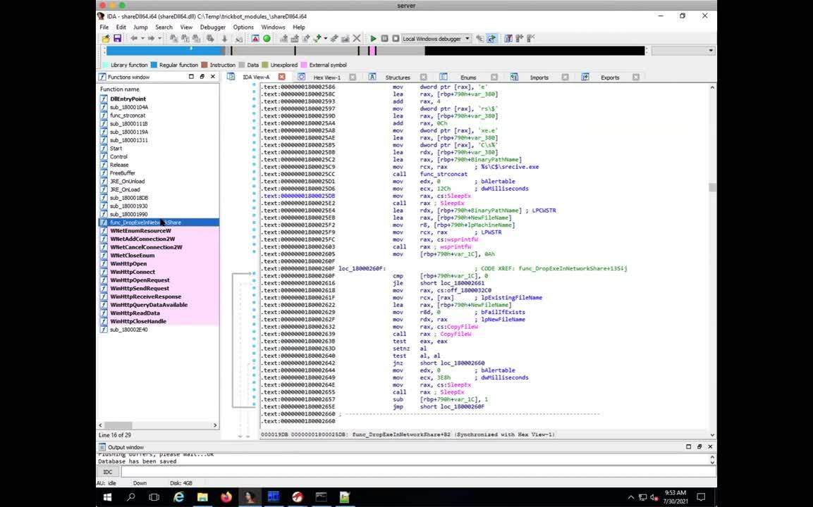

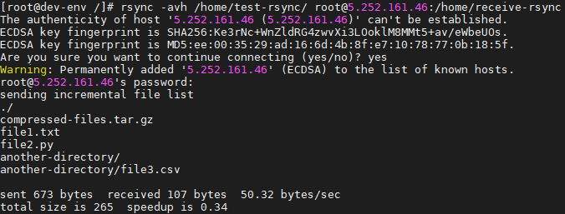

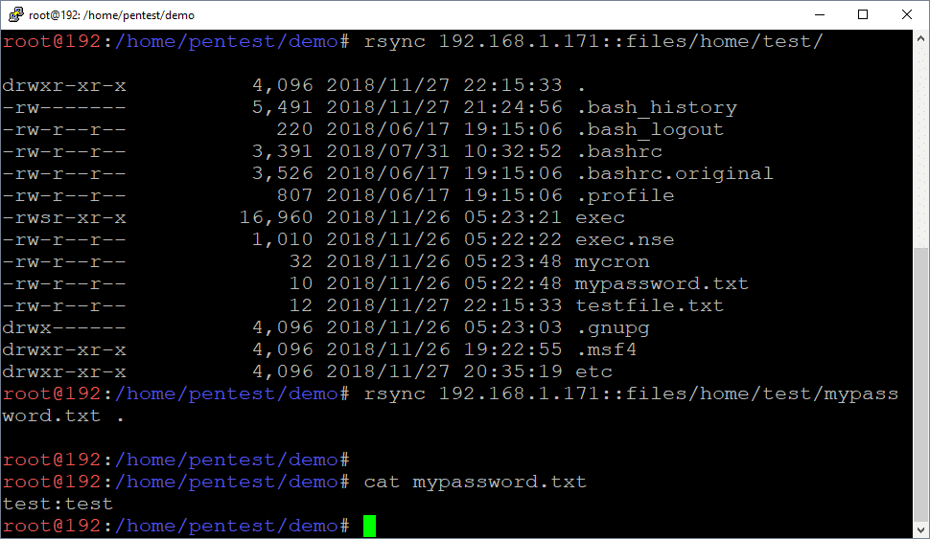

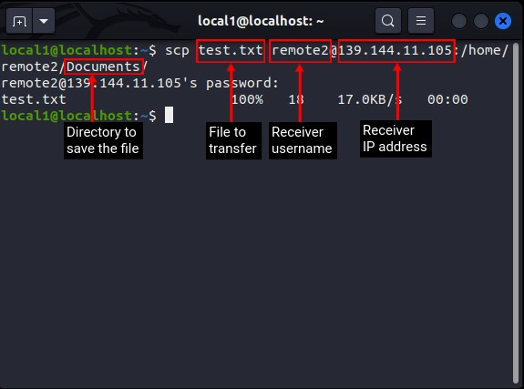

**15-Liner Summary:**

SCP and Rsync are essential tools in any system administrator's or cybersecurity professional's toolkit. SCP provides a straightforward way to copy files securely using SSH. Rsync, on the other hand, is optimized for performance and bandwidth, transferring only changes between files. Both tools rely on SSH for encryption and authentication. SCP is ideal for one-off secure transfers, while Rsync excels in syncing large directories. In cyber investigations, they can assist in pulling data from compromised machines or monitoring exfiltration attempts. Attackers may misuse these tools to stealthily tunnel and exfiltrate sensitive data. Thus, understanding their legitimate and malicious use is key in modern forensic and incident response workflows.

**Time to use/Best case scenerios:**

Rsync is a versatile tool used for efficiently synchronizing files and directories between locations, including both local and remote systems. It's particularly useful for backups, mirroring, and transferring large files because it only copies the differences between source and destination files, minimizing data transfer.secure copy, is used to transfer files between a local and a remote host, or between two remote hosts, using SSH. It's a command-line utility that allows you to copy files securely over a network.

**When to use during Investigation:**

* Pulling forensic images or logs from remote endpoints.
* Monitoring suspicious data transfers (for detection of SCP/Rsync misuse).
* Confirming scope of exfiltration in APT scenarios.
* Simulating attack behavior during red teaming or lab exercises.

**Best Person to Use That Tool and Skills Required**

SCP (Secure Copy Protocol):

* Best Person**:** System administrators, DevOps engineers, cybersecurity professionals.
* Skills Required**:**
  + Basic to intermediate Linux/Unix command-line knowledge.
  + Understanding of SSH (since SCP operates over SSH).
  + Knowledge of remote server structure and permissions.

rsync:

* Best Person: Backup administrators, system administrators, DevOps professionals.
* Skills Required:
  + Advanced command-line knowledge in Linux/Unix.
  + Experience in managing file systems and directories.
  + Familiarity with shell scripting for automation.
  + Understanding of SSH and cron for scheduling backups.

**Flaws & Suggestions to Improve**

SCP:

* Flaws:
  + No built-in mechanism for resuming interrupted transfers.
  + Copies entire file again even if minor changes are made.
  + Performance issues with large files compared to rsync.
* Suggestions to Improve:
  + Implement delta transfer like rsync.
  + Add a resume/continue feature for large files.
  + Better verbose logging and transfer status indicators.

rsync:

* Flaws**:**
  + Complex syntax for beginners.
  + Requires careful use of options (can delete data if misused).
  + Slightly slower initial transfer compared to SCP for small files.
* Suggestions to Improve:
  + Develop a GUI or wrapper script for beginners.
  + Provide clearer error messages and safer defaults.
  + Include basic tutorials or examples in command-line help.

**Good About Tools**

SCP:

* Easy to use for one-time, straightforward file transfers.
* Secure (uses SSH).
* Widely available on all Unix-like systems.
* Good for quick and simple file movements.

rsync:

* Supports differential syncing — only changed parts of files are transferred.
* Allows scheduling for automated backups.
* Provides verbose output and dry-run mode for safety.
* More efficient for large and repetitive transfers.
* Preserves file permissions, links, and timestamps accurately.