UMBRELLA BY OKAY LEGAL
Comprehensive Business Plan
India → United States → The World
3-Year Global Strategy · Year 1 Execution Plan
Version 2.0 · July 08, 2026
CONFIDENTIAL — Internal & Investor Use Only
umbrella.okaylegal.ai

Table of Contents
1. Executive Summary
2. The Opportunity — Why Now, Why Us, Why Global
3. Three-Year Global Strategy (India → US → World)
4. Market Analysis — India
5. Market Analysis — United States
6. Product Strategy & Technology Roadmap
7. Go-to-Market — India (Year 1 Primary)
8. Go-to-Market — United States (Year 1 Secondary)
9. Year 1 Monthly & Weekly Execution Plan
10. Marketing Strategy, Channels & Budget
11. Financial Model & Unit Economics
12. Fundraising Strategy & Use of Funds
13. Organization, Governance & Operating Model
14. Risk Management & Contingency Plans
15. KPI Dashboard & Reporting Cadence
16. Role Assignments — Co-CEO / CTO (Engineering)
17. Role Assignments — Garima (Co-CEO / CFO / CMO)
18. Years 2–3 Preview — Global Expansion
Appendix A: Competitive Landscape
Appendix B: Product Feature Inventory Summary
Appendix C: Key URLs & Assets
Appendix D: Glossary
Appendix E: Monthly Revenue Build-Up
Appendix F: Weekly Channel Scorecard Template
Appendix G: Investor FAQ
Appendix H: Detailed Weekly Plan — Q3 2026
Appendix I: Technology Stack Detail
Appendix J: Brand Voice & Messaging Guidelines

1. Executive Summary
Umbrella by Okay Legal is the AI-powered Legal Operating System for practicing lawyers. We launched on Sunday, July 5, 2026. After resolving initial launch bugs, the platform is now live at umbrella.okaylegal.ai with production-grade India drafting, legal research, FIR analysis, document review, lawyer leads inbox, matter management, billing, and mobile apps.
Our strategy is deliberately sequenced: dominate India first (product-market fit + volume), build US credibility and ARPU in parallel during Year 1, then expand to the rest of the world over Years 2–3. We do not pursue Africa or other developing markets in Year 1 — every dollar and engineering hour goes to India and the US, the two largest legal economies where our product has the strongest fit.

Mission
Give every lawyer in the world an AI-powered practice — starting with India and America.

Year 1 Targets (Jul 2026 – Jun 2027)
Metric | Target | Notes
Lawyer sign-ups | 1,500 | India 70% · US 30%
Activated lawyers | 900 | Completed onboarding + 1 core action
Paying firms/lawyers | 200 | Post 30-day free trial
MRR (exit run-rate) | $50,000 | India $27K + US $21K + other $2K
ARR run-rate | $600,000 | Seed-ready metric
D7 retention (activated) | > 50% | Gate before paid scale
Trial-to-paid conversion | > 20% | By Month 9
Lawyer leads delivered | 2,000 total | Issue Checker flywheel

The 100× Ambition
From a post-launch baseline of ~10 lawyers and near-zero MRR, we target 100× growth on activated users (10 → 1,000+) and MRR ($500 month-1 → $50,000 month-12). We get there through focused India + US execution: city-first market entry, a clear product wedge, founder-led onboarding, and the Issue Checker → lawyer leads growth loop.

Leadership
Role | Person | Accountability
Co-CEO / CTO | Engineering Co-Founder | Product, technology, AI, infrastructure, India product depth
Co-CEO / CFO / CMO | Garima | Finance, fundraising, marketing, sales, US GTM, operations

Immediate Priority: 100 Lawyers by July 20
Before the monthly plan begins in earnest, we have a 12-day sprint (July 8–20) to sign 100 lawyers, activate 60+, and convert 5+ to paid. India carries 85% of this sprint via influencer reels, WhatsApp advocate networks, webinars, and founder-led onboarding.

2. The Opportunity — Why Now, Why Us, Why Global

2.1 Market Size
Legal services represent an $800B+ global market. Legal technology is growing at 8–12% CAGR, with AI-native legal tools representing the fastest-growing subsegment. India alone has 1.7M+ enrolled advocates with ~600K actively practicing. The US has 1.3M licensed attorneys generating $300B+ in annual legal revenue.
Segment | TAM | SAM (AI practice tools) | SOM Year 3
India lawyers | ₹12,000Cr+ practice software | ₹1,200Cr | ₹60Cr (5%)
US lawyers | $12B legal tech | $2.4B AI-native | $120M (5%)
Global (Year 3+) | $28B legal tech 2028 | $5B AI-native | $250M (5%)

2.2 Why Now
- GPT-4 class models make legal drafting and research commercially viable for the first time.
- India's legal system is digitizing — eCourts, eFiling, and advocate tech adoption accelerating post-COVID.
- US solo and small firms (75% of all firms) are underserved by Clio/MyCase — none offer AI-native workflows.
- Consumer legal anxiety is at an all-time high — Issue Checker creates a lawyer lead pipeline no competitor has.
- Window: 18–24 months before Big Law tech (Harvey, CoCounsel) moves downmarket.

2.3 Why Umbrella Wins
Capability | Umbrella | Clio/MyCase | Harvey/CoCounsel | Generic AI (ChatGPT)
India drafting (IPC/CrPC) | ✅ Production | ❌ | ❌ | ⚠ Unverified
US drafting | 🟡 Partial → GA Oct | ❌ | ✅ | ⚠
Lawyer lead generation | ✅ Issue Checker | ❌ | ❌ | ❌
Full firm OS (matters, billing) | ✅ | ✅ | ❌ | ❌
Mobile app | ✅ | ✅ | ❌ | ✅
Price (solo lawyer) | ₹1,400 / $50 seat | $39–99 | $500+ | $20
Multi-jurisdiction | ✅ Roadmap | US only | US/EU | Global but unsafe

2.4 Strategic Sequencing
We are not trying to boil the ocean in Year 1. The global opportunity is real — but distribution follows product depth. India gives us volume, iteration speed, and a defensible AI drafting moat. The US gives us ARPU, investor credibility, and enterprise expansion. Everything else waits until we have $150K+ MRR and proven unit economics.
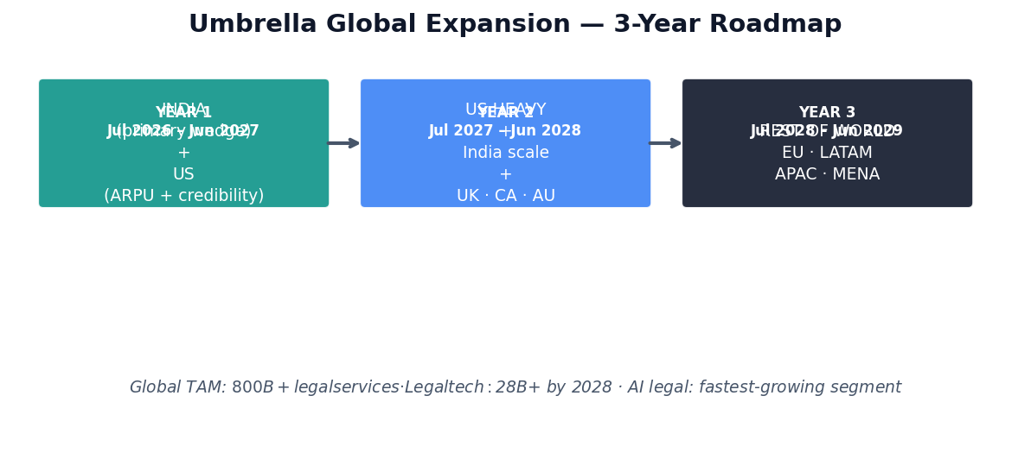
Figure 1: Three-year expansion — India + US in Year 1, then global scale

3. Three-Year Global Strategy
We plan against two financial scenarios. The Base Plan is our original investor-ready path: prove PMF in India + US, reach $50K MRR, raise Seed, scale to ~$6M ARR by Year 3. The Scale Plan is our ambitious path to $50M ARR by Year 3 — requiring US enterprise motion, Issue Checker consumer scale, and $25M+ Series A. Both share the same product and flywheel; they differ in capital, team size, and GTM intensity.

3.0 Dual Scenario Summary
Metric | Base Plan (Original) | Scale Plan ($50M ARR) | Multiple
Y1 exit MRR (Jun 2027) | $50K | $175K | 3.5×
Y2 exit MRR (Jun 2028) | $200K | $1.25M | 6.3×
Y3 exit MRR (Jun 2029) | $500K | $4.17M | 8.3×
Y3 ARR run-rate | $6M | $50M | 8.3×
Y3 paying firms | 2,000+ | 15,000+ | 7.5×
Y3 team size | 40–50 | 150–200 | 3.5×
Seed round | $1.5–2.5M | $3–5M | 2×
Series A | $8–12M | $25M | 2.5×
Series B | — | $50M (Y3) | —

Financial model: docs/marketing/UMBRELLA-3-YEAR-FINANCIAL-MODEL.xlsx — toggle scenario on Assumptions tab (Base or Scale). All cells use Excel formulas linked to assumptions.

3.1 Year 1 — India + US (Jul 2026 – Jun 2027)
Objective: Prove product-market fit in two markets. Base: $50K MRR. Scale: $175K MRR. Raise Seed round.
Market | Effort | Sign-ups | Paying | MRR Target
India | 70% | 1,050 | 140 | $27K
United States | 30% | 450 | 60 | $21K

3.2 Year 2 — US Heavy + India Scale (Jul 2027 – Jun 2028)
Objective: US becomes primary revenue driver. India transitions to self-serve scale. Enter UK, Canada, Australia.
Market | Effort | Paying | MRR Target | Key Action
United States | 50% | 400 | $200K | Sales team, ABA partnerships, integrations
India | 35% | 500 | $80K | Enterprise, bar associations, self-serve
UK / CA / AU | 15% | 80 | $40K | English-common-law expansion

3.3 Year 3 — Rest of World (Jul 2028 – Jun 2029)
Objective: Base — $500K+ MRR (~$6M ARR). Scale — $4.17M MRR ($50M ARR). Series A/B. EU, LATAM, APAC, MENA.
Region | Entry Strategy | MRR Target | Prerequisite
European Union | GDPR-ready · UK beachhead | $80K | SOC2 Type II complete
Latin America | Spanish/Portuguese drafting | $40K | US LATAM diaspora GTM
APAC (SG, JP, KR) | English-first, local partnerships | $60K | Enterprise sales team
MENA | UAE hub · English courts | $30K | Data residency option

3.4 Growth Model
Umbrella grows through four reinforcing mechanisms — not paid ads alone:
- Founder-led onboarding: personal calls and WhatsApp for the first 90 days until activation exceeds 60%.
- City-first entry: dominate Delhi NCR or Mumbai before national India spend; one US practice area before broad legal.
- Product wedge: lead with legal notice drafting in 2 minutes; expand to full Lawyer OS during onboarding.
- Issue Checker loop: consumers get clarity → lawyers receive pre-analyzed leads → lawyers subscribe and share the checker.
- Retention gates: no paid acquisition scale until D7 retention exceeds 40% and trial-to-paid exceeds 15%.
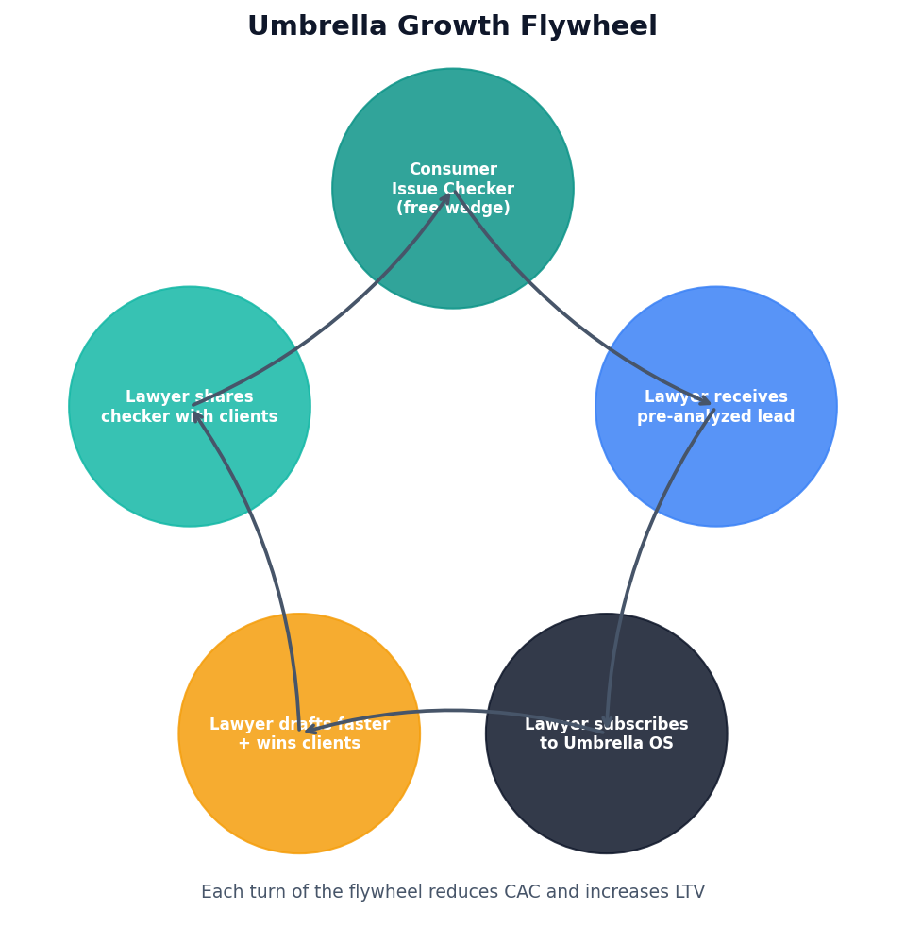
Figure 2: Growth flywheel — each turn reduces CAC and increases LTV

3.5 Scale Plan — Path to $50M ARR
The Scale Plan requires three revenue engines running in parallel by Year 3. India supplies volume and the Issue Checker flywheel. The US supplies ARPU via enterprise deals. Global expansion and Consumer Plus fill the remainder.
Engine | Y3 MRR Target | Key Actions
US SMB + mid-market | $1.8M | 15 AEs + 8 SDRs; ABA/state bar partnerships; Clio displacement
US enterprise (10+ seats) | $1.2M | 60 deals × ~$20K/mo; SSO, SCIM, SOC2 Type II
India volume | $600K | 10,000 firms; national bar MOUs; influencer → referral loop
UK / CA / AU / EU | $400K | Common-law + EU localization; GDPR-ready infrastructure
Consumer Plus + credits | $170K | 50K+ consumer subs; AI credit upsell; NRR > 120%

3.6 Scale Plan — Year-by-Year Milestones
Year | Exit MRR | ARR | Key milestone
Y1 (Jun 2027) | $175K | $2.1M | Flywheel proven; Seed $3–5M; first enterprise LOI
Y2 (Jun 2028) | $1.25M | $15M | US sales team live; Series A $25M; 5 enterprise closes
Y3 (Jun 2029) | $4.17M | $50M | Series B $50M; 15+ countries; 150–200 team

4. Market Analysis — India

4.1 Market Structure
India has the world's second-largest legal profession. The market is fragmented: 70%+ are solo practitioners or firms under 5 lawyers. These advocates are price-sensitive but increasingly tech-forward — WhatsApp is the operating system of Indian legal practice.
Segment | Size | Willingness to Pay | Umbrella Fit
Solo advocates | ~400K active | ₹500–2,000/mo | ★★★★★ Primary
Small firms (2–10) | ~80K firms | ₹5,000–30,000/mo | ★★★★★ Primary
Mid firms (10–50) | ~8K firms | ₹50K–3L/mo | ★★★★ Year 2
Large firms (50+) | ~500 | Enterprise | ★★★ Year 3
Corporate legal (in-house) | ~15K | Different product | ★★ Future

4.2 India Pricing Strategy
Plan | Price (per seat/mo) | Target User | AI Credits
Starter | ₹1,400 | Solo · 1–3 seats | ~660
Professional | ₹6,000 | Small firm · copilot | ~2,800
Pro Plus | ₹30,000 | High-volume practice | ~14,000
Enterprise | Contact sales | 10+ seats · SSO | Custom

Anchor: ₹1,400 = cost of one client consultation. 30-day free trial on all plans.

4.3 India Competitive Landscape
- Manual / Word templates — status quo, 90% of market. Our enemy is inertia, not software.
- Vakilsearch / LegalRaasta — consumer-focused, not lawyer OS.
- CaseMine / Manupatra — research databases, no AI drafting or firm OS.
- ChatGPT — used by 30%+ of young advocates but unverified, no India-specific citations.
- Umbrella moat: India drafting with IPC/CrPC verification + lawyer leads loop.

4.4 India City-First Strategy — Phase 1
Before national spend, we must own ONE city. Recommendation: Delhi NCR (largest advocate concentration, Saket/Tis Hazari courts, strong WhatsApp networks) OR Mumbai (Bombay HC ecosystem). Target: 50 activated lawyers in chosen city by August 31, 2026.

5. Market Analysis — United States

5.1 Market Structure
The US has 1.3M licensed attorneys. 75% work in firms of 1–10 lawyers (solo and small). This segment spends $3–5B annually on practice management software but has no AI-native option that combines drafting, research, client intake, and billing.
Segment | Size | ARPU Potential | Umbrella Fit
Solo practitioners | ~400K | $50–200/mo | ★★★★★ Primary
Small firms (2–10) | ~100K firms | $200–1,000/mo | ★★★★★ Primary
Mid firms (10–50) | ~30K | $1K–10K/mo | ★★★ Year 2
BigLaw (50+) | ~4K | Enterprise | ★★ Year 3

5.2 US Pricing Strategy
Plan | Price (per seat/mo) | Target User
Starter | $50 | Solo · client portal + core OS
Professional | $200 | Copilot + advanced reporting
Pro Plus | $1,000 | High-volume AI practice
Enterprise | Contact sales | SSO · data residency · SCIM

5.3 US Go-to-Market Wedge
Do NOT lead with India features in the US. Lead with: (1) AI-powered client intake via Issue Checker, (2) matter management + billing, (3) US legal research, (4) US document drafting (GA October 2026). Position against Clio ($39–99/mo, no AI) not Harvey ($500+/mo, BigLaw only).

5.4 US Competitive Landscape
Competitor | Price | AI Depth | Weakness vs Umbrella
Clio | $39–99/mo | Basic AI add-on | No AI-native workflows, no consumer lead gen
MyCase | $39–79/mo | Minimal | No drafting, no research
Harvey | $500+/mo | Deep | BigLaw only, inaccessible to solos
CoCounsel (TR) | Bundled | Deep | Westlaw dependency, expensive
ChatGPT | $20/mo | General | No legal verification, no firm OS

5.5 US Year 1 Approach — Seed, Don't Scale
- Q3 2026: 10–20 friendly lawyers via founder network and legal tech Twitter.
- Q4 2026: US drafting GA + Product Hunt launch. Target 50 US sign-ups.
- Q1 2027: 3 legal tech podcast appearances. First 20 paying US firms.
- Q2 2027: LinkedIn ad tests ($3K/mo) only if D7 retention > 40%.
- Focused entry: solo criminal defense or immigration attorneys (high document volume).

6. Product Strategy & Technology Roadmap
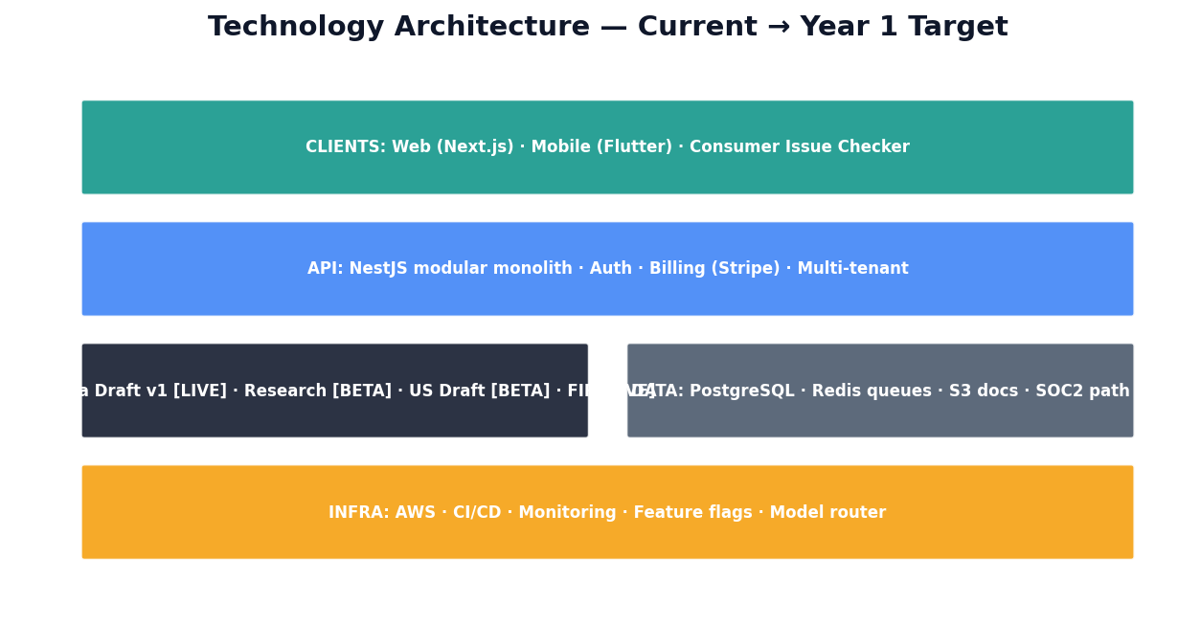
Figure 3: Technology architecture — current state and Year 1 target

6.1 Product Pillars
Pillar | Status | India | US | Priority
India Drafting v1 | ✅ Production | ✅ | N/A | Maintain + improve
Legal Research | 🟡 Partial | ✅ | ✅ | P0 — citation confidence
US Drafting | 🟡 Partial | N/A | 🟡 | P0 — GA by Oct 2026
Issue Checker | ✅ Production | ✅ | ✅ | P0 — growth flywheel
FIR Analysis | ✅ Production | ✅ | N/A | P1 — India differentiator
Document Review | ✅ Production | ✅ | ✅ | P1
Lawyer Leads Inbox | ✅ Production | ✅ | ✅ | P0 — monetization loop
Matter Management | ✅ Production | ✅ | ✅ | P1
Billing & Trust | ✅ Production | ✅ | ✅ | P2
AI Command Center | 🟡 Partial | ✅ | ✅ | P1
Mobile App (Flutter) | ✅ Production | ✅ | ✅ | P0 — demo credibility
SOC2 Compliance | 🟡 In progress | — | ✅ Required | P1 — US enterprise

6.2 Engineering Roadmap — Year 1
Quarter | Ship | Owner | GTM Unlock
Q3 2026 | Onboarding fix, welcome email + WhatsApp flow, push notifications | CTO | 100 lawyer sprint
Q3 2026 | Mobile drafting demo stable, lawyer leads WhatsApp alerts | CTO | Influencer credibility
Q4 2026 | US drafting GA, citation verifier enforcement, Product Hunt ready | CTO | US beta launch
Q4 2026 | Referral program in-app, Hindi onboarding video library | CTO | India scale
Q1 2027 | Self-serve onboarding (no call required), Stripe US tax | CTO | Scale without founder bottleneck
Q1 2027 | SOC2 Type I audit complete | CTO | US enterprise credibility
Q2 2027 | Enterprise pilot (SSO, 10+ seats), API docs v1 | CTO | First ₹3L+ / $5K+ deal
Q2 2027 | US state-specific drafting templates (5 states) | CTO | US conversion lift

6.3 AI & Infrastructure Strategy
Umbrella uses a model router architecture — GPT-4o default, with per-task model selection and cost tracking via ai-usage-recorder. India drafting uses section-level generation with verification loops (unique moat). Research uses async workers on ai.high_priority queue.
- Cost management: AI budget = 50–60% of subscription price allocated to model costs.
- Credit system: transparent AI credit consumption per task; prevents margin erosion.
- Quality gates: citation verifier must enforce confidence threshold before GA (Q4 2026).
- Data: PostgreSQL multi-tenant, S3 document storage, Redis job queues.
- Security: SOC2 path documented (CC6, CC7, CC8, CC9 controls in progress).

6.4 Technical Debt & Launch Bug Remediation
Launch week bugs are expected. Priority zero items from July 5–8 launch feedback must be resolved before marketing scale. Rule: no new feature work until activation funnel drop-off point is fixed and D1 activation > 50%.
Category | Examples | Target Resolution
Signup / auth | Google sign-up edge cases, email verification delays | Jul 10
Onboarding | Profile completion confusion, plan selection UX | Jul 12
India drafting | Generation timeout on long docs, mobile rendering | Jul 15
Credits / billing | Credit error messages, trial expiry handling | Jul 18
Performance | Cold start latency, research queue delays | Jul 31

6.5 Build vs Buy
Function | Decision | Rationale
Payments | Stripe | Global, subscriptions, tax handling
Email | Resend / SendGrid | Transactional + drip campaigns
Analytics | Mixpanel or PostHog | Funnel + cohort analysis
CRM | HubSpot free → paid | US pipeline; India WhatsApp-first
Support | WhatsApp Business API | India primary channel
AI models | OpenAI + Anthropic via router | Best quality, cost-optimized per task
Auth | Custom + Google OAuth | Multi-tenant, already built

7. Go-to-Market — India (Year 1 Primary)
India is 70% of Year 1 effort. All channels are designed for practical execution by a 2-person founding team with ≤ ₹25L marketing budget.

7.1 Positioning & Messaging
Primary message (Hinglish): 'India ke lawyers ke liye complete Legal OS — drafting, research, leads, mobile + web.'
Wedge CTA: 'Ek legal notice 2 minute mein. 30-day free trial.'
Never say: 'AI lawyer' or 'guaranteed win.' Always disclaim: legal information tool, not licensed advice.

7.2 India Channel Strategy
Channel | Q3 | Q4 | H1 2027 | Annual Spend | CAC Target
Instagram/YouTube influencers | ₹1.5L | ₹3L | ₹6L | ₹10.5L | ₹800
WhatsApp advocate networks | ₹0 | ₹50K | ₹1L | ₹1.5L | ₹400
Bar association / CLE events | ₹50K | ₹1.5L | ₹3L | ₹5L | ₹1,200
Google Ads (brand + drafting) | ₹25K | ₹1L | ₹3L | ₹4.25L | ₹1,500
Referral credits (₹500/ref) | — | ₹50K | ₹2L | ₹2.5L | ₹500
Content / SEO / YouTube | ₹25K | ₹75K | ₹1.5L | ₹2.5L | Long-term
Webinars (2/month) | ₹10K | ₹40K | ₹80K | ₹1.3L | ₹900

7.3 Influencer Operating Model
- Tier 1 (5 creators, 50K+ followers): ₹3,000/reel + ₹500/firm subscription bonus
- Tier 2 (15 creators, 10–50K): ₹3,000/reel — scripts in INFLUENCER-REEL-SCRIPTS-INDIA-3000.md
- Tier 3 (30 creators, 3–10K): ₹2,000/reel from August — volume play
- UTM: ?utm_source=CREATOR&utm_medium=influencer&utm_campaign=lawyer-reels
- Approve before publish. Pay within 7 business days. Minimum 45–90 sec, 9:16, #Ad required.

7.4 July Sprint — 100 Lawyers by July 20
Period | Sign-ups Target | Key Actions
Jul 8–10 | 15 | Funnel audit, 30 influencer DMs, 10 WhatsApp groups
Jul 11–14 | 32 | Webinar, 5 reels live, 500 outbound DMs
Jul 15–17 | 36 | Influencer wave 2, law college workshop, social proof
Jul 18–20 | 17+ | IG Live, trial-to-paid nudge, final DM blitz

Channel | Spend | Sign-ups | CAC
Micro-influencers (15 reels) | ₹45,000 | 40 | ₹1,125
WhatsApp / Telegram | ₹0 | 22 | ₹0
Direct outreach (500 DMs) | ₹0 | 18 | ₹0
Webinars (2) | ₹10,000 | 12 | ₹833
LinkedIn organic | ₹0 | 8 | ₹0
TOTAL | ₹55,000 | 100+ | ~₹550

8. Go-to-Market — United States (Year 1)
US is 30% of Year 1 effort, scaling to 50% in Year 2. Do not spend on US paid acquisition until US drafting is GA (October 2026) and D7 retention > 40%.

8.1 US Channel Strategy
Channel | Q3 2026 | Q4 2026 | H1 2027 | Annual Spend
Founder network / legal Twitter | $0 | $500 | $2K | $2.5K
Legal tech podcasts (5 appearances) | $0 | $1K | $3K | $4K
Product Hunt launch (Oct) | $0 | $300 | — | $300
ABA / state bar newsletters | $0 | $500 | $2K | $2.5K
LinkedIn content (founder) | $0 | $0 | $0 | $0
LinkedIn ads (test, gated) | — | $500 | $5K | $5.5K
Legal tech conferences (1–2) | — | $1K | $3K | $4K
US influencer/YouTube (legal) | — | $500 | $2K | $2.5K

8.2 US Launch Calendar
Date | Event | Target | Owner
Jul 2026 | 10 friendly US beta lawyers onboarded | 10 sign-ups | Garima
Oct 2026 | US drafting GA + Product Hunt | 50 sign-ups | CTO + Garima
Nov 2026 | First US case study published | 5 paying | Garima
Jan 2027 | Legal tech podcast tour (3 pods) | 25 sign-ups | Garima
Mar 2027 | ABA Techshow or equivalent | 50 cumulative paying | Garima
Jun 2027 | LinkedIn ad scale (if metrics pass) | 60 US paying | Garima

8.3 US Messaging Framework
- Headline: 'The AI-native practice platform for solo and small law firms.'
- Sub: 'Client intake, AI drafting, research, matters, and billing — one platform.'
- Proof: SOC2 in progress, 30-day free trial, no credit card required.
- Competitive frame: 'Clio + AI + client leads. At half the price of Harvey.'

9. Year 1 Monthly & Weekly Execution Plan
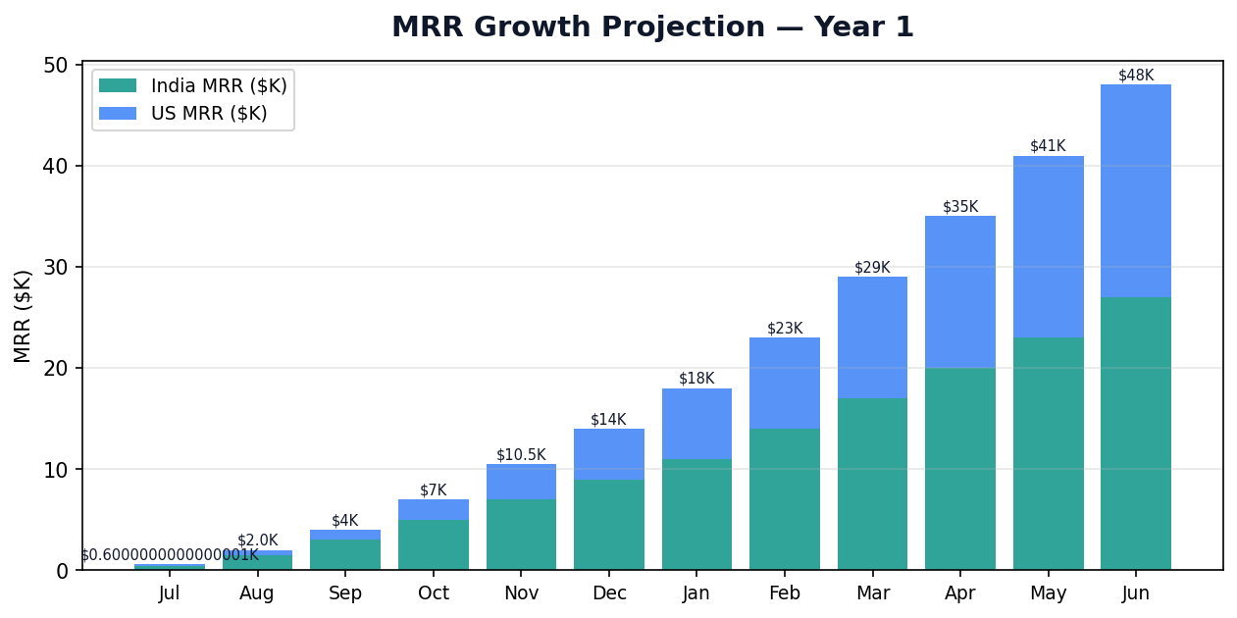
Figure 4: MRR growth projection — India + US stacked

9.1 Monthly Targets
Month | New Sign-ups | Cumulative | Activated | Paying | MRR | India %
Jul 2026 | 100 | 100 | 60 | 5 | $600 | 85%
Aug 2026 | 120 | 220 | 140 | 18 | $2,000 | 80%
Sep 2026 | 150 | 370 | 230 | 35 | $4,500 | 78%
Oct 2026 | 180 | 550 | 340 | 55 | $8,000 | 75%
Nov 2026 | 200 | 750 | 450 | 80 | $12,000 | 72%
Dec 2026 | 220 | 970 | 560 | 110 | $17,000 | 70%
Jan 2027 | 250 | 1,220 | 680 | 135 | $22,000 | 68%
Feb 2027 | 270 | 1,490 | 800 | 160 | $28,000 | 65%
Mar 2027 | 290 | 1,780 | 920 | 175 | $34,000 | 63%
Apr 2027 | 310 | 2,090 | 1,020 | 185 | $40,000 | 60%
May 2027 | 330 | 2,420 | 1,080 | 195 | $45,000 | 58%
Jun 2027 | 350 | 2,770 | 1,150 | 200 | $50,000 | 55%

9.2 Growth Phases
Phase | Months | Focus | Team
Launch | Jul–Aug | Manual onboarding, India wedge, fix launch bugs | 2 founders
Repeat | Sep–Nov | Influencer scale, US beta, leads loop | 2 founders + 1 marketing
Scale | Dec–Feb | Paid tests, bar partnerships, SOC2 | 4–5 people
Expand | Mar–Jun | National India, US podcasts, seed fundraise | 6–8 people

9.3 Weekly Operating System
Monday 9:00 AM IST · 60 min Growth Meeting · Attendees: Both co-CEOs
# | Agenda | Time | Output
1 | North Star: D7 activated retention | 10 min | Keep / fix / kill decision
2 | Funnel: sign-ups → activated → paid → churned | 15 min | Top drop-off identified
3 | Channel scorecard (UTM attribution) | 10 min | Double down or pause channel
4 | 10 user call insights | 10 min | 1 product ticket created
5 | Weekly targets by channel + owner | 10 min | Assigned in todo tracker
6 | Ship review + changelog | 5 min | Public fix log updated

10. Marketing Strategy, Channels & Budget
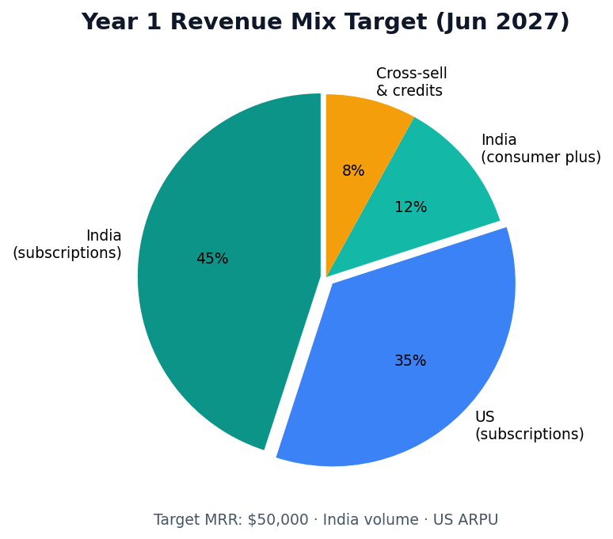
Figure 5: Year 1 exit revenue mix — India volume + US ARPU

10.1 Total Marketing Budget — Year 1
Category | Q3 2026 | Q4 2026 | H1 2027 | Annual Total
India marketing | ₹2.25L | ₹5.75L | ₹13.5L | ₹21.5L ($25K)
US marketing | ₹10K | ₹2.5L | ₹8L | ₹10.6L ($12.5K)
Events & conferences | ₹50K | ₹1.5L | ₹3L | ₹5L
Tools (analytics, CRM, email) | ₹30K | ₹60K | ₹1.2L | ₹2.1L
Content production | ₹25K | ₹75K | ₹1.5L | ₹2.5L
Contingency (10%) | ₹33K | ₹1L | ₹2.7L | ₹4L
TOTAL | ₹3.7L | ₹11.7L | ₹29.9L | ₹45.3L (~$53K)

Rule: Total marketing spend must remain below 30% of MRR until MRR exceeds $25K/month.

10.2 Brand & Content Strategy
- Founder-led content: 3 posts/week (LinkedIn + Instagram). Garima = brand/story. CTO = product demos.
- YouTube: 2 tutorials/month (India drafting, research, FIR analysis).
- Case studies: 1/month from Month 3 (solo advocate, small firm, US solo).
- Public changelog: weekly ship notes (builds trust post-launch bugs).
- PR: legal tech media (Artificial Lawyer, Law Sites, Inc42 for India) — 1 story/quarter.

10.3 Conversion Optimization
Funnel Step | Current (est.) | Target | Tactic
Visit → sign-up | 3% | 8% | Wedge landing page, social proof
Sign-up → activated | 40% | 65% | Onboarding call, single-workflow demo
Activated → D7 return | 30% | 50% | WhatsApp nudge, leads alert
Trial → paid | 10% | 22% | Day 7/14/25 sequences, price anchor

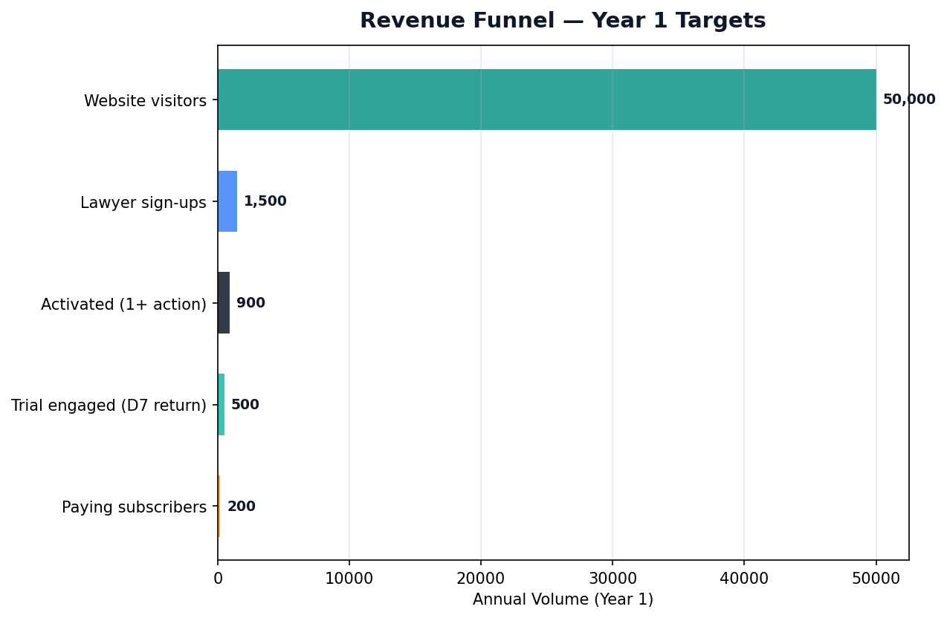
Figure 6: Annual revenue funnel targets

11. Financial Model & Unit Economics

11.1 Revenue Model Assumptions
Assumption | Value | Source
India ARPU (blended) | ₹2,000/seat/mo | 80% Starter, 15% Pro, 5% Pro Plus
US ARPU (blended) | $85/seat/mo | 70% Starter, 20% Pro, 10% Pro Plus
Avg seats per paying firm | 2.5 | Industry benchmark
Trial-to-paid (Month 1–3) | 12% | Conservative
Trial-to-paid (Month 6+) | 22% | With onboarding optimization
Monthly logo churn | < 8% | Target
Net revenue retention | > 105% | Upsells + seat expansion
AI cost as % of revenue | 35–45% | Credit system controls
Gross margin target | 55–65% | After AI costs

11.2 Year 1 P&L Summary (USD)
Line Item | Q3 2026 | Q4 2026 | H1 2027 | Year 1 Total
Revenue (MRR × avg) | $8K | $42K | $210K | $260K
AI / infrastructure COGS | $3.5K | $18K | $85K | $106K
Gross profit | $4.5K | $24K | $125K | $154K
Marketing | $4.4K | $14K | $34K | $52K
Salaries (founders + hires) | $0* | $8K | $60K | $68K
Tools & ops | $1K | $3K | $8K | $12K
Net profit / (loss) | ($0.9K) | ($1K) | $23K | $22K

* Founders at zero salary through Q3 2026. First hire (India marketing) in September at ₹60K/mo.

11.3 Unit Economics Target (Month 12)
Metric | India | US | Blended
CAC | ₹900 ($11) | $120 | $35
LTV (24-mo, 8% churn) | ₹38,000 | $1,800 | $620
LTV:CAC | 42:1 | 15:1 | 18:1
Payback period | 1.5 months | 2.5 months | 2 months
Gross margin | 60% | 58% | 59%

11.4 Cash Flow & Runway
Pre-fundraise: founders bootstrap through Q3 2026 on ≤ $5K/month burn (marketing only). Angel round ($150–300K) in Q4 2026 extends runway to 18 months. Seed ($1.5–2.5M Base / $3–5M Scale) in Q1 2027 funds US GTM scale and team growth.

11.5 Dual Scenario 3-Year Model
The full 3-year model lives in UMBRELLA-3-YEAR-FINANCIAL-MODEL.xlsx. Set Assumptions!B5 to 'Base' (original MRR plan) or 'Scale' ($50M ARR path). Revenue, headcount, OpEx, P&L, cash flow, and dividends recalculate via Excel formulas — not hardcoded values.
Exit metric | Base Plan | Scale Plan
Y1 MRR (Jun 2027) | $50K | $175K
Y2 MRR (Jun 2028) | $200K | $1.25M
Y3 MRR (Jun 2029) | $500K | $4.17M
Y3 ARR | $6M | $50M

Period | Starting Cash | Revenue | Expenses | Ending Cash | Runway
Q3 2026 | $20K | $8K | $10K | $18K | 5 months
Q4 2026 (+ angels) | $18K | $42K | $35K | $225K* | 18 months
H1 2027 (+ seed) | $225K | $210K | $180K | $1.8M* | 24+ months

* Assumes angel round closes Oct 2026 ($200K) and seed closes Mar 2027 ($2M).

12. Fundraising Strategy & Use of Funds
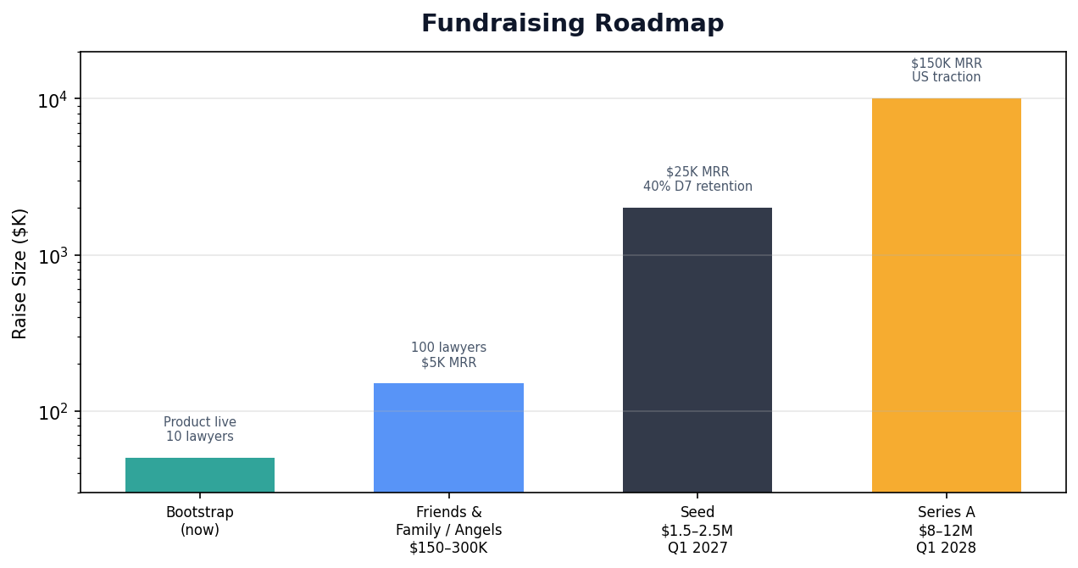
Figure 7: Fundraising timeline and triggers

12.1 Funding Rounds
Round | Timing | Amount | Valuation | Trigger
Bootstrap | Now | $0 | — | Product live, fixing bugs
Friends & Family / Angels | Oct 2026 | $150–300K | $3–5M | 100+ lawyers, $5K MRR
Seed | Mar 2027 | $1.5–2.5M (Base) / $3–5M (Scale) | $12–18M | $25K MRR (Base) / $100K+ (Scale)
Series A | Q1 2028 | $8–12M (Base) / $25M (Scale) | $50–80M / $200M+ | $150K MRR (Base) / $500K+ (Scale)
Series B | Q1 2029 | — (Base) / $50M (Scale) | — / $500M+ | $500K MRR (Base) / $3M+ (Scale)

12.2 Use of Funds — Seed ($2M scenario)
Category | % | Amount | Purpose
Engineering (incl. AI) | 40% | $800K | US drafting, SOC2, mobile, enterprise
US GTM | 25% | $500K | US BD hire, conferences, ads, content
India GTM | 15% | $300K | Influencer scale, bar partnerships, events
Operations & CS | 10% | $200K | Customer success, support, tools
G&A / legal / compliance | 5% | $100K | Incorporation, IP, SOC2 audit
Reserve | 5% | $100K | Contingency

12.3 Investor Narrative
One-liner: 'Umbrella is the AI-native Legal OS — starting with India's 600K advocates, expanding to America's 1.3M attorneys, then the world.'
- Why now: AI makes legal practice automation commercially viable for the first time.
- Why us: Only platform with India-verified drafting + consumer-to-lawyer lead flywheel + full firm OS.
- Traction: [update with live metrics before each investor meeting].
- Market: $800B legal services → $28B legal tech → AI-native is fastest-growing segment.
- Business model: SaaS per-seat + AI credits + consumer subscriptions. 60% gross margin.
- Competition: Not Clio (no AI). Not Harvey (no solos). Not ChatGPT (no verification, no OS).
- Vision: Every lawyer in the world runs their practice on Umbrella.

12.4 Target Investor Profiles
Type | Examples | Angle | When
Legal tech angels | Former Clio/MyCase execs | Category expertise | Angels Oct 2026
India SaaS angels | SaaS founders, Matrix/Accel angels | India GTM | Angels Oct 2026
Accelerators | Techstars, industry programs | Network + credibility | Apply Sep 2026
Seed VCs (US) | Bessemer, Index, a16z Speedrun | US expansion | Seed Mar 2027
Seed VCs (India) | Blume, Stellaris, Prime Venture | India depth | Seed Mar 2027

13. Organization, Governance & Operating Model
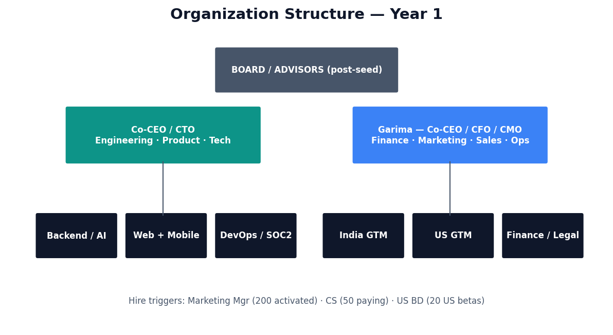
Figure 8: Year 1 organization structure

13.1 Hiring Plan (Metric-Triggered)
Role | Start | Cost/mo | Trigger | Reports To
India Marketing Manager | Sep 2026 | ₹60K | 200+ activated lawyers | Garima
Customer Success (PT) | Nov 2026 | ₹40K | 50+ paying firms | Garima
US BD (contract) | Jan 2027 | $3K | 20+ US beta users | Garima
Backend Engineer | Mar 2027 | ₹1.2L | Post-seed close | CTO
Content / Influencer Coord | Mar 2027 | ₹50K | 30+ active influencers | Garima

13.2 Decision Rights
Decision | Owner | Consult | Veto
Product roadmap priority | CTO | Garima | Either co-CEO
Marketing spend > $1K | Garima | CTO | Either co-CEO
Pricing changes | Garima | CTO | Both must agree
Fundraising / cap table | Garima | CTO | Both must agree
Engineering hires | CTO | Garima | —
GTM hires | Garima | CTO | —
Geographic expansion | Both | — | Both must agree

13.3 Governance
- Monthly board update (even pre-board): metrics, burn, hires, risks.
- Quarterly plan review: adjust targets based on actuals.
- Cap table: equal co-founder split recommended; 10–15% ESOP pool at seed.
- IP: all code and brand owned by Okay Legal entity.

14. Risk Management & Contingency Plans
Risk | Likelihood | Impact | Mitigation | Owner
Launch bugs erode trust | High | High | Public changelog + white-glove onboarding | CTO
100 sign-ups, low activation | Medium | High | Mandatory onboarding call; wedge demo | Garima
US product not ready | High | Medium | Delay US paid spend until Oct GA | CTO
Trial users don't convert | Medium | High | Day 7/14/25 sequences; price anchor | Garima
AI costs exceed revenue | Medium | High | Credit system caps; model router optimization | CTO
Influencer low quality | Medium | Medium | Approve before pay; UTM-only attribution | Garima
Fundraise fails / delays | Low | High | Bootstrap longer; reduce burn; angel first | Garima
Competitor moves downmarket | Medium | Medium | India depth + leads flywheel moat | Both
Regulatory (AI + legal) | Low | High | Disclaimers; not licensed advice; SOC2 | Both
Founder burnout | Medium | High | Strict role split; first hire Sep 2026 | Both

15. KPI Dashboard & Reporting Cadence
Metric | Jul 20 | Dec 2026 | Jun 2027 | Tool
Lawyer sign-ups (weekly) | 50+/wk | 55/wk | 70/wk | Admin + UTM sheet
Activation rate | > 60% | > 55% | > 50% | PostHog / Mixpanel
D7 retention (activated) | > 45% | > 50% | > 55% | Cohort sheet
Trial → paid conversion | > 10% | > 18% | > 22% | Stripe + admin
MRR | $600 | $17K | $50K | Stripe
India MRR % | 85% | 70% | 55% | Stripe
Lawyer leads / month | 10 | 80 | 200 | Leads inbox
CAC (blended) | < ₹1,200 | < ₹900 | < ₹700 | UTM sheet
Support response time | < 2 hrs | < 1 hr | < 30 min | WhatsApp SLA
NPS (quarterly) | — | > 40 | > 50 | Typeform

16. Role Assignments — Co-CEO / CTO (Engineering)
Accountability: Product, technology, AI, infrastructure, India product depth, engineering hires.
Review cadence: Daily standup (15 min) · Weekly ship review (Friday) · Monthly roadmap review.

16.1 Immediate — July 8–20 Sprint
# | Task | Deadline | Status
T-1 | Audit signup → activation funnel; fix top drop-off | Jul 10 | ☐
T-2 | Set up UTM tracking in admin dashboard + metrics sheet | Jul 9 | ☐
T-3 | Fix Google sign-up edge cases (issue-checker inline sign-up) | Jul 10 | ☐
T-4 | Welcome email + WhatsApp flow on lawyer sign-up | Jul 11 | ☐
T-5 | Add Calendly onboarding link to /for-lawyers + welcome email | Jul 10 | ☐
T-6 | Record 2-min Loom: legal notice drafting demo for WhatsApp groups | Jul 9 | ☐
T-7 | Mobile drafting demo stable for influencer reels | Jul 12 | ☐
T-8 | Public changelog page — 'What we fixed since launch' | Jul 11 | ☐
T-9 | Lawyer leads inbox: email + push notification on new lead | Jul 15 | ☐
T-10 | Join 3 onboarding calls/day to observe friction | Jul 8–20 | ☐

16.2 Monthly Todos — Q3 2026 (Jul–Sep)
Month | Task | Success Criteria
Jul | Fix all P0 launch bugs | D1 activation > 50%
Jul | Onboarding call insights → 4 product fixes | Activation 60%+
Aug | India drafting: timeout fix + long doc handling | < 5% generation failures
Aug | Research: citation confidence threshold enforced | Verified citations > 90%
Aug | PostHog/Mixpanel funnel analytics live | All funnel steps tracked
Sep | US drafting: first beta for 10 US lawyers | 5 US drafts completed
Sep | Lawyer leads WhatsApp alert integration | 80% leads opened < 1 hr
Sep | SOC2: CC6 access controls evidence collection | Audit prep 30% complete

16.3 Monthly Todos — Q4 2026 (Oct–Dec)
Month | Task | Success Criteria
Oct | US drafting GA (5 document types) | US beta NPS > 30
Oct | Product Hunt launch tech prep | Zero downtime launch day
Nov | Referral program (in-app, ₹500 credit) | 20 referrals in month 1
Nov | Hindi onboarding video library (5 workflows) | Activation lift + 10%
Dec | Self-serve onboarding v1 (no call required) | 50% self-serve activation
Dec | SOC2 Type I audit | Audit complete

16.4 Monthly Todos — H1 2027 (Jan–Jun)
Month | Task | Success Criteria
Jan | Enterprise pilot: SSO for 10+ seat firm | 1 enterprise LOI signed
Feb | US state templates (CA, NY, TX, FL, IL) | US conversion + 5%
Mar | Backend engineer hire (post-seed) | Engineer onboarded
Apr | API docs v1 + developer portal | 3 integration partners
May | India drafting v2 feature flag → production | Generation quality + 15%
Jun | Performance: sub-3s page loads globally | Lighthouse score > 90

16.5 Ongoing Weekly Cadence (CTO)
- Monday: Review funnel data; assign 2 engineering tasks for the week.
- Tuesday–Thursday: Ship 1 fix or feature per day. No meetings before 2 PM.
- Friday: Publish changelog. Demo to Garima. 3 onboarding calls.
- Daily: Monitor error rates, support tickets, generation failures.

17. Role Assignments — Garima (Co-CEO / CFO / CMO)
Accountability: Finance, fundraising, marketing, sales, US GTM, operations, customer success, GTM hires.
Review cadence: Daily marketing check (30 min) · Weekly growth meeting (Monday) · Monthly financial review.

17.1 Immediate — July 8–20 Sprint
# | Task | Deadline | Status
G-1 | Create metrics Google Sheet (UTM + funnel + daily tracker) | Jul 9 | ☐
G-2 | DM 30 influencers with reel scripts doc attached | Jul 10 | ☐
G-3 | Book 10 influencers for reels by Jul 12 | Jul 11 | ☐
G-4 | Post Loom demo in 10 WhatsApp lawyer groups | Jul 10 | ☐
G-5 | Book Jul 11 webinar: 'Legal Notice in 2 Minutes' (Zoom + landing) | Jul 9 | ☐
G-6 | Founder LinkedIn post: launch story + 60-sec demo | Jul 9 | ☐
G-7 | Set up WhatsApp Business support number on /for-lawyers | Jul 10 | ☐
G-8 | Approve and publish first 5 influencer reels | Jul 12 | ☐
G-9 | Personal WhatsApp welcome to every new lawyer sign-up | Jul 8–20 | ☐
G-10 | Outreach to 10 US lawyers from warm network | Jul 15 | ☐
G-11 | Set up Stripe revenue dashboard + weekly MRR email | Jul 10 | ☐
G-12 | Draft angel investor one-pager (1 page) | Jul 18 | ☐

17.2 Monthly Todos — Q3 2026 (Jul–Sep)
Month | Task | Success Criteria
Jul | 100 lawyer sign-ups by Jul 20 | 100 sign-ups, 60 activated
Jul | Influencer program: 10 reels live | 40 sign-ups from influencers
Aug | Own Delhi NCR as first city (50 activated) | 50 Delhi lawyers activated
Aug | Onboard 10 US beta lawyers | 10 US sign-ups
Aug | Financial model in spreadsheet (actuals vs plan) | Monthly P&L tracked
Sep | Hire India Marketing Manager | Hired by Sep 15
Sep | Apply to relevant accelerators | 3 applications submitted
Sep | First bar association webinar (Delhi or Mumbai) | 50 attendees, 10 sign-ups
Sep | Angel investor outreach: 20 conversations | 5 interested angels

17.3 Monthly Todos — Q4 2026 (Oct–Dec)
Month | Task | Success Criteria
Oct | Close angel round ($150–300K) | Cash in bank
Oct | Product Hunt launch (US drafting GA) | Top 5 of the day
Oct | Influencer Tier 3 scale (30 creators) | 100 sign-ups from influencers
Nov | First US case study published | 5 US paying firms
Nov | Hire Customer Success (part-time) | Hired by Nov 15
Nov | Trial-to-paid email sequences (Day 7/14/25) | Conversion + 5%
Dec | 110 cumulative paying firms | $17K MRR
Dec | Seed deck v1 + data room | Ready for Mar 2027 fundraise
Dec | First enterprise pilot conversation (India, 10+ seats) | LOI or pilot signed

17.4 Monthly Todos — H1 2027 (Jan–Jun)
Month | Task | Success Criteria
Jan | Legal tech podcast tour (3 appearances) | 25 US sign-ups
Jan | Hire US BD contractor | 20 US outreaches/week
Feb | Close seed round ($1.5–2.5M) | Cash in bank
Mar | ABA Techshow or equivalent conference | 50 qualified leads
Apr | LinkedIn ad test ($3K/mo) — only if D7 > 40% | CAC < $120
May | India bar association annual sponsorship (1 state) | 100 sign-ups from event
Jun | 200 cumulative paying · $50K MRR | Seed metrics hit
Jun | Series A prep: deck, metrics, US revenue story | Data room ready

17.5 Ongoing Weekly Cadence (Garima)
- Monday: Lead growth meeting. Update metrics sheet. Set channel targets.
- Tuesday: 2 influencer reels go live. 50 outbound DMs to lawyers.
- Wednesday: 5 lawyer user calls. Trial conversion nudges.
- Thursday: Webinar or demo. US community engagement.
- Friday: MRR report. Approve influencer payments. Social proof post.
- Saturday: Founder content (reel or LinkedIn).
- Daily: WhatsApp support (< 2 hr response). Welcome every new sign-up.

17.6 Financial Responsibilities (Garima as CFO)
- Weekly: MRR, burn rate, cash balance update.
- Monthly: P&L actual vs plan. CAC by channel. LTV cohort analysis.
- Quarterly: Board update. Fundraise progress. Budget reforecast.
- Ongoing: Stripe reconciliation. Vendor payments. Cap table management.
- Pre-seed: incorporate if not done, IP assignment, founder agreements, ESOP plan draft.

18. Years 2–3 Preview — Global Expansion
Two scenarios drive Year 2–3 planning. Base Plan is conservative and seed-ready. Scale Plan targets $50M ARR and requires Series A ($25M) and Series B ($50M). See Section 3.0 and the Excel model (Assumptions!B5 toggle).

18.1 Year 2 — US Heavy (Jul 2027 – Jun 2028)
Metric | Base Plan | Scale Plan
MRR (Jun 2028) | $200K | $1.25M
ARR run-rate | $2.4M | $15M
Paying firms | 600 | 3,000+
US revenue % | 55% | 60%
India revenue % | 30% | 25%
UK/CA/AU revenue % | 15% | 15%
Team size | 15–20 | 80–100
Funding | Series A $8–12M | Series A $25M

18.2 Year 3 — Rest of World (Jul 2028 – Jun 2029)
Metric | Base Plan | Scale Plan
MRR (Jun 2029) | $500K | $4.17M
ARR run-rate | $6M | $50M
Paying firms | 2,000+ | 15,000+
Countries live | 15+ | 20+
Team size | 40–50 | 150–200
Funding | Series A deployed | Series B $50M

Year 3 regions (sequential): UK (Y2 carry) → EU (Germany, France) → LATAM (Mexico, Brazil) → APAC (Singapore, Japan) → MENA (UAE). Each requires localized drafting engine + data residency assessment.

Appendix A: Competitive Landscape (Summary)
Company | Focus | Funding | Threat Level | Our Advantage
Clio | US practice management | $900M+ raised | Medium (US) | AI-native, India depth, lead gen
Harvey | BigLaw AI | $100M+ | Low (downmarket) | Solo/small firm pricing
Casetext/CoCounsel | US research | Acquired | Medium (US) | Full OS, not just research
CaseMine | India research | Bootstrapped | Low | AI drafting + OS, not just research
Vakilsearch | India consumer | VC-backed | Low | Lawyer-focused, not consumer
ChatGPT | General AI | OpenAI | High (awareness) | Verified citations, firm OS, leads

Appendix B: Product Feature Inventory (Summary)
Feature | Status | Route / Entry Point
India Drafting v1 | ✅ Production | /app/india-drafting/draft
Legal Research | 🟡 Partial | /app/research
US Drafting | 🟡 Partial | /app/us-drafting
Issue Checker | ✅ Production | /legal-issue-checker
FIR Analysis | ✅ Production | /app/fir-analysis
Document Review | ✅ Production | /app/document-review
Lawyer Leads Inbox | ✅ Production | /app/leads
AI Command Center | 🟡 Partial | /app/ai-command-center
Matters | ✅ Production | /app/matters
Billing | ✅ Production | /app/billing
Mobile App | ✅ Production | iOS + Android (Flutter)

Appendix C: Key URLs & Assets
- Home: https://umbrella.okaylegal.ai
- For Lawyers: https://umbrella.okaylegal.ai/for-lawyers
- Sign-up: https://umbrella.okaylegal.ai/auth/sign-up
- Pricing: https://umbrella.okaylegal.ai/pricing
- Issue Checker: https://umbrella.okaylegal.ai/legal-issue-checker
- Demo: https://umbrella.okaylegal.ai/demo
- Influencer UTM: ?utm_source=NAME&utm_medium=influencer&utm_campaign=lawyer-reels
- Influencer scripts: docs/marketing/INFLUENCER-REEL-SCRIPTS-INDIA-3000.md
- Engineering handbook: docs/umbrella-engineering-handbook/
- Feature inventory: docs/feature-inventory.md

Appendix E: Monthly Revenue Build-Up (USD)
Detailed month-by-month revenue projection for financial planning and investor updates.
Month | India Paying | US Paying | India MRR | US MRR | Total MRR
Jul 2026 | 4 | 1 | $400 | $200 | $600
Aug 2026 | 14 | 4 | $1,400 | $600 | $2,000
Sep 2026 | 27 | 8 | $2,800 | $1,700 | $4,500
Oct 2026 | 42 | 13 | $4,500 | $3,500 | $8,000
Nov 2026 | 60 | 20 | $6,500 | $5,500 | $12,000
Dec 2026 | 80 | 30 | $9,000 | $8,000 | $17,000
Jan 2027 | 95 | 40 | $11,000 | $11,000 | $22,000
Feb 2027 | 110 | 50 | $13,500 | $14,500 | $28,000
Mar 2027 | 120 | 55 | $16,000 | $18,000 | $34,000
Apr 2027 | 128 | 57 | $18,500 | $21,500 | $40,000
May 2027 | 135 | 60 | $21,000 | $24,000 | $45,000
Jun 2027 | 140 | 60 | $27,000 | $21,000 | $50,000

Appendix F: Weekly Channel Scorecard Template
Copy this table into the metrics Google Sheet. Update every Monday.
Channel | Spend (wk) | Sign-ups | Activated | Paid | CAC | Notes
Influencer (Instagram/YT) | — | — | — | — | — | —
WhatsApp / Telegram | — | — | — | — | — | —
Direct outreach (DM) | — | — | — | — | — | —
Webinar / event | — | — | — | — | — | —
LinkedIn organic | — | — | — | — | — | —
Google Ads | — | — | — | — | — | —
Referral | — | — | — | — | — | —
US network / podcast | — | — | — | — | — | —
Organic / direct | — | — | — | — | — | —
TOTAL | — | — | — | — | — | —

Appendix G: Investor FAQ (Pre-Seed / Seed)
Q: Why India first?
A: India has 600K+ practicing advocates, no AI-native legal OS, and our India drafting engine is production-ready with IPC/CrPC verification. It's the fastest path to volume and product iteration.
Q: Why not Africa?
A: Deliberate focus. Year 1 is India + US only. Africa adds distraction without proportional ARPU. Year 3+ may include select markets after core economics are proven.
Q: How do you compete with ChatGPT?
A: ChatGPT gives unverified text. Umbrella gives section-verified India drafts with statute citations, a full firm OS, and a consumer lead pipeline. Lawyers pay for trust and workflow, not text generation.
Q: What's the moat?
A: Three layers: (1) India drafting verification pipeline, (2) consumer-to-lawyer lead flywheel, (3) full firm OS with matters, billing, and mobile. No competitor has all three.
Q: What's the business model?
A: SaaS per-seat subscriptions (₹1,400–30,000 India; $50–1,000 US) plus AI credit packs and consumer Plus subscriptions.
Q: What are the unit economics?
A: Target LTV:CAC of 18:1 blended. India CAC ~₹900, US CAC ~$120. Gross margin 55–65% after AI costs.
Q: How much are you raising?
A: Base: Angels $150–300K (Oct 2026), Seed $1.5–2.5M (Mar 2027), Series A $8–12M (2028). Scale: Seed $3–5M, Series A $25M, Series B $50M.
Q: What will you do with seed money?
A: 40% engineering, 25% US GTM, 15% India GTM, 10% ops/CS, 5% G&A, 5% reserve.
Q: Who are the founders?
A: Co-CEO/CTO (engineering, product, AI) and Garima (co-CEO/CFO/CMO — finance, marketing, sales, operations).
Q: What's the 3-year vision?
A: Base: $6M ARR by Year 3 (original MRR plan). Scale: $50M ARR via US enterprise + India volume + global expansion. Both: India + US Year 1, US-heavy Year 2, global Year 3.

Appendix H: Detailed Weekly Plan — Q3 2026
Week-by-week execution for July through September. Owner: both co-CEOs.

Week Jul 8–13
Theme: 100-lawyer sprint (phase 1)
Actions: CTO: funnel fix, Loom, onboarding. Garima: 30 influencer DMs, webinar, WhatsApp groups.
Target: 40 sign-ups

Week Jul 14–20
Theme: 100-lawyer sprint (phase 2)
Actions: CTO: leads notifications. Garima: influencer wave 2, IG Live, conversion nudges.
Target: 100 total

Week Jul 21–27
Theme: Activation blitz
Actions: CTO: research citation fix. Garima: call every non-activated user. Publish 2 testimonials.
Target: 20 new, 70% activation

Week Jul 28–Aug 3
Theme: Delhi NCR atomic start
Actions: CTO: PostHog live. Garima: 5 Delhi bar association contacts. 3 influencer reels.
Target: 25 new (Delhi focus)

Week Aug 4–10
Theme: Influencer Tier 2 scale
Actions: CTO: mobile demo polish. Garima: onboard 10 US betas. 5 reels.
Target: 30 new

Week Aug 11–17
Theme: Webinar series #2
Actions: CTO: drafting timeout fix. Garima: 'FIR Analysis' webinar. Law college outreach.
Target: 30 new

Week Aug 18–24
Theme: Delhi NCR push
Actions: CTO: referral program spec. Garima: Delhi advocate association event. 50 Delhi activated target.
Target: 25 new

Week Aug 25–31
Theme: Month-end conversion
Actions: CTO: ship referral v0. Garima: trial-to-paid push. MRR $2K target.
Target: 15 new, 18 paying

Week Sep 1–7
Theme: US beta expansion
Actions: CTO: US drafting beta. Garima: hire marketing manager. Accelerator applications.
Target: 30 new

Week Sep 8–14
Theme: Bar association webinar
Actions: CTO: US draft feedback iteration. Garima: first bar webinar. Angel deck draft.
Target: 35 new

Week Sep 15–21
Theme: Marketing manager onboarded
Actions: CTO: leads WhatsApp alerts. Garima: delegate influencer ops. 20 angel conversations.
Target: 35 new

Week Sep 22–28
Theme: Q3 close
Actions: CTO: SOC2 evidence start. Garima: Q3 metrics report. MRR $4.5K target.
Target: 30 new, 35 paying

Appendix I: Technology Stack Detail
Layer | Technology | Purpose | Status
Frontend (web) | Next.js 14, React, Tailwind | Lawyer OS, consumer checker | Production
Frontend (mobile) | Flutter (Dart) | iOS + Android lawyer app | Production
Backend API | NestJS (TypeScript) | Modular monolith, multi-tenant | Production
Database | PostgreSQL (Prisma ORM) | Tenants, matters, billing, users | Production
Queue | Redis (BullMQ) | Async AI jobs, notifications | Production
Storage | AWS S3 | Documents, uploads | Production
AI models | OpenAI GPT-4o, model router | Drafting, research, analysis | Production
Payments | Stripe | Subscriptions, credits, invoicing | Production
Auth | Custom JWT + Google OAuth | Multi-tenant auth | Production
Infra | AWS (ECS/RDS) | Hosting, CI/CD | Production
Monitoring | CloudWatch + custom | Errors, latency, AI costs | Partial
Compliance | SOC2 controls (CC1-CC9) | US enterprise trust | In progress

Appendix J: Brand Voice & Messaging Guidelines
India (Hinglish): Professional but relatable — like a senior lawyer talking to a junior. Mix Hindi and English naturally.
US (English): Confident, practical, no hype. Lead with time saved and risk reduced. Avoid 'AI lawyer' or 'revolutionary.'
Context | Do | Don't
Product description | Legal information & practice tools | AI lawyer, guaranteed outcomes
India CTA | 30-day free trial · Link in bio | Free forever, no catch
US CTA | Start your 30-day free trial | Disrupting the legal industry
Social proof | X lawyers trust Umbrella | Best legal AI in the world
Competitive | More than Clio, more affordable than Harvey | Clio is terrible
Disclaimer | Not a substitute for licensed counsel | Skip disclaimers

Appendix D: Glossary
Term | Definition
Activated | Lawyer who completed profile + 1 core action (draft, research, FIR, or leads)
City-first entry | Single city or practice-area focus before national or broad market spend
CAC | Customer Acquisition Cost — total marketing spend / new paying customers
D7 retention | % of activated lawyers who return within 7 days
Flywheel | Self-reinforcing growth loop: consumer → lead → lawyer → more consumers
LTV | Lifetime Value — ARPU × average customer lifetime in months
MRR | Monthly Recurring Revenue from subscriptions
North Star | D7 activated retention — predicts long-term revenue
Wedge | Single compelling feature that drives initial adoption (India legal notice drafting)

Umbrella by Okay Legal · Confidential
Document owner: Garima (CFO) + CTO (Engineering)
Review cadence: Weekly (Monday growth meeting) · Full revision: Monthly
Next review: August 1, 2026
Contact: g.jain@okaylegal.ai

