Implementation of K-Means and K-Medoid Clustering
In Parallel Environment

Viranchi Badheka (15IT111), Bhabesh Chanduka(15IT113), Nihar Raichada (15IT132), Poojan Shah(15IT227), Department of Information Technology, National Institute of Technology Karnataka, Surathkal, Mangalore – 575025.
badheka.viranchi002@gmail.com , bhabesh.chanduka@gmail.com, raichada.nihar3@gmail.com, shahpoojan98@gmail.com

Abstract: Clustering is one of the most popular methods for data analysis, which is prevalent in many disciplines such as image segmentation, bioinformatics, pattern recognition and statistics etc. The most popular and simplest clustering algorithm are K-means and K-medoid because of their easy implementation, simplicity, efficiency and empirical success. However, the real-world applications produce huge volumes of data, thus, how to efficiently handle of these data in an important mining task has been a challenging and significant issue. In addition, MPI (Message Passing Interface) and openMP(open multi-processing )as programming models present high performances, scalability and portability. Motivated by this, a parallel K-means clustering algorithm with MPI and openMP, are proposed in this report. It enables applying the algorithm effectively in the parallel environment. Experimental study demonstrates that parallel K-means is relatively stable and

Dr. Geetha V
Department of Information Technology, National Institute of Technology Karnataka, Surathkal, Mangalore – 575025.
geethav@nitk.ac.in

portable, and it performs with low overhead of time on large volumes of data sets.

Keywords : OpenMP - Open multi-processing,MPI - Message Passing Interface,K-Mean Clustering,K-Medoid Clustering,Euclidean distance,Manhattan distance,Centroids,Parallelizm

I. Introduction
K-Means clustering:
k-means clustering is a method of vector quantization which is often used in cluster analysis in data mining. k-means clustering aims to partition n observations into k clusters in which each observation belongs to the cluster with the nearest mean, serving as a prototype of the cluster.

K-Medoid clustering:
The k-medoids algorithm is a clustering algorithm related to the k-means algorithm and the
1
medoid shift algorithm. Both the k-means and k-medoids algorithms are partitional (breaking the
dataset up into groups) and both attempt to minimize the distance between points labeled to be in a cluster and a point designated as the center of that cluster. In contrast to the k-means algorithm, k-medoids chooses data points as centers (medoids or exemplars) and works with a generalization of the Manhattan Norm to define distance between data points.

II. Related Work
The computational complexity of k-means is linear with respect to the number of data points. The number of iterations of the algorithm until convergence is proportional to the size of the data set. This approach yields a speedup for two reasons. First, less data are clustered and second because the k-means algorithm converges more quickly for smaller data sets than larger data sets from the same source.
k-means algorithm in MapReduce framework is implemented by Hadoop to make the clustering method applicable to large scale data. By applying proper <key, value> pairs, the proposed algorithm can be parallel executed effectively. We conduct comprehensive experiments to evaluate the proposed algorithm. The results demonstrate that our algorithm
can effectively deal with large scale datasets.

III. Proposed parallel algorithms

K means algorithm in MPI:
Input: Data, K Cluster
Output: K Centroid
1: MPI_INIT// start MPI Procedure
2: Read N object from file
*/start parallel proccess by divide same amount of object to each processes/*
3: repeat
4:Choose K point as intial centroid randomly
5: Initiate each object to the closest centroid by using Euclidean Distance Formula
6: until centroid don’t change
*/merge centroid procedure /*
7: Generate cluster id to each object
8: Generate new centroid cluster by centroid result in each processes
9: Generate final centroid
10: MPI_Finalize() // Terminate MPI Process
Proposed parallel algorithm - Master - Slave model and dynamic load balancing technique

K means algorithm in OpenMP

Input: D={d1,d2,d3,d4,...dn}
K= Initial Clusters
Output: K Clusters
Procedure:
1.Initialize the OpenMP Processes {P1,P2,... Pn}
2.Take the preprocessed dataset and arrange the dataset in ascending order.
3.Partition the sorted dataset into k clusters and assign each part of dataset to each process
4.For each partition, calculate the k centroids of all the clusters
5.Continue the process to form k final local clusters until the convergence is met.
Proposed parallel algorithm - Master - Slave model and dynamic load balancing technique

K medoid algorithm in MPI:
Input: Data, K Cluster
Output: K Centroid
1: MPI_INIT// start MPI procedure
2: read N object from file 2
*/start parallel proccess by divide same amount of object to each processes/*
3: repeat
4:Choose K point as intial centroid randomly
5: Initiate each object to the closest centroid by using Euclidean Distance Formula
6: Choose K point non medoid randomly
7: Compute total cost K Medoid and K non Medoid then .
8: until centroid don’t change
*/merge the result from each processes/*
9: Generate cluster id for each processes
10: Generate centroid new cluster
11: Generate final centroid
12: MPI_Finalize() // terminated MPI process
Proposed parallel algorithm - Master - Slave model and dynamic load balancing technique

K medoid in OpenMP:
Input: D={d1,d2,d3,d4,...dn}
K= Initial Clusters
Output: K Clusters
Procedure:
1. Initialize the openMP processes {P1,P2…,Pn}
2: read N object from file
*/start parallel proccess by divide same amount of object to each processes/*
3: repeat
4:Choose K point as intial centroid randomly
5: Initiate each object to the closest centroid by using Euclidean Distance Formula
6: Choose K point non medoid randomly
7: Compute total cost K Medoid and K non Medoid then .
8: until centroid don’t change
*/merge the result from each processes/*
9: Generate cluster id for each processes
10: Generate centroid new cluster
11: Generate final centroid
Proposed parallel algorithm - Master - Slave model and dynamic load balancing technique

IV. System Requirements

Hardware :
- 256 MB (Minimum)
- 64 GB ROM
- Pentium 4 processor

Software:
- Ubuntu/windows (Operating System)
- C++
- OpenMP
- MPI
- Python

V. Results and Discussion

We have implemented the algorithms in parallel environments - OpenMP and MPI and the results are shown as the time elapsed in dividing the dataset into K clusters as the dataset varies.

3
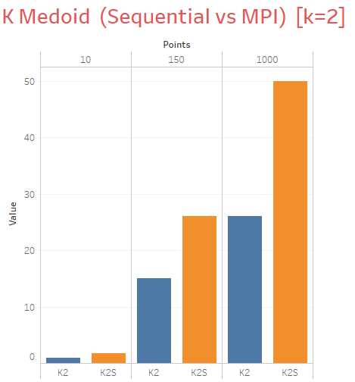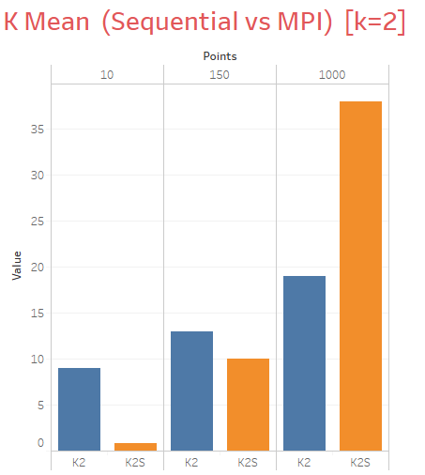
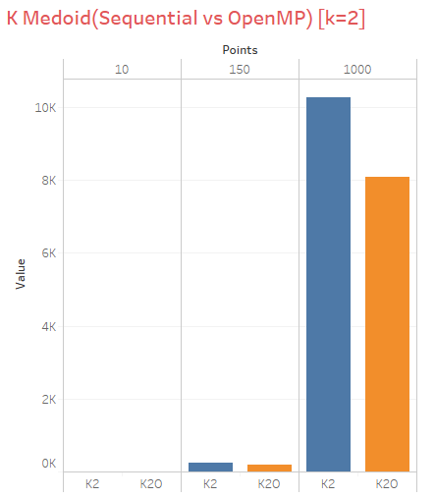
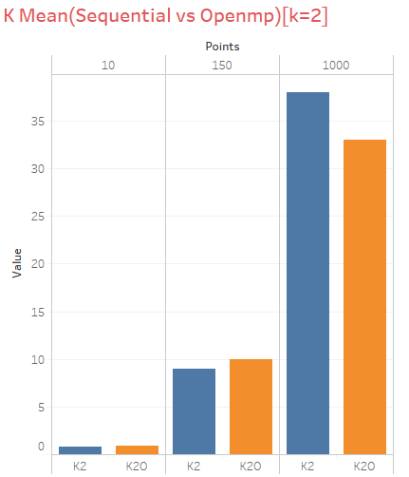V. Conclusion

In this project we conclude the results of both K- mean and K-Medoids clustering algorithms with respect to the number of clusters formed and distance metric. The comparison results show that time taken in cluster selection and space complexity of overlapping of cluster is much better in K-Medoids than K-Means.
The result from K-Means and K-Medoids algorithm and time performance using High Performance Computing (HPC) Cluster parallelize K-Means and K-Medoids algorithms and use Message Passing Interface (MPI) library and OpenMP . The results showed that K-Means algorithm gives smaller SSE than K-Medoids. And also parallel algorithm that used MPI and OpenMP gives faster computation time than sequential algorithm when dataset is having large number of tuples.
Also the result of dataset shows that K-Medoids is better in all aspects such as execution time, non sensitive to outliers and reduction of noise but with the drawback that the complexity is high as compared to K-Means.

VI. References
- www.google.com
- www.wikipedia.com
- www.aAc.els-cdn.com
- http://ieeexplore.ieee.org/stamp/stamp.jsp?arnumber=6128477
- http://ieeexplore.ieee.org/document/6579448/
- http://ieeexplore.ieee.org/stamp/stamp.jsp?arnumber=6724291
- http://www.ece.northwestern.edu/~wkliao/Kmeans/index.html
- https://www.cse.buffalo.edu//faculty/miller/Courses/CSE633/Chandramohan-Fall-2012-CSE633.pdf

5

