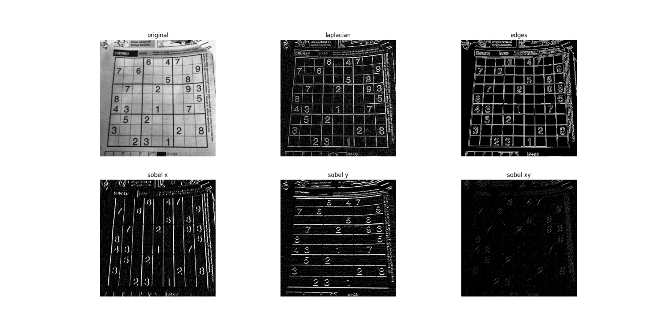

* **Sobel Filter**

In here edges are detected along X axis, Y axis and both at once. When calling the Sobel function we can specify the axis, so that it detect the edges along that axis.

* **Laplacian Filter**

This determines the edges by detecting horizontal and vertical directions separately and then combined them both. Using this detect the edges of whole image at once.

* **Canny**

Canny edge detection composed of 5 steps

1. Noise reduction.
2. Gradient calculation.
3. Non-maximum suppression.
4. Double threshold.
5. Edge Tracking by Hysteresis.