**Bank Transaction Services**

**Summary**

* OpenAPI data modeled User for Spring Embedded Mongo *(SpringMongoRestAPI .docx)* CRUD Rest APIs as development baseline
* OpenAPI data modeled Transaction for core system functionality aka listing transaction page totals by month*(Solution-TransactionPaginationRest.docx),* implemented by “bank-data-admin-client” project containing REST APIs
* EUR as a common base currency (*Solution-TransactionPaginationRest.docx*) for debit/credit total amount computation
* Spring Security component powered JWT web token *(SpringSecurityRestAPI.docx)* identity governance, implemented by “jwt-OAuth-OpenAPI” project, with authentication/authorization security on Rest API. Extra security features include,
* “bank-account-data-encrypt” to supplement proprietary encryption method for sensitive information
* “access-sec-app” *(/account-security-python-client/access-sec-app.py*) designed to facilitate cross domain identity security and developed from Swagger generated client code (/*OpenAPI-generated-docs /bank-access-api.json)*
* Mongo NoSQL database *(/data-lake/NoSql-mongo)* enabling JSON serializable/de-serializable data operations on Transaction-User-Account data schema (*OpenAPI-generated-docs /bank-Transaction/index.html* ). Extra data streaming stability features include,
* MariaDB console as DB Admin client(Appendix)
* MaxScale as NoSql clustering solution (Appendix)
* Global Exchange (“global-exchange” project) connected to 3rd Party – Free Currency API
* Kafka Spring (“Kafka-Spring” project) and MongoDB Connector Components (*(/data-lake/NoSql-mongo)*)
* Kubernetes Orchestration Scheme *(/kube-deploy)*
* Bank Data Admin transaction DB logs fetching (Appendix)
* DevOps CirclCI compatible pipeline Dev-Test-Deploy scripts *(/cicd*) and successfully run (Appendix)

**Architecture Diagram**

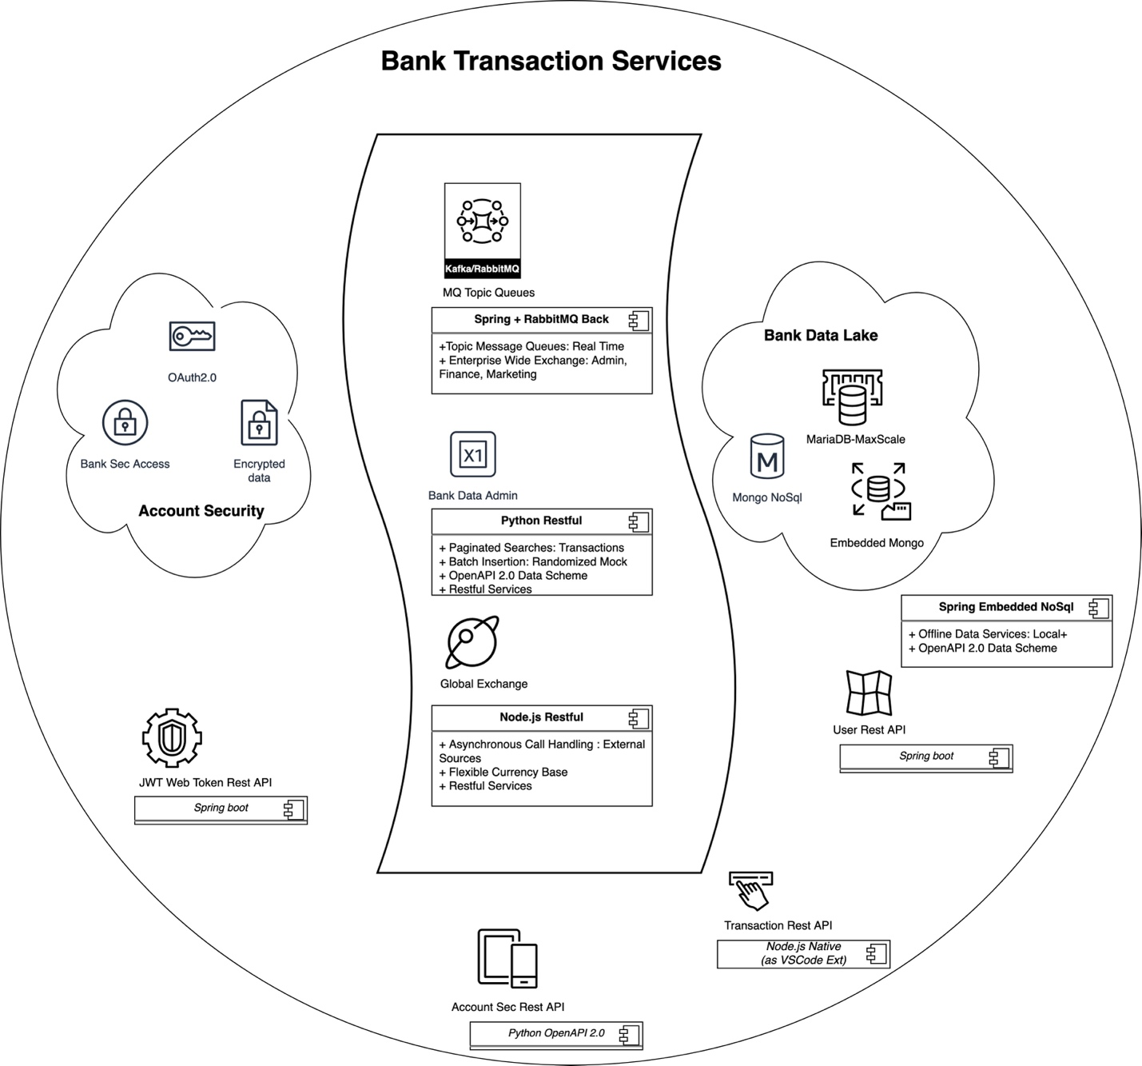

**Major Tech Stacks**

* Spring Microservices
* Node.js with Axios Asynchronous external API calls for Global Exchange
* Python Restful API with built in mocking, batch inserting, easy fetching data capabilities
* MongoDB and MariaDB, NoSql clustering and embedded database, Maria MaxScale Enterprise
* RabbitMQ Kafka message queue exchange for topic data consumption
* Docker as containerization tool

**Appendix**

**MariaDB console as DB Admin client**

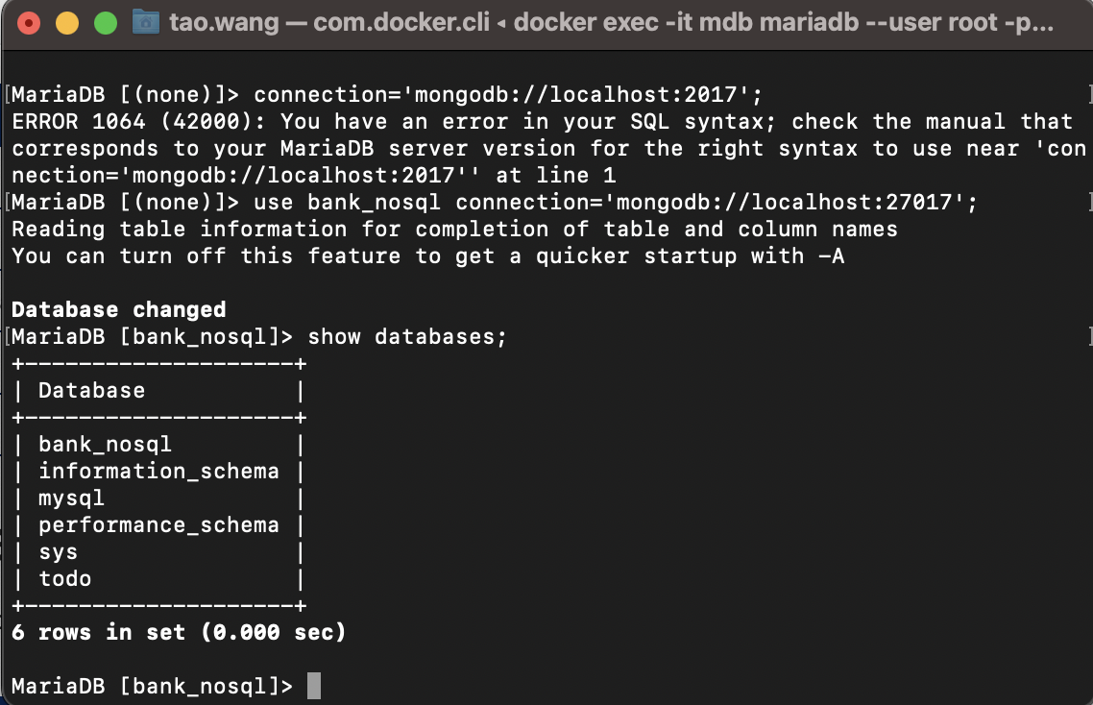

**NoSql clustering**

Maria DB MaxSca1e 
server 1 
Schemas 
Filter schema objects 
bank_nosql 
Tables 
EMPLOYEES 
transactions 
Columns 
Indexes 
Triggers 
% Views 
Stored Procedures 
Query Tab 1 
Admin v 
SERVERI 
Row limit 10000 
1 
2 
3 
use bank_nosql; 
DELETE FROM transactions 
WHERE id=3, 
Results 
Data Preview History/Snippets 
Table: 'bank_nosqr : transactions' 
DATA 
DETAILS 
2 
3 
4 
5 
id 
group 
2 
4 
5 
6 
doc 
group 
[0] 
[{'currency_amount': 
('currency_amount': 
('currency_amount': 
'CHF 75 
'CHF 75 
'CHF 75 
', 'description': Online payment CHF', 'eur_amount': 
'description': Online payment CHF', 'eur_amount': 
'description': 'Online payment CHF', 'eur_amount'. 
77.78, id . 
77.78, 'id . 
• 77.78, 'id . 
' O, 'month_ 
" O, 'month_ 
" O, 'month_ 
num : 
num . 
num : 
' 10, 'user_uid': 
7, 'user_uid': 
' 11, 'user_uid . 
0.05 seconds 
'P-0123456789' 
'P-0123456789' 
'P-0123456789' 

Atlas 
Tao's Org - 2m 
Access Manager 
Project O 
DEPLOYMENT 
Database 
Data Lake 
SERVICES 
Device Sync 
Triggers 
Data API 
Data Federation 
Search 
Stream Processing 
sample_airbnb 
a SECURITY 
Backup 
Database Access 
Network Access 
sample_guides 
Advanced 
Data Services 
App Services 
Billing 
Charts 
All Clusters 
Get Help 
Tao 
A 
TAO'S ORG - 2023-07-21 > PROJECT O > DATABASES 
ClusterO 
Overview 
Real Time 
Metrics 
Collections 
Search 
Profiler 
Performance Advisor 
VERSION 
6.0.8 
Online Archive 
REGION 
AWS N. Virginia (us-east-I) 
Cmd Line Tools 
DATABASES: 1 
COLLECTIONS: 
+ Create Database 
Q 
Search Namespaces 
bank_nosql 
transactions 
sample_analytics 
sample_geospatial 
sample_mflix 
bank_nosql.transactions 
STORAGE SIZE:4KB LOGICAL DATA SIZE: 0B TOTAL DOCUMENTS: O INDEXES TOTAL SIZE: 4KB 
Find 
Filter g 
Indexes 
Type 
Schema Anti-Patterns O 
Aggregation 
Search Indexes 
a 
query : 
field: 
value 
Reset 
Apply 
INSERT DOCUMENT 
More Options 
QUERY RESULTS: 1-1 OF 1 
_id: Obj ectld( 64bc3955fddff121dac8c2df' ) 
currency_amount: " CHF 

Bank Data Admin transaction DB logs

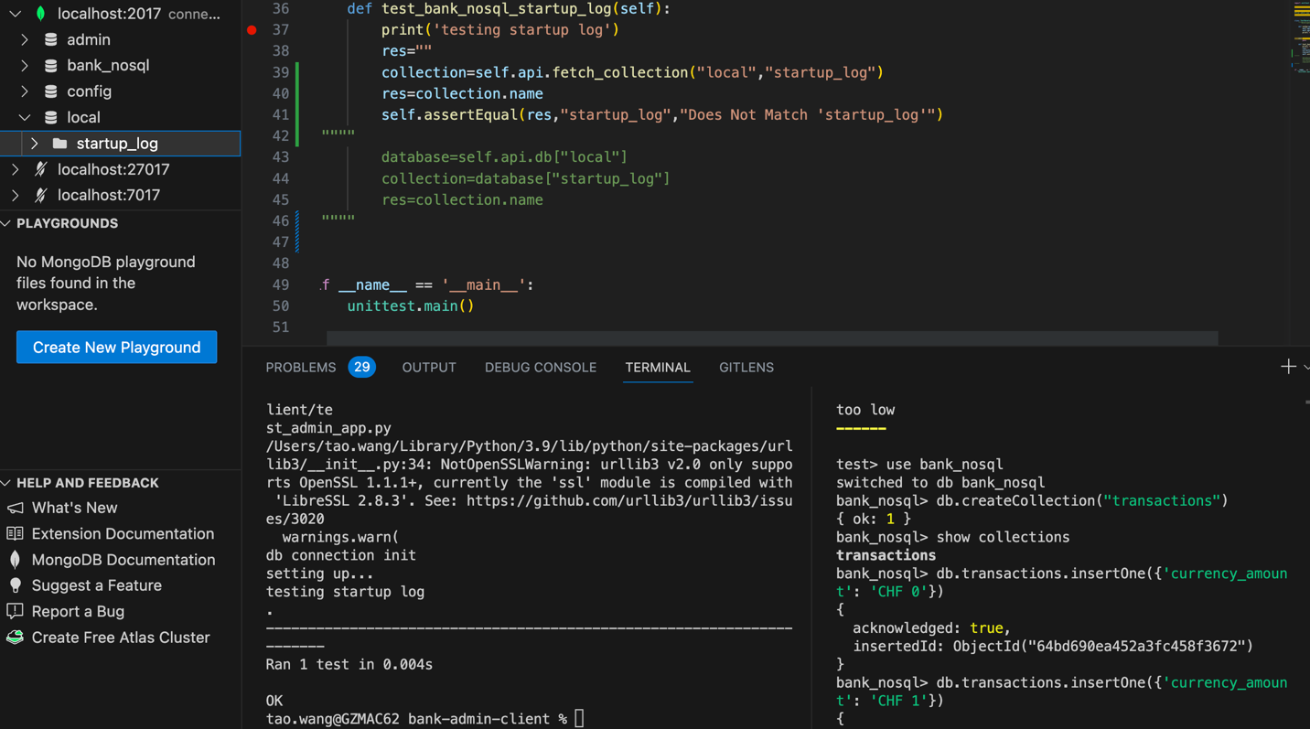

**CirclCI Pipeline Run Successfully**

