**Spring Mongo Rest API**

/bank-embed-nosql-rest-api

**Mock Rest API - Coding**

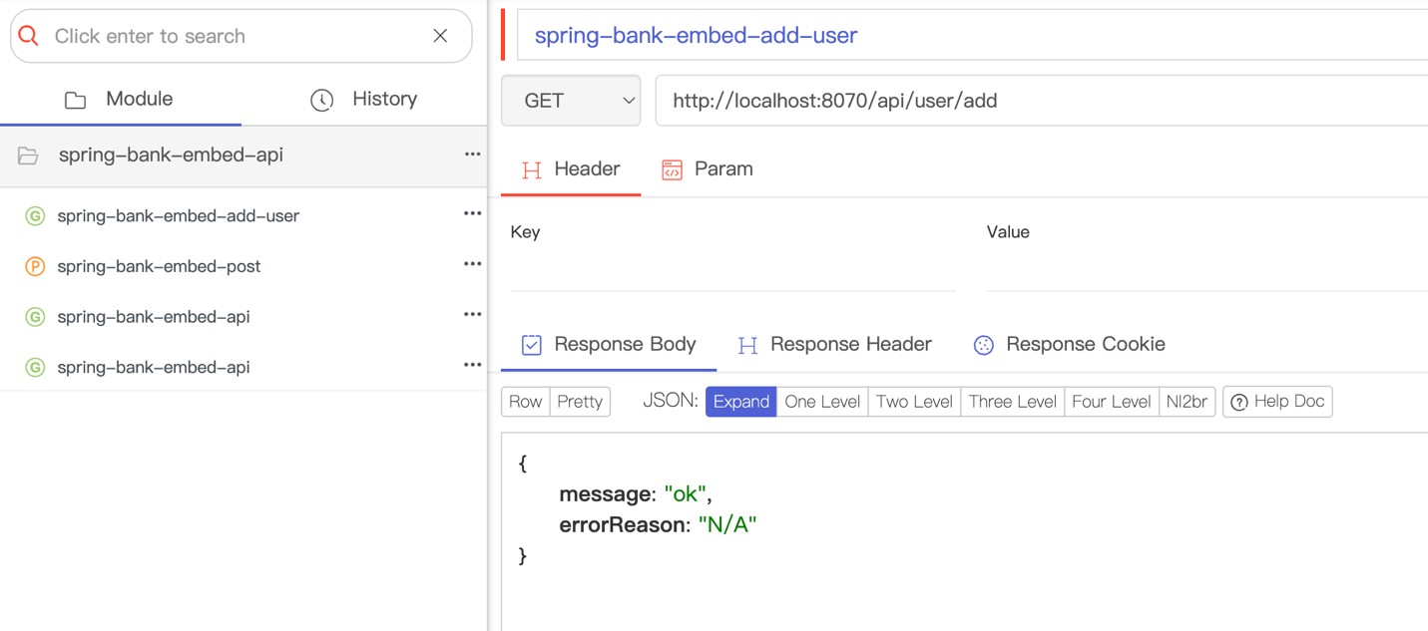

main 
v fullstack 
v restAPl 
v bankdata 
Transaction.java 
User.java 
ResponseMessage.java 
v mongodb 
DataModel.java 
Model.java 
97 
98 
99 
100 
102 
103 
104 
105 
106 
1ß7 
ModelMongoRepository.java 
MongoController.java 
Launcher.java 
v resources 
application.properties 
v fullstack 
v restAPl 
romanNumMongoTests.java 
108 
109 
110 
111 
112 
113 
114 
115 
116 
2 viraree • 
= "/user/add" , 
= RequestMethod . GET) 
method 
public ResponseEntitY<ResponseMessage> addUser() { 
ResponseMessage result-new ResponseMessage() ; 
try { 
User user-new User(); 
user . initData(); 
user . setld(System. currentTimeMi11is()) ; 
mongoTemptate . save(user) ; 
catch(Exception e) 
result. setMessage(" error") ; 
result. setErrorReason(e. getMessage()) ; 
return ResponseEntity . ok(resutt) ; 

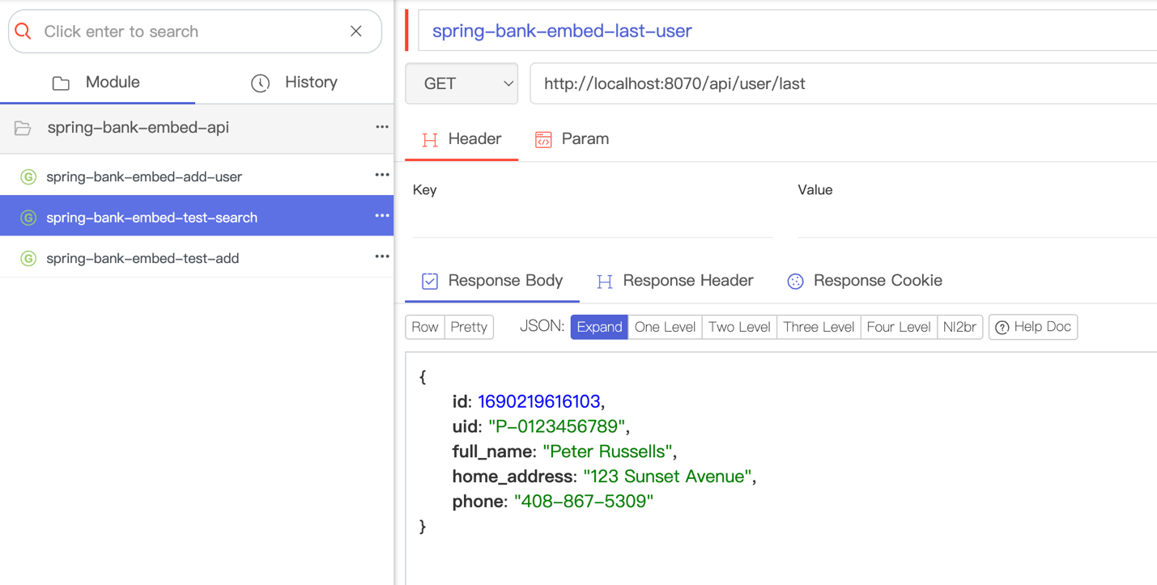

146 
147 
148 
149 
15B 
151 
152 
153 
154 
155 
= "/user/last", 
public User fetchLastUser() { 
User tast= mongoTemptate. 
method = 
second) 
RequestMethod . GET) 
return 
findA1t(User. class) 
. stream() 
. second) 
. orEtse(nuLI) ; 
last; 

**OpenAPI Data Model- Swagger Generated Classes**



