College Majors 2026: Models, Model Comparison & Conclusion
We predicted the 4-year median earnings of 25,283 bachelor's programs with three supervised models. The random forest performed best (test R² 0.786, average error $6,232), essentially tied with gradient boosting (0.783), and both clearly beat Ridge regression (0.744) and a field-median baseline (0.566).

Models and tuning
All three models share the same setup, so the comparison is fair:
- Target: log of median earnings 4 years after completion (log reduces skew from 1.49 to 0.25).
- Inputs: 31 predictors (25 numeric, 6 categorical) covering field, school, location, job market and AI exposure; 88 columns after one-hot encoding.
- Preprocessing pipeline: median imputation with missing-value flags, standard scaling and one-hot encoding, fit on training folds only.
- Split: 80/20 by school. 19,932 training programs from 1,439 schools; 5,351 test programs from 360 different schools.
- Tuning: 5-fold GroupKFold cross-validation grouped by school, scored by R².
Model | Why we used it | Hyperparameters tried | Chosen | CV R²
Ridge regression | Linear model from class; interpretable; the L2 penalty handles correlated predictors | alpha: 13 values from 0.001 to 1,000 (grid search) | alpha = 3.16 | 0.753
Random forest | Averages many decorrelated trees; captures nonlinear effects and interactions | max_depth 12/20/none; min_samples_leaf 1/5/20; max_features 0.3/0.6 (8 random combinations); 200 trees | No depth limit, leaf ≥ 5, 30% of features per split | 0.789
Gradient boosting | Builds small trees in sequence, each fitting the previous errors; often the strongest on tabular data | learning_rate 0.03/0.05/0.1; max_leaf_nodes 15/31/63; min_samples_leaf 20/50/100; l2_regularization 0/1/5 (10 random combinations); early stopping | Rate 0.03, 31 leaves, leaf ≥ 20, L2 = 1; ~910 trees | 0.788
Tuning notes:
- Ridge: performance was flat for alpha up to about 10 and fell only with very strong penalties. Training and validation scores were close (0.759 vs 0.753), so Ridge is limited by bias, not overfitting.
- Random forest: leaves of a single program fit the training data almost perfectly (train R² 0.971) without improving validation (0.787). Requiring 5 programs per leaf smoothed predictions at no cost; 20 per leaf was too smooth (0.774).
- Gradient boosting (HistGradientBoostingRegressor in scikit-learn):
  - How it extends what we learned in class: it starts from the average prediction and repeatedly fits a small tree to the current errors. It adds each tree scaled down by the learning rate, so no single tree dominates.
  - Robust to tuning: all 10 settings scored between 0.783 and 0.788, so results aren't sensitive to the exact choice.
  - Early stopping held out 10% of the training data and stopped once 30 trees in a row failed to improve it. It settled on about 910 trees, and raising the cap from 1,000 to 3,000 changed nothing.

Model comparison

Metrics and why we chose them
Metric | What it measures | Why it fits our problem
R² (log scale) | Share of variation in log earnings explained | Matches the scale the models were trained on; comparable across models
MAE ($) | Average absolute error in dollars | Easiest to interpret: "off by $X per program"
RMSE ($) | Typical error, penalizing large misses more | Shows whether a model makes occasional big mistakes
Median absolute % error | Typical error relative to the program's actual pay | A $10k miss matters more on a $40k program than on a $150k one
Share within ±10% / ±20% | How many programs are predicted closely | Practical accuracy a student could rely on
Every metric is computed on the test set: 360 schools no model saw during training or tuning. As a reference point, the baseline predicts each program's earnings as the national median for its field.

Results
Model | CV R² | Test R² | MAE | RMSE | Median % error | Within ±10% | Within ±20%
Baseline (national field median) | — | 0.566 | $8,760 | $12,624 | 10.4% | — | —
Ridge regression | 0.753 | 0.744 | $7,030 | $10,005 | 8.6% | 56% | 85%
Random forest | 0.789 | 0.786 | $6,232 | $8,914 | 7.6% | 61% | 88%
Gradient boosting | 0.788 | 0.783 | $6,314 | $8,957 | 7.7% | 61% | 88%

Interpretation
- Every model beats the baseline. Even Ridge explains 18 points more variance than the field median alone, so school, location, job-market and AI features carry real information.
- Tree models clearly beat Ridge: about +0.04 R² and roughly $750 less error per program. Earnings depend on nonlinear effects and interactions (for example, location and school quality matter differently across fields) that a linear model cannot represent.
- Random forest and gradient boosting are effectively tied. The gaps (0.003 R², $82 MAE) are too small to be meaningful (just 0.001 apart in cross-validation), and both predict 61% of programs within ±10%.
- The results generalize. For every model, cross-validation R² and test R² differ by less than 0.01. Because the split was by school, this means the models work on schools they have never seen, not just on new programs from familiar schools.
- Chosen model: random forest. It is marginally best on both cross-validation and test, its performance was stable across settings, and it has fewer hyperparameters to tune than gradient boosting.

Where the models struggle: the highest earners
All three models over-predict low earners and under-predict high earners. Gradient boosting has the smallest bias at the top, and Ridge the largest.
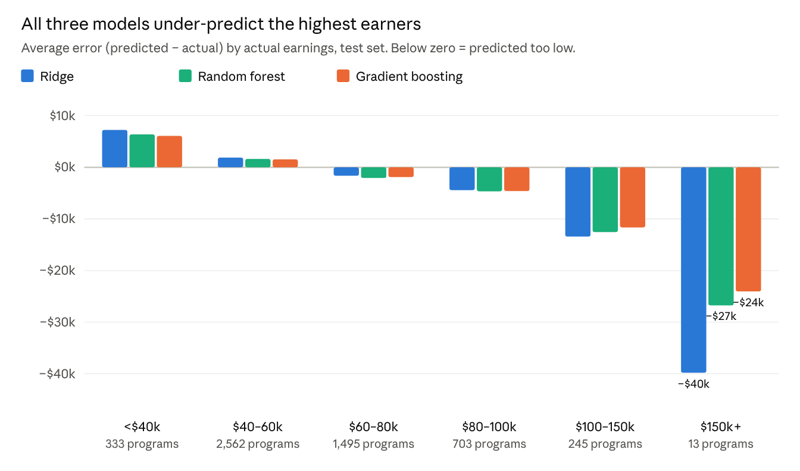
Test set, 5,351 programs · College_Majors_Model3_GradientBoosting.ipynb, section 7.2
This pattern is regression toward the middle: very high-earning programs are rare, so predictions are pulled toward typical values. For $100–150k programs the average misses are similar (Ridge −$13.4k, random forest −$12.5k, gradient boosting −$11.6k). The tree models cut Ridge's miss for $150k+ programs by about a third, but only 13 test programs fall in that group, so that comparison is indicative rather than firm. Because three very different methods share the bias, it most likely reflects information our predictors don't capture (such as a specific school's reputation in a specific field) rather than a modeling choice.

What drives earnings
We measured permutation importance on the test set: how much R² drops when one predictor's values are shuffled. It works the same way for every model, so the rankings are comparable.
Rank | Ridge | Random forest | Gradient boosting
1 | National field median | National field median | National field median
2 | Region | Latitude | Longitude
3 | In-state tuition | SAT | In-state tuition
4 | Field family | Longitude | Latitude
5 | School enrollment | In-state tuition | SAT
- Field of study comes first in every model. Shuffling the field median destroys most of each model's accuracy.
- Location is next. Ridge can only use broad regions; the tree models use exact latitude and longitude to pick up local wage levels such as large metro areas, which is part of why they do better.
- School quality and price (SAT, tuition) follow, consistent with the EDA finding that selective schools pay about $20k more.
- Job-market and AI-exposure features rank lower once field is known. They are largely properties of the field, so the field median already captures much of their signal. In the EDA, AI-linked programs paid $67k vs. $55k, but that gap mostly reflects which fields they are.

Conclusion

The takeaway
We asked how much a bachelor's program's graduates earn four years out, and what drives the differences. A random forest predicts a program's earnings within about 7.6% for a typical program, on schools it has never seen. It cuts the average error by 29% compared with simply using the field's national median.
Field of study sets the baseline, but where the school is and how selective and expensive it is explain a meaningful share of the rest. Those effects are nonlinear, which is why tree-based models outperform a linear one.

Insights
- Choosing a major matters most, but not entirely. Field explains about 59% of the variation in earnings; school and location factors add roughly another 20 points of R².
- Location matters more than school type. Precise location is among the strongest predictors, while public vs. private on its own makes little difference.
- Selectivity carries a premium within the same field, consistent with the EDA ($77k at schools admitting under 25% vs. $57k at those admitting 75–100%).
- AI exposure is mostly a field effect. Programs leading to AI-using jobs earn more, but once field is known, AI features add little extra predictive power.
- Method matters less than information. Two very different tree methods converge at about R² 0.785, suggesting we are near the ceiling for these predictors.

Limitations
- Programs with fewer than 16 graduates are excluded, because their earnings are privacy-suppressed. Results may not apply to small programs.
- Earnings come from graduates who received federal aid, not all graduates.
- Correlation, not causation. For example, selective schools may admit students who would earn more anywhere.
- All models under-predict the very top earners. Three different methods share this bias, so it comes from missing information rather than the algorithm.

Future steps
- Add richer program-level information, such as the detailed field (target-encoded) or school reputation measures, to better capture top earners.
- Test student debt as a predictor, and model debt-to-earnings as a second outcome.
- Run the classification version: predict whether a program beats its field's national median, using logistic regression and tree classifiers scored by accuracy, F1 and ROC-AUC.
- Extend to other degree levels (master's, associate's) with separate models for each.

