College Majors 2026: Data Prep, EDA & Ridge Model
We cleaned 227,980 college programs down to 25,283 bachelor's programs, and a first Ridge model predicts their earnings with test R² = 0.744, clearly beating a simple baseline (0.566).

Why we're doing this
Question: how much will graduates of a given bachelor's program earn 4 years after finishing, and what drives the difference?
- What we predict: median earnings 4 years after completion, per program (one program = one school × one field of study).
- Why it matters: students take on debt to choose a major and a school. Knowing what drives earnings beyond the major itself (school, region, job market, AI exposure of the jobs it leads to) helps make that choice.
- Why bachelor's only: bachelor's programs have the most reported earnings of any degree type (39%), and focusing on one degree removes degree level, the single biggest earnings driver, so the model can focus on the other factors. It is also simpler to explain.

The data at a glance
The raw file has 227,980 programs × 72 columns, built from the College Scorecard plus BLS job data and O*NET AI-tool data.
Column group | Examples | How we use it
Institution | public/private, region, admission rate, SAT, tuition, enrollment | Features
Program | field of study, online delivery, number of graduates | Features
Outcomes | earnings at 1/4/5 years, debt, employment rates | Target, and a leakage risk
Job market & AI | wage and growth of linked jobs, share of those jobs using AI software | Features
IDs & text | program ID, school name, field name | Identifiers only
The main data problem: earnings are hidden (privacy-suppressed) when a program has too few graduates, under 16. About 75% of all programs, and 61% of bachelor's programs, have no earnings figure. We do not fill these in; we model the programs that report earnings and say so in the report.

Data cleaning
Five steps take the data from 227,980 programs to 25,283 bachelor's programs ready to model.
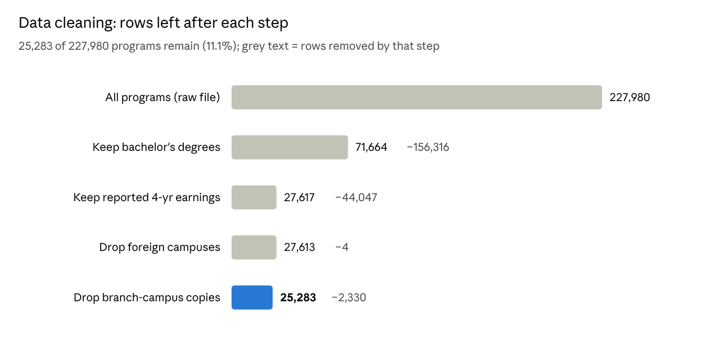
bachelors_cleaning_log.csv · output of the data-prep notebook
Why each step:
- Keep bachelor's degrees: our chosen scope.
- Keep reported 4-year earnings: a program with no earnings figure can't be used to train or test. We don't make up missing targets.
- Drop foreign campuses: they have no US state, tuition or job-market data.
- Drop branch-campus copies: when campuses share one ID, the same earnings number is copied onto every campus (one Penn State figure appears ~20 times). Left in, one number would count many times. We keep one row, preferring the main campus.
- Fix impossible values: zero enrollment, $0 tuition or a 0% admission rate are reporting errors, so we set them to blank (1 value in the bachelor's data).

Leakage: columns we removed on purpose
A feature is allowed only if it would be known before graduates' earnings are measured. Otherwise the model is "seeing the answer" and its score is fake.
Removed | Why
Earnings at 1 and 5 years, earnings growth, trajectory | Other measurements of the same outcome
Earnings vs. national %, debt-to-earnings, payment-to-income | Calculated directly from the target (we rebuilt them from earnings and they matched exactly)
Employment rates and counts at 5 years | Also outcomes measured after graduation
Cohort sizes and status flags | Defined by the earnings measurement itself
National 25th/75th percentile, monthly payment, duplicate ID/count columns | Redundant with columns we keep
We keep the national median earnings for the field: it is the field's typical pay, known in advance, and our strongest feature.

Targets and features
Targets (both built, so the team can choose):
- Regression (used now): log of 4-year median earnings. Earnings are right-skewed (median $59,166, max $297,029); the log cuts skewness from 1.49 to 0.25. Top earners are real (e.g. Duke math, Carnegie Mellon CS), so we keep them.
- Classification (optional): does the program earn more than the national median for its field? 45% yes / 55% no, so balanced enough.
Features: 72 raw columns → 31 model features (25 numeric + 6 categorical) → 88 columns after turning categories into 0/1 columns.
New feature | What it is | Why
log_awards_avg, log_enrollment, log_occ_employment | Log of program size, school size, job-market size | Very skewed counts
tuition_out_minus_in | Out-of-state minus in-state tuition | Public-school pricing signal
sat_missing, admission_rate_missing | 1 if the value is blank | Blank usually means open admission; those programs earn less ($57k vs $60k)
selectivity | Admission-rate bands: <25%, 25–50%, 50–75%, 75–100%, open/unknown | Readable, nonlinear effect
online | None / some / all programs online | Delivery mode
any_ai_occupation | 1 if any linked job uses AI software | AI-exposure flag
Remaining blanks (SAT 28%, admission rate 7.5%, others under 4%) are filled with the median inside the model pipeline, using training data only, so no test information leaks in.

What the EDA shows
Field of study matters most, then how selective the school is; public vs. private matters little.
Finding | Evidence
Field is the biggest driver | Computer Engineering pays $106k vs. Drama/Theatre $40k (median of programs)
The field's national median alone explains ~59% of the variation | Correlation 0.77 on log scale; this becomes our baseline
Selective schools pay more | Admission rate under 25%: $77k vs. 75–100%: $57k and open/unknown: $55k
Public vs. private matters little | For-profit $55k, public $58k, nonprofit $61k
AI-linked jobs pay more | Programs whose linked jobs use AI software: $67k vs. $55k (partly because these are engineering/CS fields)
No duplicated information among features | No pair of features correlates above 0.8 after removing redundant columns
All charts are in the notebook and in figures.zip (8 PNGs, ready for slides).

Train/test split, preprocessing and baseline
Split by school, not by row: 19,932 training programs (1,439 schools) and 5,351 test programs (360 schools), with no school in both. If the same school appeared on both sides, the model could memorize "this school pays well" and look better than it really is.
Preprocessing pipeline (the same for every model): fill blanks with the median, put numbers on a common scale, and turn categories into 0/1 columns. It learns its medians and scales from training data only, then applies them to the test data.
Baseline to beat: predict each program's earnings as its field's national median. That alone gets R² = 0.566 and is off by $8,760 on average. A model that can't beat this adds nothing.

Model 1: Ridge regression
Ridge cuts the average error by 20% compared with the baseline, and performs the same on schools it has never seen.
How it works: ordinary linear regression plus a penalty (alpha) that shrinks coefficients toward zero. This keeps the model stable when features overlap, such as our several AI-exposure measures.
Why start with it: it's the standard model from class, fast, and its coefficients show the direction and size of each effect, which gives a clear benchmark for Models 2 and 3.
Tuning: 13 values of alpha from 0.001 to 1,000, tested with 5-fold cross-validation grouped by school. Best: alpha = 3.16.
Metric (test set) | Baseline | Ridge
R² (log earnings) | 0.566 | 0.744
Average error (MAE) | $8,760 | $7,030
Typical error (median %) | 10.4% | 8.6%
Cross-validation R² | — | 0.753
- No overfitting: cross-validation R² (0.753) and test R² (0.744) are nearly equal.
- Accuracy in plain terms: 56% of programs are predicted within ±10% of actual earnings, and 85% within ±20%.
- Top features: the field's national median, then region, in-state tuition, field family and school size. Far West and New England programs earn more; programs in Puerto Rico and other US territories earn much less.
- Weak spot: it under-predicts the very top earners ($150k+, elite CS/math programs). A straight-line model can't capture the extra boost from combining a top field with a highly selective school.

Next steps and decisions for the team
- ☐ Build Model 2: random forest and Model 3: gradient boosting with the same pipeline, split and metrics. Both can capture nonlinear effects, which should help with the top earners.
- ☐ Decide whether to add debt as a feature: it's known before earnings (not leakage) but blank for ~14% of programs.
- ☐ Decide whether to also run the classification target (above vs. below the field's national median).
- ☐ Compare all three models in one table (R², MAE, % error) for the Model Comparison section.
Files: College_Majors_Bachelors_Data_Prep_EDA.ipynb (cleaning + EDA), bachelors_model_ready.csv (clean data), College_Majors_Model1_Ridge.ipynb (Ridge model), figures.zip (charts).

