Will This Program Pay Off?
Predicting Which College Programs Beat Their Field’s National Earnings Median
BUAN 6341 Applied Machine Learning · Group Project · Fall 2026 · Group members: ______________________

1. Motivation

Problem definition
A college program is one field of study at one school and one credential level, for example a bachelor’s in nursing at a particular university. The U.S. Department of Education’s College Scorecard reports the median earnings of each program’s graduates four years after completion, along with the national median for the same field and credential. We predict a binary outcome:
Will graduates of this program earn more than the national median for their field and degree?
We use only information that is available before a student enrolls: where the school is, its size, selectivity, price and type, how much its students typically borrow, and labor-market data for the occupations linked to the field. Every post-graduation outcome is left out, so the model could actually be used at decision time.

Why it matters
Most salary tools rank majors. But students choose a school as much as a field, and within the same field outcomes differ widely between institutions. A program that consistently out-earns its field’s national norm is a better return on tuition and debt. A model that flags such programs helps students, advisors and policymakers compare options that look similar on paper. It also shows which school characteristics are associated with better-paying programs.

Reformulating the task
Predicting raw salary would mostly teach a model that engineering pays more than education, which is a fact a student already knows once they have chosen a field. Benchmarking each program against its own field-and-credential national median removes that effect and asks the more useful question: given this field, is this school a good place to study it? As a bonus, the target is close to balanced (47.3% positive), so no resampling is needed.

2. Data

Data description
The file college_majors_2026.csv has 227,980 programs and 72 columns. It merges three sources: (1) the College Scorecard field-of-study file (earnings and debt per program); (2) IPEDS institution data (control, region, location, admission rate, SAT, tuition, enrollment); and (3) BLS / O*NET occupation data (employment, 2024–34 projected growth, wages, AI-tool usage) linked through the CIP-to-SOC crosswalk. Inputs are a mix of continuous (tuition, SAT, wages), count (enrollment, completions), binary (HBCU, main campus) and nominal categorical variables (state, region, field family, credential).
Stage | Programs | Note
Raw file | 227,980 | All programs, all credential levels
4-year earnings reported | 58,112 | 74.5% privacy-suppressed (cohort too small)
After de-duplication (modeling set) | 51,867 | 6,245 duplicate campus rows removed; 4,672 institutions
Train / test (split by institution) | 40,986 / 10,881 | No school appears in both sets
Table 1. From raw file to modeling sample.

Data preparation
Missing outcome. Earnings are privacy-suppressed for most programs, so those rows have no label and cannot be used for supervised learning. Our conclusions therefore apply to programs large enough to report earnings.
Anomaly: duplicated campus rows. Some multi-campus institutions report a single outcome for all campuses (outcomes_shared_across_campuses = 1). The file repeats that identical row once per campus, for example Arizona State’s in-person and online campuses. All 6,245 extra rows had identical earnings and debt, so we kept one row per program (school × field × credential), preferring the main campus.
Leakage control. We removed every column measured after graduation or computed from earnings: 1- and 5-year earnings, earnings growth and trajectory, debt-to-earnings, payment-to-income, employment shares, and the earnings_vs_national_pct column used to create the target. Identifiers and free text were dropped too.
Skewness and outliers.
- Log transform (log(1+x)) for right-skewed counts and dollars: enrollment, completions, debt, borrower count, occupation employment and openings.
- Winsorizing at the 1st and 99th percentiles for tuition, the tuition gap, completions growth, monthly payment, occupation growth and wage. The extreme values are real (very expensive schools, programs that jumped from 0 to 50 completions), so we capped them rather than dropping rows. The caps are computed on the training set only.
Missing inputs. SAT (≈51% missing) and admission rate (≈36%) are mostly missing at open-admission schools, so the gap itself is informative. We added missing-value indicators and used median imputation for numeric columns, plus a "missing" category for categorical ones. Imputation is fit inside the pipeline on training folds only.
Feature engineering and encoding. We built tuition_gap (out-of-state minus in-state tuition, a proxy for public pricing) and awards_growth (the change in completions between two years). Numeric features are standardized. Nominal features (control, region, state, field family, credential, distance-education status, the occupation’s typical entry education) are one-hot encoded, with levels rarer than 20 rows pooled. The final set has 33 numeric and 7 categorical inputs.
Train/test split by institution. Programs from the same school share reputation, location and cost. A random split would let a model memorize schools and overstate accuracy. We used GroupShuffleSplit (80/20) grouped by institution, and GroupKFold for tuning, so every evaluation is on schools the model has never seen.

Exploratory analysis
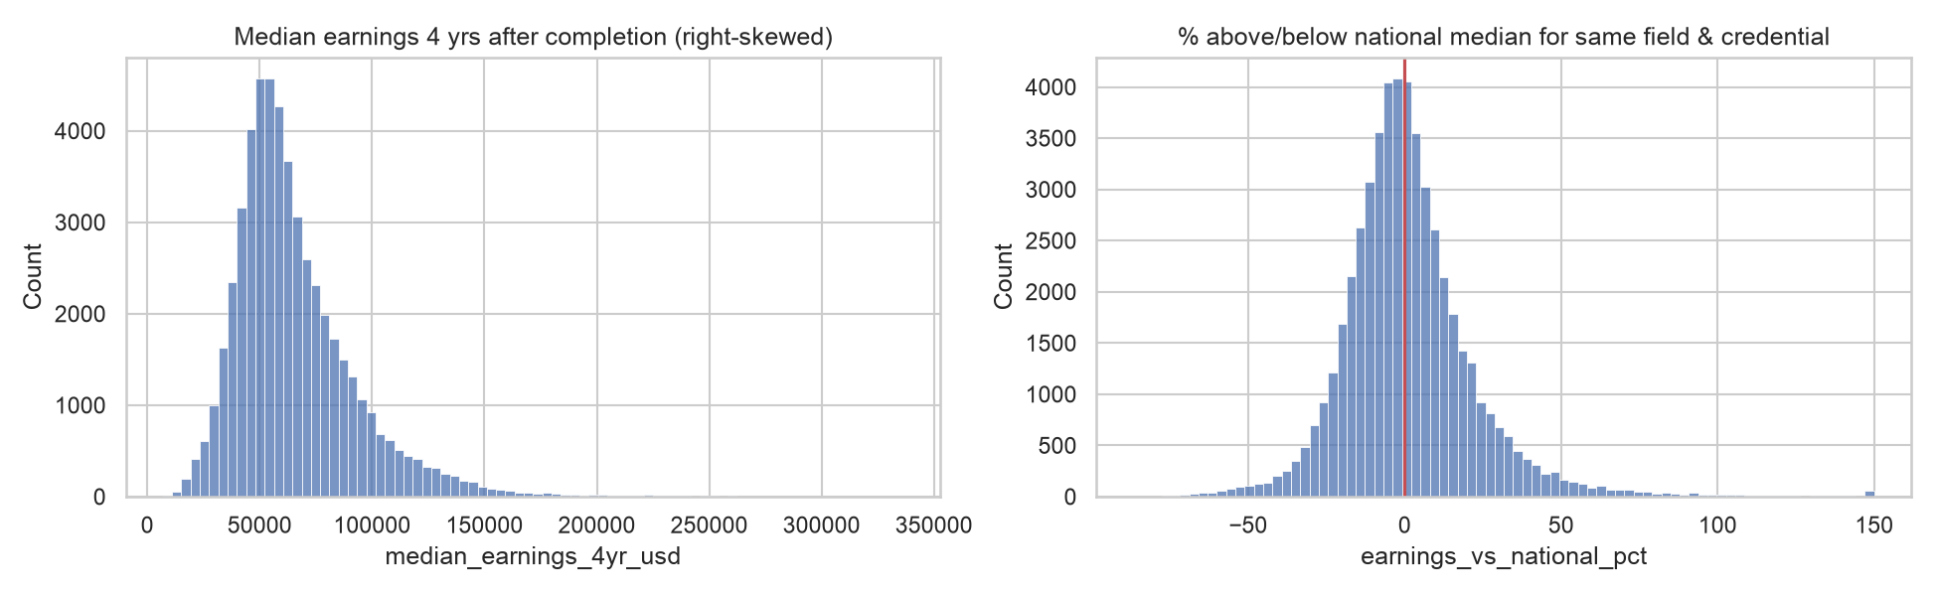
Figure 1. Raw 4-year earnings are right-skewed (left). The target compares each program with its field’s national median (right, red line = 0).
Raw program earnings have a median of $59,564 and a long right tail (max $336,392). Benchmarking against the field median centers the outcome around zero. Figure 2 shows clear segment differences. For-profit programs beat their field’s median least often, and private non-profits most often. New England, the Far West and the Mid East lead, while the Southeast and outlying territories trail. Above-median programs also come from schools with higher SAT scores, lower admission rates and higher tuition (see figures/eda_numeric.png).
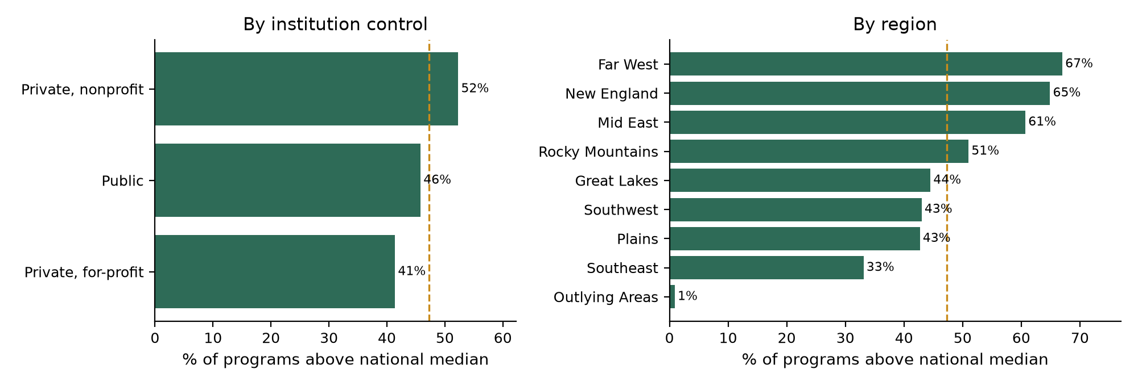
Figure 2. Share of programs above their field’s national median, by segment (dashed line = overall 47.3%).

3. Model
We trained four supervised classifiers, all covered in lectures, with one shared preprocessing pipeline. Each was tuned by grid search with K-fold cross-validation (Lecture 3), using 3 group folds and ROC-AUC as the selection metric. For the larger search spaces we used randomized search, which tests a random sample of grid combinations, because the lecture warns that exhaustive tuning is expensive. The test set was used once, for the final comparison.
Model (lecture) | Hyperparameters searched | Selected
Logistic Regression (L4, L3) | C ∈ {0.01, 0.1, 1, 10}; penalty ∈ {L1 / LASSO, L2 / Ridge}; full grid | C = 0.1, penalty = l2
Decision Tree – CART (L7) | max_depth {6, 10, 15, None}; min_samples_leaf {20, 50, 100}; ccp_alpha {0, 1e-4, 5e-4}; full grid | ccp_alpha = 0.0001, max_depth = None, min_samples_leaf = 100
Random Forest (L8) | n_estimators {200, 400}; max_depth {None, 15, 25}; min_samples_leaf {1, 3, 10}; max_features {sqrt, 0.3}; 10 random draws | n_estimators = 200, min_samples_leaf = 3, max_features = sqrt, max_depth = 25
XGBoost (L8, L10a) | learning_rate {.03, .06, .1}; n_estimators {300, 600}; max_depth {4, 6, 8}; min_child_weight {1, 5, 20}; gamma {0, 1}; reg_lambda {1, 5}; subsample {0.8, 1}; 15 draws | subsample = 0.8, reg_lambda = 5, n_estimators = 600, min_child_weight = 1, max_depth = 6, learning_rate = 0.03, gamma = 0
Table 2. Models, tuning grids and selected hyperparameters.
Logistic regression applies the Ridge/LASSO penalty from Lecture 3 to classification. L1 can drop features, and L2 shrinks them. L2 with moderate regularization won, which suggests most features carry some signal, so L1’s variable selection did not help.
Decision tree (CART). A single tree splits on Gini impurity. Unpruned trees overfit (Lecture 7), so we tuned pre-pruning (depth, minimum leaf size) and cost-complexity post-pruning (ccp_alpha). The search preferred no hard depth cap but a large minimum leaf size (100 programs) plus a small pruning penalty, so the tree is controlled by leaf size rather than depth. It is the building block of the next two models.
Random forest (bagging plus random feature subsets) averages hundreds of decorrelated deep trees, which reduces the variance of a single tree. Restricting each split to a random √p subset of features worked best.
XGBoost (Lectures 8 and 10a) starts from a constant prediction. Each round adds a small tree fit to the negative gradient of the log-loss, scaled by the learning rate (shrinkage). It adds a complexity penalty to the cost function: gamma per extra leaf, and an L2 penalty reg_lambda on leaf weights. It also uses histogram split-finding, cutting each variable into bins, which is the "dices" idea from the slides. The lecture notes that XGBoost is sensitive to hyperparameters, so we tuned seven of them. The search chose many small steps (low learning rate, many trees), row subsampling and a stronger L2 penalty, which is a well-regularized configuration.

4. Model Comparison

Metrics
The classes are nearly balanced, so ROC-AUC is our primary metric: it measures how well a model ranks programs regardless of the cutoff. We also report PR-AUC (area under the precision-recall curve), accuracy, precision, recall and F1 at the default 0.5 cutoff, and log loss, which measures the quality of the predicted probabilities. Precision matters most to a student who will act on an "above-median" flag. Recall matters to a policymaker who wants to find every high-value program. All metrics are computed on the held-out schools.
Model | CV AUC | Test AUC | PR-AUC | Accuracy | Precision | Recall | F1 | Log loss
XGBoost | 0.787 | 0.781 | 0.768 | 0.703 | 0.698 | 0.650 | 0.673 | 0.556
Random Forest | 0.784 | 0.778 | 0.764 | 0.700 | 0.697 | 0.640 | 0.668 | 0.565
Logistic Regression | 0.746 | 0.735 | 0.704 | 0.673 | 0.664 | 0.619 | 0.640 | 0.601
Decision Tree | 0.718 | 0.698 | 0.660 | 0.646 | 0.627 | 0.610 | 0.618 | 0.642
Table 3. Test-set performance on 10,881 programs at unseen institutions, sorted by test AUC. Majority-class baseline accuracy = 0.527.
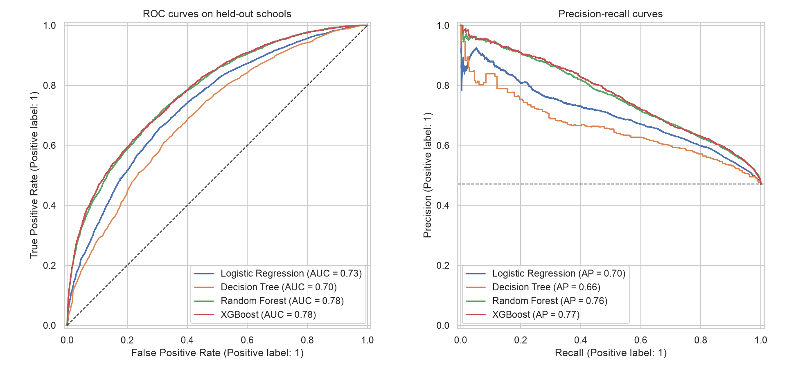
Figure 3. ROC (left) and precision-recall (right) curves on held-out schools.

Interpretation
- All four models clearly beat the 52.7% baseline. The best, XGBoost, reaches a test AUC of 0.781 and 70.3% accuracy.
- Ensembles beat their building block. A single pruned tree reaches an AUC of 0.698. Bagging (random forest, 0.778) and boosting (XGBoost, 0.781) the same kind of tree add about 8 AUC points. This is the "wisdom of the crowd" effect from Lecture 8.
- Non-linearity matters. The tree ensembles beat logistic regression (0.735) by about 5 AUC points. The effect of selectivity, price and location depends on credential level and field, which a linear model cannot capture.
- XGBoost vs. Random Forest are close on AUC (0.781 vs 0.778), but XGBoost has the lower log loss (0.556 vs 0.565), so its probabilities are better calibrated.
- Tuning did not overfit: CV and test AUC are within about 0.01 for every model, which confirms that the group split works as intended.
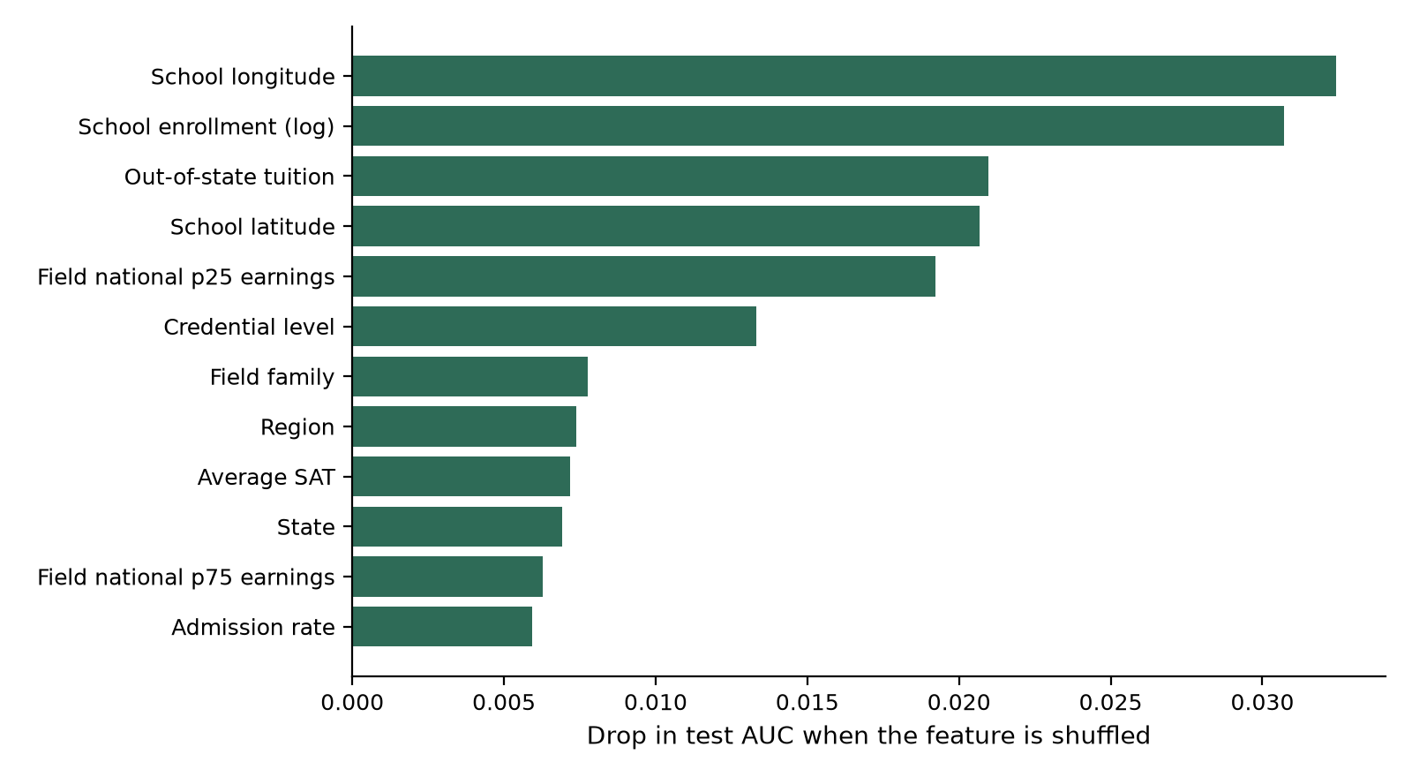
Figure 4. Permutation importance for XGBoost: the drop in test AUC when each feature is shuffled.
What drives the predictions. Permutation importance (Figure 4) shows three groups of drivers. Location: longitude is the single most important feature, and latitude, region and state also rank in the top ten. School profile: enrollment size, out-of-state tuition, average SAT and admission rate. The field and credential: the field’s national 25th-percentile earnings, credential level and field family.
The logistic-regression coefficients tell the same story: for-profit control, Puerto Rico and other outlying territories lower the odds, while the Far West, the Mid East and D.C. raise them.

5. Conclusion
[GenAI-assisted: Claude]
Takeaway. Using only information available before enrolling, we can predict whether a program will beat its field’s national earnings median with an AUC of 0.78. That is right about 70% of the time, at schools the model has never seen. The strongest signals are where a school is and what kind of school it is (size, price, selectivity, for-profit status), not just what it teaches.
Insights. (1) For a student who has already picked a field, the choice of school and region matters: the same major pays very differently across the country. (2) For-profit programs underperform their field’s norm even after controlling for field. (3) Ensemble tree methods (bagging and boosting) are the right tool for this kind of mixed, tabular data. They beat both a single tree and a linear model.
Limitations. The model covers only programs large enough to report earnings (about a quarter of all programs), so small programs may behave differently. Much of the location effect likely reflects regional wage levels and cost of living rather than program quality. The results are associations, not causal effects.
Future steps. Adjust earnings for regional cost of living to separate "high-wage region" from "high-value program". Model log earnings directly as a regression. Fit separate models for undergraduate and graduate credentials, or for clusters of similar schools found with K-Means (Lecture 10). Add SHAP explanations so a student can see why a specific program was flagged.

Appendix: GenAI use (course policy)
Per the course policy, sections produced with GenAI are marked [GenAI-assisted: Claude], and the conversation is submitted with this report. Replace a tag with [Group-written] where your group has rewritten a section in its own words.
Component | GenAI use | Group contribution
Python notebook (analysis_class_only.ipynb) | Code generated with Claude | ______________________
Report sections 1–5 | Drafted with Claude | ______________________
Presentation slides | Drafted with Claude | ______________________
Conversation link / PDF: ______________________

