Console Banking Application - Student Question Guide
Console Banking Application - Student Question Guide
Part 1 - First Output
1. How can you show the bank name in the console?
2. How can you show a welcome message under the bank name?
3. How can you print a simple line above and below the welcome message?
4. How can you make the console output look like a small banking screen?

Part 2 - Store Bank Details
5. How can you store the bank name in the program?
6. How can you store the account holder name?
7. How can you store an account number?
8. How can you store the account balance?
9. Which data type is better for storing money?
***demimal
10. How can you print the account holder name with a label?
11. How can you print the account number with a label?
12. How can you print the current balance with a label?
Part 3 - Get User Input
13. How can you ask the user to enter their name?
14. How can you read the name typed by the user?
15. How can you store the typed name in a variable?
16. How can you print a greeting using the entered name?
17. How can you ask the user to enter an opening balance?
18. How can you read the opening balance entered by the user?
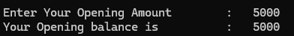
Part 4 - Display Account Details
19. How can you display all account details together?
20. How can you display the account holder, account number, and balance on separate lines?
21. How can you format the balance to show two decimal places?
22. How can you clear the console before showing account details?
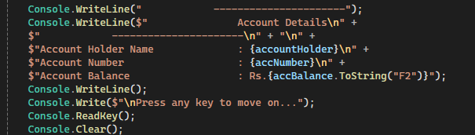
Part 5 - Create a Menu
23. What options should a simple banking app show to the user?
24. How can you print a menu with options such as View Account, Check Balance, Deposit, Withdraw, and Exit?
25. How can you ask the user to choose a menu option?
26. How can you store the selected option?
27. How can you show a message based on the selected option?
Part 6 - Make Decisions
28. If the user enters 1, how can you show account details?
29. If the user enters 2, how can you show the balance?
30. If the user enters 3, how can you start the deposit process?
31. If the user enters 4, how can you start the withdrawal process?
32. If the user enters a wrong option, how can you show an invalid choice message?
33. How can you rewrite the menu selection using a switch statement?
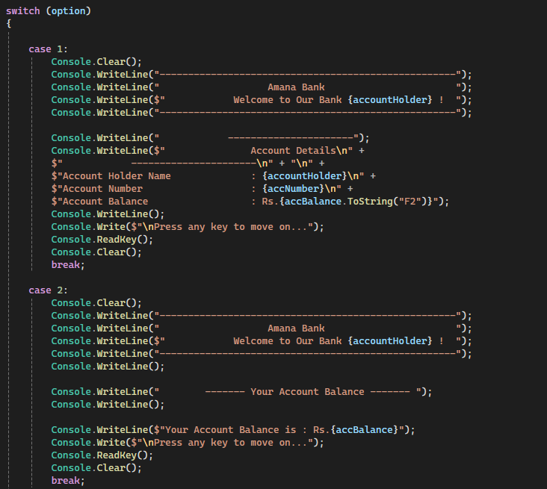
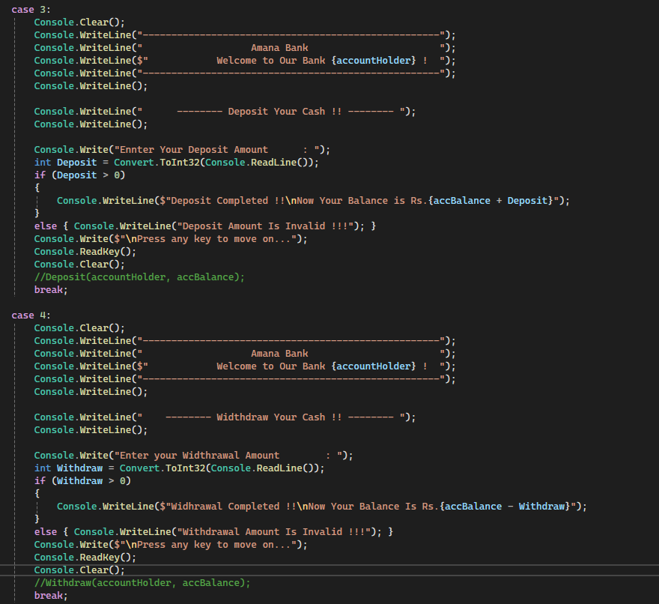
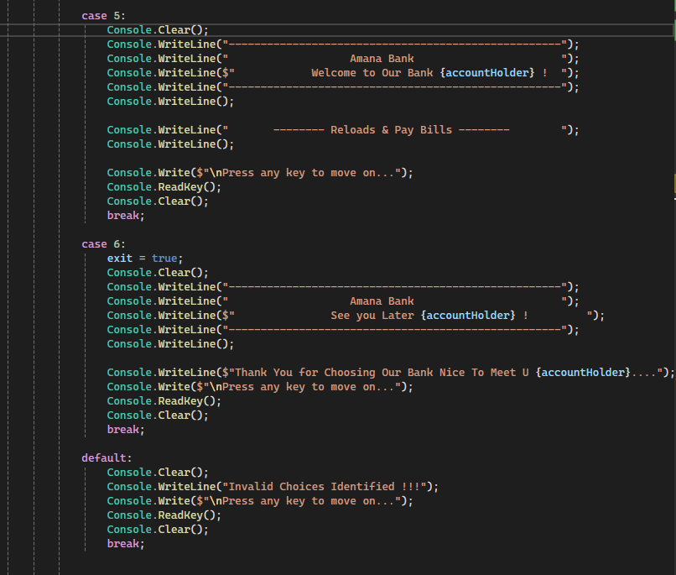
Part 7 - Deposit Money
34. How can you ask the user to enter a deposit amount?
35. How can you convert the entered deposit amount into a number?
36. How can you check whether the deposit amount is greater than zero?
37. How can you add the deposit amount to the current balance?
38. How can you show the updated balance after deposit?
39. What message should appear if the deposit amount is invalid?
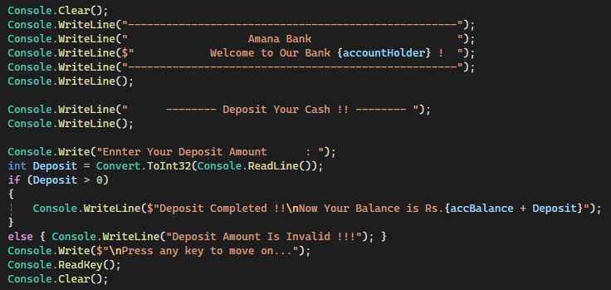
Part 8 - Withdraw Money
40. How can you ask the user to enter a withdrawal amount?
41. How can you check whether the withdrawal amount is greater than zero?
42. How can you check whether the user has enough balance?
43. How can you subtract the withdrawal amount from the balance?
44. How can you show the remaining balance after withdrawal?
45. What message should appear if the user does not have enough balance?
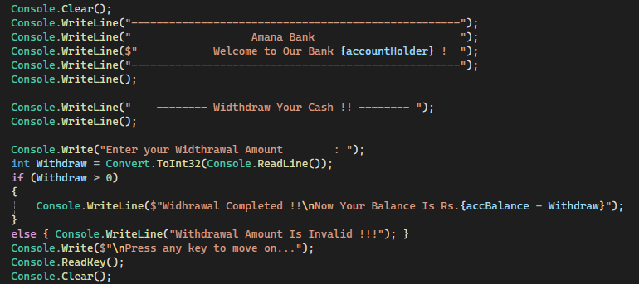
Part 9 - Repeat the Application
46. How can you keep showing the menu until the user chooses Exit?
47. Which loop can be used to repeat the menu?
48. How can you stop the loop when the user chooses Exit?
49. How can you pause the screen before returning to the menu?
50. How can you clear the screen before showing the menu again?
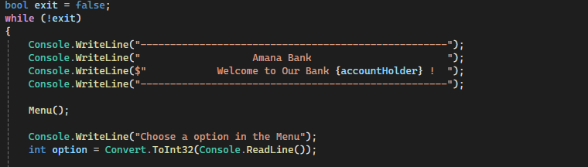
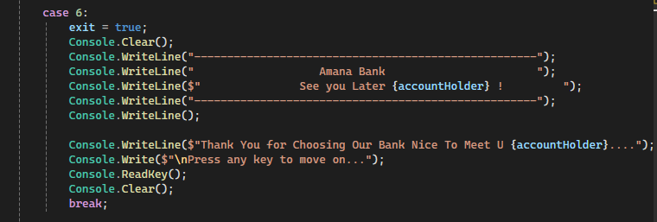
Part 10 - Organize the Code
51. How can you move the welcome message into a separate method?
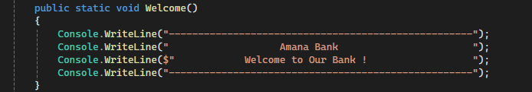
52. How can you move the menu display into a separate method?
53. How can you move account details display into a separate method?
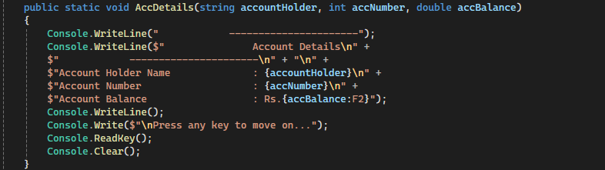
54. How can you move deposit logic into a separate method?
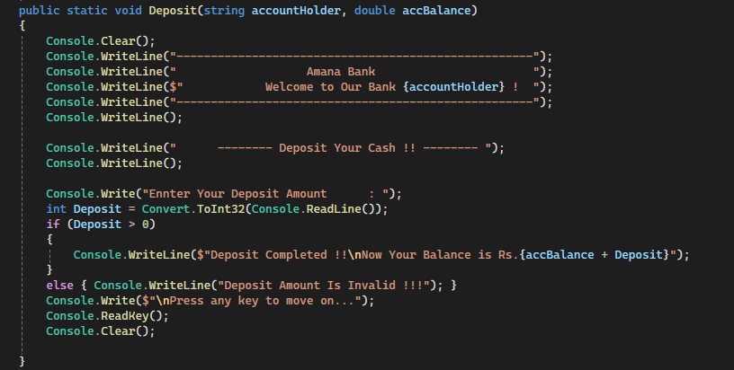
55. How can you move withdrawal logic into a separate method?
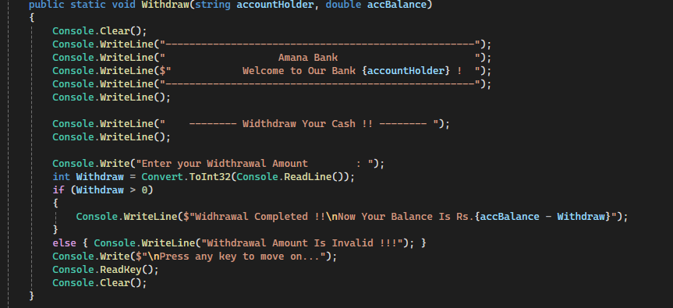
56. Why is it better to split the program into methods?
Part 11 - Create a Bank Account Object
57. How can you create a class called BankAccount?
58. What properties should a BankAccount have?
59. How can you create a BankAccount object?
60. How can you store account holder, account number, and balance inside the object?
61. How can you print details from the BankAccount object?
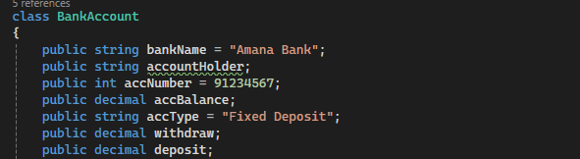
Part 12 - Add Banking Actions to the Class
62. How can you create a Deposit method inside the BankAccount class?
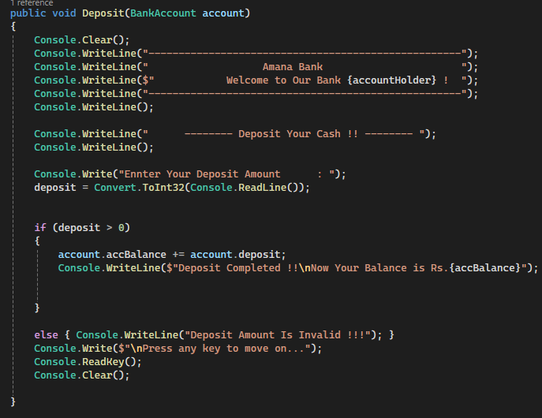
63. How can you create a Withdraw method inside the BankAccount class?
64. How can the Withdraw method return true or false?
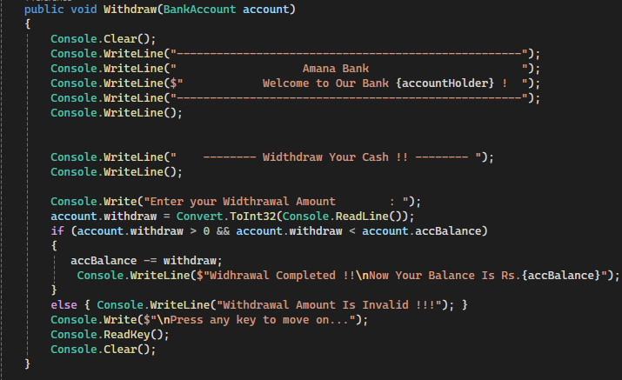
65. How can the balance be protected from being changed directly?
66. How can the console menu call the Deposit and Withdraw methods?
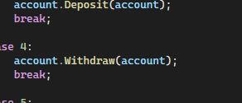
Part 13 - Transaction History
67. How can you store many transaction records?
68. How can you add a message when money is deposited?
69. How can you add a message when money is withdrawn?
70. How can you show all transactions to the user?
71. What should be shown if there are no transactions yet?
Part 14 - Final Console Banking App
72. Can the user create or view an account?
73. Can the user check the balance?
74. Can the user deposit money?
75. Can the user withdraw money?
76. Can the user view transaction history?
77. Can the user exit the application?
78. Does the application handle invalid menu options?
79. Does the application handle invalid money values?
80. Is the banking logic separated from the console display logic?
Part 15 - Prepare for WPF Migration
81. Which parts of the app are only console UI?
82. Which parts of the app are banking logic?
83. Which methods can be reused in WPF?
84. Which console inputs will become text boxes in WPF?
85. Which console menu options will become buttons in WPF?
86. Which console outputs will become labels or text blocks in WPF?
Quick Lesson Path
1. Print bank name and welcome message.
2. Store account holder, account number, and balance.
3. Read user input.
4. Show account details.
5. Build a menu.
6. Handle choices.
7. Add deposit.
8. Add withdrawal.
9. Repeat until exit.
10. Split into methods.
11. Create BankAccount class.
12. Move banking logic into the class.
13. Add transaction history.
14. Identify what can be reused in WPF.
Minimal Teaching Rule
Ask one question, let students answer, then code only that small part.

