### **Step-by-Step Git Commands Execution:**

**Initialize a Git repository:** git init

Creates a new Git repository in the folder 24MCR078.

**Add a file to staging area:** git add 24MCR078.txt

Adds 24MCR078.txt to the staging area.

**Commit the file:** git commit -m "Added Personal Details"

Creates a commit with the message "Added Personal Details".

**Check Git status:**  git status

Shows that 24MCR078.txt has been modified but not staged.

**View commit log:**  git log

Displays the commit history (one commit at this point).

**Add remote GitHub repository:**  git remote add origin <https://github.com/viratpk18/24MCR078.git>

Links the local repository to a remote GitHub repo.

**Check current branch:**  git branch

Shows the current branch is master.

**Rename branch from master to main:**  git branch -M main

Renames the current branch to main.

**Set Git global config for email and username:** git config --global user.email "[praveenkumar2k4.t@gmail.com](mailto:praveenkumar2k4.t@gmail.com)"

git config --global user.name "viratpk18"

Sets your global Git identity.

**Push code to remote repo for the first time:**  git push -u origin main

Pushes the main branch to GitHub and sets upstream tracking.

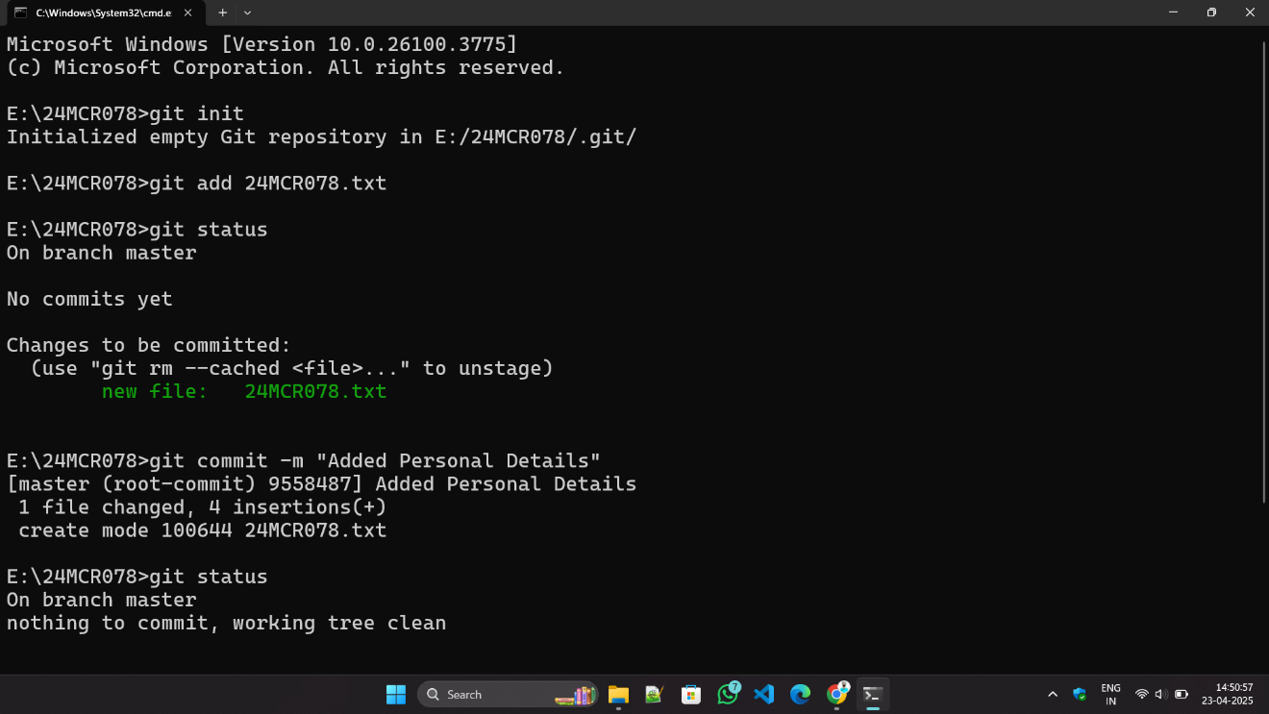

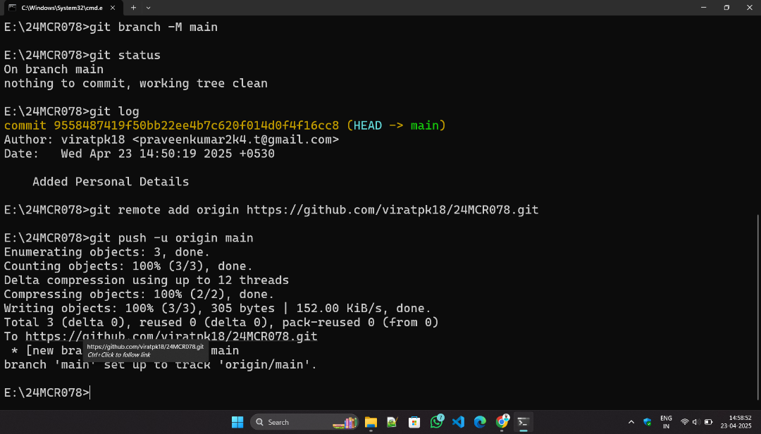

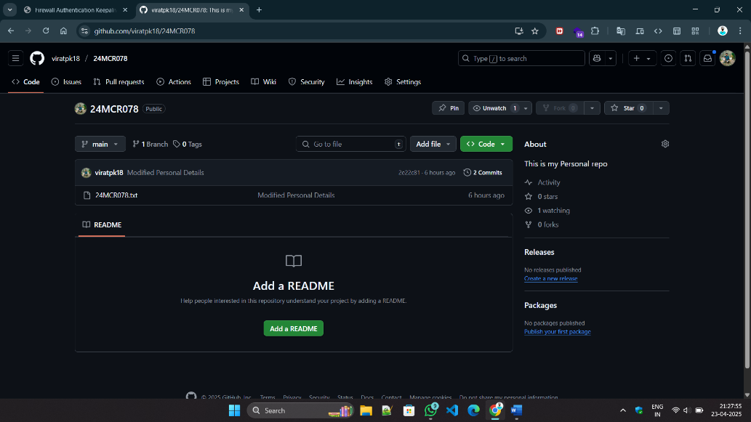

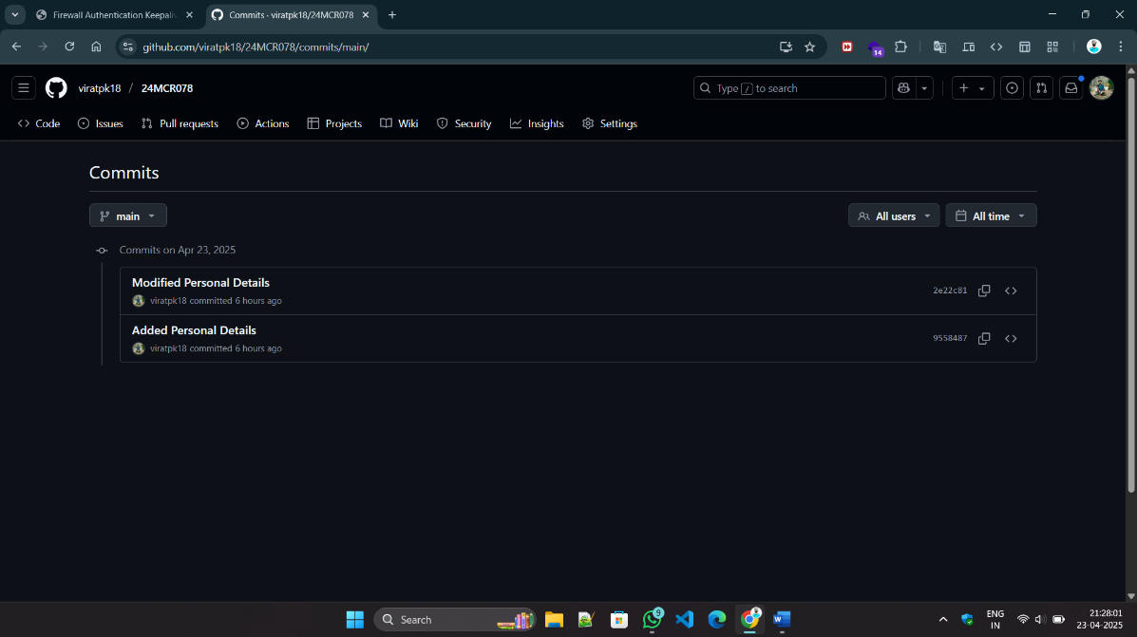

Then , Again We will Modify or add new file means we need to follow the same steps, like

git add .

git commit -m “message”

git push origin main