**Day -1 DevOps Training**

**Installing and Setting Up WSL with Ubuntu on Windows 11**

**Step 1: Enable WSL**

Before installing Ubuntu, ensure that WSL is enabled on your Windows system

**Enable WSL Feature**

1. Open PowerShell as Administrator and run:

2. wsl --install This installs the default Linux distribution and enables necessary components.

3. If WSL is already installed but not enabled, use:

4. dism.exe /online /enable-feature /featurename:Microsoft-Windows-Subsystem-Linux /all /norestart

5. Enable the Virtual Machine Platform feature (required for WSL 2):

6. dism.exe /online /enable-feature /featurename:VirtualMachinePlatform /all /norestart

7. Restart your computer to apply changes.

**Step 2: Install Ubuntu**

1. Open Command Prompt or PowerShell and run:

2. wsl --install -d Ubuntu

If the installation fails due to timeout issues, retry the command after shutting down WSL:

wsl --shutdown

wsl --install -d Ubuntu

3. Once installed, start Ubuntu:

4. wsl.exe -d Ubuntu

**Step 3: Set Up Ubuntu**

When Ubuntu runs for the first time, it will ask you to create a new user account.

1. Enter a username (must start with a lowercase letter or underscore, and contain only lowercase letters, digits, underscores, and dashes).

2. Set a password (enter and confirm the password). If passwords do not match, you will need to retry.

3. Once successful, Ubuntu will be set up and ready to use.

**Step 4: Verify Installation**

To check the installed distributions and their versions:

wsl -l -v

To verify Ubuntu is running:

wsl -d Ubuntu

**Step 5: Configure Ubuntu**

**Update System Packages**

After logging in, update the package list and upgrade installed packages:

sudo apt update && sudo apt upgrade -y

**Set Default WSL Version**

To use WSL 2 as the default version for future installations:

wsl --set-default-version 2

To check the current WSL version:

wsl -l -v

To convert an existing installation to WSL 2:

wsl --set-version Ubuntu 2

**Step 6: Enable .hushlogin to Suppress Login Message**

To disable the daily login message, create a .hushlogin file in your home directory:

touch ~/.hushlogin

**Additional Commands**

Restart WSL:

wsl –shutdown

Uninstall a Distribution:

wsl --unregister Ubuntu

Access Windows Files in WSL:

cd /mnt/c

**Conclusion**

You have successfully installed and set up WSL with Ubuntu on Windows 11. You can now use the Ubuntu terminal to run Linux commands and manage your system efficiently.

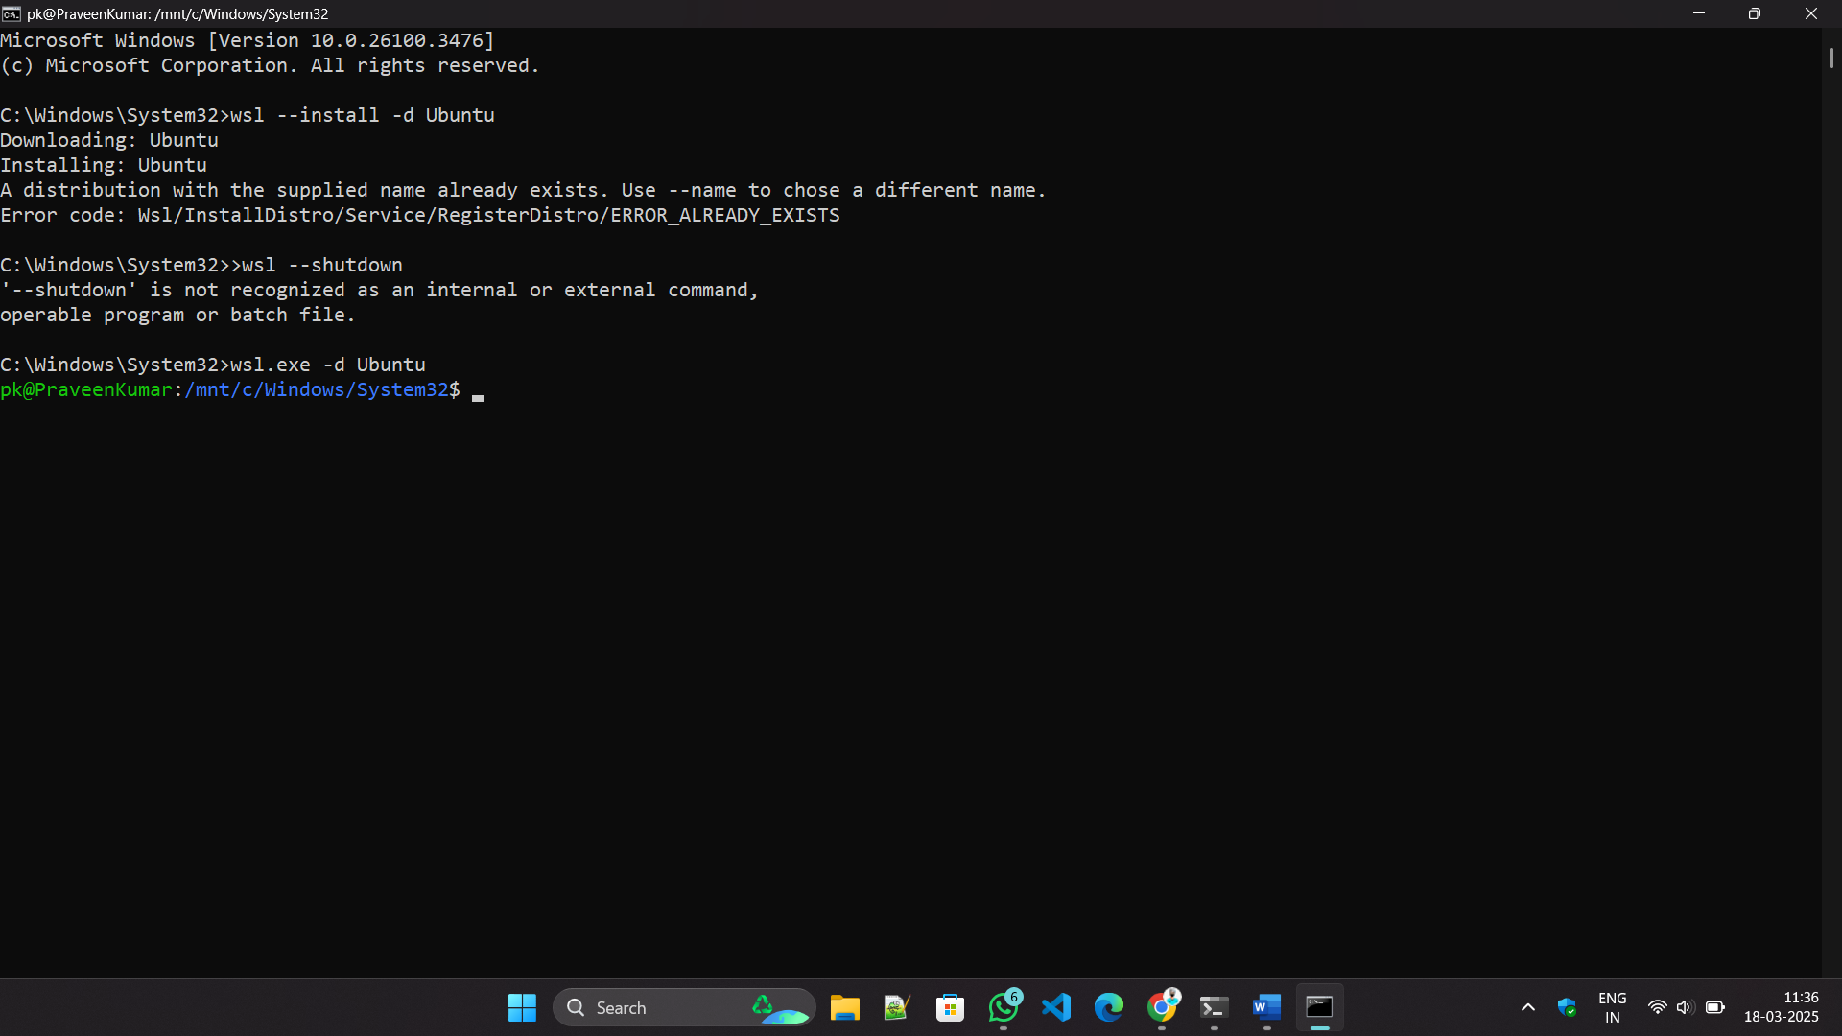

Check Java Version

**Step-by-Step Guide to Creating a Freestyle Job in Jenkins to Install Nginx on a Local Ubuntu VM**

**Prerequisites for Setting Up a Freestyle Job to Install Nginx in Jenkins**

Before creating the Freestyle Job, ensure that the following prerequisites are met:

**1. Install Jenkins on Ubuntu (If Not Installed)**

If Jenkins is not installed on your Ubuntu VM, follow these steps:

**Step 1**: Update Package Lists

sudo apt update -y

**Step 2**: Install Java (Required for Jenkins)

sudo apt install -y openjdk-17-jdk

**Step 3**: Verify Java Version

java -version

**Step 4:** Add Jenkins Repository Key

**(Note: The apt-key add command is deprecated in newer Ubuntu versions. Use the correct method below.)**

Correct Way to Add Jenkins Repository (Without apt-key)

**Step 4.1:** Add Jenkins GPG Key

wget -q -O- https://pkg.jenkins.io/debian-stable/jenkins.io-2023.key | sudo tee /usr/share/keyrings/jenkinskeyring.asc > /dev/null

**Step 4.2**: Add Jenkins Repository

echo "deb [signed-by=/usr/share/keyrings/jenkins-keyring.asc] https://pkg.jenkins.io/debianstable binary/" | sudo tee /etc/apt/sources.list.d/jenkins.list > /dev/null

**Step 5:** Install Jenkins

sudo apt update -y sudo apt install -y jenkins

**Step 6:** Start and Enable Jenkins Service

sudo systemctl start jenkins

sudo systemctl enable Jenkins

**Step 7:** Check Jenkins Status

sudo systemctl status Jenkins

**2. Access Jenkins Web Interface**

Jenkins will be available at http://<VM_IP>:8080

**To Get the Jenkins Server URL, Follow These Steps:**

**Method 1:** Check the Default URL

By default, Jenkins runs on port 8080. Open in a browser:

http://<your-server-ip>:8080

If you're on the same machine as Jenkins,

use: http://localhost:8080

**Method 2:** Get Server IP Address

hostname -I

or

ip a | grep inet

**Method 3**: Check Jenkins Logs (If Unable to Access)

sudo journalctl -u jenkins --no-pager --lines=50

Look for lines mentioning "Jenkins is fully up and running" and the URL.

**3. Access Jenkins Web Interface and Log In**

1. Open a browser and go to http://<JENKINS_SERVER_IP>:8080

2. Enter the username (admin) and the admin password retrieved from the following command:

sudo cat /var/lib/jenkins/secrets/initialAdminPassword

3. Choose Install Suggested Plugins (recommended) or manually select plugins.

**4. Ensure Sudo Access for Jenkins User**

Jenkins runs as a system user (jenkins). If your script requires sudo, allow Jenkins to execute commands without a password:

sudo visudo

Add the following line at the end of the file:

jenkins ALL=(ALL) NOPASSWD: ALL

Save and exit

**Step-by-Step Guide to Creating a Freestyle Job in Jenkins to Install Nginx**

**Step 1:** Create a New Freestyle Job

1. Click on New Item from the Jenkins Dashboard.

2. Enter a name for the job, e.g., Install-Nginx.

3. Select Freestyle project.

4. Click OK

**Step 2:** Configure the Job

Add Build Step

1. Scroll down to Build → Click Add build step → Select Execute shell.

2. Paste the following script in the command box:

#!/bin/bash

echo "Updating package lists..."

sudo apt update -y

echo "Installing Nginx..."

sudo apt install -y nginx

echo "Starting Nginx service..."

sudo systemctl start nginx

echo "Enabling Nginx to start on boot..."

sudo systemctl enable nginx

echo "Nginx Installation Completed!"

**Step 3:** Save and Run the Job

1. Click Save.

2. Click Build Now.

3. Check the Console Output to verify the installation.

**Step 4:** Verify the Installation

1. Check Nginx Status

systemctl status nginx

If running, you should see output like "active (running)".

2. Open Nginx in Browser

http://<VM_IP>

You should see the default Nginx welcome page.

**Conclusion**

You have successfully set up a Jenkins Freestyle Job to install Nginx on a local Ubuntu VM. This guide covers everything from Jenkins installation, configuration, and running the job to verify that Nginx is installed and running correctly.

Now, your Jenkins automation is ready to deploy Nginx effortlessly!

