

**webMethods.io Connector for Pipeline CRM**

| January 2022

Contents

1 Document Change History 3

2 What is Pipeline CRM? 4

3 Steps to create the connector connection 5

4 Pipeline CRM Connector 6

4.1 Connector Details 6

4.1.1 Supported Resources 6

4.1.2 Usage Notes 7

# Document Change History

|  |  |
| --- | --- |
| **Document revision date** | **Summary of changes** |
| January 2022 | First release of this document. |

# What is Pipeline CRM?

Pipeline CRM is a sales platform that offers easy setup, seamless integrations, and intuitive tools. With Pipeline CRM, you’ll have everything you need to accelerate sales.

Pipeline is the most adopted CRM for small and midsize businesses, empowering sales teams across a breadth of industries to build game changing relationships. Pipeline is built around an easy-to-use and customizable user experience, sales focused features, and leading customer support and service. Today more than 18,000 users in 60 countries use Pipeline to gain visibility into their sales, accelerate opportunities, and close more deals.

# Steps to create the connector connection

Following are the steps to create a connector connection:

1. Login to Pipeline CRM (<https://app.pipelinecrm.com>).
2. Click on the profile icon on the top right corner and click ‘Account Settings’.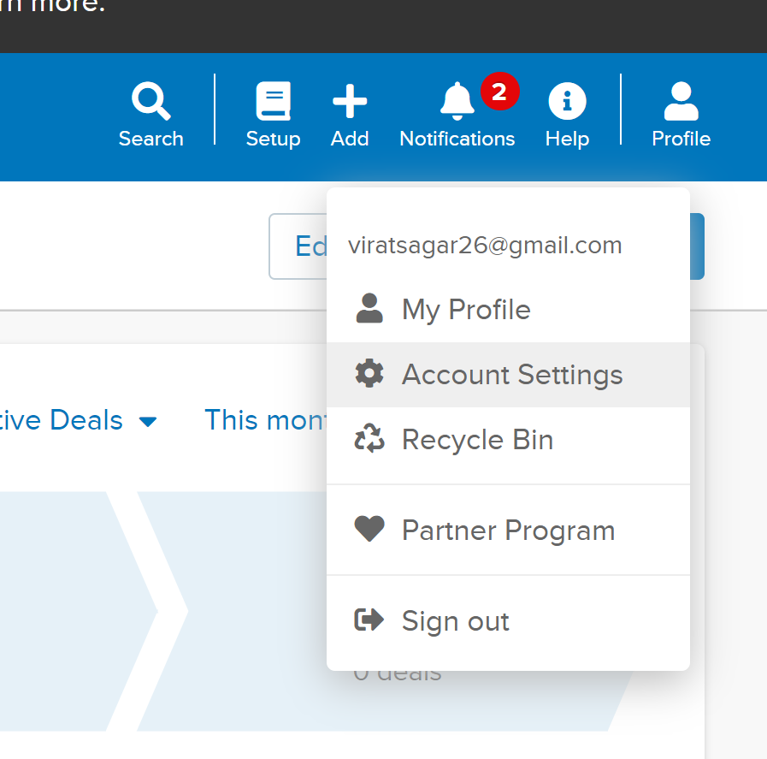
3. In account settings, scroll down to API Integration and generate the ‘App Key’ and the ‘API Key’ as shown:

1. Now, these two secrets can be used to connect to Pipeline CRM while calling the APIs or given as inputs in the connector authentication step.

# Pipeline CRM Connector

## Connector Details

The connector details include:

* **SaaS Provider**: Pipeline CRM
* **API Version**: V3
* **API Type**: REST
* **Developer**: Virat Sagar, Neha Neha
* **Group**: Developers
* **CloudStreams Minimum Version Compatibility**: NA
* **Provider Package Name**: NA

### Supported Resources

List down resources supported by the provider:

|  |  |  |  |  |
| --- | --- | --- | --- | --- |
| **Service: Bundle** | | | | |
|  | **Name** | **Path** | **Method** | **Description** |
| 1 | Create Calendar Entry | /v3/calendar_entries | POST | Create a new calendar entry. |
| 2 | Create Company | /v3/companies | POST | Create a new company. |
| 3 | Create Deal | /v3/deals | POST | Create a new deal. |
| 4 | Delete Calendar Entry | /v3/calendar_entries/{id} | DELETE | Delete an existing calendar entry. |
| 5 | Delete Company | /v3/companies/{id} | DELETE | Delete an existing company. |
| 6 | Delete Deal | /v3/deals/{id} | DELETE | Delete an existing deal. |
| 7 | List Calendar Entry | /v3/calendar_entries | GET | Get all calendar entries. |
| 8 | List Company | /v3/companies | GET | Get all companies. |
| 9 | List Deal | /v3/deals | GET | Get all deals. |
| 10 | Retrieve Calendar Entry | /v3/calendar_entries/{id} | GET | Get details of a particular calendar entry. |
| 11 | Retrieve Company | /v3/companies/{id} | GET | Get details of a particular company. |
| 12 | Retrieve Deal | /v3/deals/{id} | GET | Get details of a particular deal. |
| 13 | Update Calendar Entry | /v3/calendar_entries/{id} | PUT | Update an existing calendar entry. |
| 14 | Update Company | /v3/companies/{id} | PUT | Update an existing company. |
| 15 | Update Deal | /v3/deals/{id} | PUT | Update an existing deal. |

### Usage Notes

Any special notes