**Observation 1**

Base on the analysis on gender and age demographics, the most prevalent population in this game are Players between the age of 20-24.

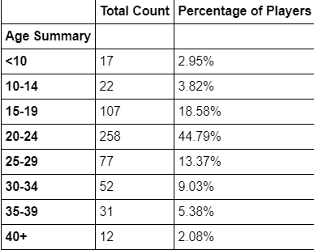

**Observation 2**

**Lisosia93** has the most purchase count of 5 itmes.

**Observation 3**

Most Profitable and Most Popular Items amongst the players is **Oathbreaker, Last Hope of the Breaking Storm.**

**Most Popular Items**

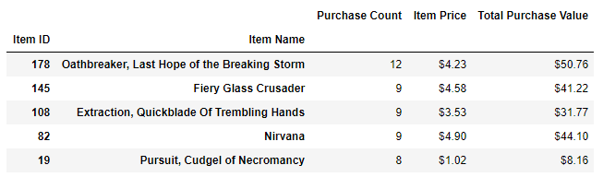

**Most Profitable Items**

