6. THE DEVELOPMENT PROCESS, SDLC COST MODEL AND OTHER SDLC TOOLS
6.1 Development Methodology Used
This project will use the Agile style of developing, and will be using the Scrum method. The work will be divided into several period lengths, known as sprints, and the higher priority items from the product backlog will be produced in each of these sprints. Once produced, these will be demonstrated and tested, and any problems encountered will be taken into account for the next sprint, and this process will be continued. This allows the project to be flexible and extend the requirements of the C&E Bookshop Book Sales Recording System.
6.2 SDLC Model Used
6.1 Development Methodology As the project is based on the process of Application Development Life Cycle, it has been decided to use the Agile SDLC methodology. In this case, the system cannot be developed in a large phase, so it is divided into many iterations. One iteration can cover all the phases of Planning, Requirements, design, Development, Testing, Review.
6.3 SDLC Model Figure
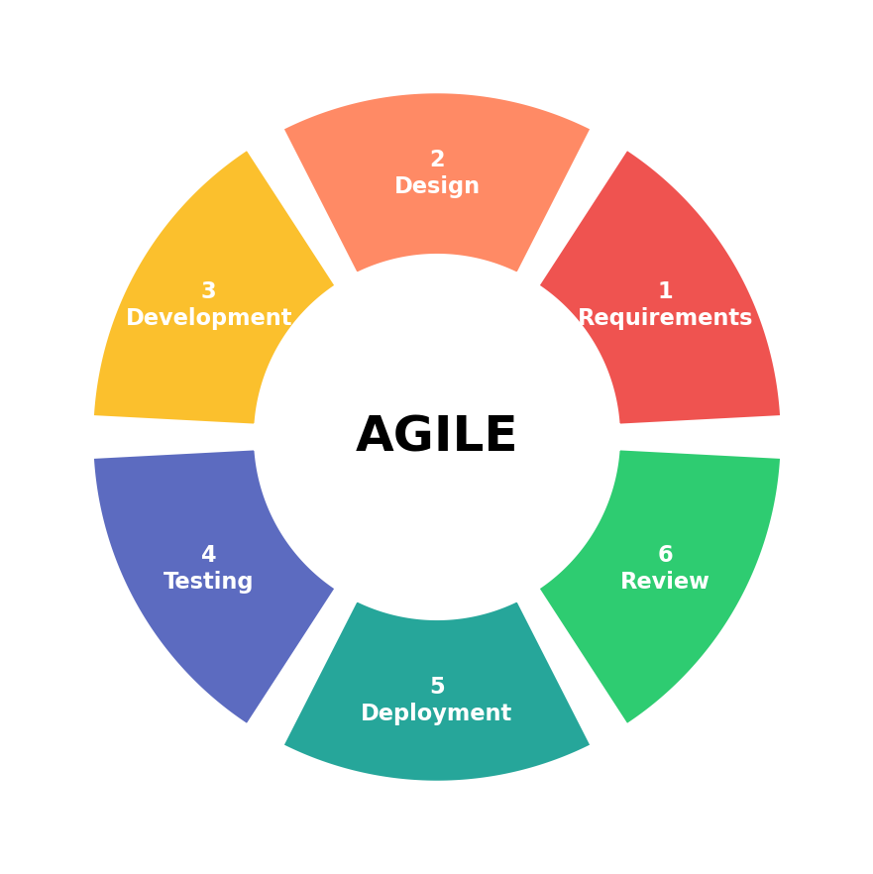
Fig 1: Agile SDLC Model used for C&E Bookshop Book Sales Recording System
6.4 Software and Development Tools Used
Below is the list of the softwares and technologies to be used in the building of this desktop based C&E Bookshop Book Sales Recording System.
Software / Technology | Use in the Project
Net Beans IDE | Involved in designing and coding the Java based desktop application, which included GUI, login, books, sales, reporting, inventory, users and other operations.
XAMPP | Required to host the local development environment, and also the MySQL database services for the system.
MySQL / phpMyAdmin | Originally designed to input books info, user accounts, prices, number of copies, number of copies sold, and transaction records. We use phpMyAdmin to create the database tables and records, and to view and manage the tables and records.
The team will use Net Beans IDE to develop and code the application created in Java. Local Development Environment will be provided by using the XAMPP which also the have the mysqld database services. The database will be set up and managed using phpMyAdmin.
6.5 Motivation of chosen method and SDLC model
Agile SDLC with Scrum is applicable to the C&E Bookshop project, as the requirements can be developed once the system has been tested and viewed. The iterations are short, which allows the team to tackle the most important aspects first, gather user feedback and develop the features iteratively and gradually to obtain the desired functionality before proceeding to the next iterations. Agile methodology can aid planning development based on school calendar.
6.6 Expected Development Approach
• Prepare and prioritize the initial system requirements.
• Breaking down the work into small features or backlog items.
• Create a working set of features on each sprint.
• Test completed features before adding more work.
• End the process by passing the created or updated progress back to the client or mentor for critique.
• Improve the system based on accepted feedback.
7. SDLC STAGES AND PROJECT APPLICATION
SDLC Stage | Application to the C&Es Bookshop Book Sales Logging System
Planning | Identify the bookshop sales recording problem, the scope of the project, project objectives, users, time scale and resources, and main constraints.
Requirements Analysis | Establish and validate system requirements such as books, sales recording, stock control, login, search and reporting.
System Design | Configure screen layout and objects, navigation flow and step, database structure, sales process, inventory process, and user access.
Development | Develop the following modules of the system: Login, Book Management, Sales Recording, Inventory, Dashboard, Search, and Reporting with Java on Net Beans and connect the system to MySQL using XAMPP.
Testing | Test each function, check the correctness of the sales and stock values, test for invalid data input, and give users an opportunity to try the process of recording the sale of books.
Deployment | Install the approved build onto the target desktop PC, set up the local database environment needed and put together simple user instructions for the bookshop staff.
Maintenance | Fix identified errors, notify and update book details or system operations as appropriate, back up data and plan potential upgrades.
Sample note: The team needs to be informative on what they actually did in each stage of the SDLC. The stages of SDLC must be linked to the C&E Bookshop Book Sales Recording System instead of defining the stages.
10. PROJECT BUDGET AND COSTING
10.1 Estimated Project Cost
In addition the possibility exists to put a value on any resources that might be needed and might therefore cost money in designing and building the system. Where possible free or educational software will be used in the development team.
Cost Item | Basis | Estimated Cost
Development Software | Free / educational tools | PHP 0
Database Software | Free / open-source option | PHP 0
Transportation | Client meetings and testing visits | PHP 1,500
Backup Storage / USB | Optional project backup | PHP 500
Hardware Adjustment | Allowance for minor peripherals or replacement needs | PHP 1,500
Contingency | Allowance for unexpected project expenses | PHP 900
TOTAL ESTIMATED COST |  | PHP 4,400
10.2 Cost Justification
Sample budget is also present, the cost of development & deployment, which does not include the student's work. Transportations can be used for the meeting with the client and to do the testing, and backup storages can also be used to help keeping the project file safe. Hardware adjustment and contingency is used to make a reserve fund in case the real project require more resources. Each of the amount may be allocated differently according to the hardware, equipment and environment at C&E Bookshop.

