#include <stdio.h>

#include <graphics.h>

#include <conio.h>

#include <math.h>

#include <process.h>

#define TRUE 1

#define FALSE 0

typedef unsigned int outcode;

outcode CompOutCode(double x, double y);

enum { TOP = 0x1, BOTTOM = 0x2, RIGHT = 0x4, LEFT = 0x8 };

float xmin, xmax, ymin, ymax;

void clip(double x0, double y0, double x1, double y1)

{

outcode outcode0, outcode1, outcodeOut;

int accept = FALSE, done = FALSE;

outcode0 = CompOutCode(x0, y0);

outcode1 = CompOutCode(x1, y1);

do

{

if (!(outcode0 | outcode1))

{

accept = TRUE;

done = TRUE;

}

else if (outcode0 & outcode1)

done = TRUE;

else

{

double x, y;

outcodeOut = outcode0 ? outcode0 : outcode1;

if (outcodeOut & TOP)

{

x = x0 + (x1 - x0) * (ymax - y0) / (y1 - y0);

y = ymax;

}

else if (outcodeOut & BOTTOM)

{

x = x0 + (x1 - x0) * (ymin - y0) / (y1 - y0);

y = ymin;

}

else if (outcodeOut & RIGHT)

{

y = y0 + (y1 - y0) * (xmax - x0) / (x1 - x0);

x = xmax;

}

else

{

y = y0 + (y1 - y0) * (xmin - x0) / (x1 - x0);

x = xmin;

}

if (outcodeOut == outcode0)

{

x0 = x;

y0 = y;

outcode0 = CompOutCode(x0, y0);

}

else

{

x1 = x;

y1 = y;

outcode1 = CompOutCode(x1, y1);

}

}

} while (done == FALSE);

if (accept)

line(x0, y0, x1, y1);

rectangle(xmin, ymin, xmax, ymax);

}

outcode CompOutCode(double x, double y)

{

outcode code = 0;

if (y > ymax)

code |= TOP;

else if (y < ymin)

code |= BOTTOM;

if (x > xmax)

code |= RIGHT;

else if (x < xmin)

code |= LEFT;

return code;

}

int main()

{

double x1, y1, x2, y2;

int n, poly[14], i;

printf("Number of vertices: ");

scanf("%d", &n);

printf("Enter vertices:\n");

for (i = 0; i < 2 * n; i++)

scanf("%d", &poly[i]);

poly[2 * n] = poly[0];

poly[2 * n + 1] = poly[1];

printf("Window coordinates (min, max): ");

scanf("%f%f%f%f", &xmin, &ymin, &xmax, &ymax);

initwindow(640, 480);

drawpoly(n + 1, poly);

rectangle(xmin, ymin, xmax, ymax);

while( !kbhit() );

cleardevice();

for (i = 0; i < n; i++)

clip(poly[2 * i], poly[(2 * i) + 1], poly[(2 * i) + 2], poly[(2 * i) + 3]);

while( !kbhit() );

return EXIT_SUCCESS;

}

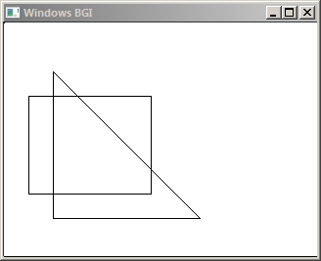 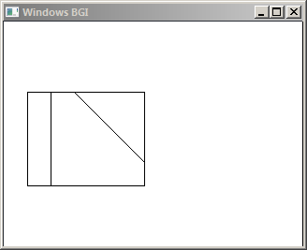

Number of vertices: 3

Enter vertices:

50 50 50 200 200 200

Window coordinates (min, max): 25 75 150 175

#include <stdio.h>

#include <stdlib.h>

#include <graphics.h>

#include <conio.h>

#define MAX 20

#define TRUE 1

#define FALSE 0

int top=1, bottom=2, right=4, left=8;

typedef unsigned int outcode;

outcode compute_outcode(int x, int y,int xmin, int ymin, int xmax, int ymax)

{

outcode oc = 0;

if (y > ymax)

oc |= top;

else if (y < ymin)

oc |= bottom;

if (x > xmax)

oc |= right;

else if (x < xmin)

oc |= left;

return oc;

}

void cohen_sutherland (double x1, double y1, double x2, double y2, double xmin, double ymin, double xmax, double ymax)

{

int accept;

int done;

outcode outcode1, outcode2;

accept = FALSE;

done = FALSE;

outcode1 = compute_outcode (x1, y1, xmin, ymin, xmax, ymax);

outcode2 = compute_outcode (x2, y2, xmin, ymin, xmax, ymax);

do

{

if (outcode1 == 0 && outcode2 == 0)

{

accept = TRUE;

done = TRUE;

}

else if (outcode1 & outcode2)

done = TRUE;

else

{

double x, y;

int outcode_ex = outcode1 ? outcode1 : outcode2;

if (outcode_ex & top)

{

x = x1 + (x2 - x1) * (ymax - y1) / (y2 - y1);

y = ymax;

}

else if (outcode_ex & bottom)

{

x = x1 + (x2 - x1) * (ymin - y1) / (y2 - y1);

y = ymin;

}

else if (outcode_ex & right)

{

y = y1 + (y2 - y1) * (xmax - x1) / (x2 - x1);

x = xmax;

}

else

{

y = y1 + (y2 - y1) * (xmin - x1) / (x2 - x1);

x = xmin;

}

if (outcode_ex == outcode1)

{

x1 = x;

y1 = y;

outcode1 = compute_outcode (x1, y1, xmin, ymin, xmax, ymax);

}

else

{

x2 = x;

y2 = y;

outcode2 = compute_outcode (x2, y2, xmin, ymin, xmax, ymax);

}

}

} while (done == FALSE);

if (accept == TRUE)

line (x1, y1, x2, y2);

}

int main()

{

int n, i, j, ln[1][4], clip[4];

printf("Window coordinates (min, max): ");

scanf("%d %d %d %d", &clip[0], &clip[1], &clip[2], &clip[3]);

printf("Line coordinates: \n");

scanf("%d %d %d %d", &ln[0][0], &ln[0][1], &ln[0][2], &ln[0][3]);

initwindow(320, 240);

rectangle (clip[0], clip[1], clip[2], clip[3]);

for(i=0; i<n; i++)

line (ln[i][0], ln[i][1], ln[i][2], ln[i][3]);

getch();

cleardevice();

rectangle (clip[0], clip[1], clip[2], clip[3]);

for (i=0; i<n; i++)

{

cohen_sutherland (ln[i][0], ln[i][1], ln[i][2], ln[i][3], clip[0], clip[1], clip[2], clip[3]);

getch();

}

return 0;

}

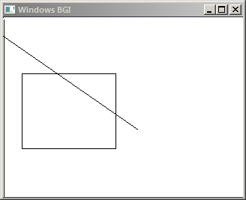 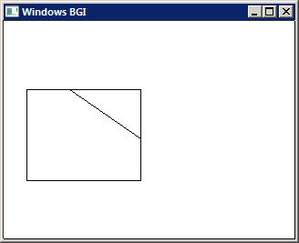

Window coordinates (min, max): 25 75 150 175

Line coordinates:

0 25 180 150

#include <stdio.h>

#include <stdlib.h>

#include <graphics.h>

void scanline(int, int, int, int);

void scanline(int x, int y, int fill_color, int border)

{

putpixel(x,y,fill_color);

if(getpixel(x+1,y) != border && getpixel(x+1,y) != fill_color)

scanline(x+1,y,fill_color,border);

if(getpixel(x,y+1) != border && getpixel(x,y+1) != fill_color)

scanline(x,y+1,fill_color,border);

if(getpixel(x-1,y) != border && getpixel(x-1,y) != fill_color)

scanline(x-1,y,fill_color,border);

if(getpixel(x,y-1) != border && getpixel(x,y-1) != fill_color)

scanline(x,y-1,fill_color,border);

return;

}

int main()

{

initwindow(320,240);

rectangle(32, 24, 188, 216);

circle(160, 120, 29);

scanline(50, 40, BLUE, WHITE);

while(!kbhit())

delay(50);

return EXIT_SUCCESS;

}

