Patient Management System

for Dispensaries

The Specification Document

­

Functions of the product

* Handle all the patient records
* Automate systems so as to reduce manual efforts
* Make regular backups
* Generate reports and analyse data
* Provide reasonable data security, redundancy and privacy
* Provide an easy & convenient way for new patients to register
* Provide an easy to use User Interface for the staff members to use

Expections of the client

* A system with automatic data processing so as to reduce the manual effort
* A central data location where all information can be stored, allowing patients to visit other hospitals in the same chain without having to carry charts.
* An easy way for new patients to get registered.
* An automatic data backup system so as to secure the data for easier future reference.
* An easy & fast user interface reducing time consumption and effort.
* Reasonable amount of data security to maintain the privacy of the patient and his records for reference.

How the new system works

* Instead of a chart, the patient will be given a smart card, eliminating the need of a chart.
* All patient records are stored in a centralised, encrypted, limited access and redundant server for easy and safe access and manipulation of all the records.
* A desktop app will be designed to communicate with the server, handle data entries and display to provide an easy interface to the user.
* A web interface will allow patients to get registered and reduce the time and effort wasted by both the patient and the staff.

Operation in detail

* Patient is given a chart where all the data is recorded regarding his/her medical history and prescriptions given on the last visit.
* After examination, the doctor fills up the chart, the details of the disease or ailment , symptoms detected and prescribing the relevant drugs.
* The patient is required to maintain the chart and bring it with them on every visit so that the staff as well as the doctor can use it as reference to the history of the patient.
* The patient carries the now updated chart to the pharmacist
* The pharmacist provides the drugs as prescribed
* In case of serious/chronic conditions, the patient is referred to a specialist doctor

The Underlying Framework

Frontend

The frontend and the graphical user interface is provided by Microsoft Visual Basic (MS VB) and the .NET Framework. Optionally, a web based interface may be provided with Hyper Text Markup Language/Cascading Style Sheets (HTML/CSS).

Backend

The app is to be powered by Oracle Database linked with the frontend by ODBC. ODBC is the programming interface that enables applications to access data in Database Management Systems using the Structured Query Language (SQL) as a data access standard. Moreover the web interface shall be powered PHP: Hypertext Preprocessor.

User Interface Mockups

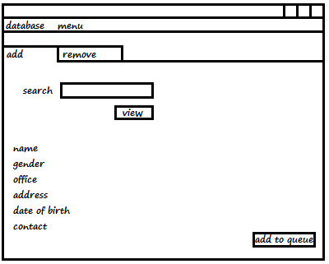

Patient Record Detail Screen

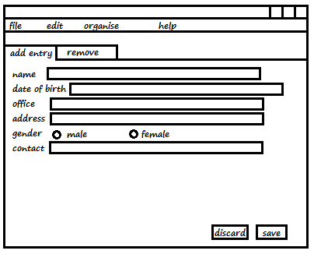

New Patient Record Screen

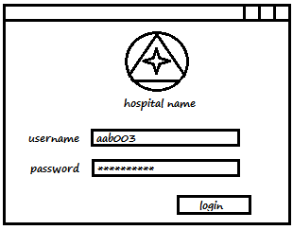

User Login Dialog Box

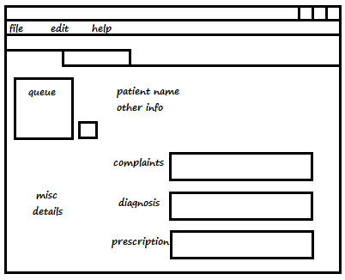

Doctor Screen