Patient Management System

for Dispensaries

The Design Document

­

The Underlying Framework

Frontend

The frontend and the graphical user interface is provided by Microsoft Visual Basic (MS VB) and the .NET Framework.

Backend

The app is to be powered by Oracle Database linked with the frontend by ODBC. ODBC is the programming interface that enables applications to access data in Database Management Systems using the Structured Query Language (SQL) as a data access standard.

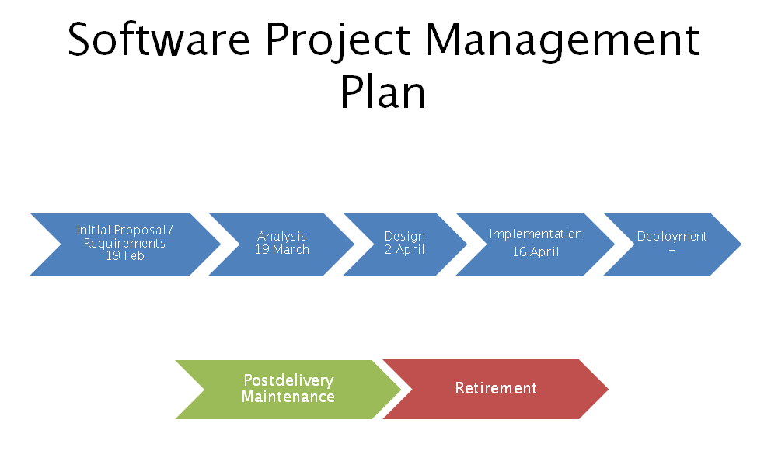

Flow of Data

* Patient is given a chart where all the data is recorded regarding his/her medical history and prescriptions given on the last visit.
* After examination, the doctor fills up the chart, the details of the disease or ailment , symptoms detected and prescribing the relevant drugs.
* The patient is required to maintain the chart and bring it with them on every visit so that the staff as well as the doctor can use it as reference to the history of the patient.
* The patient carries the now updated chart to the pharmacist
* The pharmacist provides the drugs as prescribed
* In case of serious/chronic conditions, the patient is referred to a specialist doctor

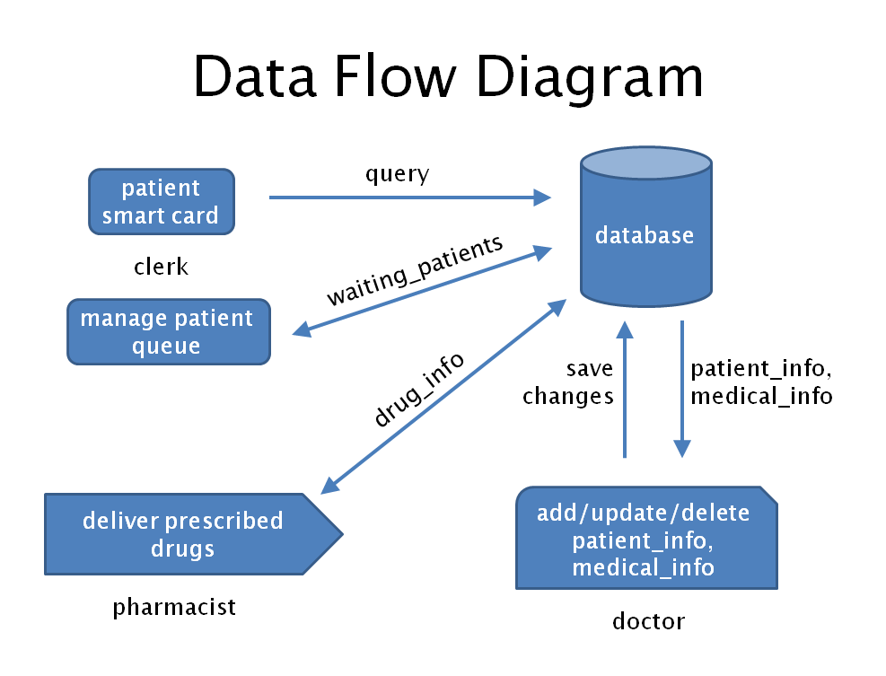

User Interface Design

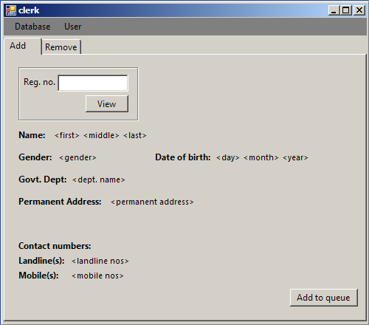

Patient Record Detail Screen

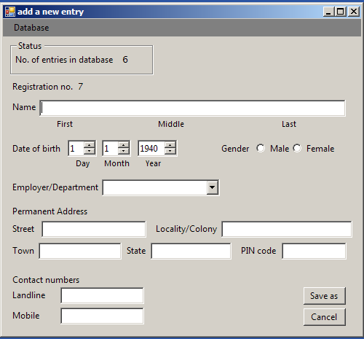

New Patient Record Screen

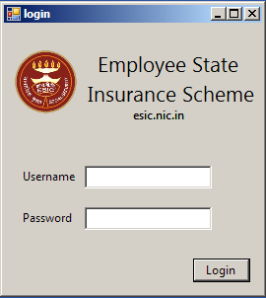

User Login Dialog Box

­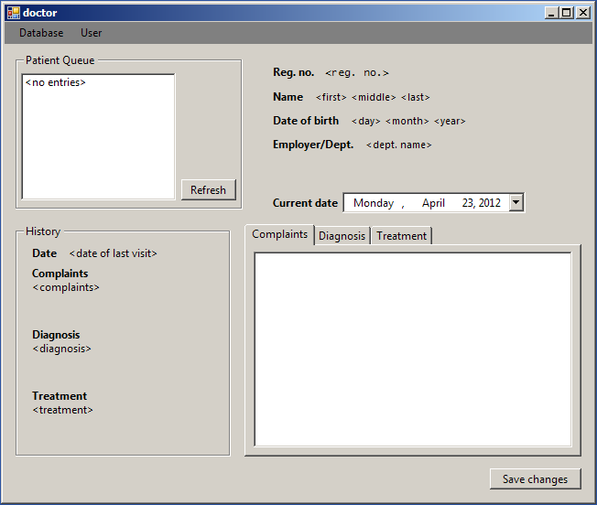

Doctor Screen