Drone Architecture
VIREN SRIRAM

Abstract—This report looks at the main components, sensors and communication links used in autonomous quadcopters, with a focus on Search and Rescue (SAR). It covers how each part works, along with its advantages and limits, and then proposes a system architecture and a set of components for an autonomous SAR drone.
Index Terms—autonomous quadcopter, drone components, sensors, flight control, Search and Rescue

I. INTRODUCTION
Autonomous quadcopters combine propulsion, flight control, sensing and onboard computing so they can fly and do tasks with very little human input. For Search and Rescue, the drone needs reliable positioning, a way to avoid obstacles and a way to spot survivors. To get this, the components have to work well together and we need to know their limitations. This report goes through the main drone subsystems, compares the sensing options, and proposes an architecture and component list for a SAR mission.
II. SYSTEM ARCHITECTURE Figure 1 shows the proposed system architecture of the autonomous drone for Search and Rescue.

III. ELECTRONIC COMPONENTS
A. Flight Controller
It is an embedded computing system which does the calculations to manage a drone’s movement and stability.
Main Responsibilities:
- Reading high-frequency inertial and environmental sensordata.
- Filtering noise and estimating the drone’s 3D attitude, ve-locity, and position via an Extended Kalman Filter (EKF).
- Decoding pilot commands from the RC receiver.
- Executing PID (Proportional-Integral-Derivative) controlloops and motor mixing algorithms to calculate individual motor speeds.
Stabilization uses a cascaded PID control loop, computing the torque corrections needed along the axes:
^{Z t} de(t)
u(t)= K_{p}e(t)+K_{i} 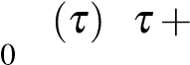e d K_{d} dt (1)
Onboard sensors:
- IMU (accelerometer + gyroscope): Integrated on the PCB,measures the acceleration on the three axes and the rotation about each axis. It should be isolated from motor vibrations.
- Barometer: Integrated on the PCB to measure static air pres-sure.
- Magnetometer: It’s the electronic compass of the drone.
Flight modes: Various flight modes are available including acro, stabilise, loiter, altitude hold etc.
Motor control: The motor mixer takes the collective thrust demand and the output of the PID loops, and calculates the throttle for each motor based on the frame geometry.
Failsafe Handling: In case of RC link loss or low battery voltage, the FC automatically triggers actions such as Land, Return-to-Launch (RTL) or hold/loiter, depending on the severity and configuration [1,2].
B. Electronic Speed Controller (ESC)
Drone motors have no brushes, so an ESC acts as a DC to threephase AC inverter. It controls the speed, direction and braking of a brushless DC motor (BLDC) based on signals from the FC. It uses MOSFETs to switch current through the motor windings. It also measures the back-emf induced by the spinning magnets, works out the rotor position and fires the next MOSFET.
The FC and ESC communicate using Pulse Width Modulation (PWM) or digital signals.
Current and Voltage rating:
- Exceeding the voltage rating destroys the MOSFETs andonboard capacitors.
- Continuous current rating (what it can sustain with airflow)and burst current (what it can sustain for a short time).
C. Brushless Motors and Propellers
Brushless DC motors: Drones use outrunner BLDC motors, where the stator sits on the inside and the rotor on the outside spins around it. This is more efficient than brushed motors and gives higher torque at lower RPM, but it needs a precise ESC.
Motor Sizing Nomenclature (XXYY):
- XX – stator diameter in mm.
- YY – stator height in mm.
K_{v} Rating (RPM per volt): Gives the theoretical unloaded speed of the motor for each volt applied:
RPMunloaded ≈ Kv ×Vbattery (2)
Propeller Geometry:
- Diameter (DD): The total circle traced by the spinning tips.Thrust scales roughly with the swept disc area, and larger propellers are more aerodynamically efficient.
- Pitch (PP): The theoretical forward distance the propeller
AUTONOMOUS QUADCOPTER - SYSTEM ARCHITECTURE
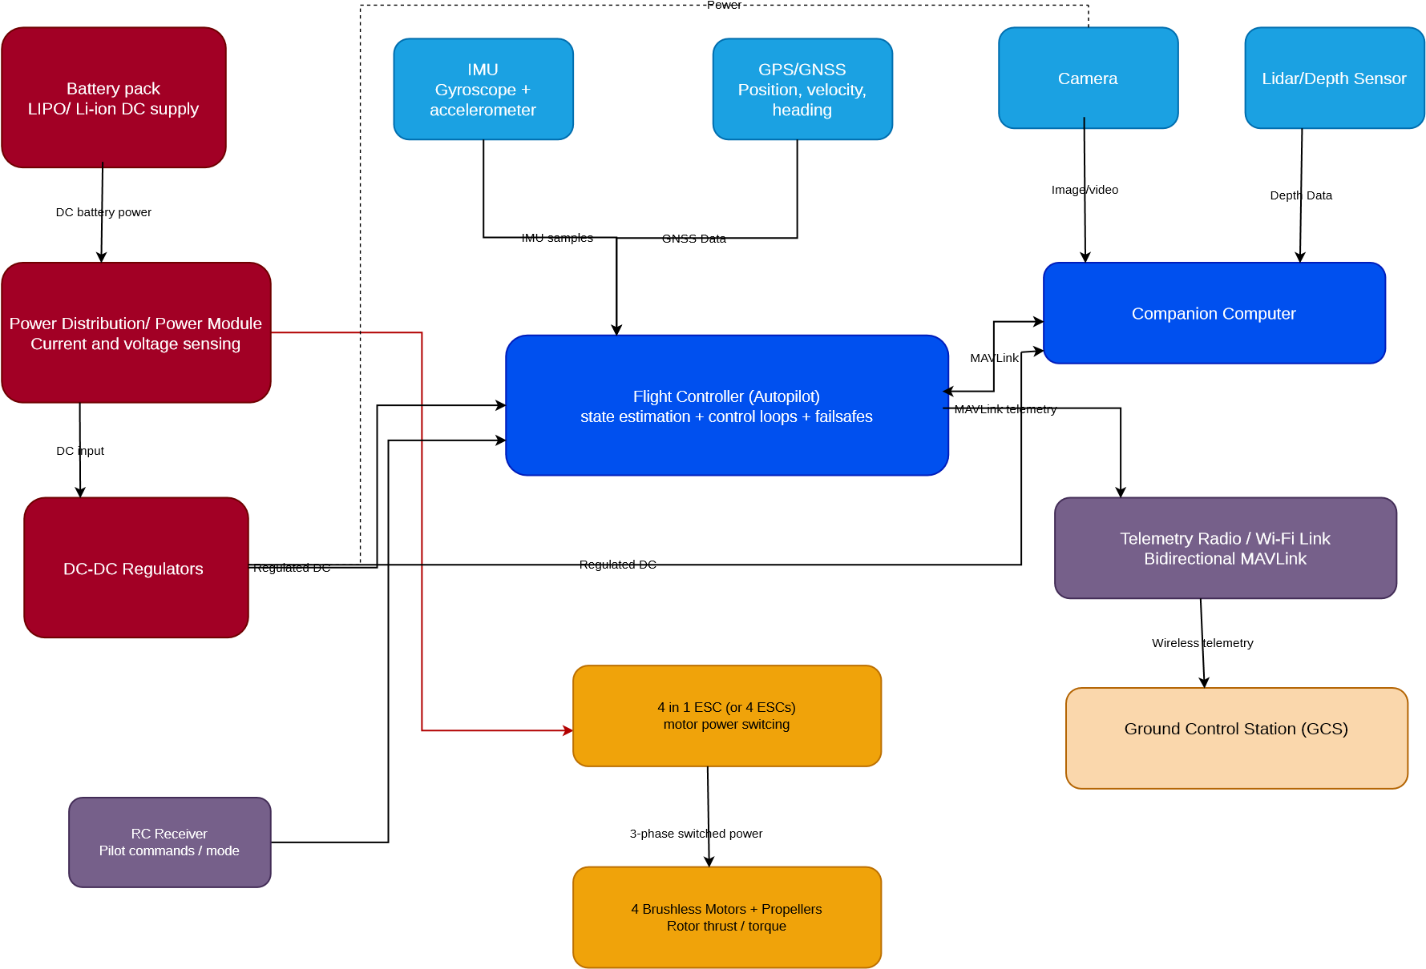
Figure 1: System architecture of the autonomous Search and Rescue drone.
would travel in one complete revolution.
Counter-Rotating pairs: Every spinning propeller exerts a reaction torque on the frame opposite to its spin direction. To stop the drone from spinning in yaw, half the motors spin clockwise and the other half counter-clockwise, using mirrored propellers so that all of them push air downward while the reaction torques cancel out in hover [2].
D. Battery and Power System Battery Chemistry:
- Lithium Polymer (LiPo): Uses a polymer electrolyte thatsupports high discharge rates (C-rating), delivering high burst current without severe voltage sag.
- Lithium-ion: Higher energy density, but has high internalresistance and lower C-ratings. Cell Voltage (LiPo):
- Nominal voltage: 3.7 V/cell
- Fully charged: 4.20 V/cell
- Storage voltage: 3.80–3.85 V/cell
- Safe minimum under load: 3.50 V/cell (dropping below 3.0V causes irreversible chemical damage and puffing).
- Series and parallel combinations: Series multiplies voltage.Parallel multiplies capacity and current delivery.
- Capacity (mAh or Ah): Charge storage. Total stored energyin watt-hours is Wh = Ah×V_{nominal}.
C-Rating: Defines the maximum safe continuous current draw
[4]:
I_{max} = Capacity (in Ah)×C-Rating (3)
E. GPS and GNSS
GNSS (Global Navigation Satellite System) is the umbrella term for the global satellite constellations, including GPS (USA), GLONASS (Russia), Galileo (EU), and BeiDou
(China).
The GNSS receiver compares the transmission timestamp with its local arrival time to get the signal’s time of flight (∆t). Multiplying by the speed of light (c) gives the pseudorange to each satellite (d = c·∆t). Data from at least 4 satellites lets the receiver solve for four unknowns using 3D trilateration:
- Latitude (_{φ}): Angular distance north or south of the Earth’s equator (−90◦ to +90◦).
- Longitude (_{λ}): Angular distance east or west of the Prime Meridian (−180◦ to +180◦).
- Altitude (h): Height above the WGS84 reference ellipsoid (or converted to Mean Sea Level using a geoid model).
- Receiver Clock Bias (b): Corrects the drift in the drone receiver’s cheap quartz clock against the satellites’ atomic clocks.
RTK (Real-Time Kinematic) GPS uses an onboard RTK rover module and a stationary base station to get a horizontal accuracy of 0.01–0.02 m (1–2 cm) [5].
F. RC Transmitter and Receiver
Gives low-latency, direct manual control and an emergency override over the UAV.
- The RC transmitter sends the commands over RF.
- The RC receiver on the drone picks up the RF signal fromthe transmitter.
G. Companion Computer
An onboard Linux-based Single Board Computer (SBC) paired with the flight controller to handle heavy computing work. Examples: Raspberry Pi 4/5, NVIDIA Jetson.
An FC cannot store gigabytes of map data or run convolutional neural networks, so this is done on the companion computer.

IV. SENSORS
A. Inertial Measurement Unit (IMU)
- Accelerometer: Measures specific force (linear accelerationplus Earth’s gravity) along three orthogonal axes (X, Y, Z) in m/s² or g.
- Gyroscope: Measures angular velocity (rate of rotation)about the three body axes (roll rate p, pitch rate q, yaw rate r) in deg/s or rad/s.
Gyroscope Flaw (Integration Drift): To find the tilt angle from a gyroscope, the FC integrates angular velocity over time (_{θ}(t)=_{θ0} +^{R}_{ω}dt). Even tiny sensor biases and thermal noise add up during integration, and the estimated angle drifts by several degrees per minute.
Accelerometer Flaw (Vibration Noise): An accelerometer can measure absolute pitch and roll tilt relative to Earth’s 1g

gravity vector (_{θ} = arctan(a_{x}/^{q}a²_{y} +a²_{z})) without drifting over time. However, spinning propellers and linear accelerations corrupt the gravity reading with high-frequency vibration noise, so the raw accelerometer angles are unusable over short timescales.
An EKF or Complementary Filter fixes this by trusting the integrated gyroscope for fast, short-term changes (high-pass) and the accelerometer for the long-term gravity reference (lowpass), which removes the gyro drift:
θest =α(θest,prev +ωgyro ·∆t)+(¹−α)θ_{accel} (4)
[6]
B. Magnetometer
A 3-axis magnetometer measures the strength and direction of the magnetic field (in Gauss or microtesla, _{µ}T) along the drone’s X, Y, Z body axes.
C. Barometer
A MEMS pressure sensor with a tiny silicon diaphragm that flexes when the static atmospheric pressure changes (measured in Pascals or hectopascals, hPa).
- LiDAR
Sends out rapid pulses of near-infrared laser light and uses a photodetector to measure the time of flight of the pulse reflected back from a surface:
d = c·^{∆t} (5)
2
where c ≈ 3×10⁸ m/s is the speed of light and the factor of 2 accounts for the round trip.
Applications: Directly measures the distance to objects like trees, walls and wires for real-time collision avoidance.
- Depth Camera
A standard 2D camera only captures the colour intensity of each pixel. A depth camera produces a depth map (Z-buffer) where every pixel stores the perpendicular distance from the camera plane to the surface, using two horizontally separated cameras and triangulation.
F. Optical Flow Sensor
A small downward-facing, high frame rate monochrome camera that looks at the ground and tracks how the brightness patterns move across successive frames.
It tracks pixel patches between frames and uses algorithms such as Lucas-Kanade optical flow or block matching to measure the angular pixel velocity.
V. ADDITIONAL SENSOR RESEARCH FOR AUTONOMOUS DRONES
- Millimeter-Wave (mmWave) RadarmmWave radar sends out radio waves and analyses what is reflected back from objects. Frequency-modulated continuouswave (FMCW) radar sends chirps whose frequency changes with time. The difference between the sent and received frequency gives the range of the target, and the Doppler shift gives its radial velocity. With an antenna array it can also give the direction of the object. For example, Texas Instruments’ IWR6843 works in the 60–64 GHz band and the AWR1843 in the 76–81 GHz band [7,9,10].
On a drone, radar can help with obstacle detection and navigation in darkness, smoke or haze, where cameras struggle. Because it measures velocity directly, it can also tell stationary surroundings from moving objects [7].
- Long-Wave Infrared (LWIR) Thermal CameraA thermal camera picks up the infrared radiation that objects give off, so it does not need visible light. LWIR cameras usually work in the 8–14 _{µ}m band. In an uncooled microbolometer, the absorbed radiation heats tiny sensing elements and changes their electrical resistance, and the electronics turn this into a thermal image. Some cameras can also give calibrated temperature readings, but this depends on the model [8].
For SAR drones, thermal imaging helps in finding people or other warm targets at night or in low light. It can also be used to find fire hotspots and overheating equipment.
VI. COMPONENT SELECTION FOR SEARCH AND RESCUE DRONE The components were chosen to balance reliability, computing power, weight and cost for an autonomous SAR quadcopter.
- Flight Controller
Selected component: Holybro Pixhawk 6C running PX4.
The Pixhawk 6C handles attitude stabilisation, sensor integration, waypoint navigation and failsafes. It has redundant IMUs and ports for GPS, RC and telemetry, which suits reliable outdoor flying [11].
- Companion Computer
Selected component: NVIDIA Jetson Orin Nano.
Its GPU can run computer vision and deep-learning models onboard. It can detect people in camera images and help with autonomous navigation by exchanging commands and vehicle state with the flight controller over MAVLink. Its power consumption and weight have to be considered when choosing the airframe [12].
- Positioning System
Selected technology: Multi-constellation GNSS receiver with an external compass.
The GNSS receiver gives position and velocity outdoors for waypoint navigation, and the compass gives the heading. A module like the u-blox NEO-M9N can receive several satellite constellations. GNSS accuracy gets worse near buildings or under dense trees, so it is backed up by the IMU and, if needed, visual positioning [13].
- Obstacle-Detection Sensor
Selected component: Benewake TFmini-S LiDAR.
The TFmini-S measures distance by time of flight and is small and light, which makes it good for detecting nearby obstacles. Its range goes up to 12 m on highly reflective targets and is shorter on dull surfaces. It is a single-point sensor and not a scanning LiDAR, so several sensors or a depth camera may be needed to cover a wider field of view [14].
- Human-Detection Sensor/Camera
Selected component: Raspberry Pi Camera Module 3, connected to the companion computer.
The camera images are processed by a trained persondetection model running on the Jetson Orin Nano. This way humans are detected onboard, without sending raw video to the ground station all the time. Performance depends on lighting, distance, occlusion, camera angle and model accuracy, so a thermal camera can be added for night-time or low-visibility searches [15].
- Communication System
Selected technology: MAVLink-compatible telemetry radio link between the flight controller and the Ground Control Station.
The telemetry radio lets the ground station receive position, battery status, flight mode and other data, and also upload missions and change parameters. MAVLink is the message protocol and the radio carries it. A separate Wi-Fi or cellular link can be used for sending higher-bandwidth images when coverage allows. Range and reliability depend on antenna placement, radio regulations, interference and terrain.

REFERENCES
- ArduPilot documentation. Available: https://ardupilot.org/
- Q. Quan, Introduction to Multicopter Design and Control. Springer, 2017. Chapters 4, 6, and 10 cover flight controller hardware architecture, attitude representation, and cascaded PID control.
- Q. Quan, Introduction to Multicopter Design and Control. Springer, 2017.
- D. Linden and T. B. Reddy, Eds., Linden’s Handbook of Batteries, 4th ed. McGraw-Hill.
- E. D. Kaplan and C. J. Hegarty, Understanding GPS/GNSS: Principles and Applications, 3rd ed. Artech House, 2017.
- W. T. Higgins, “A comparison of complementary and Kalman filtering,” IEEE Transactions on Aerospace and Electronic Systems, 1975.
- C. Iovescu and S. Rao, “The fundamentals of millimeter wave radar sensors,” Texas Instruments, White Paper SPYY005A, 2020.
- M. Vollmer and K.-P. Möllmann, Infrared Thermal Imaging: Fundamentals, Research and Applications, 2nd ed. Wiley-VCH, 2017.
- Texas Instruments, “IWR6843 product documentation.”
- Texas Instruments, “AWR1843 product documentation.”
- PX4 Autopilot, “Holybro Pixhawk 6C,” PX4 User Guide. [Online]. Available:
https://docs.px4.io/main/en/flight_controller/pixhawk6c
- NVIDIA, “Jetson Orin Nano Developer Kit User Guide.”
[Online]. Available: https://docs.nvidia.com/jetson/orin-nanodevkit/user-guide/
- u-blox, “NEO-M9N GNSS Module,” product documentation. [Online]. Available: https://www.u-blox.com/
- Benewake, “TFmini-S LiDAR Datasheet.” [Online].
Available: https://ai.benewake.com/en/resources/technicaldocuments/tfmini-s-datasheet/
- Raspberry Pi Ltd., “Camera Module 3 Product Brief.” [Online]. Available: https://datasheets.raspberrypi.com/camera/cameramodule-3-product-brief.pdf

