1. **Start Your Backend Server**

Make sure your backend is running:

node index.js

If it's set up correctly, it should say:

Server running on port 5000

MongoDB connected

**2. Use Postman to Test the Backend**

**BASE URL:**

http://localhost:5000/api

**Step 1: Register a New User (Admin or User)**

**POST** /auth/register

**In Postman:**

* Method: POST
* URL: http://localhost:5000/api/auth/register
* Body: Select **raw** > **JSON**:

{

"email": "admin@example.com",

"password": "admin123",

"role": "admin"

}

Press **Send**  
You should see:

{ "message": "User created" }

**Step 2: Login**

**POST** /auth/login

* URL: http://localhost:5000/api/auth/login
* Body (JSON):

{

"email": "admin@example.com",

"password": "admin123"

}

Press **Send**  
You’ll get:

{ "token": "xxx.yyy.zzz", "role": "admin" }

**Copy this token** – you’ll use it for protected requests.

**Step 3: Upload a Flight (with Logo)**

**POST** /flights (admin only)

* URL: http://localhost:5000/api/flights
* Method: POST
* Authorization tab:
  + Type: **Bearer Token**
  + Paste the token you got from login  
    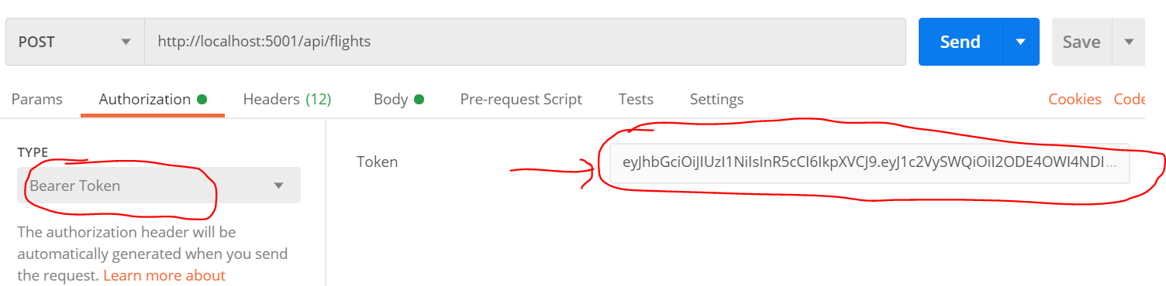
* Body: **form-data** (not raw):
  + flightNumber: ABC123
  + departure: New York
  + arrival: London
  + time: 2025-05-10 15:00
  + logo: (type = File, choose an image)  
    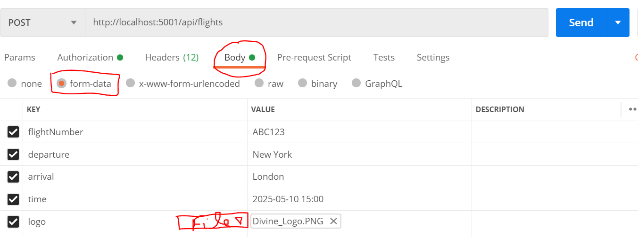

press **Send**  
Response should return the new flight object with logo path.

**Step 4: Get All Flights (Public Route)**

**GET** /flights

* URL: http://localhost:5000/api/flights
* Method: GET

No token needed Returns list of flights with their details and logo URLs.  
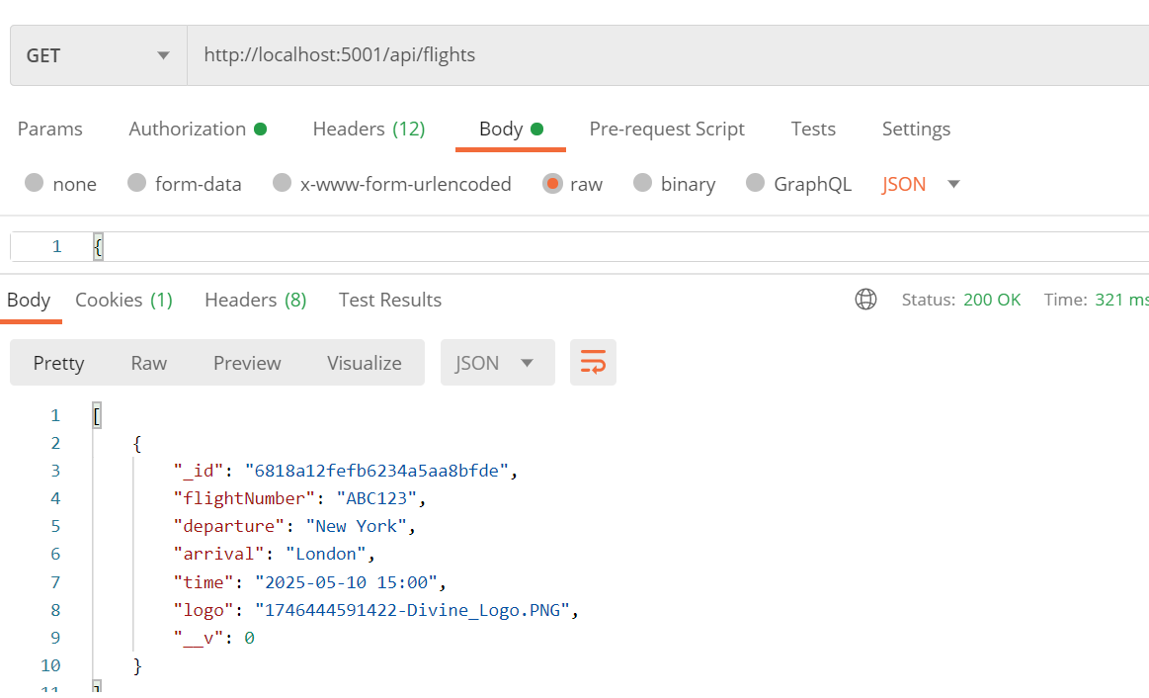

**Step 5: Edit a Flight**

**PUT** /flights/:id

* First, copy a flight _id from /flights response.
* URL: http://localhost:5000/api/flights/<flight_id>
* Method: PUT
* Authorization: Bearer Token (admin)
* Body: **form-data**
  + Only include fields you want to change (e.g. new departure)
  + Include logo only if you're uploading a new one

Hit **Send**, flight gets updated.

**Step 6: Delete a Flight**

**DELETE** /flights/:id

* URL: http://localhost:5000/api/flights/<flight_id>
* Method: DELETE
* Authorization: Bearer Token (admin)

Flight will be deleted.