What Is DevOps?
DevOps is a set of practices, tools, and a cultural philosophy that automate and integrate the processes between software development and IT teams. It emphasizes team empowerment, cross-team communication and collaboration, and technology automation.
DevOps combines development (Dev) and operations (Ops) to increase the efficiency, speed, and security of software development and delivery compared to traditional processes. A more nimble software development lifecycle results in a competitive advantage for businesses and their customers.
- A DevOps team includes developers and IT operations working collaboratively throughout the product lifecycle, in order to increase the speed and quality of software deployment.
- It’s a new way of working, a cultural shift, that has significant implications for teams and the organizations they work for.
- Under a DevOps model, development and operations teams are no longer “different.”
- Sometimes, these two teams merge into a single team where the engineers work across the entire application lifecycle — from development and test to deployment and operations — and have a range of multidisciplinary skills.
- DevOps teams use tools to automate and accelerate processes, which helps to increase reliability.
- A DevOps toolchain helps teams tackle important DevOps fundamentals including continuous integration, continuous delivery, automation, and collaboration.
DevOps values are sometimes applied to teams other than development. When security teams adopt a DevOps approach, security is an active and integrated part of the development process. This is called DevSecOps.
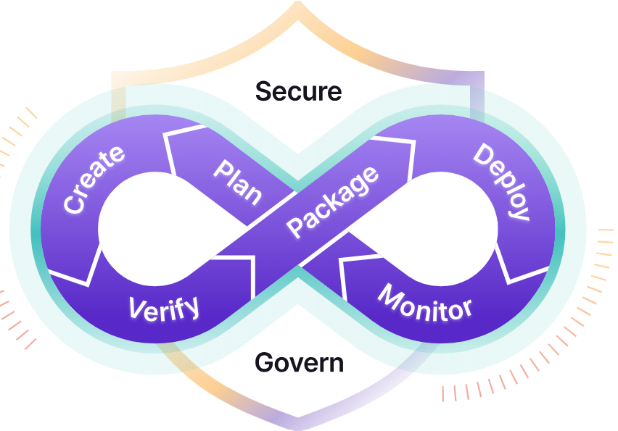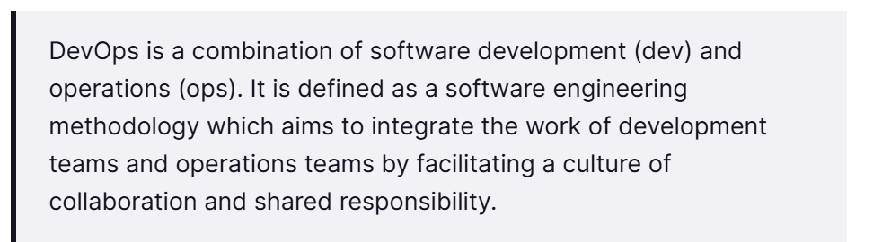
Operations teams ensure that an organization's inputs are converted into outputs efficiently. They also ensure that the organization's goals are aligned.
Roles and responsibilities of operations teams
- Operations manager
Ensures that the organization's inputs are converted into outputs efficiently. They also lead the team, foster collaboration, and create a positive work environment.
- Support trainer
Develops training materials, informs new employees about company protocols and products, and runs training sessions.
- Knowledge manager
Creates and maintains a knowledge base of resources to help customer service representatives find answers to recurring questions.
- Sales operations executive
Optimizes sales processes and works with the sales team to ensure data input is centralized and aligned with business goals.

DevOps, at its core, focuses on implementing automation at each and every stage of the software development lifecycle.
The term DevOps is a combination of two terms: Development and Operations. DevOps aims to simplify and reduce the development life cycle of a system.
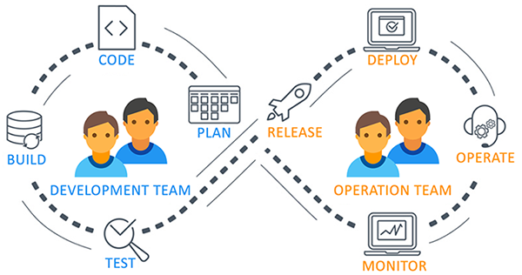
Before DevOps, the development team and the operations team worked separately. This often created a lot of issues in production because both teams were working separately without consulting each other and integrating best practices.
Suppose the operations team has an issue during deployment and they want to communicate with the deployment team. But the deployment team isn't available at that time, so they have to wait a while. Not only that, but the entire process was manual.
Because of all of these issues, the DevOps team got created. Again, it combines the Development Team and the Operations Team and automates every step of the process.
Let's look at a sample workflow a DevOps team might follow:
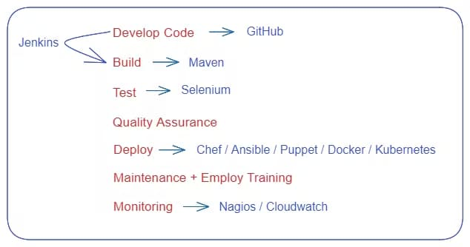

DevOps workflow
- In general, developers use version control systems like Git to manage changes in their codebase, and they can use platforms like GitHub to collaborate with others and share their work.
- Continuous integration and continuous delivery (CI/CD) tools like Jenkins can be used to automate software building, testing, and deployment, and they often work together with build automation tools like Maven.
- Browser automation tools like Selenium can be used to automate web application testing, and deployment automation tools like Chef, Ansible, Docker, and Kubernetes can be used to automate the process of deploying software to different environments.
- Finally, monitoring tools like AWS CloudWatch can be used to monitor software applications and infrastructure performance and health.
Before DevOps: The early days of software development
- In the early days of computing, software was developed and maintained by a small group of specialists, often working in isolation from the rest of an organization.
- The development process known as “Waterfall” was slow, with teams spending months or even years building and testing software before it was ready to be deployed.
- The Waterfall model breaks project activities into pre-defined phases, passing the project down from one phase to another.
- In the waterfall model, each phase depends on the deliverables of the previous one; as a result, each phase must be completed before the next phase can begin with no overlap.
- Developers and IT/Ops professionals had separate (and often competing) objectives, separate department leadership, separate key performance indicators by which they were judged, and often worked on separate floors or even separate buildings.
- The result was different teams concerned only with their own fiefdoms, long hours, botched releases, and unhappy customers.
- What began in online forums and local meet-ups is now a major theme in the software zeitgeist, which is probably what brought you here! You and your team are feeling the pain caused by different teams and broken lines of communication within your company.
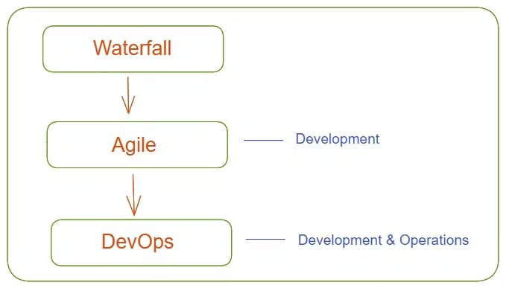

DevOps is an extension of Agile, which itself evolved from the traditional Waterfall methodology.
DevOps is an extension of Agile practices. DevOps builds on the principles of Agile, which emphasizes collaboration, flexibility, and iterative development.
Agile phases are comprised of scrums, sprint planning, sprint review, and so on. DevOps, on the other hand, includes planning, building, continuous delivery, testing, and feedback.
Example:
Suppose a customer wants to build an e-commerce app. Let's have a look at the workflow:
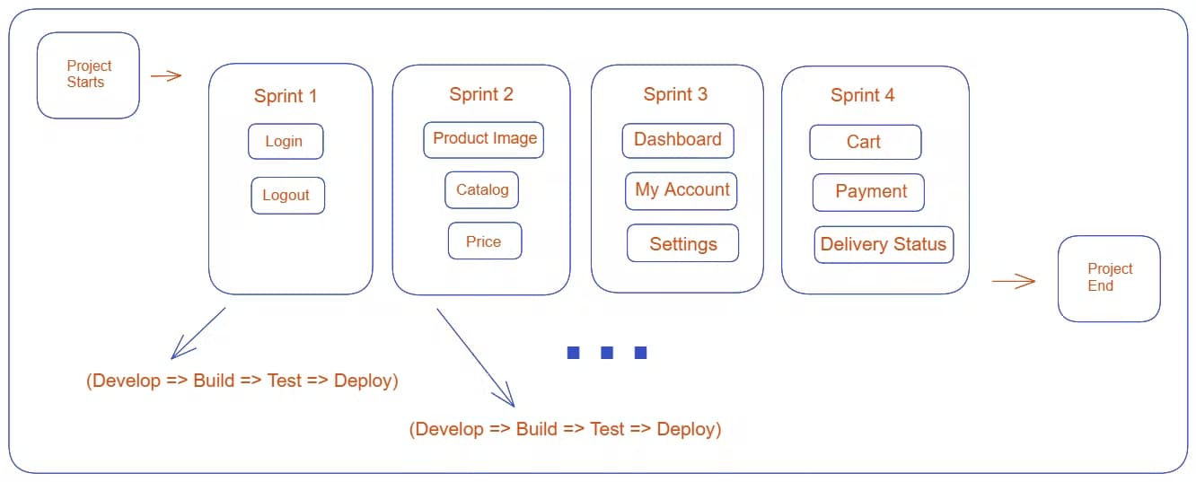Each sprint involves: Develop, Build, Test, and Deploy
The sprints shown in the figure represent the steps in the project. Each sprint includes Develop, Build, Test, and Deploy phases.
After completing a sprint, the team contacts the client to check in. If the client wants any changes, the team can easily make them. Once a sprint finishes, the team move on to the next one.
This process may take several days or weeks, which is where DevOps comes in. By implementing DevOps practices like continuous integration and continuous delivery, you can automate the process of building, testing, and deploying the app.
If any issues arise, the team can quickly fix them without causing any downtime for the users.

DevOps Impact on Software Development
The impact of DevOps on modern software development has been significant. The following are some of the key ways that DevOps is changing the way software is developed and deployed:
- Faster Time-to-Market: DevOps enables teams to deliver software quickly and efficiently, which reduces the time it takes to bring new features or products to market.
- Improved Collaboration: DevOps encourages collaboration between developers, testers, and IT operations teams, which leads to better communication and a faster resolution of issues.
- Increased Quality: By automating testing and deployment processes, DevOps reduces the chance of errors and increases the overall software quality.
- Greater Efficiency: DevOps automates repetitive tasks and streamlines processes, freeing time and resources for more important tasks.
- Better Customer Satisfaction: DevOps allows teams to respond quickly to customer feedback and make necessary changes, resulting in better customer satisfaction.
Who can learn DevOps:
- Deep Knowledge of a programming language is not required: You only need to have a basic understanding of programming concepts to be able to work with code and automate processes.
- Linux experience is not must: You don't need to be an expert in it. Knowing some basic commands and navigating the file system is enough to get started.
- Prior IT experience is not required: DevOps is about collaboration between development and operations teams to improve software delivery. You don't need prior IT experience to be part of a DevOps team.
- Non-technical background people can be a DevOps engineer: Anyone can become a DevOps engineer, regardless of their technical background. While technical skills are important, soft skills like teamwork, communication, and problem-solving are equally valuable in DevOps.

