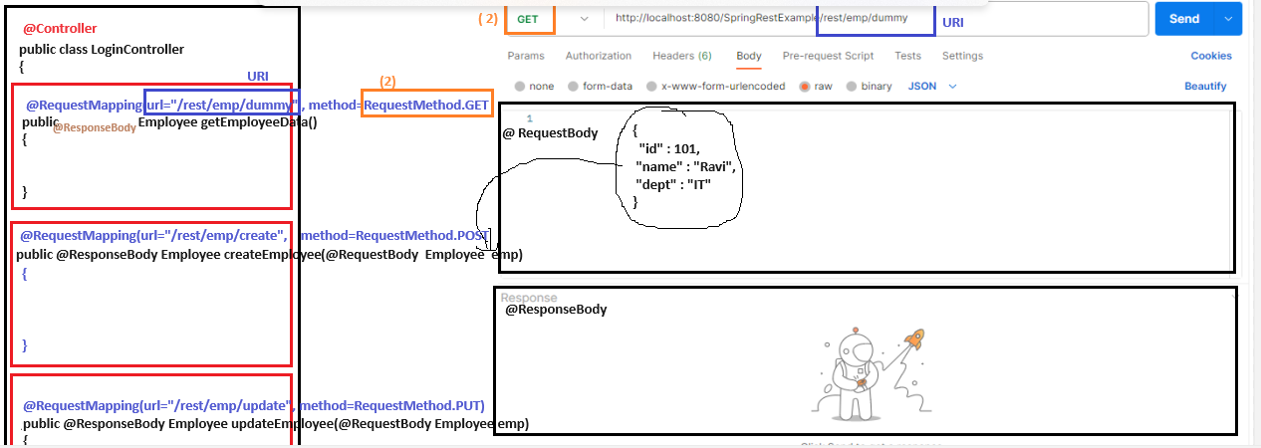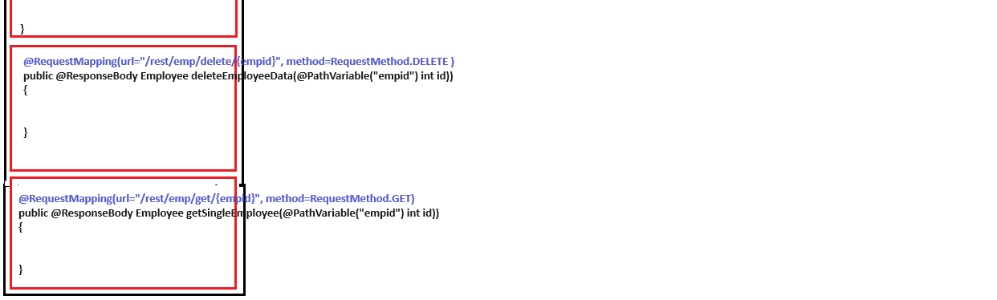

Flow Architecture of Spring Application:
Model: this will contain the POJO beans
Service Layer: this will contain the business logic of your application
DAO layer: This will contain the Database code to connect to “DB” ( for insert/ fetch/ update/ delete) records
Controller layer : This layer will contain your controller classes in which various HTTP methods are stored.
Request:
POSTMAN Controller Service Layer DAO layer DB (database)
Response:
POSTMAN Controller Service Layer DAO layer DB (database)
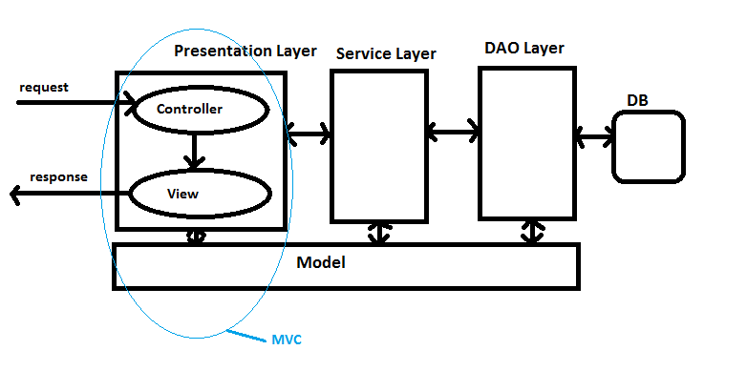
How to create spring boot project:
1) Click “File” Click “New” Choose “Spring Starter Project” dialog box will open
2) Write name of the project and let others be default option Click “Next”
3) Select the depdendencies which you want to include in the project by writing the depdendency name in “Search box” Click “Finish” Below project will be created with [boot] in front of the project
Spring boot Project Structure:
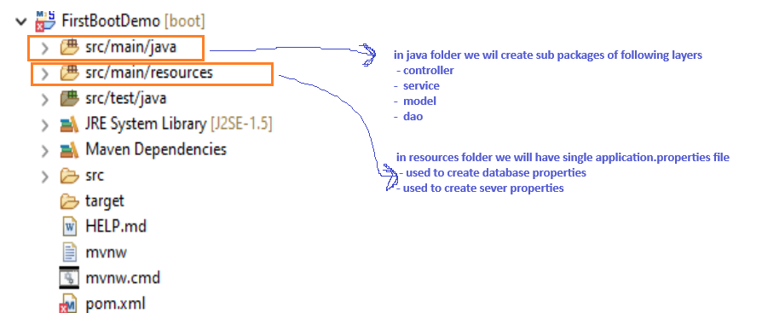
What is POM File:
The pom.xml file is a crucial configuration file in a Maven-based Spring Boot project. It defines project-specific information, dependencies, plugins, and other build-related configurations. This file is created automatically inside the project as we are selecting the ”Maven” option from the drop-down while creating the spring boot project above.
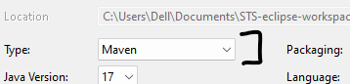
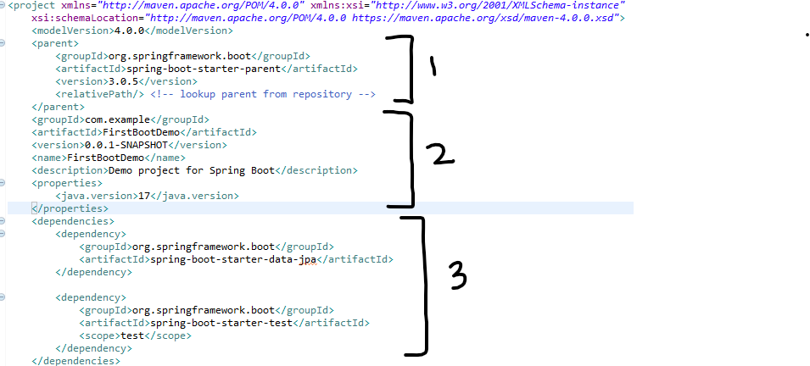
1) <parent> : Spring Boot Starter Parent is a starter project that provides the default configuration for spring-based applications. It is added as a parent in the pom. xml file. The spring-boot-starter-parent defines spring-boot-dependencies as its parent.
Spring Boot provides a number of “Starter POMs” that make easy to add jars to your classpath. Our sample application has already used spring-boot-starter-parent in the parent section of the POM. The spring-boot-starter-parent is a special starter that provides useful Maven defaults. It also provides a dependency-management section so that you can omit version tags for “blessed” dependencies.
Other “Starter POMs” simply provide dependencies that you are likely to need when developing a specific type of application. Since we are developing a web application, we will add a spring-boot-starter-web dependency
2) all these properties which are already initialized during the project creation
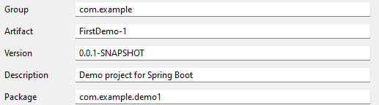
How to manually add the jars files to the project:
if you create normal core java project / or jdbc project /or hibernate project / or spring core project(like Dibycons) so we don’t need have the MAVEN features and that’s the reason we don’t have the pom file and we have to manually add the jar files into th4 build path.
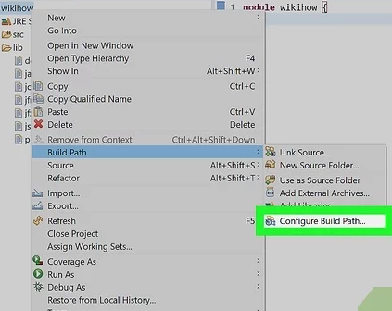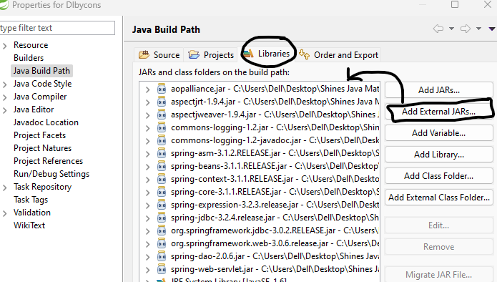
3) <dependencies> :
How to add the dependencies in MAVEN or springboot project?
If we create any spring project with MAVEN or spring boot project then only you will see pom.xml file get created automatically and you can add as many dependencies inside the <dependencies>.
In the context of Maven, a dependency is simply a JAR file used by a Java application. Based on the POM file, Maven will download and add the JAR file to our Java path.
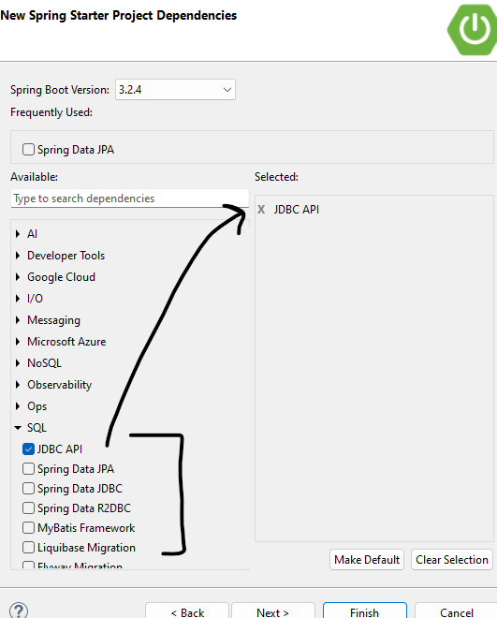
Annotations
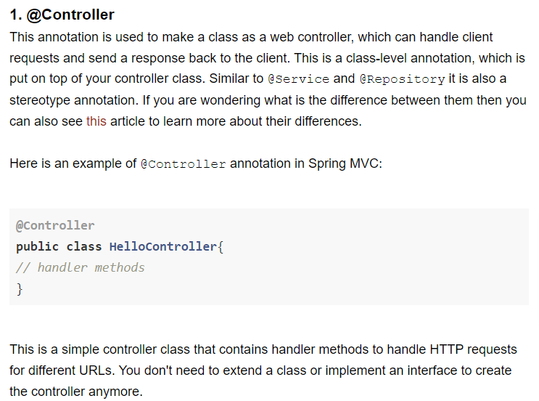

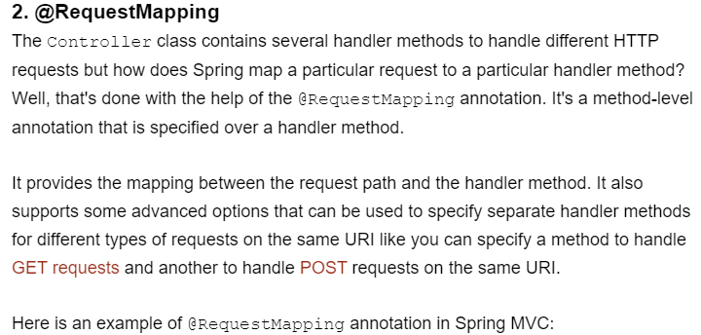
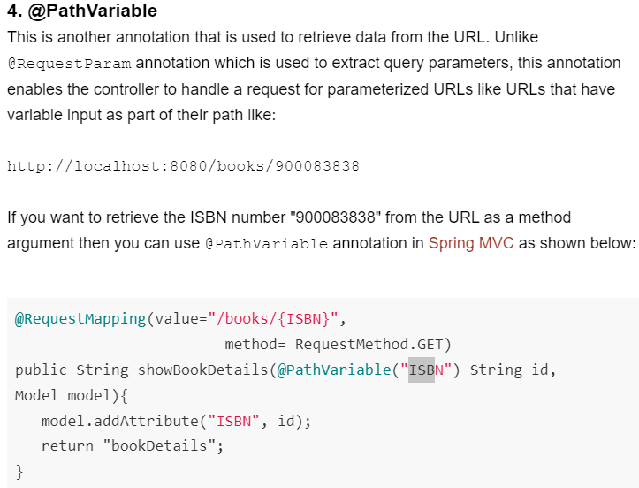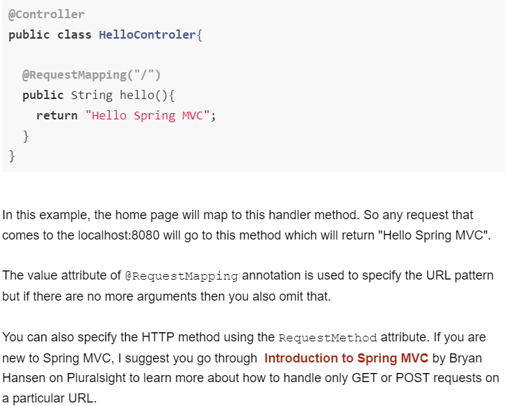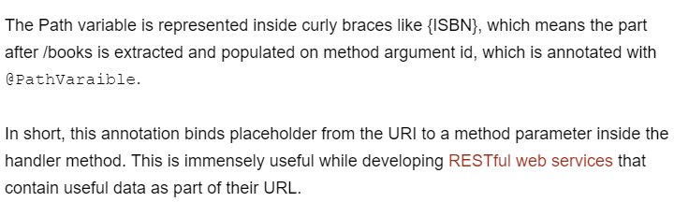

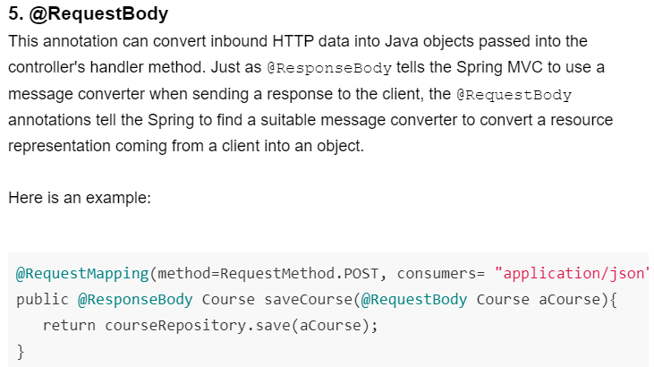

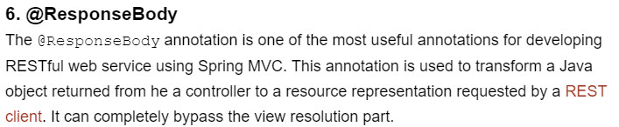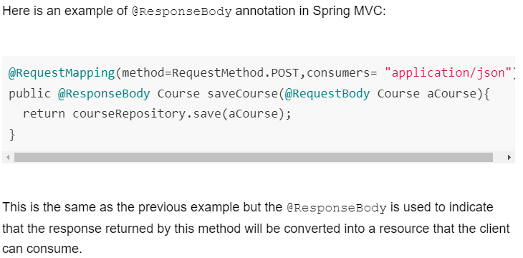
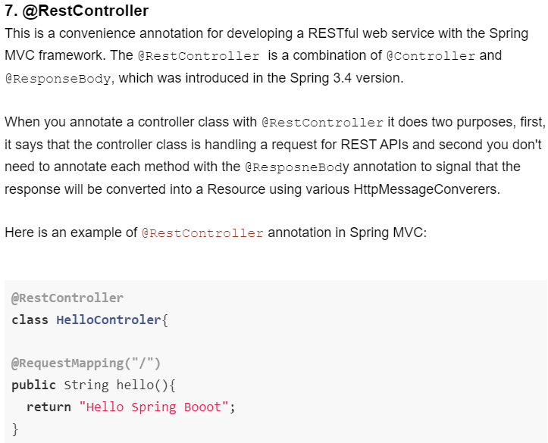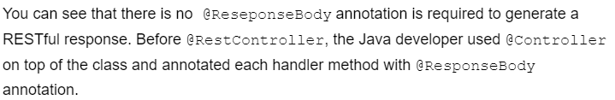

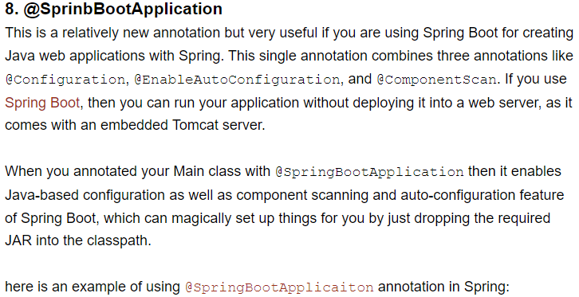
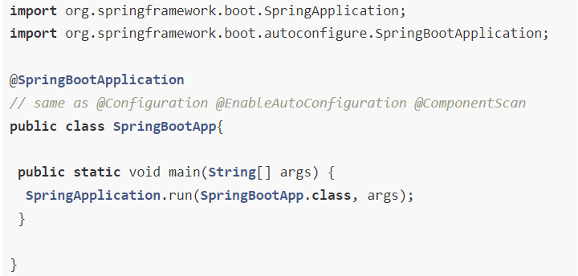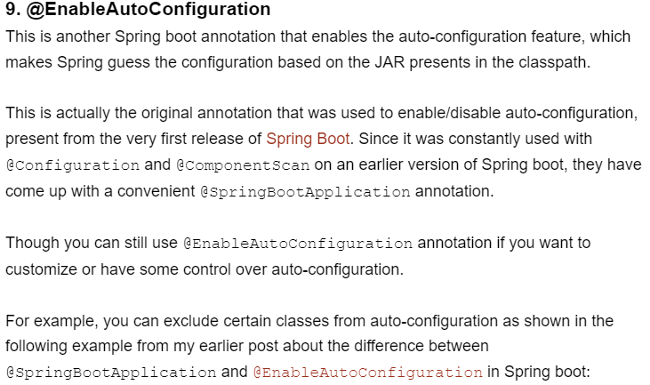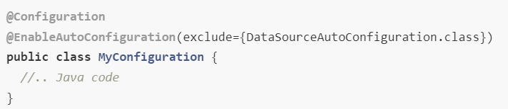
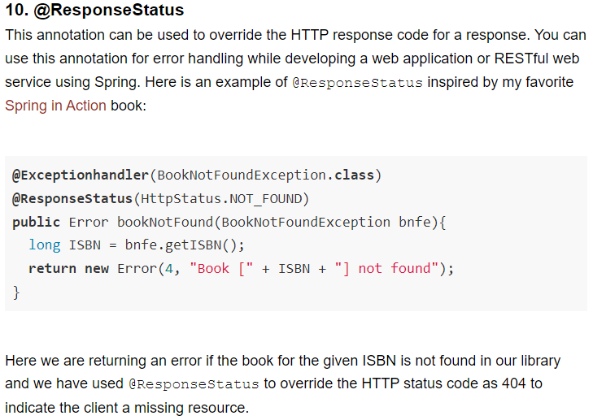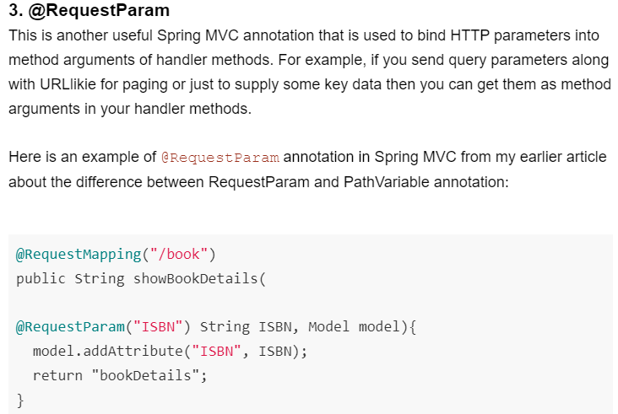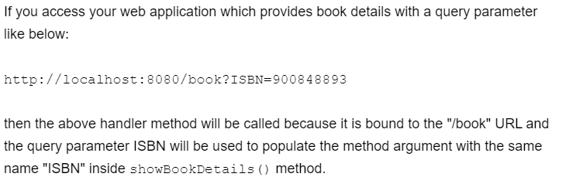
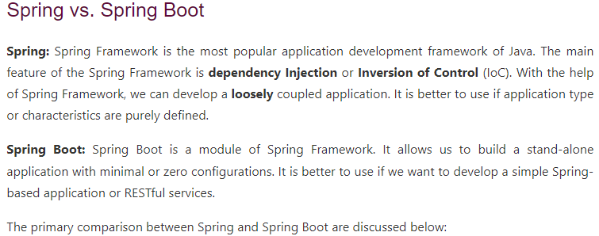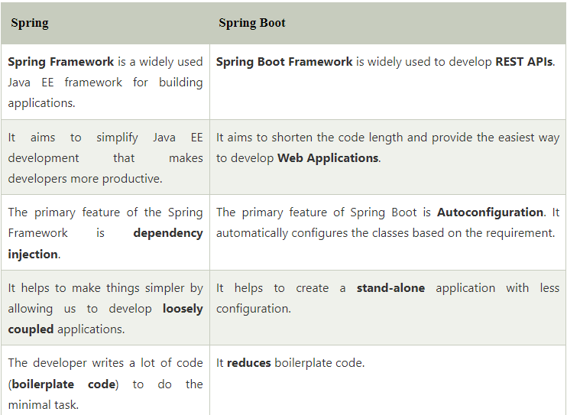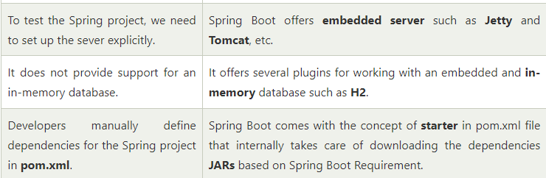

MAVEN
Maven is a powerful project management tool that is based on POM (project object model). It is used for projects build, dependency and documentation.

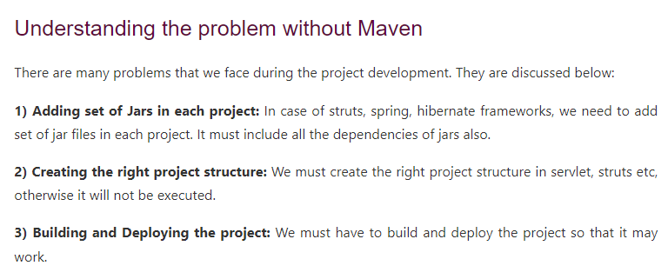

What it does?
Maven simplifies the above mentioned problems. It does mainly following tasks.
- It makes a project easy to build
- It provides uniform build process (maven project can be shared by all the maven projects)
- It provides project information (log document, cross referenced sources, mailing list, dependency list, unit test reports etc.)
- It is easy to migrate for new features of Maven

_{Maven pom.xml file}
POM is an acronym for Project Object Model. The pom.xml file contains information of project and configuration information for the maven to build the project such as dependencies, build directory, source directory, test source directory, plugin, goals etc.
Maven reads the pom.xml file, then executes the goal.
_{ELEMENTS OF POM.XML.}
Element | Description
project | It is the root element of pom.xml file.
modelVersion | It is the sub element of project. It specifies the modelVersion. It should be set to 4.0.0.
groupId | It is the sub element of project. It specifies the id for the project group.
artifactId | It is the sub element of project. It specifies the id for the artifact (project). An artifact is something that is either produced or used by a project. Examples of artifacts produced by Maven for a project include: JARs, source and binary distributions, and WARs.
version | It is the sub element of project. It specifies the version of the artifact under given group.
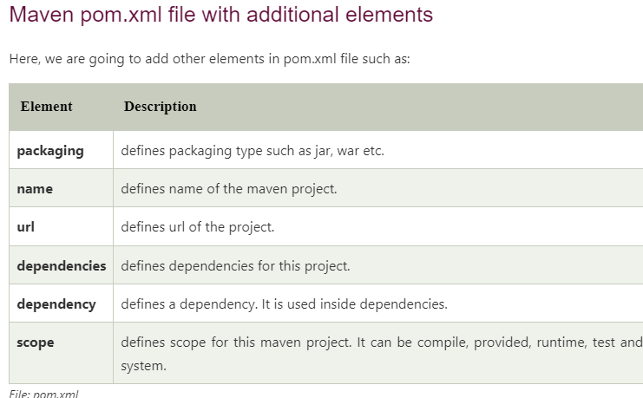
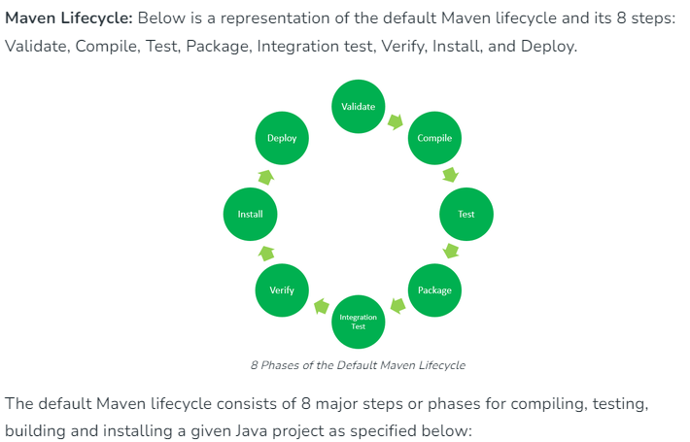
- Validate: This step validates if the project structure is correct. For example – It checks if all the dependencies have been downloaded and are available in the local repository.
- Compile: It compiles the source code, converts the .java files to .class, and stores the classes in the target/classes folder.
- Test: It runs unit tests for the project.
- Package: This step packages the compiled code in a distributable format like JAR or WAR.
- Integration test: It runs the integration tests for the project.
- Verify: This step runs checks to verify that the project is valid and meets the quality standards.
- Install: This step installs the packaged code to the local Maven repository.
- Deploy: It copies the packaged code to the remote repository for sharing it with other developers.

