Critical Mission Computing Ltd
119 - 125
14-07-2016
Frontier Support

Priority (P) | Status (S)
High (H) | Open (O)
Medium (M) | Closed (C)
Low (L) | Query (Q)
Wish List (WL) | Under Testing (UT)
Design (D) | Carried Forward (CF)

S.No. | Details | P | S
119 | All Pages  The editor section needs to expand width wise to be the same alignment as the Short Description and Meta Title and all other fields.  This needs to be changed for all the pages  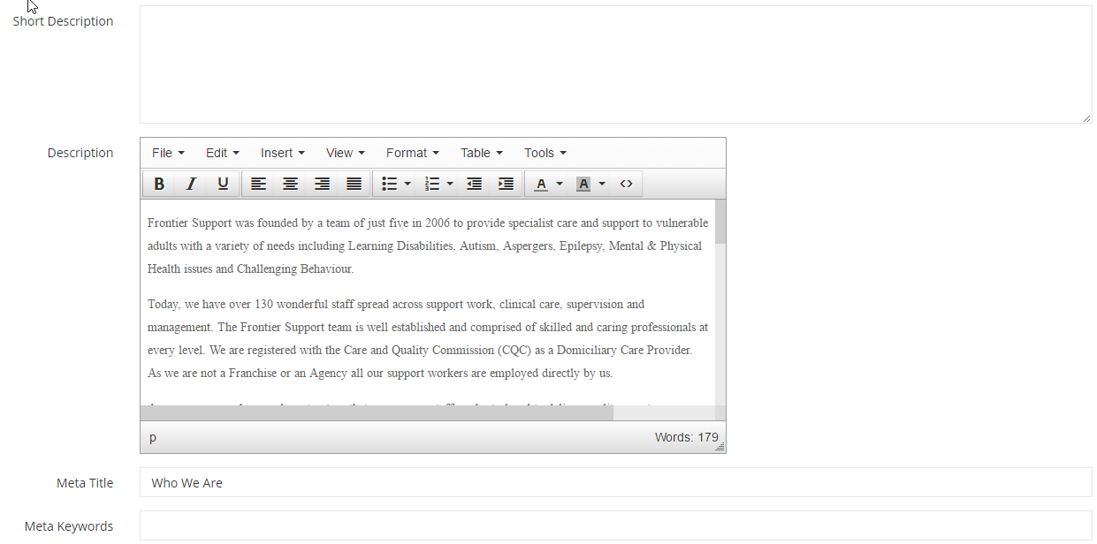
120 | What We do  Rename this as ‘What We Do’  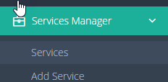
121 | Buzzz Timetable  Rename to Buzzz Timetable  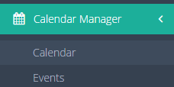  Place all Buzzz options together  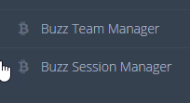
122 | Buzzz Timetable  All the activities were for the same week and repeating every week  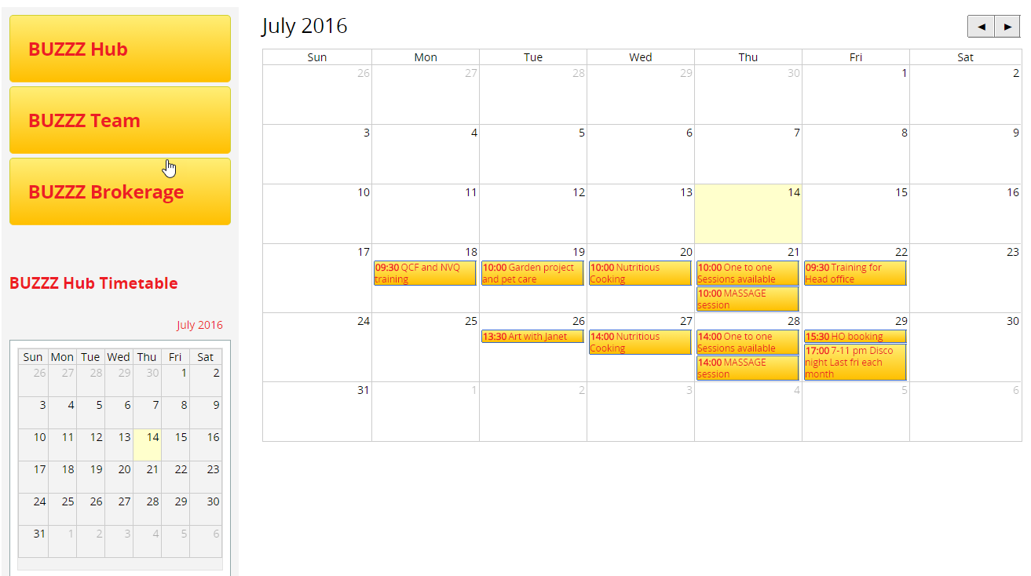
123 | Buzzz Timetable  ‘July 2016’ should be on the left and ‘August 2016’ should be where ‘July 2016’ is.  The calendar should move forward to the next month when clicked on ‘August 2016’  ‘<<’ and ‘>>’ should take the months forward and backewards  ‘July 2016’ ‘<<’ ‘August 2016’ >>  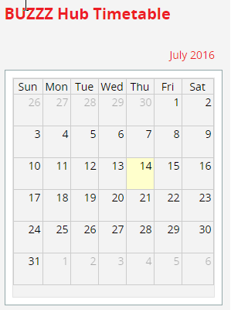
124 | Upload CV  I have an email from the client saying that she uploaded the CV and submitted. Not sure where the CV is going?  - Can you check and let me know where the CV is going: to what email id? Can you add alkabagga@gmail.com as well to the submission of the CV till the system is signed off  - Where on CMS can they change the email-id for CV submission
125 | Credentials  Why are the file name 01.jpg etc.  They should be renamed to the actual credential name  