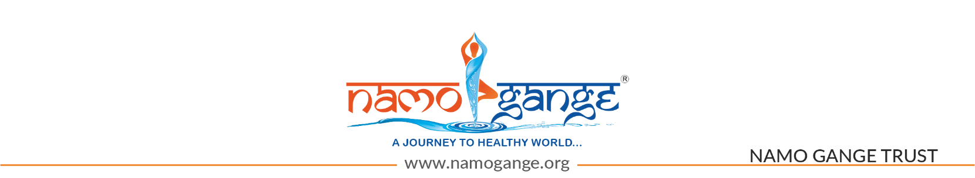
CORPORATE VISITOR REGISTRATION CONFIRMED | 9TH IHWE 2026
Dear Mr. Vijay Sharma,
Greetings from the 9th Edition of International Health & Wellness Expo 2026 (IHWE – Global Edition).
We are pleased to confirm your registration as a Corporate Visitor for this prestigious international platform, bringing together global leaders, innovators, and stakeholders from the health, wellness, and sustainability ecosystem.
EXHIBITION OVERVIEW (MSME-FOCUSED SEGMENTS)
The Expo is designed as a comprehensive MSME-centric platform showcasing an integrated spectrum of products, technologies, and services across key sectors including AYUSH & Traditional Medicine, Healthcare & Pharmaceuticals, Wellness & Preventive Healthcare, Nutrition & Fitness, Organic & Natural Products, Agriculture & Medicinal Plants, Herbal Cosmetics & Personal Care, Green & Sustainable Solutions, Handicrafts & Sustainable Lifestyle, and HealthTech & Digital Innovations.
It brings together manufacturers, startups, research institutions, healthcare providers, wellness brands, agri-innovators, and technology enablers presenting solutions such as organic products, nutraceuticals, fitness equipment, wellness services, hospitals, diagnostics, herbal solutions, eco-friendly innovations, handicrafts, and advanced digital healthcare technologies.
As a Corporate Visitor, you will have the exclusive opportunity to network with key industry stakeholders, explore cutting-edge innovations, and discover business collaborations.

EVENT DATE & VENUE: 21st August to 23rd August 2026, Hall No. 8, 9 & 10, Pragati Maidan, New Delhi, Bharat
Timings: 09:30 AM to 6:30 PM (Open for Visitors)
SCAN THE QR CODE BELOW FOR ENTRY
Please present it at the entrance for hassle-free access to the exhibition area.
[QR CODE HERE]
🔸 Important Note:
- This QR Code is valid for exhibition area access only.
- To attend the Arogya Sangosthi Seminar, please register separately.
- To attend the Buyer Seller Meet, please register separately.

BUYER REGISTRATION (RECOMMENDED)
To maximize your business engagement and unlock exclusive B2B opportunities, we strongly recommend registering as a Buyer. This will enable you to connect directly with exhibitors, schedule meetings, and explore high-value sourcing and partnership opportunities.
For enhanced B2B engagement and priority business meetings, you may also register as a Buyer using the link below:
[Insert Buyer Registration Link]

ATTEND THE 15TH EDITION OF AROGYA SANGOSTHI SEMINAR
The 18th Arogya Sangoshthi Seminar will feature six key tracks—Medical Leadership, Wellness, Mental Health, AYUSH, Nutrition, and Health-Tech—covering hospital management, preventive healthcare, traditional medicine, nutrition, and digital health innovations, creating a focused platform for insights, collaboration, and networking.
REGISTER FOR AROGYA SANGOSTHI SEMINAR HERE:
[Click to Register]

HOW TO REACH THE VENUE
BY METRO: Visitors traveling by metro are advised to deboard at Supreme Court Metro Station (Blue Line). From there, proceed towards Pragati Maidan Gate No. 10 for entry. Complimentary shuttle service will be available from the gate to the event venue at Hall No. 8, 9 & 10.
BY PUBLIC TRANSPORT: Visitors arriving via bus, auto, or taxi should enter through Pragati Maidan Gate No. 4. Dedicated shuttle services will be available to transport you to Hall No. 8, 9 & 10.
BY CAR: Visitors arriving by private vehicle may park at Basement Parking No. 2, Bharat Mandapam, Pragati Maidan, with entry accessible via Mathura Road. After parking, please proceed to the designated shuttle pickup point, from where complimentary shuttle services will transport you to Hall No. 8, 9 & 10.

SUPPORT TEAM
If you need any further information or any help, feel free to contact our team members, who will be happy to assist you:
📞 Dharmendra: 9220448101 📞 Swati: - 9311301071 📞 Gaurav: 7042466330

We look forward to welcoming you to the 9th Edition of International Health & Wellness Expo 2026 (IHWE – Global Edition), Buyer Seller Meet, and the Arogya Sangoshthi Seminar for an enriching and impactful experience.
May Mother Ganga bless you with health, prosperity, and well-being.
With warm regards,

Vijay Sharma
Chairman
Namo Gange Trust®

FOLLOW US ON SOCIAL MEDIA FOR INTERNATIONAL HEALTH & WELLNESS EXPO UPDATES:

Facebook: [Link]
Instagram: [Link]
Website: [Link]
LinkedIn: [Link]

