LangGraph

🧠 Core Problem: LLMs Are Stateless
Large Language Models (LLMs) like LangChain pipelines work well for:
- single prompts
- RAG chains
- linear workflows
But real AI systems are NOT linear.
👉 Traditional chains break here.
Chains = Linear Execution
Agents = Dynamic Execution

✅ Benefits of LangGraph

🧠 Memory / State Sharing
  - LangGraph provides a centralized shared state accessible by all nodes and agents.
- 🔀 Conditional Routing
  - Execution dynamically moves to different nodes based on state or model output.
- 🛠 Tool Calling
  - Tools become first-class graph nodes instead of hidden agent behavior.
- 👨‍💻 Human-in-the-Loop
  - Execution can pause and wait for human approval before continuing.
- 💾 Persistence
  - LangGraph saves execution checkpoints automatically.
- ⚡ Async & Streaming
  - Supports asynchronous execution and real-time streaming outputs.

Example
🎯 Graph Structure
START → hello → bye → END

from typing import TypedDict
from langgraph.graph import END, START, StateGraph
from util.langgraph_util import display

class HelloWorldState(TypedDict):
message: str

def hello(state: HelloWorldState):
print(f"Hello Node: {state['message']}")
return {"message": "Hello "+state['message']}

def bye(state: HelloWorldState):
print(f"Bye Node: {state['message']}")
return {"message": "Bye "+state['message']}

graph = StateGraph(HelloWorldState)
graph.add_node("hello",hello)
graph.add_node("bye",bye)

graph.add_edge(START,"hello")
graph.add_edge("hello","bye")
graph.add_edge("bye",END)

runnable = graph.compile()
display(runnable)
output = runnable.invoke({"message": "Bharath"})
print(output)

Q) What is set_entry_point() in LangGraph?
A) set_entry_point() tells LangGraph: “Start executing the graph from this node.”
So you can either use graph.set_entry_point(Nodename) or graph.add_edge(START, Nodename)

Display Graph Image using display() in LangGraph

✅ Concept
In LangGraph:
- Compiled graph = Runnable
- The display method takes this runnable object
- Generates a visual graph image
👉 Used mainly in Jupyter / notebooks / documentation.

🧠 Flow
Graph Builder → compile() → Runnable Graph → display() → Graph Image

✅ invoke() — Synchronous Execution

Meaning
Runs the graph step-by-step and blocks execution until finished.
👉 Program waits for result.

Example : result = graph.invoke({"message": "hi"})

✅ ainvoke() — Asynchronous Execution

Meaning
Runs graph using async event loop.
👉 Program continues doing other work while graph runs.

Example
result = await graph.ainvoke({"message": "hi"})

🧠 What is Streaming?
Streaming = receiving outputs incrementally while the graph is still running.

✅ Core Streaming Methods
LangGraph Runnable supports: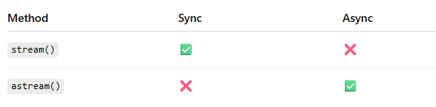

🎯 Streaming Modes (VERY IMPORTANT)
LangGraph allows multiple stream modes.

✅ 1. Values Mode
graph.stream(input, stream_mode="values")
Streams updated state values.
{"message": "Hello"}
{"message": "Hello Bye"}

✅ 2. Updates Mode (Most Used)
graph.stream(input, stream_mode="updates")
Streams node updates.
hello executed
bye executed
Best for debugging agents.

✅ 3. Messages Mode
graph.stream(input, stream_mode="messages")
Streams LLM tokens/messages.
Perfect for chat UI.

✅ 4. Events Mode (Deep Debugging)
Streams internal runtime events.
Used by advanced observability tools.

🚀 Why Streaming is Powerful in LangGraph
Streaming turns agents into:
✅ realtime copilots
✅ live reasoning systems
✅ observable workflows
✅ interactive AI applications

🔀 Conditional Routing in LangGraph

✅ What is Conditional Routing?
Conditional Routing = choosing the next node dynamically based on state or logic.
👉 Instead of fixed flow:
START → A → B → END
LangGraph decides at runtime:
START → decision → (A or B)
from typing import TypedDict
from langgraph.graph import END, START, StateGraph

# Define the structure of the input state (customer support request)
class SupportRequest(TypedDict):
message: str
priority: int # 1 (high), 2 (medium), 3 (low)

# Function to categorize the support request
def categorize_request(request: SupportRequest):
print(f"Received request: {request}")
# TODO: Implement Conditional Routing
if "urgent" in request['message'].lower() or request['priority'] == 1:
return "high"
return "low"

# Function to process high-priority requests
def handle_urgent(request: SupportRequest):
print(f"Routing to Urgent Support Team: {request}")
return request

# Function to process standard requests
def handle_standard(request: SupportRequest):
print(f"Routing to Standard Support Queue: {request}")
return request

# Create the state graph
graph = StateGraph(SupportRequest)
# TODO: Create the graph
graph.add_node("urgent",handle_urgent)
graph.add_node("standard",handle_standard)

graph.add_conditional_edges(START,categorize_request,{"high":"urgent","low":"standard"})
graph.add_edge("urgent",END)
graph.add_edge("standard",END)

runnable = graph.compile()

# Simulate a customer support request
print(runnable.invoke({"message": "My account was hacked! Urgent help needed.", "priority": 1}))
print(runnable.invoke({"message": "I need help with password reset.", "priority": 3}))

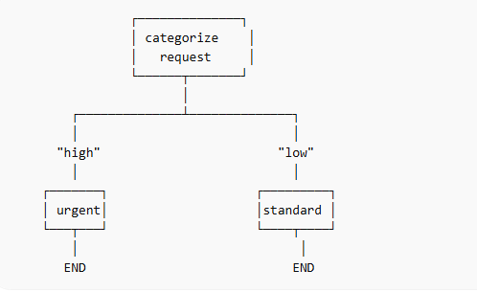
What is Node Match in LangGraph?
Node Match = selecting the next node whose name matches the routing result returned by a function.

✅ What is a Tool?
Tool = a Python function that an AI agent can call to perform real-world actions.
LLMs alone can only generate text.
Tools allow the agent to:
✅ fetch data
✅ call APIs
✅ perform actions
✅ execute business logic

🧠 Simple Definition
A tool is an external capability exposed to the LLM so it can act instead of just talk.
Graph
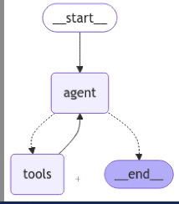
Code
from langgraph.graph import END, START, StateGraph, MessagesState
from langchain_openai import ChatOpenAI
from langchain_core.tools import tool
from langgraph.prebuilt import ToolNode
from langchain_core.messages import HumanMessage
from util.langgraph_util import display
from langgraph.checkpoint.memory import MemorySaver

@tool
def get_restaurant_recommendations(location: str):
"""Provides a single top restaurant recommendation for a given location."""
recommendations = {
"munich": ["Hofbräuhaus", "Augustiner-Keller", "Tantris"],
"new york": ["Le Bernardin", "Eleven Madison Park", "Joe's Pizza"],
"paris": ["Le Meurice", "L'Ambroisie", "Bistrot Paul Bert"],
}
return recommendations.get(location.lower(), ["No recommendations available."])

@tool
def book_table(restaurant: str, time: str):
"""Books a table at a specified restaurant and time."""
return f"Table booked at {restaurant} for {time}."

# Bind the tool to the model
tools = [get_restaurant_recommendations, book_table]
model = ChatOpenAI().bind_tools(tools)
tool_node = ToolNode(tools)

# TODO: Define functions for the workflow
def call_model(state: MessagesState):
messages = state["messages"]
response = model.invoke(messages)
return {"messages": response}

# TODO: Define Conditional Routing
def should_continue(state: MessagesState):
messages = state["messages"]
last_message = messages[-1]
if last_message.tool_calls:
return "tools"
return END

# TODO: Define the workflow

workflow = StateGraph(MessagesState)
workflow.add_node("agent",call_model)
workflow.add_node("tools",tool_node)

workflow.add_edge(START, "agent")
workflow.add_conditional_edges("agent", should_continue)
workflow.add_edge("tools","agent")

checkpointer = MemorySaver()
graph = workflow.compile(checkpointer=checkpointer)

display(graph)
config={"configurable":{"thread_id":"1"}}
# First invoke - Get one restaurant recommendation
response = graph.invoke(
{"messages": [HumanMessage(content="Can you recommend just one top restaurant in Paris? "
"The response should contain just the restaurant name")]},config)

# TODO: Extract the recommended restaurant
recommended_restaurant = response["messages"][-1].content
print(recommended_restaurant)

response = graph.invoke(
{"messages": [HumanMessage(content=f"Book a table at this restaurant")]},
config
)

# TODO: Extract the recommended restaurant
final_response = response["messages"][-1].content
print(final_response)

What is Memory in LangGraph?

Memory in LangGraph means: 👉 Saving the graph state between executions so the agent remembers past interactions, decisions, and results.
Without memory → every invoke() call is a new conversation.
With memory → the graph behaves like a persistent intelligent agent.

✅ Simple Definition
Memory = Persistent State + Conversation History stored using a Checkpointer
LangGraph saves the state object (MessagesState) automatically after each step.

🔥 Why Memory is Needed
LLMs are stateless by default.
Example without memory:
User: Recommend restaurant in Paris
AI: Le Meurice

User: Book a table
AI: ❌ Which restaurant?
Example with LangGraph memory:
User: Recommend restaurant in Paris
AI: Le Meurice

User: Book a table
AI: ✅ Table booked at Le Meurice
👉 The graph remembers previous output.

🧠 Types of Memory in LangGraph

Memory Type | Class | Use Case
In-Memory | MemorySaver() | Testing
Database | PostgresSaver() | Production
Custom | Custom Checkpointer | Enterprise

Code
from typing import TypedDict
from psycopg import connect
from psycopg.rows import dict_row
from langgraph.graph import END, START, StateGraph, MessagesState
from langchain_openai import ChatOpenAI
from langchain_core.tools import tool
from langgraph.prebuilt import ToolNode
from langchain_core.messages import HumanMessage
from langgraph.checkpoint.postgres import PostgresSaver

DB_CONNECTION_STRING = "postgresql://localhost:5432/langgraph_memory"
# Define state format
class ChatState(TypedDict):
messages: list

# Define tool for restaurant recommendations
@tool
def get_restaurant_recommendations(location: str):
"""Provides a single top restaurant recommendation for a given location."""
recommendations = {
"munich": ["Hofbräuhaus", "Augustiner-Keller", "Tantris"],
"new york": ["Le Bernardin", "Eleven Madison Park", "Joe's Pizza"],
"paris": ["Le Meurice", "L'Ambroisie", "Bistrot Paul Bert"],
}
return recommendations.get(location.lower(), ["No recommendations available."])[0] # Return only the top recommendation

# Define tool for table booking
@tool
def book_table(restaurant: str, time: str):
"""Books a table at a specified restaurant and time."""
return f"Table booked at {restaurant} for {time}."

# Bind tools to the model
tools = [get_restaurant_recommendations, book_table]
model = ChatOpenAI().bind_tools(tools)
tool_node = ToolNode(tools)

# Define function to invoke the model
def call_model(state: MessagesState):
messages = state["messages"]
response = model.invoke(messages)
return {"messages": messages + [response]} # Add response to the state

# Define conditional routing logic
def should_continue(state: MessagesState):
messages = state["messages"]
last_message = messages[-1]
if last_message.tool_calls:
return "tools"
return END

# Establish a database connection
with connect(DB_CONNECTION_STRING, autocommit=True, prepare_threshold=0, row_factory=dict_row) as conn:
# TODO: Initialize Postgres-backed memory
checkpointer = PostgresSaver(conn)
checkpointer.setup()

# Create the workflow graph
workflow = StateGraph(MessagesState)

workflow.add_node("agent", call_model)
workflow.add_node("tools", tool_node)

workflow.add_edge(START, "agent")
workflow.add_conditional_edges("agent", should_continue)
workflow.add_edge("tools", "agent")

# TODO: Compile the graph with PostgreSQL-backed memory
graph = workflow.compile(checkpointer=checkpointer)

# Define configuration for memory
config = {"configurable": {"thread_id": "1"}}

# First invoke - Get one restaurant recommendation
response = graph.invoke(
{"messages": [HumanMessage(content="Can you recommend just one top restaurant in Paris? "
"The response should contain just the restaurant name")]},
config
)

# Extract the recommended restaurant from the response
recommended_restaurant = response["messages"][-1].content
print("Recommended restaurant:", recommended_restaurant)

# Second invoke - Book a table at the recommended restaurant
response = graph.invoke(
{"messages": [HumanMessage(content=f"Book a table at this restaurant for 7 PM")]},
config
)

# Extract the final response
final_response = response["messages"][-1].content
print("Final response:", final_response)

✅ What is Command in LangGraph
Command is a special return object used inside a node to:
👉 control graph execution dynamically
Instead of only returning state data, a node can:
- choose next node
- update state
- end execution
from langgraph.types import Command
Node using Command
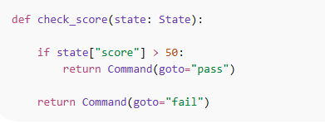

Or
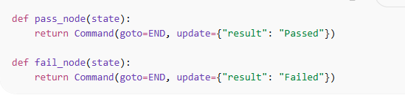

✅ Human-in-the-Loop (HITL) in LangGraph
Human-in-the-Loop (HITL) means:
🤖 Agent pauses execution → asks a human → resumes with human decision
Used when AI should NOT decide automatically.

🧠 Short Definition (Notes Version)
HITL = Pause graph execution using interrupt() and wait for human feedback before continuing.

✅ Why We Need HITL
Used in real production systems:
- Loan approval
- Medical diagnosis validation
- Legal document signing
- Customer escalation
- Payment authorization
AI proposes → Human approves/rejects.
Below is the way to use interrupt
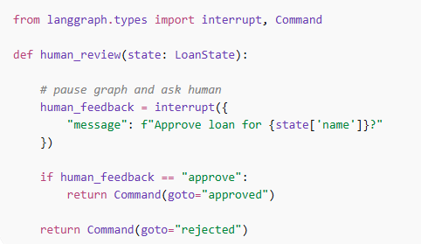

Compile With Memory
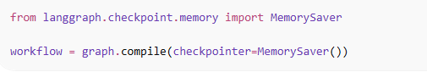

How Interrupt Works
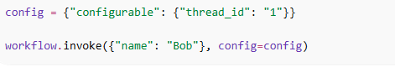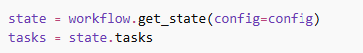
After human provide the input
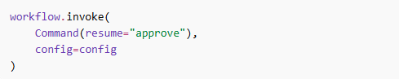

✅ Memory Types in LangGraph
LangGraph memory is divided into two major types:
👉 Short-Term Memory
👉 Long-Term Memory

🧠 1️⃣ Short-Term Memory

✅ Definition (Notes Version)
Short-term memory stores conversation or state only during an active session/thread.
It remembers current workflow context.

🔹 Characteristics
- Exists during one conversation
- Stored per thread_id
- Used for agent reasoning
- Fast access
- Temporary

🔹 Implementation
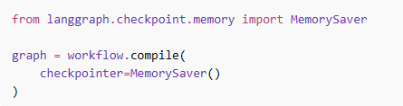
Memory lives in RAM.

🔹 Real Usage
- Chat conversations
- Tool results
- Multi-step reasoning
- Agent loops

🧠 2️⃣ Long-Term Memory

✅ Definition (Notes Version)
Long-term memory persists information across sessions, restarts, and users.
Memory survives even after program shutdown.

🔹 Characteristics
- Persistent storage
- Survives restart
- Cross-session recall
- User history storage

🔹 Implementation
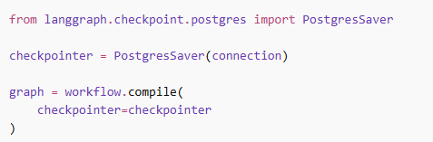
Stored in:
- PostgreSQL
- Redis
- Vector DB
- External storage
⚡ Quick Comparison
