Step 1) Setup the Cloud witness
Crate the share drive and provide the everyone full control on share and security Tab.
- Create share Drive on Server ( I will choose the 4th Server apart from SQL1, SQL2, AD.)
- Create a folder (my suggestion to create Witnessdisk).
- Right-click → Properties → Sharing tab
- Click Advanced Sharing
- Check Share this folder
- Share name: Witnessdisk Everyone: Full Control
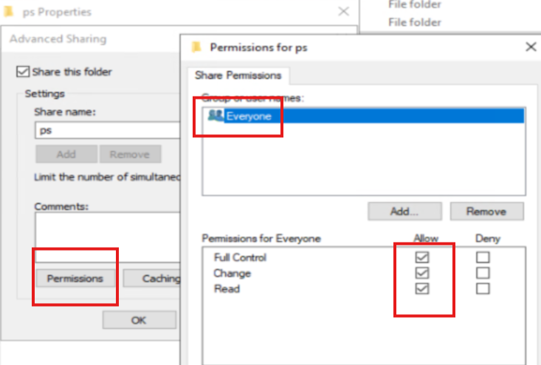
- Security Tab: Add Everyone: Full Control
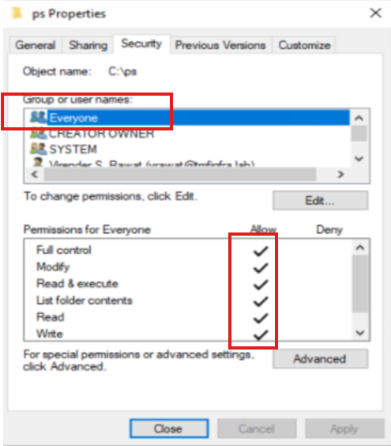

Step 2) Configure File Share Witness
Go to any cluster SQL node:
- Open Failover Cluster Manager
- Right-click Cluster Name
- Click More Actions → Configure Cluster Quorum Settings
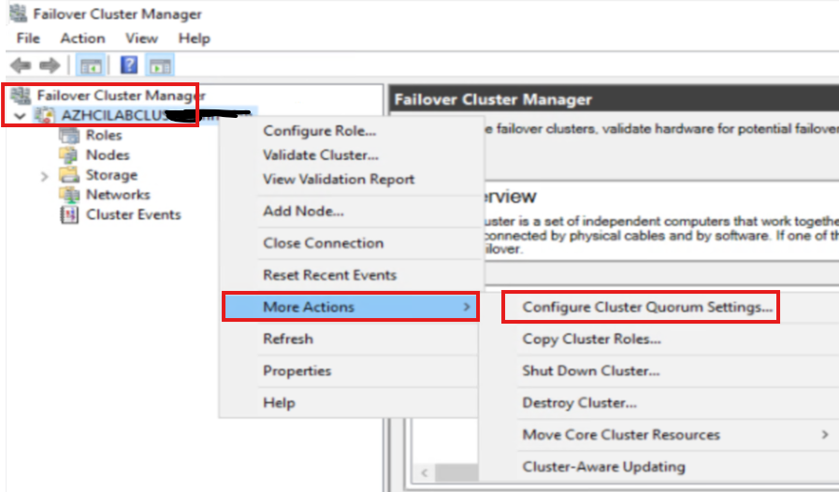
- Choose:
  - ✅ Select the quorum witness
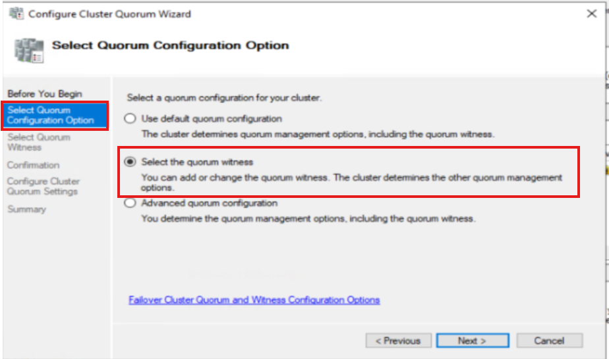
- Select:
  - ✅ Configure a file share witness
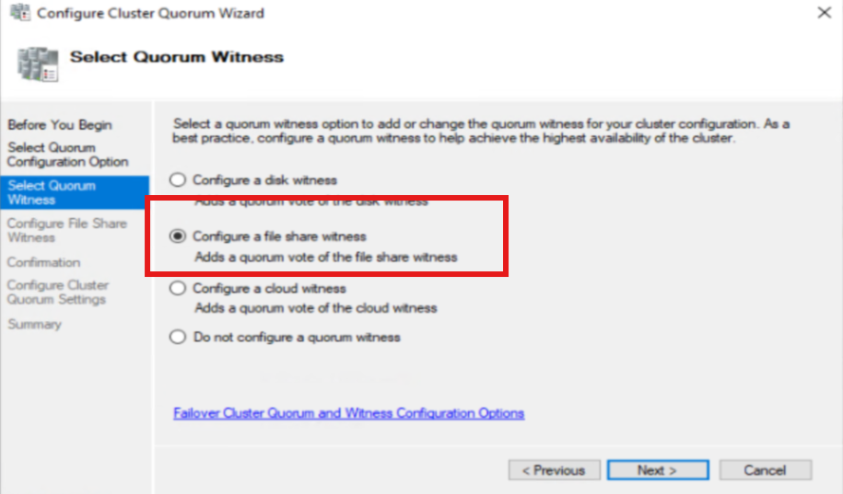
- Enter UNC path: (change path as per your folder)
\\contoso.com\Witnessdisk
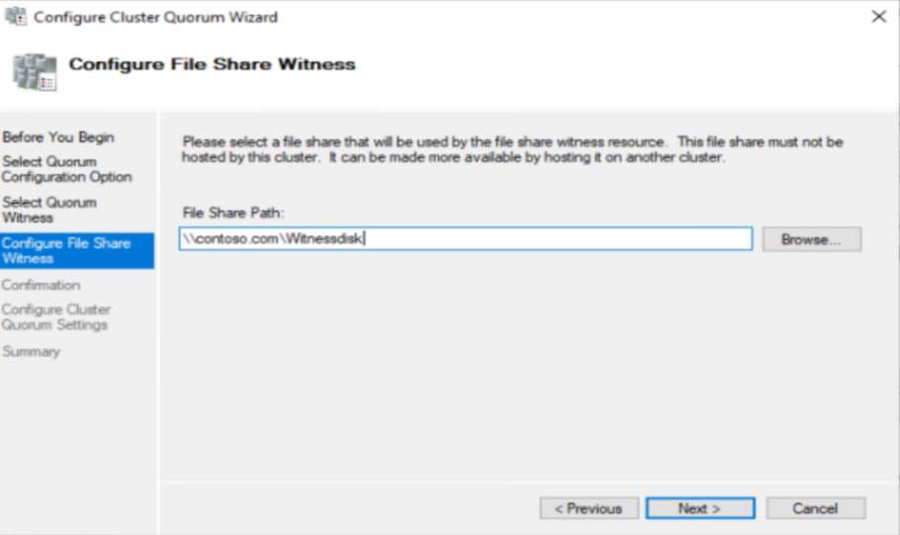
Click next and next Finish.
You can verify the witness information.
