AI ASSISTANT

A PROJECT REPORT
Submitted by
RAJPUT VIRENDRASINH NARPATSINH
221250107042
In partial fulfilment for the award of the degree of

BACHELOR OF ENGINEERING

In
Computer Engineering
SHREE SWAMINARAYAN INSTITUTE OF TECHNOLOGY, BHAT




Gujarat Technological University, Ahmedabad
April, 2026


Shree Swaminarayan Institute of Technology
Gandhinagar - Ahmedabad Rd, Near EDI & Sardar Patel Ring Road Circle

CERTIFICATE
This is to certify that the project report submitted along with the project entitled “AI Assistant” has been carried out by Rajput Virendrasinh Narpatsinh under my guidance in partial fulfillment for the degree of Bachelor of Engineering in Computer Engineering, 8th Semester of Gujarat Technological University, Ahmedabad during the academic year 2025-26.

Dr. Darshan Patel  Internal Guide  Computer Engineering SSIT, Bhat, Gandhinagar | Dr. Darshan Patel Head of Department Computer Engineering  SSIT, Bhat, Gandhinagar

COMPLITION CERTIFICATE
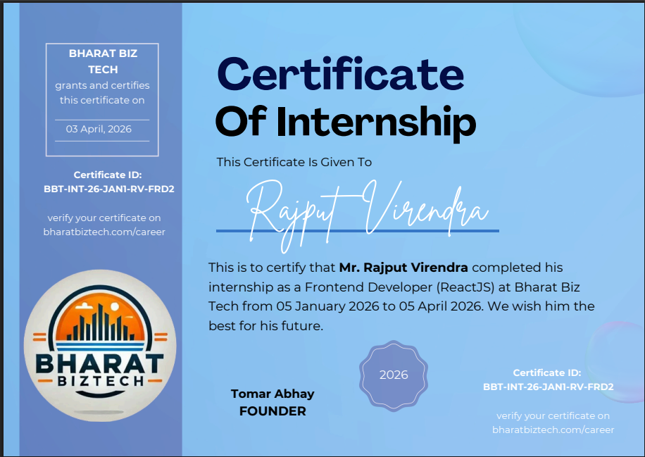



Shree Swaminarayan Institute of Technology
Gandhinagar - Ahmedabad Rd, Near EDI & Sardar Patel Ring Road Circle

DECLARATION
We hereby declare that the Internship report submitted along with the Internship entitled “AI Assistant” submitted in partial fulfilment for the degree of Bachelor of Engineering in Computer Engineering to Gujarat Technological University, Ahmedabad, is a Bonafide record of original project work caried out by me at Bharat Biz Tech under the supervision of Dr. Darshan Patel and that no part of this report has been directly copied from any students reports or taken from any other source, without providing due reference.

Name of the Student Sign of Student
Rajput Virendrasinh Narpatsinh ________

ACKNOWLEDGEMENT

I would like to express my sincere gratitude to several individuals for supporting me throughout my internship project. First, I wish to express my sincere gratitude to my Internal Guide Dr. Darshan Patel for his enthusiasm, patience, insightful comments, helpful information, practical advice and unceasing ideas that have helped me tremendously at all times in my project. Without her support and guidance, this project would not have been possible.
We are grateful to Dr. Darshan Patel HOD of the Computer Engineering for allowing us to take an internship. We are sincerely thankful to him for his time to time and valuable guidance during the training period. We are also thankful to my family members for providing mentally strength during my project preparation.
Thus, in conclusion to the above said, we once again thank the staff members of Bharat Biz Tech team for their valuable support in completion of the project.

ABSTRACT

AI Assistant is an advanced College AI Chatbot engineered specifically for Shree Swaminarayan Institute of Technology (SSIT) to modernize institutional data accessibility. The project addresses the limitations of traditional manual college information systems—typically characterized by fragmented data in spreadsheets and offline forms—by centralizing knowledge into an AI-driven automation framework.
The architecture is founded upon three critical technical pillars: Retrieval-Augmented Generation (RAG) for localized institutional data, an interactive 3D talking avatar for user engagement, and the integration of the Groq API for general query processing.The RAG engine represents the core intellectual property of the system, utilizing Xenova Transformers for local embedding generation and FAISS for vector similarity search.
This ensures that the chatbot provides accurate, context-aware responses based on SSIT’s specific documentation, such as academic calendars and fee structures. To enhance the user experience, a 3D avatar (Ready Player Me) is integrated via the TalkingHead library, synchronizing facial movements with Google Cloud Text-to-Speech (TTS) outputs.
The application is built using modern technologies such as React.js for the frontend and Node.js with Express.js for the backend, along with MongoDB for database management. Mongoose is used to handle database operations.
This report details the full-stack development, the technical hurdles associated with Python subprocess overhead for vector management, and the future roadmap for mobile expansion and security hardening. By bridging the gap between academic learning and automated AI services, AI Assitant provides a robust blueprint for the next generation of educational assistants.

 | LIST OF FIGURES
Figure  Number | Description | Page Number
Fig. 1.1.1 | Company Logo |  | 01
Fig. 1.3.1 | Organization Chart |  | 02
Fig. 2.3.1 | Sequence of Operation |  | 05
Fig. 3.7.2 | Gantt Chart |  | 10
Fig. 4.5.1 | PDF Question Answering Flow |  | 13
Fig. 4.7.1 | Main Modules of Proposed System |  | 14
Fig. 5.1.1 | System Design |  | 15
Fig. 5.2.1 | Class Diagram |  | 16
Fig. 5.3.1 | Use case Diagram |  | 17
Fig. 5.3.2 | Sequence Diagram |  | 18
Fig. 5.3.3 | Activity Diagram |  | 19
Fig. 6.3.1 | Home Page |  | 24
Fig. 6.3.2 | Chat Interface |  | 24
Fig. 6.3.3 | PDF Upload page |  | 25
Fig. 6.3.4 | PDF Question Answering Page |  | 25

 | LIST OF TABLES
Table Number | Description | Page Number
Table 3.7.1 | Internship Schedule | 09
Table 4.7.1 | New System Module | 13
Table 7.2.1 | Test Result | 29

LIST OF ABBREVIATIONS

- SEO - Search Engine Optimization
- MUI – Material UI
- API - Application Programming Interface
- FAISS – Facebook AI Similarity Search
- LLM – Large Language Model
- NLP – Natural Language Processing
- RAG – Retrieval Augmented Generation
- CRUD - Create Read Update Delete
- TTS – Text to Speech
- UI - User Interface
- UX - User Experience
- JWT - JSON Web Token
- REST – Representational State Transfer
- QA - Quality Assurance
- JSON - JavaScript Object Notation
- CSS – Cascading Style Sheets
- HTML - Hypertext Markup Language

TABLE OF CONTENTS
Acknowledgement i
Abstract ii
List of Figures iii
List of Tables iv
List of Abbreviations v
Tables of Contents vii

Chapter 1 Overview of Company 1
1.1 Company Profile 1
1.2 About Us 1
1.3 Organization Chart 2
1.4 Capacity 2
Chapter 2 Department Overview 3
2.1 Work being carried out in each department 3
2.2 List of technical specification of major equipment 4
2.3 Sequence of Operations 5
Chapter 3 Introduction to Project/Internship 6
3.1 Internship/Project Summary 6
3.2 Purpose 6
3.3 Objective 6
3.4 Scope 7
3.5 Technology and Literature Review 7
3.6 Internship Planning 8
3.6.1 Internship Development Approach and Justification 8
3.6.2 Effort and Time, Cost Estimation 8
3.6.3 Roles and Responsibilities 8
3.6.4 Group Dpendencies 9
3.7 Internship Scheduling 9
Chapter 4 System Analysis 11
4.1 Study of Current System 11
4.2 Problem and weakness of current system 11
4.3 Requirement Analysis of new system 11
4.4 System Feasibility 12
4.4.1 Contribution to Organization Objectives 12
4.4.2 Technology, Cost and Schedule Constraints 12
4.4.3 Integration with Existing Systems 12

4.5 Process in new System/Proposed System 12
4.6 Features of new System/proposed system 13
4.7 Main module of new system/proposed system 13

Chapter 5 System Design 15
5.1 System design & Methodology 14
5.2 Class Diagram 15
5.3 Behavioral Modelling 16
5.3.1 Usecase Diagram 16
5.3.2 Sequence Diagram 17
5.3.2Activity Diagram 18

Chapter 6 Implementation and Tools during Internship 20
6.1 Implementation Platform/environment 20
6.2 Process / Program / Technology / Module Specifications 21
6.3 Result 23
6.4 Result Analysis 36

Chapter 7 Testing 27
7.1 Testing plan/ strategy 27
7.2 Test result and analysis 28

Chapter 8 Conclusion and discussion 31
8.1 Overall analysis of internship 31
8.2 Dates of continuous evaluation 31
8.3 Problem Encountered and Solution Adopted 32
8.4 Summary of internship 32
8.5 Future enhancement 33
References 34

CHAPTER - 1: OVERVIEW OF COMPANY

1.1 COMPANY PROFILE

Company Name: Bharat Biz Tech
Address: Navlakha Bunglow, Bapunagar, Ahmedabad – 380024
contact No.: +91 7984075054

Fig. 1.1.1 Company Logo
BharatBiz Tech is an IT-based organization that offers services in web development and advanced digital solutions. The company is committed to building high-quality, efficient, and user-friendly applications by using modern technologies. It provides a professional working environment where individuals can gain practical knowledge and real-world industry experience.

1.2 ABOUT US

BharatBiz Tech, located in Ahmedabad, is a technology-driven company that provides services such as web and application development, digital marketing, branding, company incorporation, startup support, and business consulting. The company helps businesses establish their digital presence and grow in the modern market.
The organization promotes innovation, teamwork, and skill development by providing practical exposure to real-world projects. It helps individuals and businesses adapt to modern technologies and industry standards while supporting long-term growth and development.

1.3 ORGANIZATION CHART

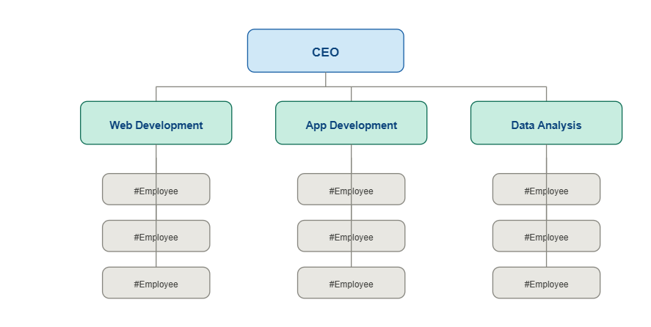
Fig. 1.3.1 Organization Chart

1.4 CAPACITY
BharatBiz Tech is a technology-oriented company that specializes in web development, application development, digital solutions, and business support services. The organization maintains a professional and cooperative work culture where innovation, teamwork, and organized workflows are highly valued. By utilizing modern technologies and working on real-world business projects, BharatBiz Tech ensures quality standards and encourages continuous learning and professional growth.

CHAPTER- 2: DEPARTMENT OVERVIEW

At BharatBiz Tech, the software development process is carried out using a structured and industry-oriented approach. The organization follows a modular system design where frontend, backend, and database layers are clearly separated. This approach helps in improving scalability, easier maintenance, and better performance of applications.
The frontend team focuses on developing interactive and responsive user interfaces to enhance user experience. The backend team is responsible for handling server-side operations, API development, and implementing authentication mechanisms. Database management is handled carefully to ensure proper data storage, security, and fast retrieval. Testing and debugging are also important parts of the workflow to maintain application quality. All teams work together using version control systems and organized workflows to deliver reliable and efficient software solutions.

2.1 WORK BEING CARRIED OUT IN EACH DEPARTMENT
The development work is carried out through multiple specialized departments, each handling a specific part of the software development process. These departments work collaboratively to ensure efficient development, quality output, and timely delivery of projects.
- Web Development:
Focuses on building web applications, including frontend interfaces and backend functionality to ensure smooth system performance.
- Mobile App Development:
Responsible for developing mobile applications for Android and iOS platforms with optimized performance and user experience

- UI/UX Design:
Designs user interfaces and improves user experience through wireframes, layouts, and visual design principles.
- iOS Development:
Handles development of applications specifically for Apple devices, ensuring compatibility and performance.
- Quality Assurance (QA):
Performs testing, debugging, and validation to ensure the application is reliable and errorfree.
- Sales Department:
Manages client interactions, project acquisition, and business growth activities..

2.2 LIST OF TECHNICAL SPECIFICATION OF MAJOR EQUIPMENT
The development of this project was carried out using a personal computer with the following configurations:
- Operating System: Windows 10/11
- Processor: Intel i5 or higher ( or equivalent)
- RAM: 16 GB or higher
- Code Editor: Visual Studio Code, Android Studio (for mobile development)
- Browser: Google Chrome,Firefox (for testing and debugging)
- Backend Environment: Node.js with Express,Flutter,etc
- Database Tool: MySQL
- Testing Tools: Postman for API validation, or project specific tools
- UI/UX Design: Figma (for initial layout planning)
- Version Control: Git and GitHub (for code management and version tracking)
- Others: npm for package management, and useful extensions for development.

2.3 Sequence Of Operation which are performed

- Requirement Gathering:
Understanding the basic requirements of a food delivery system such as restaurant listing, menu display, order placement, and user management.
- Planning:
Dividing the project into different parts like user interface, backend logic, and database handling, along with setting a simple development flow.
- Design:
Designing the layout of the application and structuring how users will interact with the system for smooth navigation and usability.
- Development:
Building the frontend and backend of the application, connecting them through APIs, and implementing core functionalities.
- Testing:
Testing the application at different stages to check functionality, fix errors, and improve performance.

- Deployment & Optimization:
The project was run locally, with scope for future improvements and deployment..
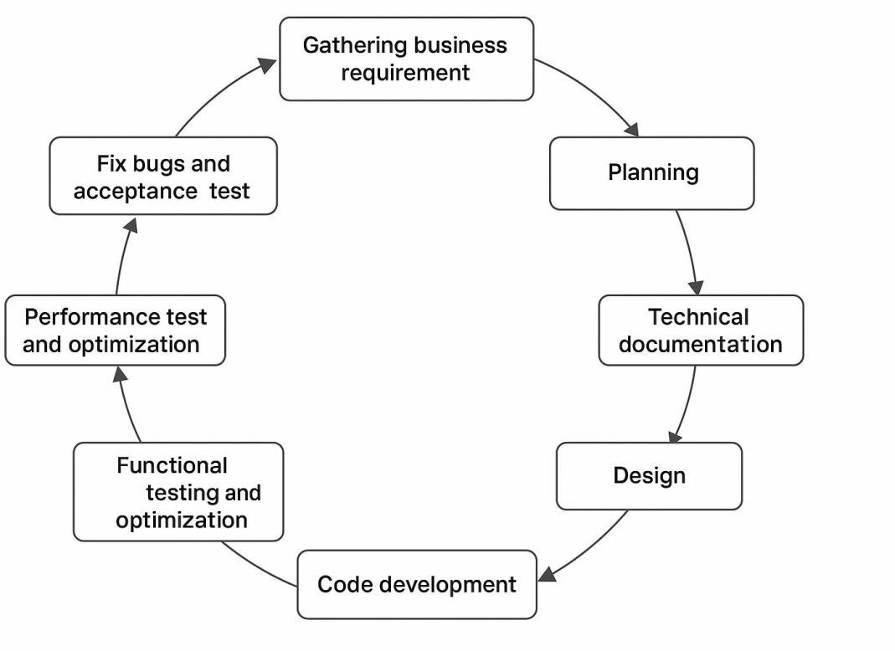
Fig 2.3.1 Sequence of Operation

CHAPTER- 3: INTRODUCTION TO INTERNSHIP/PROJECT

3.1 INTERNSHIP/PROJECT SUMMARY
The AI Assistant is an interactive assistant designed to provide SSIT students with instant access to institutional knowledge. Its purpose is to automate information retrieval through voice and text, reducing administrative overhead and enhancing the student experience through AI engagement.
During my internship, I worked as a React Developer and was mainly responsible for frontend development. I worked on designing user interfaces, creating reusable components, implementing routing and protected routes, and integrating frontend with backend APIs. This project helped me understand real-world web application development and frontend architecture using React.js.

3.2 PURPOSE

The purpose of the project is to provide a college oriented AI assistant that reduces manual searching, supports natural interaction and improves access to information through both general chat and document specific question answering.

3.3 OBJECTIVE

- Deploy a personalized RAG-based assistant for Colleges.
- Implement real-time 3D avatar lip-sync for synthesized speech.
- To integrate frontend with backend APIs
- Allow document upload and PDF specific question answering
- Ensure smooth and reliable interaction between frontend and backend systems
- Develop a dual-mode query engine for domain and general queries.

3.4 SCOPE

What it can do:
- includes frontend chat interaction
- backend APIs, retrieval augmented responses working
- Provide voice interaction
- Multiple chat history management
What it doesn’t currently support:
- No user Authentication
- No cloud deployment (runs locally)
- Can not provide multilingual support
- Not support broader institutional integration

3.5 TECHNOLOGY AND LITERATURE REVIEW

Technologies Used:
- Frontend: React.js
- Backend: Nodejs+ Expressjs
- Programming Language: JavaScript
- Design: Bootstrap and Material UI
- Database: MongoDB
- API-keys: Groq and Web Speech API
- IDE: Visual Studio Code
- Testing: Postman (for API), browser dev tools
- Version Control: Git and GitHub

Literature & Resources:
- Official documentation of React.js, Node.js and Express.js
- MongoDB documentation
- Retrieval augmented generation and avatar based user interaction documentation
- GitHub repositories and Stack Overflow for debugging
- JavaScript(ES6+) documentation and online tutorials

3.6 INTERNSHIP PLANNING

3.6.1 Development Approach and Justification
An incremental development approach was followed so that the chat interface, backend logic, retrieval system, PDF processing and avatar interactions could be validated step by step. This reduced integration risk and allowed issues to be isolated early
3.6.2 Effort and Time, Cost Estimation
The total project duration was three months (05/01/2026 to 05/04/2026).
Time was distributed as follows:
- Training and Learning – 4 weeks
- UI Design and Frontend Development – 4 weeks
- API Integration and State Management – 1 weeks
- Testing and Debugging – 2 weeks
- Documentation and Report Preparation – 1 week
No major cost was involved as the entire project was developed using open-source tools on a personal device.
3.6.3 Roles and Responsibilities
- Developer: Rajput Virendrasinh (221250107042)
o Planning and designing the architecture
o Implementing the frontend workflows
o Creating backend APIs with Node.js/Express
o Creating React components
o Modeling the MongoDB database
o Routing and protected routes
o API integration
o Testing, debugging, and running the project locally
o Preparing documentation and reports

- Guide: Dr. Darshan Patel
o Provided guidance and support throughout the project o Helped in improving ideas and project direction
o Reviewed progress and overall performance

3.6.4 Group Dependencies
This project was mainly developed as an individual frontend development work during the internship. However, backend APIs and database were part of the overall system, and coordination with backend structure and API responses was necessary for proper frontend integration. Guidance from mentors and help from online resources also played an important role during development and problem-solving.

3.7 INTERNSHIP SCHEDULING
Table 3.7.1 Internship Schedule
Sr. No. | Activity | Duration | Timeframe
1 | Training & Learning (React, APIs, Workflow) | 25 days | 05 – 30 Jan
2 | Requirement Understanding | 3 days | 31 Jan– 02 Feb
3 | UI Design & Planning | 5 days | 03 – 07 Feb
4 | Frontend & Backend Development | 30 days | 08 Feb – 09 Mar
5 | API Integration & State Management | 9 days | 10 – 18 Mar
6 | Testing & Debugging | 9 days | 19 – 27 Mar
7 | Documentation & Final Review | 3 days | 28 – 30 Mar
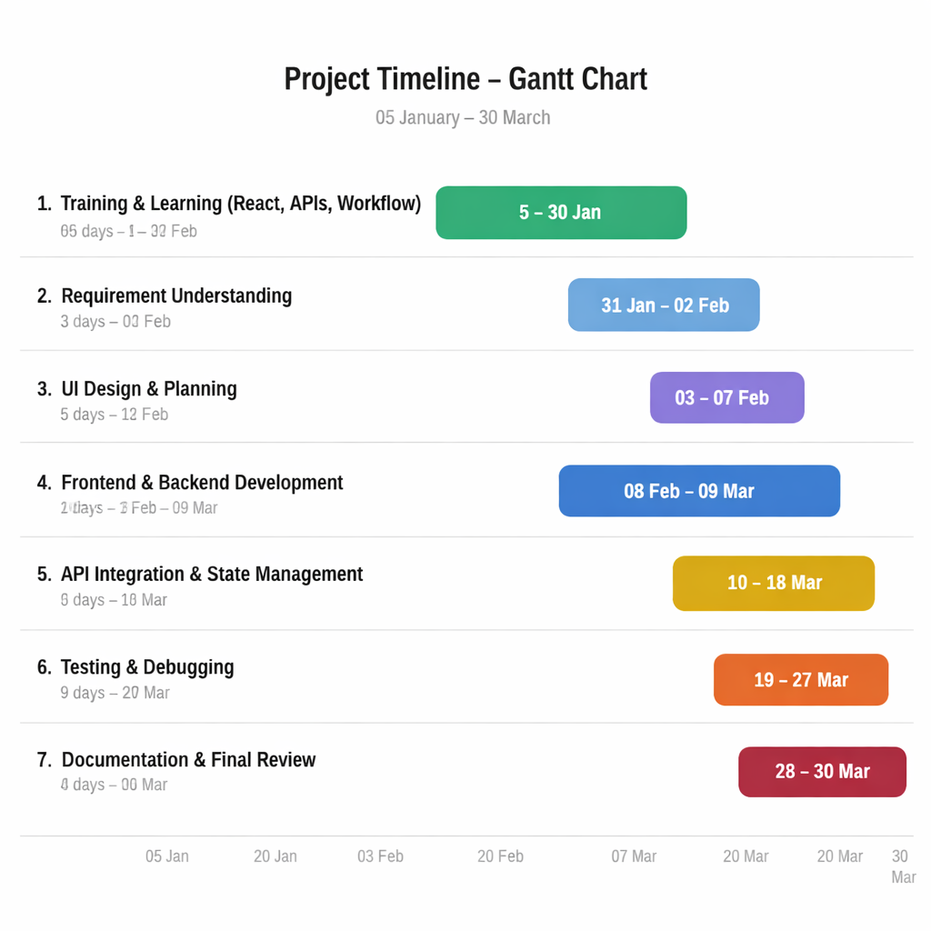
Fig. 3.7.2 Gantt Chart

CHAPTER– 4: SYSTEM ANALYSIS

4.1 STUDY OF CURRENT SYSTEM
Traditional support systems typically rely on static pages, manual browsing or human guidance. They do not provide dynamic conversational answers, contextual PDF understanding or a richer multimodal interaction model.
Present college systems rely on manual data handling. For example, student queries regarding fee schedules or exam dates often require physically checking notice boards or spreadsheets, leading to data redundancy and lack of transparency.

4.2 PROBLEM AND WEAKNESSES OF CURRENT SYSTEM
- Users spend time navigating multiple sources for answers
- Static pages cannot answer natural language questions effectively
- Large PDF files are difficult to search manually
- User engagement remains low without voice or avatar interaction

4.3 REQUIREMENT ANALYSIS OF NEW SYSTEM

The proposed system must:
- Provide secure login for Users
- Allow Users to manage data
- Keyword-based query classification.
- High-accuracy retrieval from College-specific PDF documents.
- Scalability for multi-institutional data sets.
- Provide responsive and user-friendly interface
- Ensure proper data management and validation
- Integrate frontend with backend APIs

4.4 SYSTEM FEASIBILITY

4.4.1 CONTRIBUTION TO ORGANIZATIONAL OBJECTIVES
The proposed AI Assistant helps in digital data management and reduces manual work. It improves data accuracy, Users communication with AI assistant. The system provides a centralized platform for managing conversation operations efficiently.

4.4.2 TECHNOLOGY, COST & SCHEDULE CONSTRAINTS
The system is developed using React.js and other web technologies. The development was done using open-source tools like Visual Studio Code, making the project cost-effective. The system is scalable and can be improved in the future, and the project was completed within the internship duration.

4.4.3 INTEGRATION WITH EXISTING SYSTEMS
The system is built using modular architecture and API integration, which allows future integration with other systems such as payment systems, notification services, or mobile applications without affecting existing functionality.

4.5 PROCESS IN NEW SYSTEM/PROPOSED SYSTEM
- Secure login for users
- Application accepts a PDF
- Converts it into serchable chunks
- Stores vector data and then retrieves the most relevant context when the user asks a question
- This process supports precise and faster document level answers.
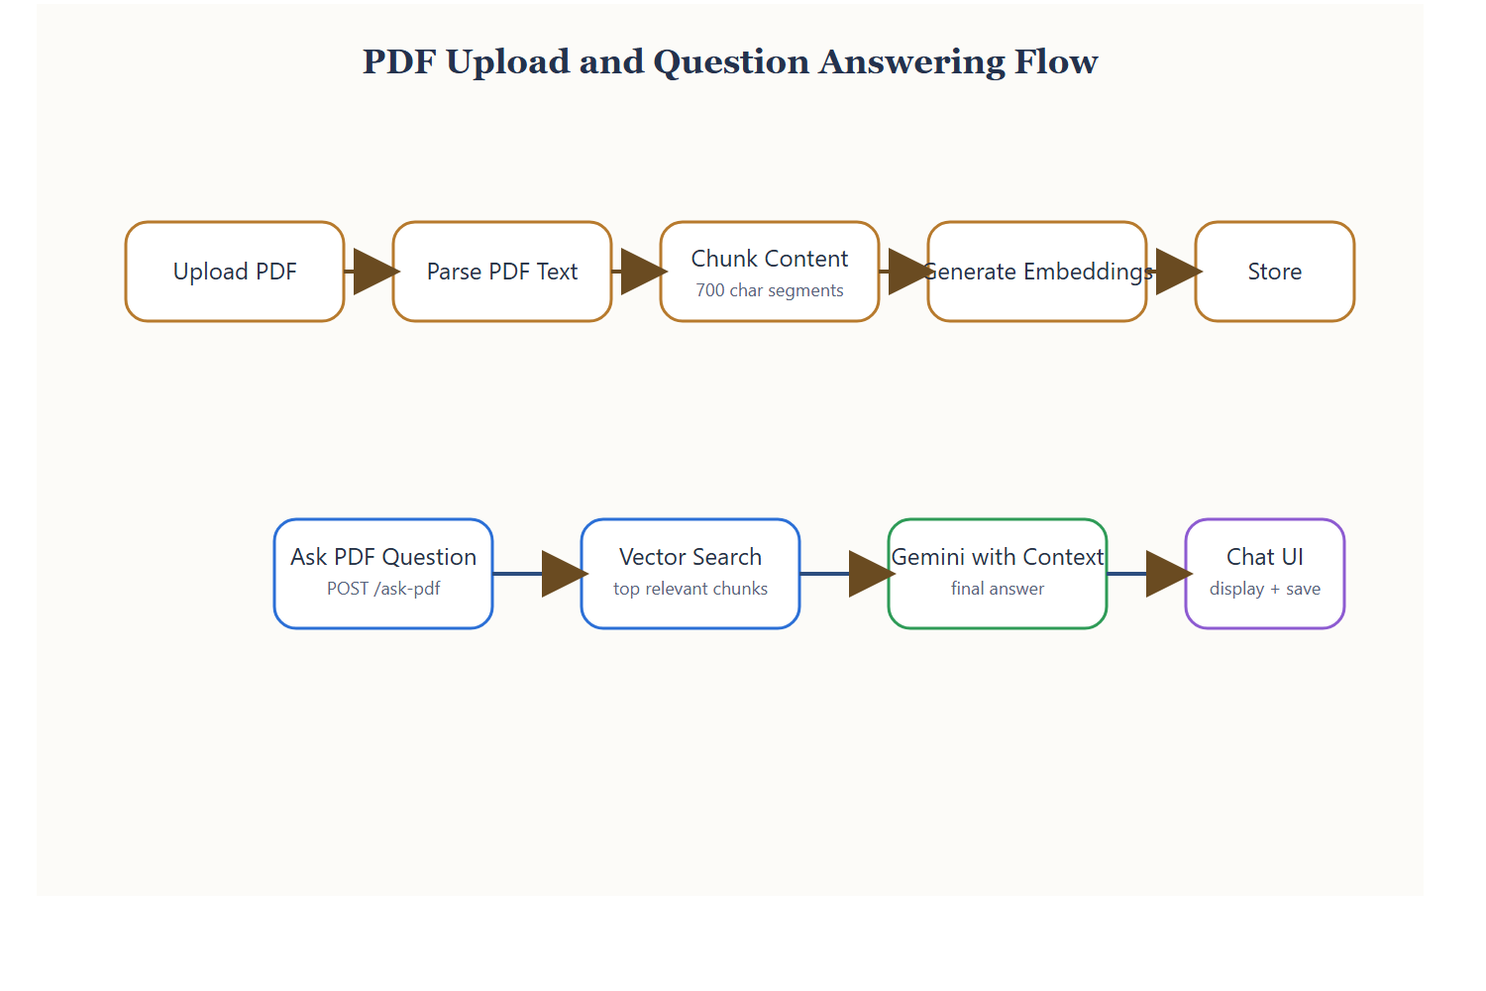
Fig. 4.5.1 PDF Question Answering Flow

4.6 FEATURES OF NEW SYSTEM/ PROPOSED SYSTEM
- Secure user authentication and login system
- General and college specific question answering
- PDF upload and semantic search
- Voice input and speech output
- 3D avatar based response presentation
- Chat history and modular backend design

4.7 MAIN MODULES OF NEW SYSTEM/ PROPOSED SYSTEM

Module Name | Description
Chat Interface | Collect questions and displays responses
Sidebar History | Provides saved and recent chats
PDF Upload Engine | Parses and stores PDF related data
Retrieval Layer | Finds relevant context using embeddings and FAISS
AI Generation Layer | Creates final responses with Groq
Voice and Avatar | Supports speech input and talking output

4.7.1 New/Proposed System Module

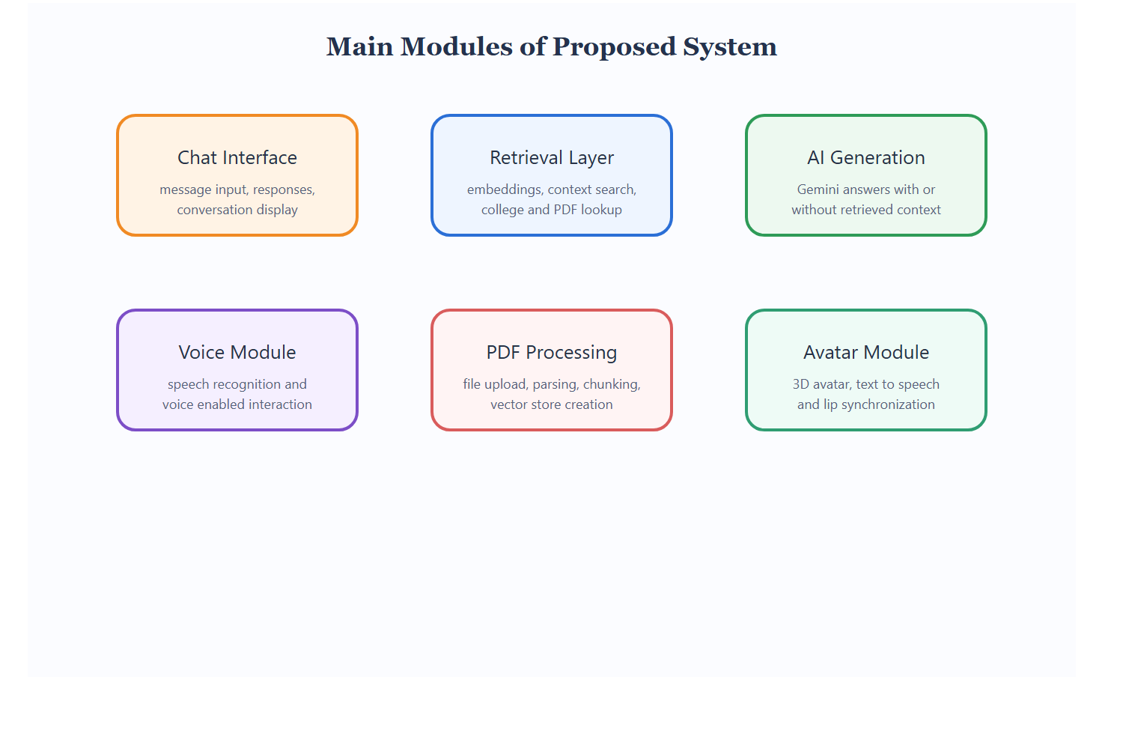

Fig. 4.7.1 Main Modules of Proposed System

CHAPTER- 5: SYSTEM DESIGN

5.1 SYSTEM DESIGN & METHODOLOGY

The system uses a layered architecture where the React interface manages user experience, the Express backend coordinates requests, the retrieval layer provides context and external services complete language generation and speech synthesis. The design allows each concern to evolve independently while preserving clean integration points.

The design follows three-tier architecture:
- Client Layer (Frontend): Built using React.js to provide a dynamic and interactive user interface.
- Server Layer (Backend): Developed using Node.js and Express.js to handle application logic and API communication.
- External Services: Multiple plateform which provide api keys to connect to their models.

The system includes separate functionalities for users and administrators with controlled access. Reusable components and structured modules are used to maintain code quality, scalability, and ease of future enhancements.

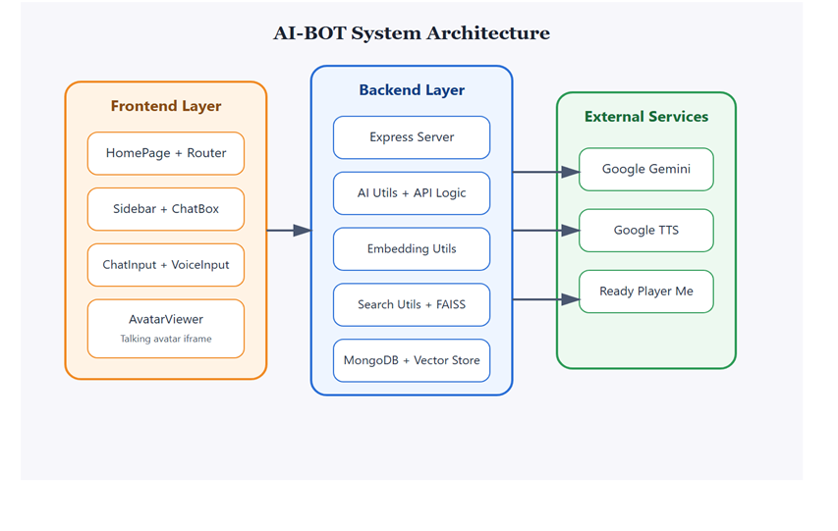
5.1.1 System Architecture of AI Assistant

5.2 Class Diagram

The system includes well-defined input and output interfaces:
- HomePage is the main controller class of the frontend.
- Sidebar handles chat history navigation. And displays recent conversations.
- ChatBox is responsible for rendering conversation messages.
It stores the visible messages, shows loading feedback
- ChatInput manages user input operations.
- PDFChat stores PDF-related conversation records.
- EmbeddingUtils handles semantic representation logic.
It provides generateEmbedding() and isCollegeQuery().
- AIUtils is the answer generation service. It takes the user query and optional retrieved context.

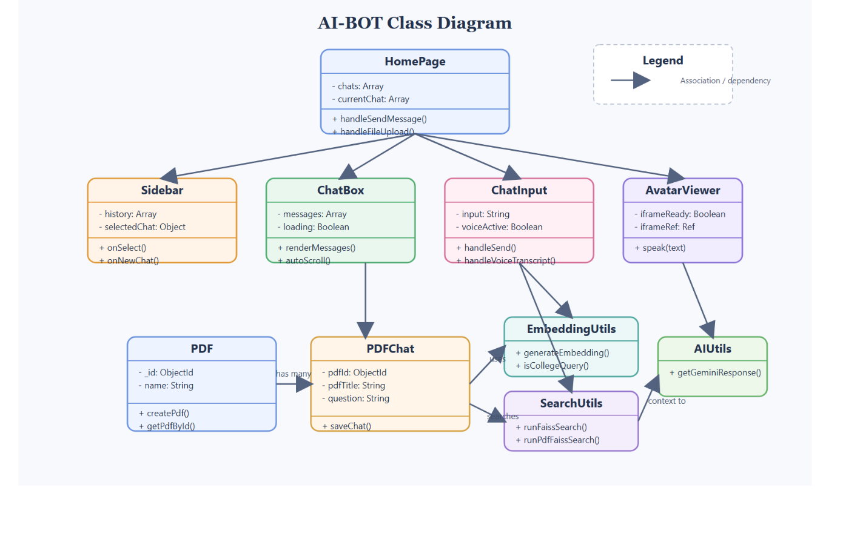

5.2.1 Class Diagram

5.3 Behavioral Modelling

5.3.1 UseCase Diagram

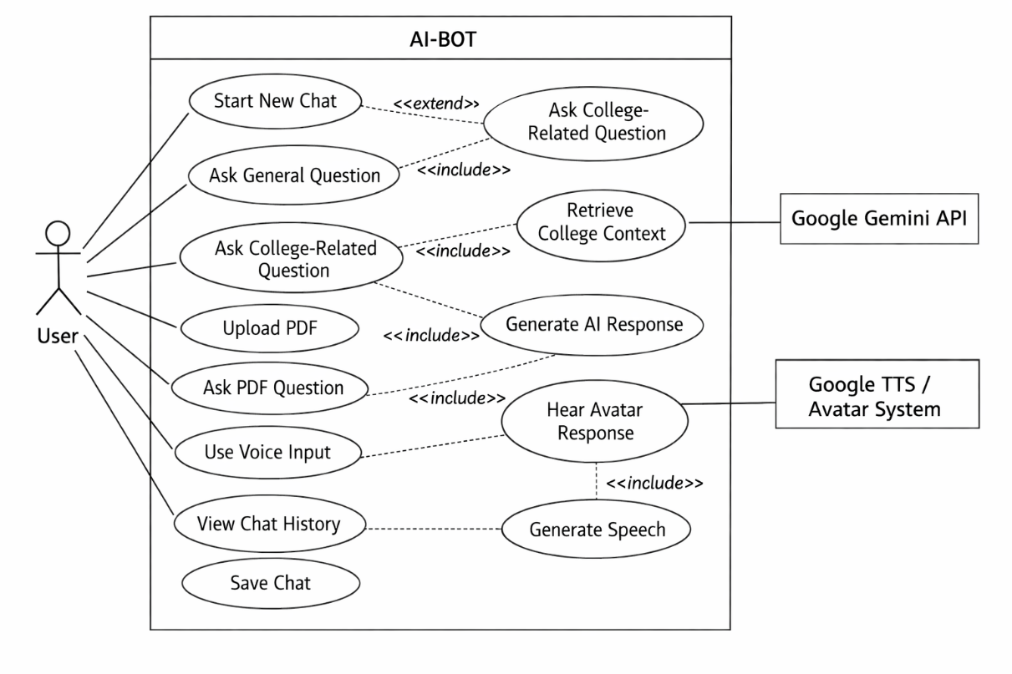

5.3.1 Usecase Diagram

The Use Case Diagram provides a high-level overview of the activities that each actor can perform within the AI Assistant boundary. The system includes one main actor: User

There are other supporting external systems like Google Groq API and Google Text-to-Speech After that their Main use cases inside the system boundaries like Start New chat, Ask Generatl Question , Ask College-Related Question , Upload PDF , Use Voice Input, View Chat History and many more. The User is connected ot all primary use cases.
Ask College-Ralated Question includes Retrieve Colledge Context. Ask PDF Question includes Retrieve PDF Context. Use Voice Input extends Ask General Question and Ask PDF Question because voice is just another input method.
.

5.3.2 Sequence Diagram

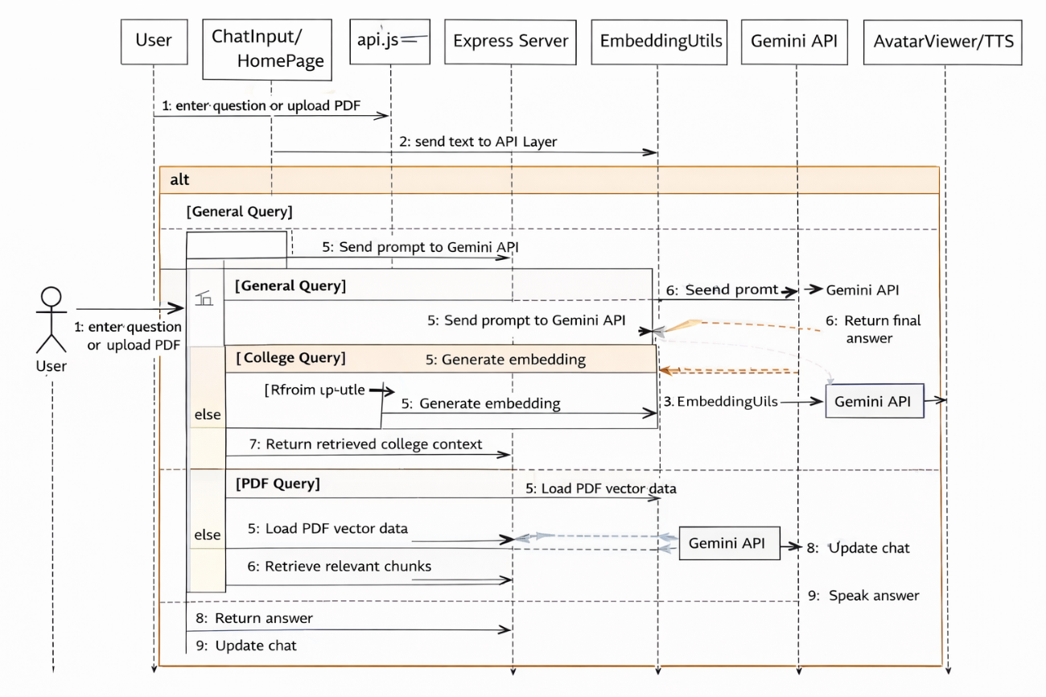

5.3.2 Sequence Diagram

The Sequence Diagram shows the flow of actions in the system from login to data operations. When a user logs in, the request is sent from the React frontend to the authentication API for verification.After successful login, the dashboard data is fetched through APIs. When users perform actions like adding uploading pdfs or User types a question or uses voice input. ChatInput sends the text to HomePage. HomePage calls API layer.API layer sends request to Express backend /ask.Express backend checks query type.If query is college-related: SearchUtils performs FAISS search on college data. Express backend sends prompt and optional context to Groq API. Groq API returns final answer. Backend sends answer to API layer. API layer returns answer to HomePage. HomePage updates chat. AvatarViewer / TTS speaks the answer.
Additional PDF sequence:
- User uploads PDF.
- Frontend calls upload API
5.3.3 Activity Diagram

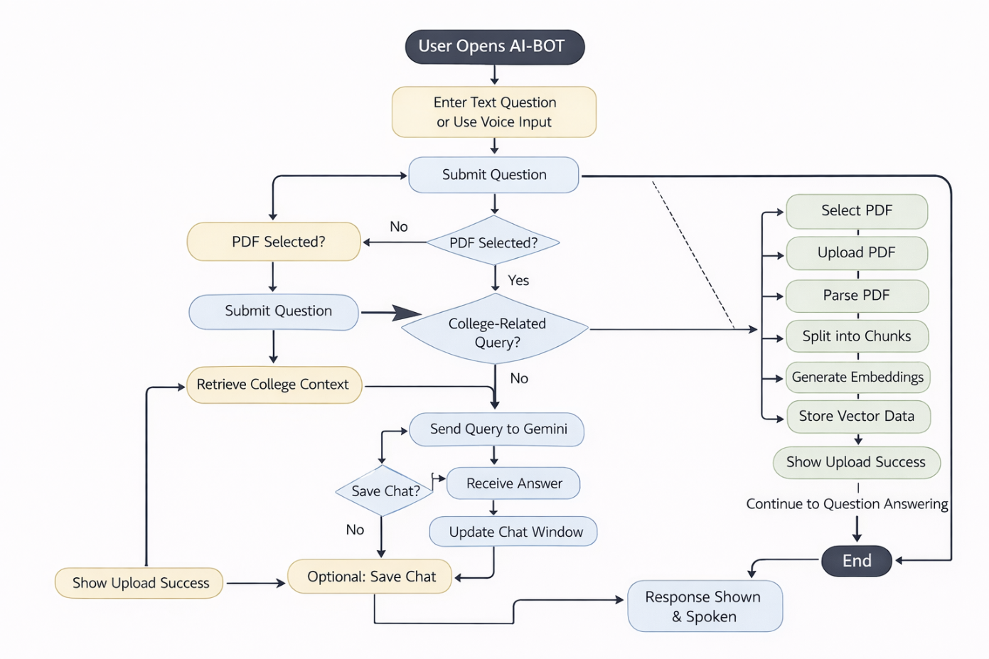

5.3.3 Activity Diagram

The activity diagram of AI Assistant shows the complete flow of how a user interacts with the system from start to finish. It begins when the user opens the chatbot and enters a question, either by typing or using voice input, where speech is first converted into text. Once the question is submitted, the system checks whether a PDF is selected; if yes, it processes the query using stored PDF data. If not, it determines whether the question is college-related, retrieving relevant context when needed, otherwise treating it as a general query. The processed query is then sent to the AI model to generate a response. After receiving the answer, the system updates the chat interface and also converts the response into speech using an avatar. The user is then given the option to save the chat or continue the conversation. Additionally, a separate flow handles PDF uploads, where the document is parsed, split into chunks, converted into embeddings, and stored for future queries.

CHAPTER- 6: IMPLEMENTATION AND TOOLS USED DURING INTERNSHIP

6.1 IMPLEMENTATION PLATFORM / ENVIRONMENT

The AI-BOT project was implemented in a local development environment using modern web technologies and AI integration tools. Below is the breakdown of the development environment:
- Operating System: Windows 11 (64-bit)
- Frontend Framework: React.js 19 with Vite 6
- Styling: Tailwind CSS 4
- Routing: React Router DOM 7
- Backend Runtime: Node.js with Express.js
- Database: MongoDB with Mongoose
- AI Integration: Groq API
- Vector Search: Python FAISS scripts
- File Upload Handling: Multer
- PDF Processing: pdfjs-dist
- Text-to-Speech: Google Text-to-Speech API
- Voice Input: Web Speech API
- 3D Avatar: TalkingHead library with Ready Player Me avatar model
- Code Editor: Visual Studio Code
- Tools Used: Postman, Git, GitHub
- Browser: Google Chrome / Microsoft Edge
The application was developed using a modular architecture in which the frontend, backend, retrieval utilities, and avatar-related functions were separated into different components and folders. This improved maintainability, readability, and testing of the system.

6.2 Process / Program / Technology / Module Specifications

The AI-BOT project was divided into logical modules based on the major functionalities of the system such as chatbot interaction, PDF processing, retrieval-based answering, speech handling, and avatar-based response generation. Below is the breakdown of the key modules.
Frontend Modules:
- HomePage Module:
Handles the complete chatbot workflow, including sending questions, uploading PDF files, viewing chat responses, and connecting with the avatar.
- Sidebar Module:
Displays recent chats and saved chat history. It also allows the user to start a new conversation and reopen previous sessions.
- ChatBox Module:
Responsible for displaying user questions and AI-generated answers in a structured conversational format.
- ChatInput Module:
Accepts typed input from the user, triggers send functionality, supports file upload, and connects with voice input.
- VoiceInput Module:
Uses the Web Speech API to capture speech from the user and convert it into text before sending it as a chatbot query.
- AvatarViewer Module:
Loads the 3D avatar interface in an iframe and enables the avatar to speak responses generated by the system.
Backend Modules:
- Server Module (server.js):
Main backend controller that handles all API routes related to asking questions, uploading PDFs, saving chats, and fetching chat history.
- AI Utility Module (aiUtils.js):
Sends prompts and context to the Groq API and receives the final response generated by the AI model.
- Embedding Utility Module (embeddingUtils.js):
Generates embeddings for user queries and document chunks, and also helps determine whether a query is college-related.
- Search Utility Module (searchUtils.js):
Performs semantic search using FAISS over stored embeddings to retrieve relevant college or PDF context.
- Database Module (db.js):
Manages MongoDB connection and ensures database communication for storing and retrieving chat and PDF records.
PDF Processing Modules:
- PDF Upload Module:
Accepts PDF files from the frontend using Multer and stores them in the backend uploads folder.
- PDF Parsing Module:
Extracts text from uploaded PDF files using pdfjs-dist.
- Chunking and Vector Storage Module:
Splits the extracted PDF text into chunks and stores the corresponding embeddings in vector JSON files for later retrieval.
- PDF Question Answering Module:
Searches the stored PDF vectors and generates a context-aware answer based on the retrieved chunks.
Speech and Avatar Modules:
- Google TTS Integration:
Converts generated text answers into speech output.
- Avatar Speech Module:
Sends the generated speech request to the avatar so that the answer is presented in an interactive talking format.
- Fallback Voice Output:
If avatar communication fails, direct TTS playback is used to ensure the answer can still be heard.
Backend API Modules (Used for API Integration):
Since the project follows a frontend-backend integrated architecture, backend APIs are used for all chatbot and document-related operations.
- POST /ask - Handles general and college-related questions
- POST /upload-pdf - Uploads a PDF file to the server
- POST /ask-pdf - Handles document-based question answering
- POST /save-chat - Saves chat data into the database
- GET /all-chats - Fetches all grouped chat history
- GET /chat-history/:pdfId - Fetches conversation history for a selected PDF
Database Collections:
The database contains collections to store uploaded files and conversation data. Main collections used in the system are:
- PDFs
- PDFChat
- Chat history records
- Metadata for uploaded files
- Vector JSON files for semantic search
Security and Validation:
- API requests are validated before processing
- Environment variables are used to protect sensitive API keys and configuration values
- File upload handling is restricted to PDF format
- Backend and utility modules are separated for secure and manageable code execution
- Chat and document data are stored in a structured format for reliability and maintainability

6.3 RESULT
Upon successful development and testing of the system, the following key results were achieved:

- Interactive chatbot interface for general and college-related question answering
- PDF upload and document-based question answering through semantic search
- Retrieval-Augmented Generation improves relevance of college and document answers
- Voice input support enables hands-free interaction with the chatbot
- 3D talking avatar makes the system more engaging and user-friendly
- Chat history management allows users to revisit previous conversations easily
- Modular backend APIs handle question processing, file upload, and chat storage efficiently
- Reduced manual effort in searching information and improved response accessibility

6.3.1 Home Page

The Home page allows users to securely access the system ,ensuring that each user is redirected to their respective dashboard after successful authentication.

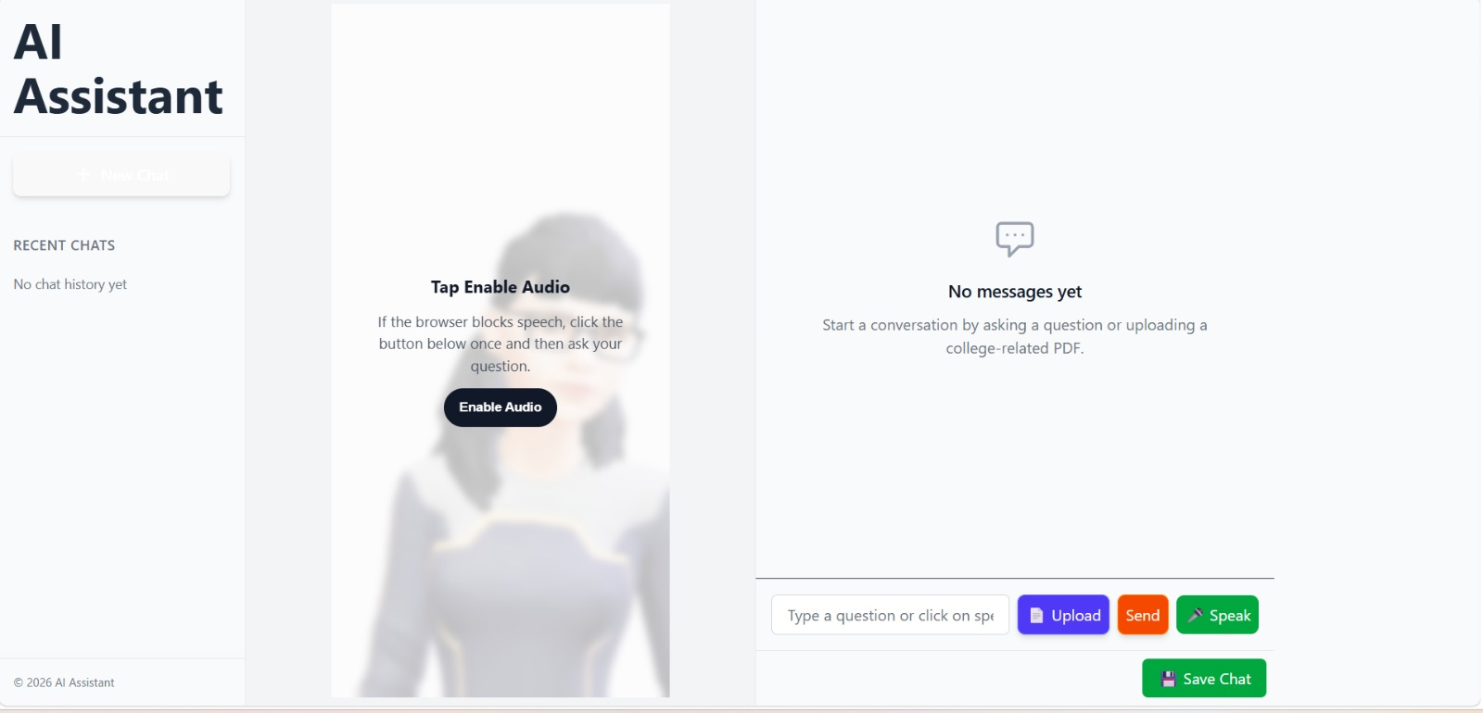
6.3.1 Home page
6.3.2 Chat Interface

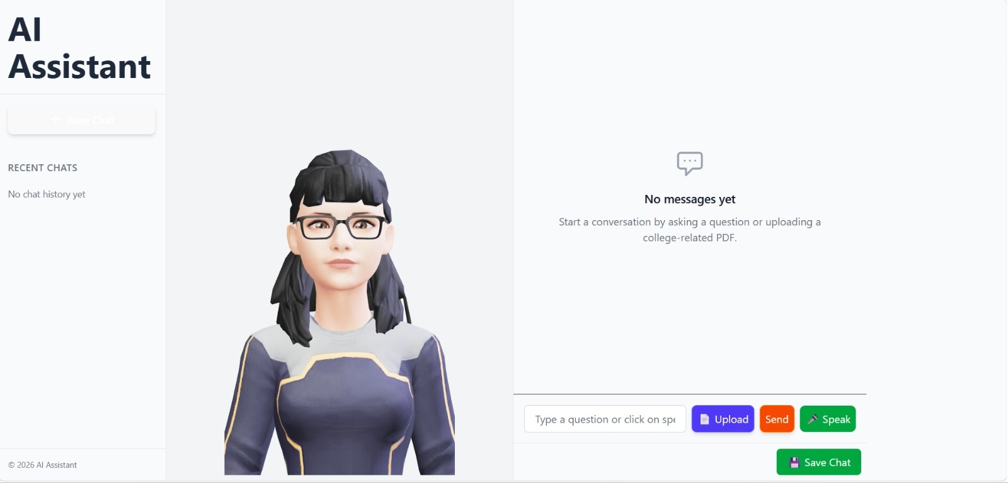

6.3.2 Chat Interface

6.3.3 PDF Upload Page
The page lets users upload the pdf for the further conversation and the context.

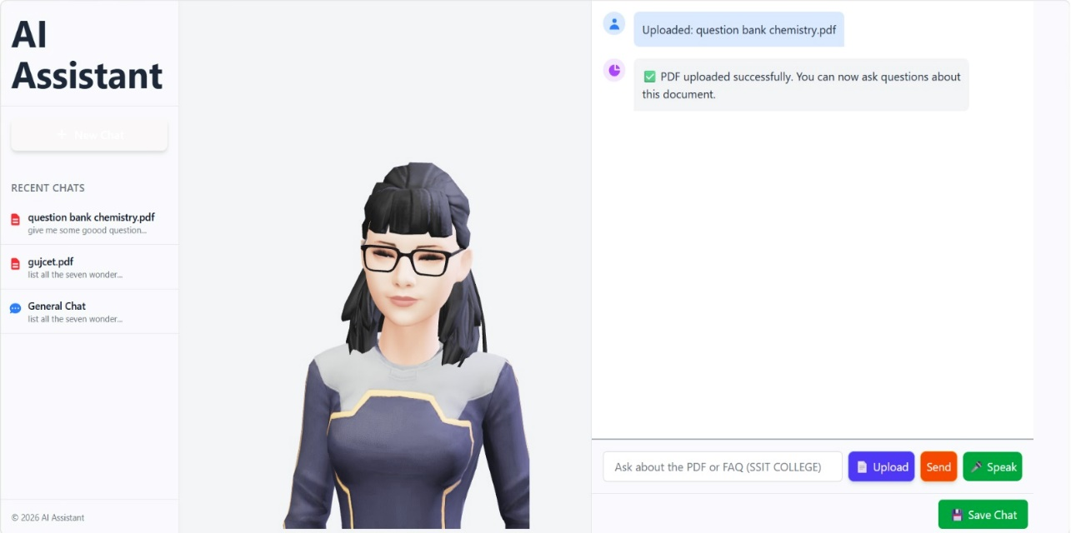
6.3.3 PDF Upload Page

6.3.4 PDF Question Answering Page

On this page the user can communicate to the AI Assistant using text or speech.

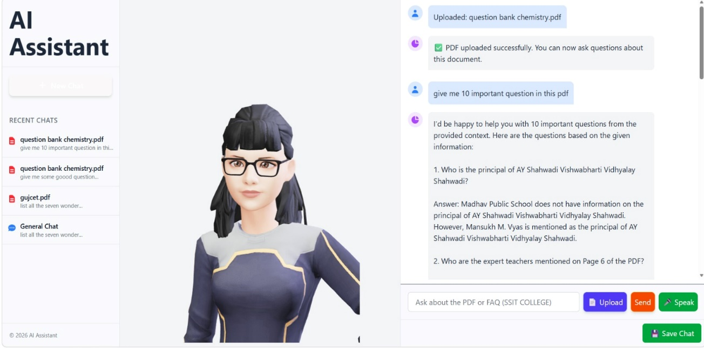
6.3.4 PDF Question Answering Page

6.4 Result Analysis
- The result of the AI-BOT project shows that the system successfully meets its main objective of providing an intelligent and interactive chatbot platform for general queries, college-related queries, and PDF-based question answering.
- The system performs well by combining frontend interaction, backend processing, retrieval-based search, and AI-generated responses in a single platform.
- The integration of embeddings and FAISS improves answer relevance for contextual and document-based queries
- Voice input and avatar-based speech output make the system more interactive and user-friendly.
- The modular implementation also makes the project scalable and easier to maintain.
- Overall, the project reduces manual effort in information search, improves accessibility of answers, and demonstrates the practical use of AI, retrieval systems, and modern web technologies in a real application..

CHAPTER- 7: TESTING

7.1 TESTING PLAN / STRATEGY
The testing phase of the AI-BOT project focused on verifying the correctness, stability, and usability of all implemented modules. The objective of testing was to ensure that the chatbot interface, backend APIs, PDF processing, retrieval-based answering, voice input, and avatar output all worked properly both individually and together as one integrated system.
- Unit Testing:
Individual modules and components were tested separately to ensure that each function performed correctly. Frontend components such as ChatBox, ChatInput, Sidebar, and AvatarViewer were checked independently.
- Integration Testing:
Integration testing was carried out to check communication between frontend and backend modules. This included verifying that user input from the React interface correctly reached the Express backend, that backend APIs returned valid responses.
- Manual UI Testing:
The user interface, navigation, and responsiveness were tested manually across different screen sizes.
- API Testing:
APIs were tested using Postman to verify correct responses and data flow.
- PDF Processing Testing:
Uploaded PDF documents were tested to verify whether text extraction, embedding creation,and question answering from the PDF worked properly.
- Voice Input Testing:
The voice input feature was tested to ensure that spoken input was correctly converted to text and passed into the chatbot workflow.
All implemented modules were tested individually and together to ensure proper functionality, with further testing planned as development continues.

7.2 Test Result and Analysis
The following test outcomes were observed:
- General question answering worked correctly and the chatbot produced proper AI-generated responses.
- PDF upload functionality worked correctly and uploaded files were processed without major issues.
- PDF-based question answering returned context-aware and relevant responses.
- Chat history loading and chat saving worked properly.
- Voice input functionality successfully converted speech into text.
- Avatar response and speech output worked correctly after answer generation.
- Frontend and backend integration behaved as expected during testing.
- some major functional issues were found during testing.
- Minor UI and flow-related issues were identified and corrected during implementation.
The testing results indicate that the AI-BOT system is working successfully as an integrated application. The project meets its main functional requirements and provides a stable platform for chatbot interaction, PDF-based querying, and voice-enabled response delivery.

Test ID | Test Condition | Expected  Output | Actual Output | Remark
TC01 | User asks a general question | AI-generated answer should be returned | Answer returned successfully | Passed
TC02 | User asks a college-related question | Relevant context-based answer should be displayed | Context-aware answer shown correctly | Passed
TC03 | User uploads a valid PDF file | PDF should upload and process successfully | PDF uploaded and processed correctly | Passed
TC04 | User asks a question from uploaded PDF | Answer should be generated from document context | Relevant PDF-based answer shown | Passed
TC05 | User clicks voice input and speaks | Speech should convert into text | Voice input converted successfully | Passed
TC06 | Chatbot response is generated | Avatar should speak the answer | Avatar speech triggered successfully | Passed
TC07 | Invalid or empty question is submitted | System should avoid processing or show safe handling | empty input ignored correctly | Passed
TC08 | User saves a conversation | Chat should be stored in history | Chat saved correctly | Passed
TC09 | User opens previous chat history | Past messages should load properly | Chat history displayed correctly | Passed
TC10 | Backend API request is sent from frontend | Proper API response should be received | API communication worked correctly | Passed
7.2.1 Test Result

CHAPTER- 8: CONCLUSION AND DISCUSSION

8.1 OVERALL ANALYSIS OF INTERNSHIP
The AI_Assitant project was a very good learning experience for me from both technical and practical points of view. During this internship, I got the opportunity to work on a real project that combines frontend development, backend integration, AI response generation, PDF processing, and voice_based interaction. This helped me understand how a complete web application is built and managed. way.
The use of React.js helped in understanding component-based architecture, state management, routing, and API integration. The modular structure of the project helped in maintaining proper code structure and scalability of the application. Role-based dashboards were developed for students, teachers, and admin, ensuring that each user could access their respective features securely.

While working on this project, I improved my understanding of React.js components, state handling, user interaction flow, backend communication, and modular code structure. I also learned how different technologies like Groq API, MongoDB, FAISS search, voice input, and avatar-based speech can work together in a single application.

8.2 DATES OF CONTINUOUS EVALUATION

Review 1 of Internship: 07/03/2026
Evaluations were conducted in front of the assigned internal panel. The progress was demonstrated using a live walkthrough of the project.

8.3 PROBLEM ENCOUNTERED AND POSSIBLE SOLUTIONS

Problem Encountered | Solution Adopted
Difficulty in managing different types of chatbot queries | Used separate handling logic for general, college-related, and PDF-based questions
PDF question answering was difficult for long documents | Implemented PDF text extraction, chunking, and semantic search
Voice input handling was not always straightforward | Used Web Speech API and transcript handling carefully in the frontend
Inconsistent UI across pages | Created reusable components and maintained consistent UI design
Managing chat history and PDF-based chats together | Structured chat storage and retrieval using backend APIs and MongoDB
API communication and async response updates caused some UI issues | Handled loading states, async calls, and state updates properly

8.3.1 Test Result

8.4 SUMMARY OF INTERNSHIP

The internship started with understanding the project requirements, studying the existing structure of the application, and learning how the chatbot system should behave. After that, the focus was on understanding the frontend flow, backend APIs, PDF handling, and AI response generation.

This experience helped me improve my skills in React development, UI design, and API integration. Overall, the internship provided practical exposure to real-world development and improved my technical and problem-solving abilities.

8.5 FUTURE ENHANCEMENT

Limitations:
- The current system does not include user authentication and role-based access
- The chatbot is mainly focused on current implemented query types and can be expanded further
- The PDF question answering depends on uploaded content quality and extracted text accuracy
- The system currently has limited analytics and monitoring features
- The user interface can still be improved further for more advanced production use
Future Enhancement:
- Add login and authentication for personalized user sessions
- Add multilingual support so users can interact in multiple languages
- Improve retrieval quality using better ranking or hybrid search methods
- Add support for more file types in addition to PDF
- Improve avatar interaction with more realistic animation and better speech control

References

REFERENCES

React.js Documentation
https://reactjs.org/docs/getting-started.html
Official documentation used for understanding components, hooks, routing, and state management.

Node.js Documentation
https://nodejs.org/en/docs
Reference for building the backend server, handling requests, and middleware setup. Express.js Documentation
https://expressjs.com/
Used for setting up API routes, middleware functions, and request handling in backend.
MongoDB Documentation
https://mongooes.js.com/doc/
Used for schema design, model creation, and database operations between Node.js and MongoDB..

Bootstrap & CSS Flexbox/Grid
https://getbootstrap.com/
https://developer.mozilla.org/en-US/docs/Web/CSS/CSS_Flexible_Box_Layout Resources for styling and creating responsive UI layouts.

Git and GitHub
https://docs.github.com/
Used for version control, code sharing, and collaborative development.

Figma for UI/UX Design
https://www.figma.com/
Used to design and prototype interfaces and layouts.
Groq API Documentation
https://console.groq.com/keys
Used for AI-based response generation, prompt handling, and integration of generative AI into the chatbot system.

W3Schools and MDN Web Docs
https://www.w3schools.com/ https://developer.mozilla.org/
General reference for JavaScript, HTML, CSS, and frontend behavior.
Web Speech API Reference
https:// developer.mozilla.org/en-US/docs/Web/API/Web_Speech_API/
Used for implementing voice input functionality in the chatbot interface.
MDN Web Docs
https://developer.mozilla.org/
General reference used for JavaScript, HTML, CSS, browser APIs, and frontend behavior.

Bharat Biz Tech (Internship Organization)
Internal project discussions, practical guidance, and implementation support received during the internship period

