Load data from local:-

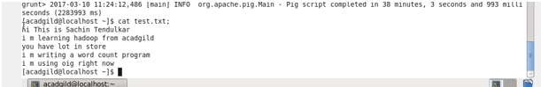

Convert sentence into words:-

C:\Users\613008\Desktop\a2.PNG

Convert the column into rows:-

C:\Users\613008\Desktop\a3.PNG

Apply group by:-

C:\Users\613008\Desktop\a4.PNG

Generate word count:-

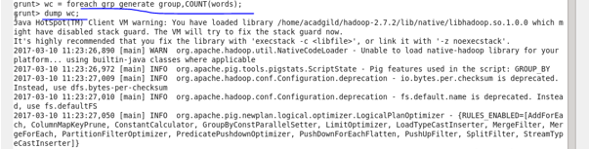

Output:-

