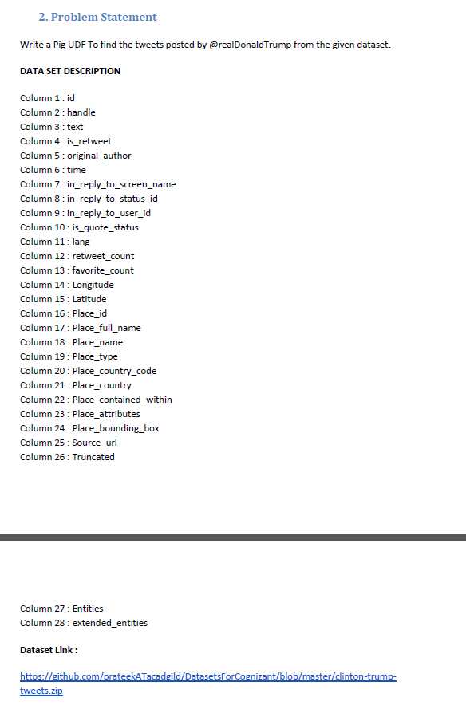

*Code:-*

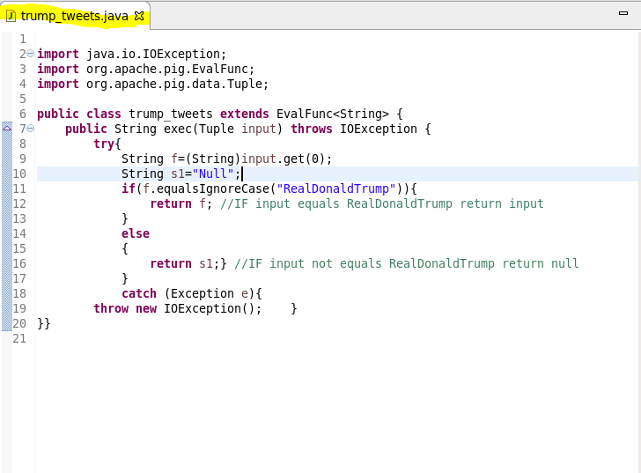

*In the user define function for checking To find the tweets posted by @real Donald Trump from the given dataset. We will extend the evaluation function that will take string as argument.*

*Pig code:-*

*C:\Users\613418\Desktop\s.png*

*pig script.:-*

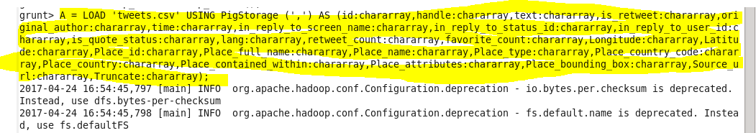

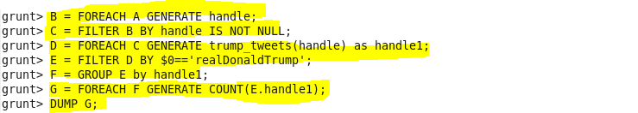

*OUTPUT :-*

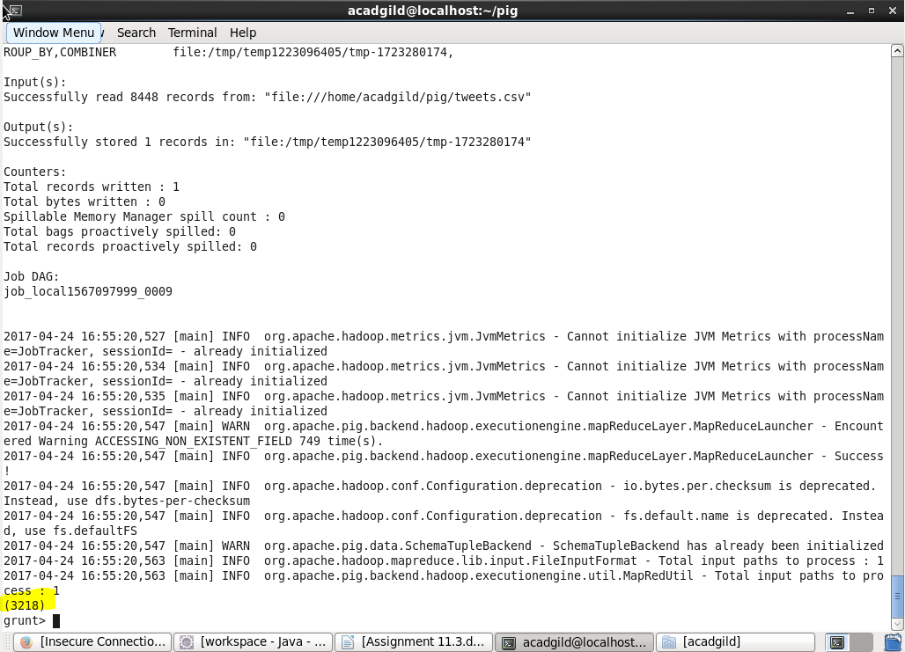

*Total no of tweets= 3218*