Task1:-Create a Flume

Installed flume

Flume.conf

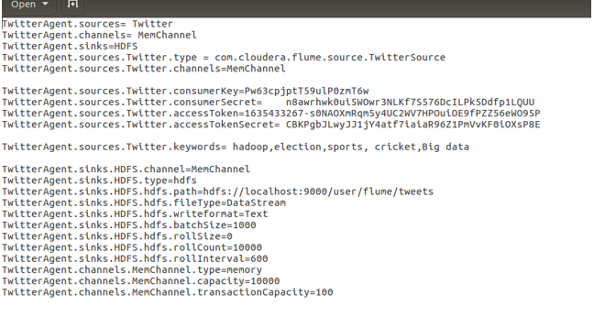

Twitter app.

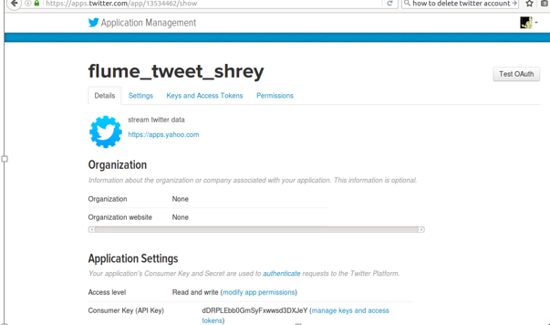

Running flume agent:-

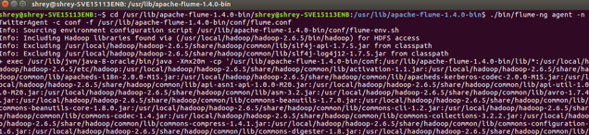

Checking :-

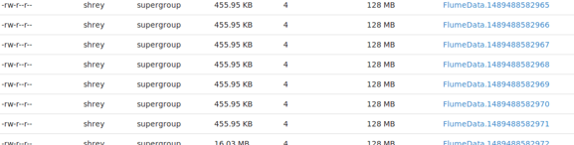

Flume data file:-

