Task:

Produce the word whose count is greater than or equal to the configuration  
Hadoop is good sub

Hadoop is good sub

Hadoop is good sub

Hadoop is good sub

Sol:-

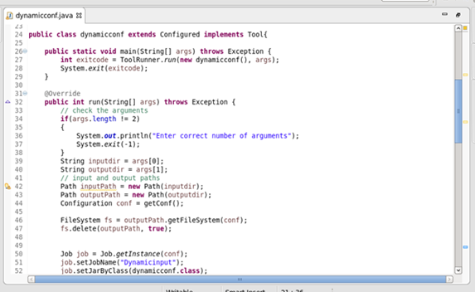

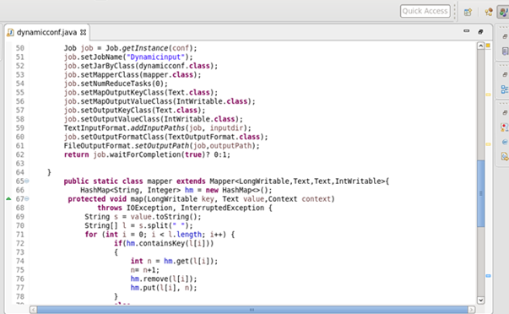

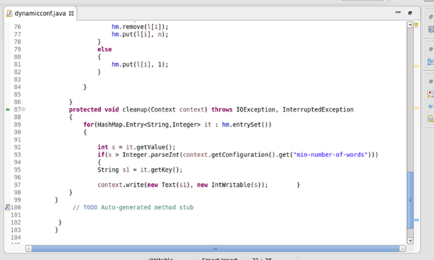

Output:

