**Input file data set**

Hadoop is good sub

Hadoop is good sub

Hadoop is good sub

Hadoop is good sub

->Run a map only job

Driver:-

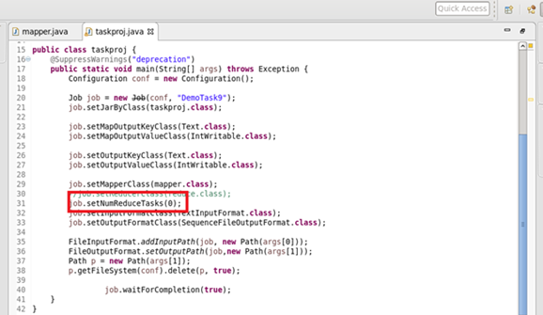

Mapper:-

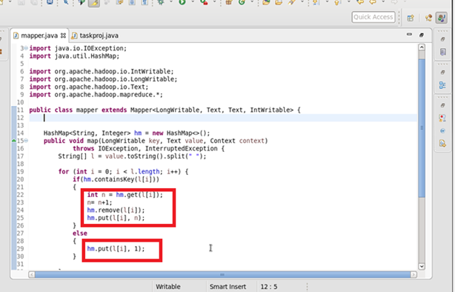

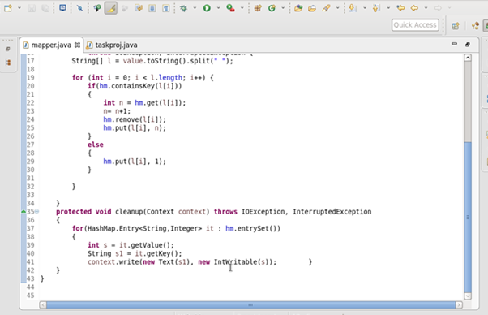

O/P:-

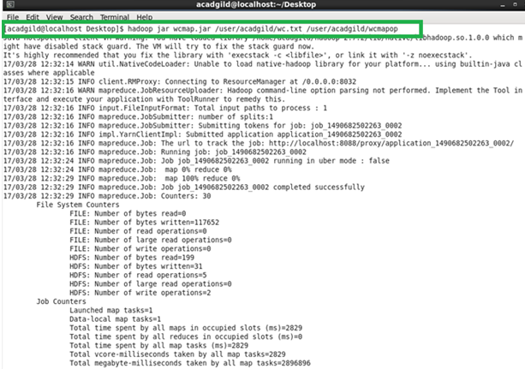

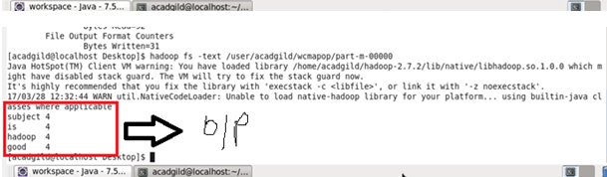

Map reduce word count program

Driver:-

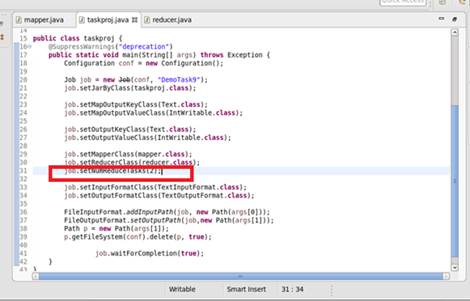

Mapper:-

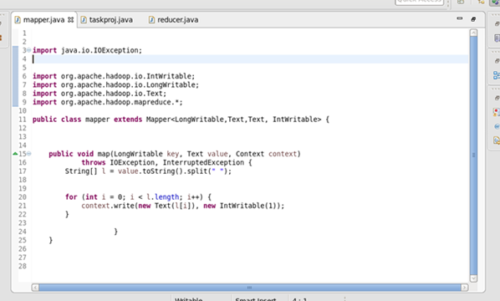

Reducer:-

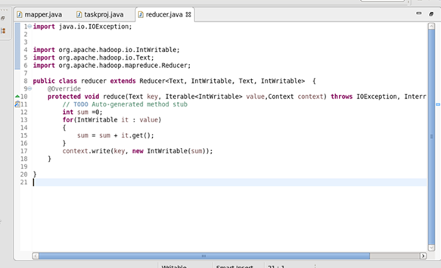

O/P:-

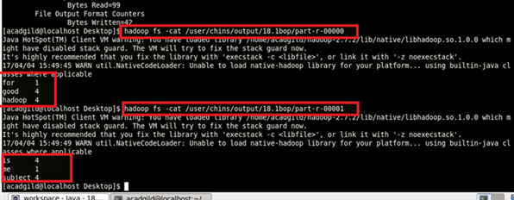

////bnhjjkjkjklkl

Ouuisvhu

ooo

O