*Convert XML File into Json File Format:-*

*PROGRAM***:-**

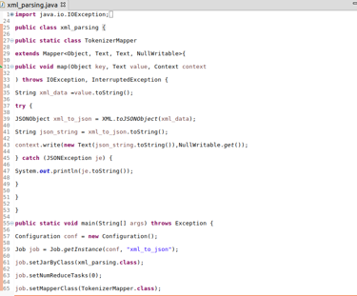

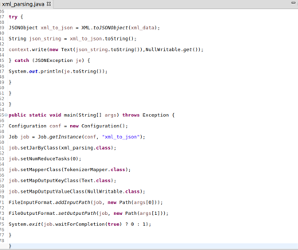

*EXECUTING COMMAND:-*

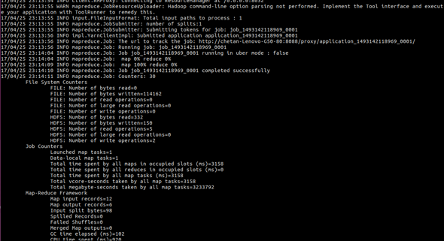

*OUTPUT***:-**



