*Writable Interface Introduction:-*

It is an Interface that is used for wrapping the primitive data types like int so as to provide Serialization for Datatype

Hadoop comes with several wrappers around primitive types and widely used classes in Java:

|  |  |
| --- | --- |
| Java primitive | Writable implementation |
| Boolean | Boolean Writable |
| Byte | Byte Writable |
| Short | Short Writable |
| Int | Int Writable Vint Writable |
| Float | Float Writable |
| Long | Long Writable VLong Writable |
| Double | Double Writable |

*Serialization:*

Serialization is nothing but converting the raw data into a stream of bytes which can travel along different networks and can reside in different systems

Since Hadoop deals with large volume of data and the data is to transmitted across the framework from mappers to reducer .

*IMPORTANCE OF WRITABLE AND ITS EDGE OVER SERIALISATION OBJECT OF JAVA:-*

Serialization is important in Hadoop because it enables easy transfer of data. If Writable is not present in Hadoop, then it uses the serialization of Java which increases the data over-head in the network as shown in fig.

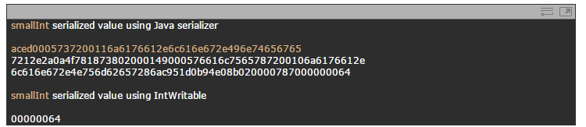

This shows the clear difference between serialization in Java and Hadoop and also the difference between Object Input Stream and Writable interface.

*METHODS USED BY WRITABLE TIO ACHIEVE SERIALISATION:-*

*1.void read Fields(Data Input in):*

It is used for reading data from the stream(transmission channel) and writing it into local disk. The wrappers we saw above just send and receive their binary representation over a stream.

*2. void write(Data Output out):*

write() is used for writing the data onto the stream, The wrappers we saw above just send and receive their binary representation over a stream.

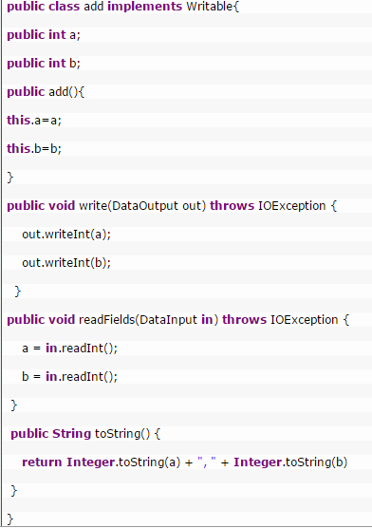

*Drawback:*

In this method if we implement writable as there is no compare method to sort the key value pairs in the frame work but if it is a default int writable a raw comparator will take care of this sorting

Writable Comparable: It is an sub interface that extends writable and comparable that uses for serialization and deserialization of writable Interface and compare to method of Comparable class

*Methods*

**1.void read Fields(Data Input in);**

It is used for reading data from the stream(transmission channel) and writing it into local disk. The wrappers we saw above just send and receive their binary representation over a stream.

**2. void write(Data Output out);**

 write() is used for writing the data onto the stream, The wrappers we saw above just send and receive their binary representation over a stream.

**3**.**int compare To(Writable Comparable):**

it is used to compare the objects.

Eg:

