Task 1

Input data:-

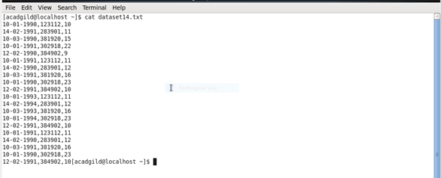

Data base

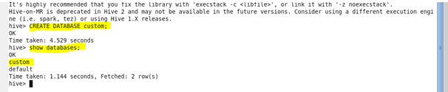

Database Custom:-

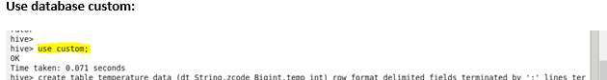

Temperature data:-

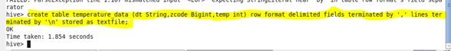

Show table:-

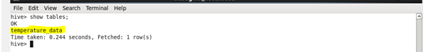

Load the data:-

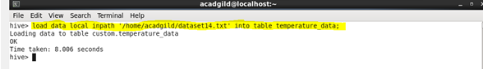

Display the content:-

