Create table:

Load data:-

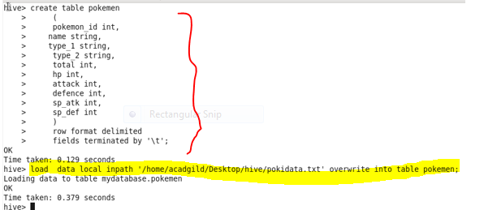

Find the avg hp:

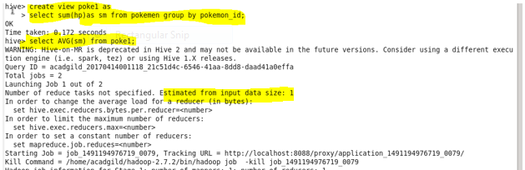

O/P:

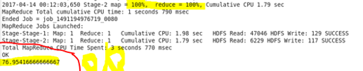

Find Avg defense:-

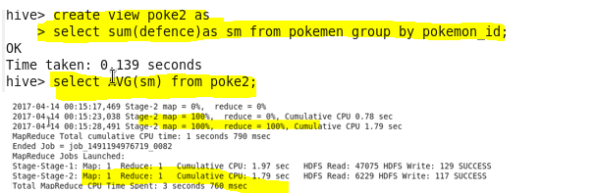

O/P:-

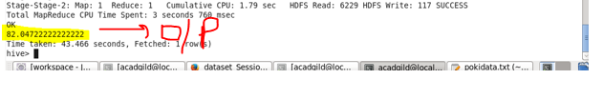

Avg sp.attack:

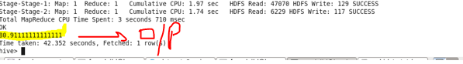

O/P:

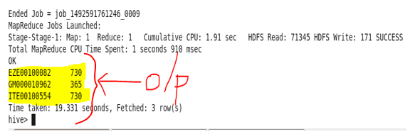

Avg sp. Defense:

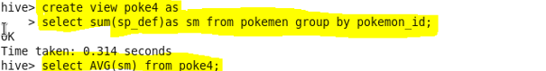

O/P:

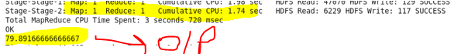

Find the avg speed:

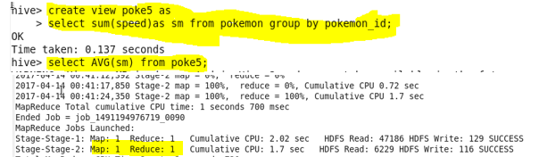

O/P:

