*travel data:-*

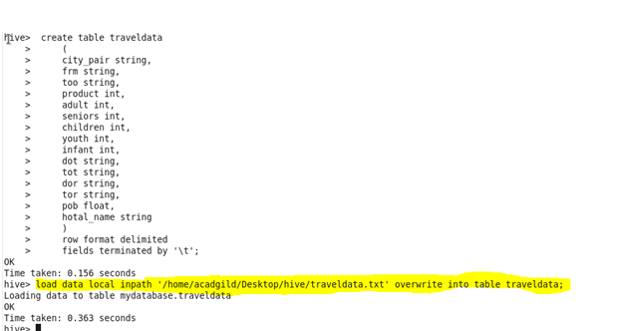

*Task1 Find top 20 destination which people travel the most*

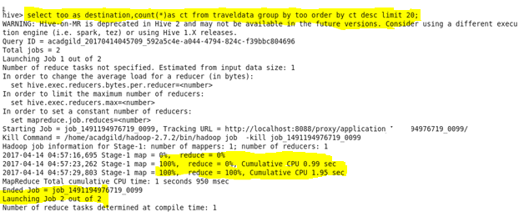

*Output :-*

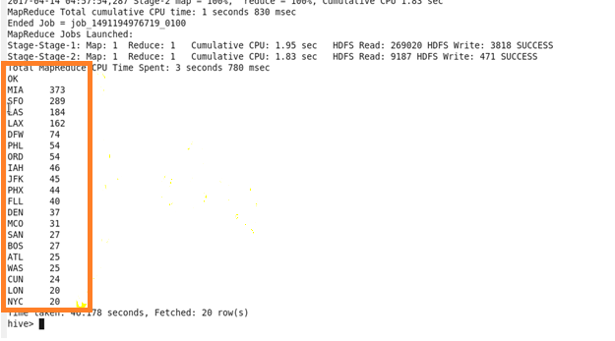

*Task 2. Find top 20 locations from where people travel the most.*

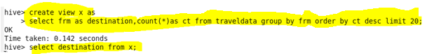

*Output:-*

