*Create table:-*

*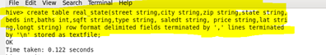*

*Load data:-*

*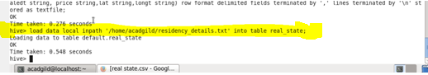*

*Task1 List top 5 residency details which lie in the given conditions*

*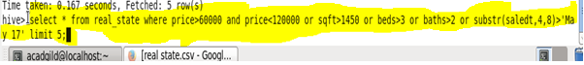*

*O/P:-.*

*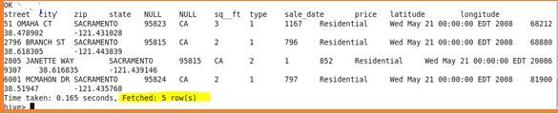*

*Task 2:- separate list of residential apartments under given conditions*

*C:\Users\613008\Desktop\a5.PNG*

*O/P:-*

*