*Create table:-*

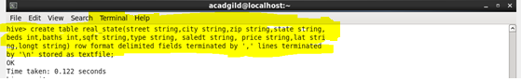

*Load data into table:-*

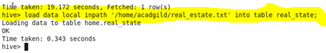

*Task 1:-find the city wise list all the Condos which is not less than 10,000.*

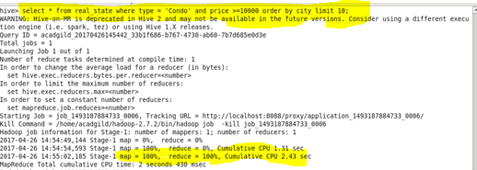

*Output :-*

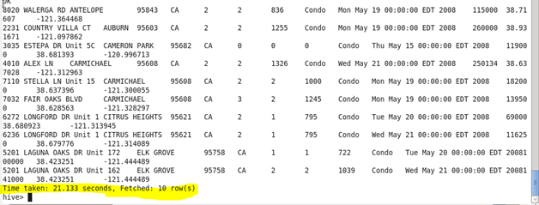

*Task2. Find which is the cheapest Condo in CA.*

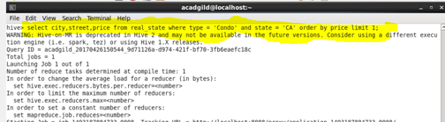

*Output :-*

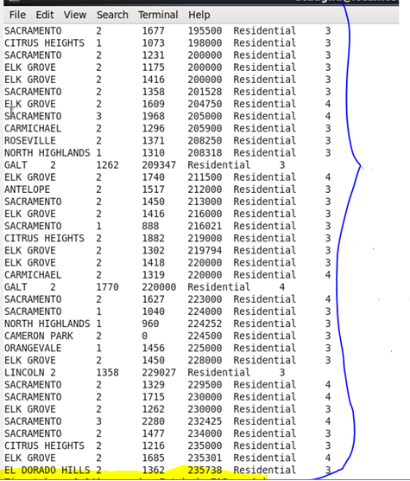

*Task3: Write a hive query to list top 5 residency details which lie in the budget of 60000-120000, an area more than 1450, sold after 17th may, min bedroom 3 and,min bathroom 2.*

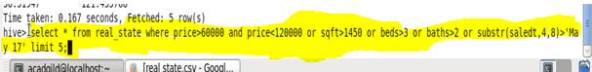

*Output:-*

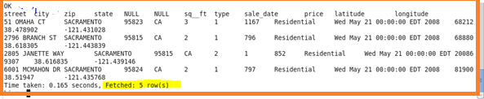

*Task4. separate list of residential apartments under given conditions*

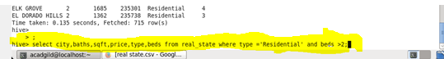

*Output :-*

