Perfom word count

I/P file:-

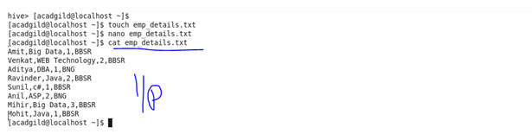

Creating table and loading command:

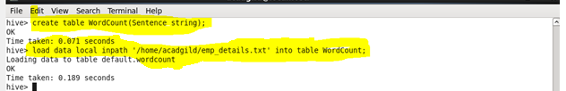

Split command:

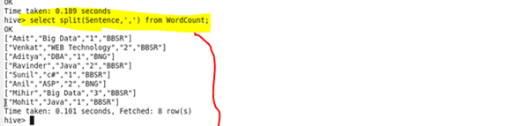

Explode:

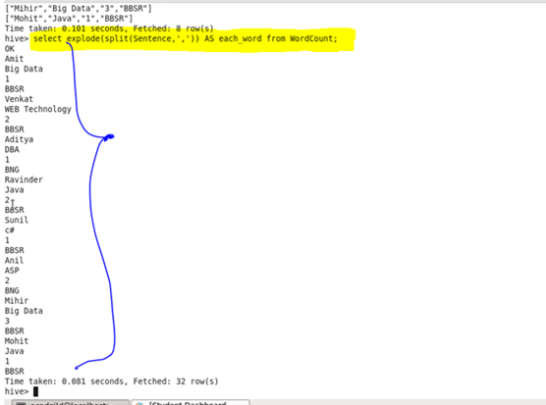

Count each word:

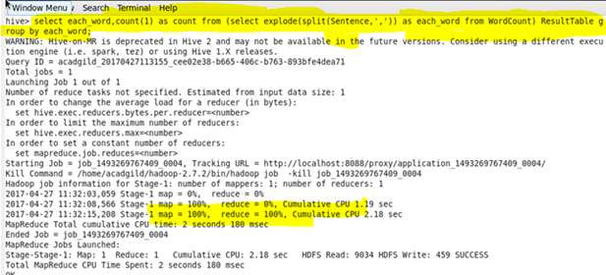

O/P:

