Implementing view in hive:-

Input file 1:

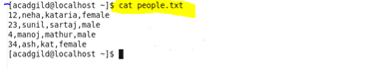

Input file 2:

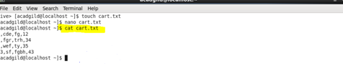

Create table and load:

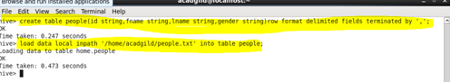

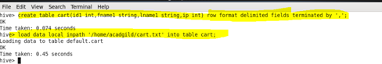

Create view :

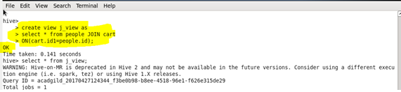

O/P:

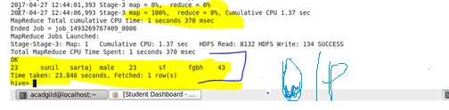

Query:

