Explain the following

i/p file:

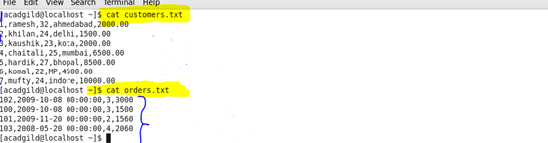

Join:

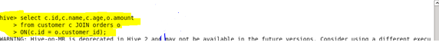

O/P:

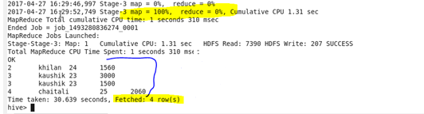

Left outer join:

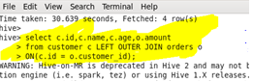

O/P:

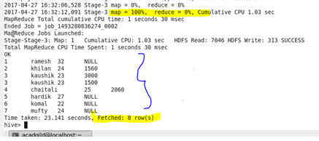

Right outer join:

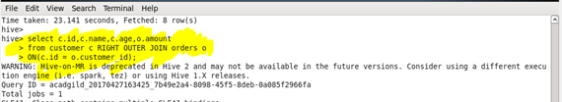

O/P:

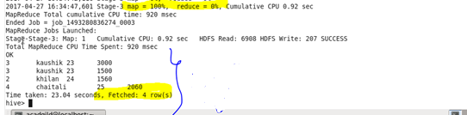

Full Outer Join:

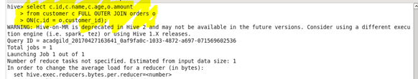

O/P:

