Parallel job in hive:

i/P file:

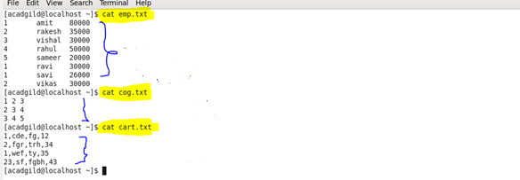

Create & load file emp:

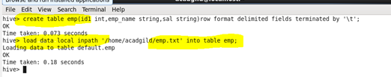

Create & load file cog:

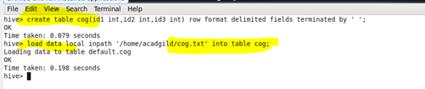

Create and load file cart:

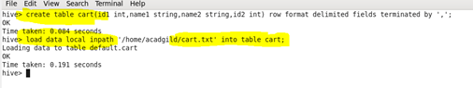

Set the parallel configuration in hive command line:

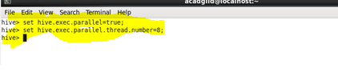

Query:

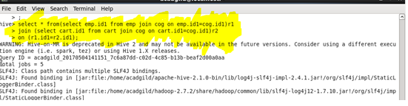

O/P:

