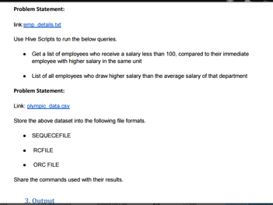

1. Create table
2. Load data into the table
3. Display all the data of table
4. Then, according to question finding list of employees who receive a salary less than 100, compared to their immediate employee with higher salary in the same unit using lag and partition keywords.

1)

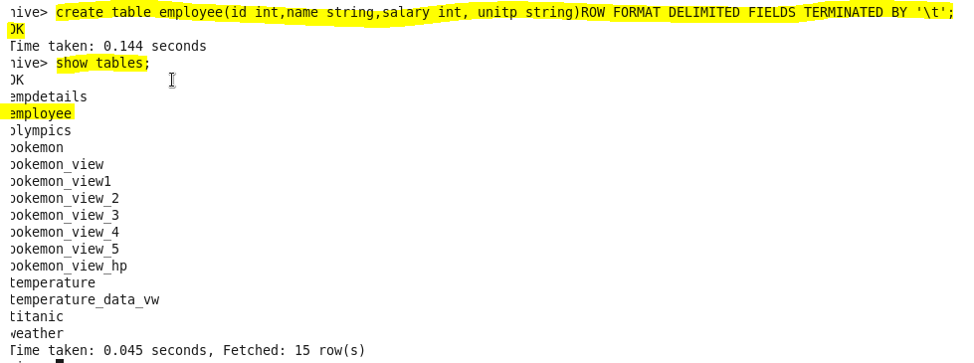

2) load our dataset employee.txt using LOAD command

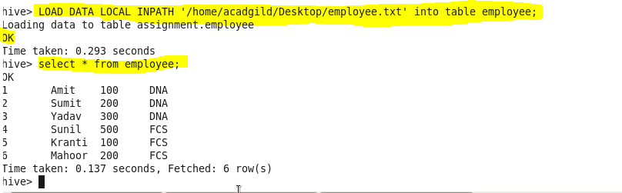

1. list of employees who receive salary less than 100 immediate employee with higher salary in the same unit

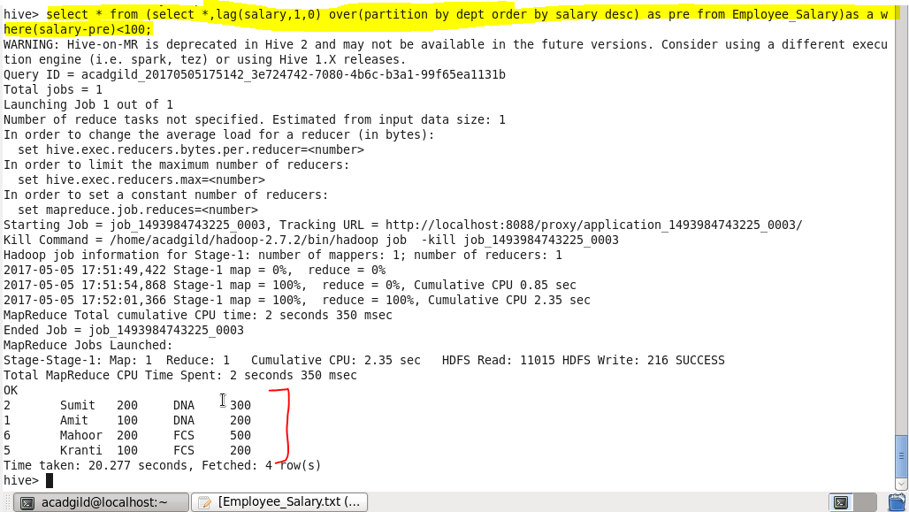

1. List of all employees who draw higher salary than the average salary of their department.

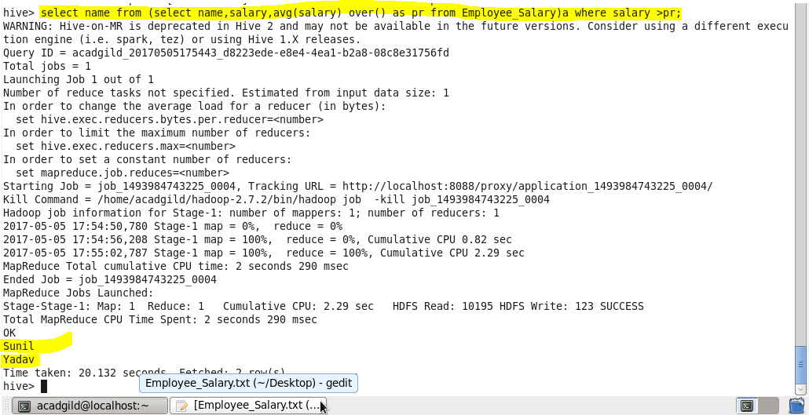

*olympic_data.csv Store the above dataset into the following file formats.*

*SEQUENCE FILE*

->Creating table in sequencefileformat

->Describing the contents of it

->Loading dataset into file

->displaying all the data using ‘select’ keyword.

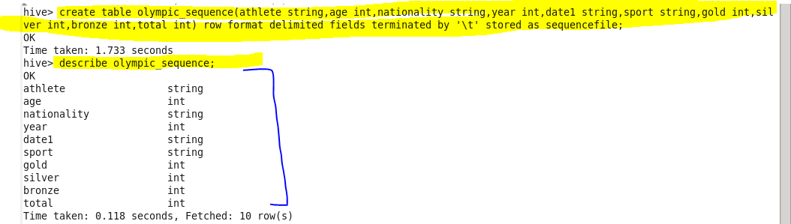

*Insert data :*

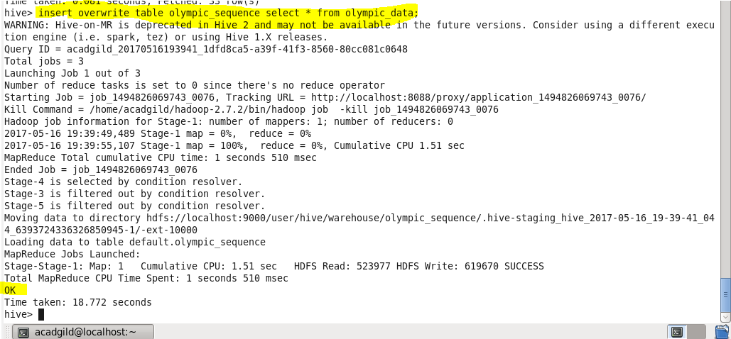

*Showing result :*

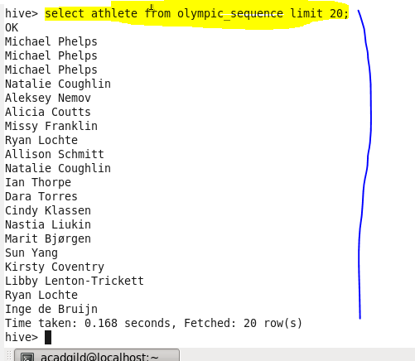

*RCFILE*

->Creating table in rc file format.

->Describing the contents of it.

->Inserting the data into created table.

->Displaying all the data using ‘select’ keyword.

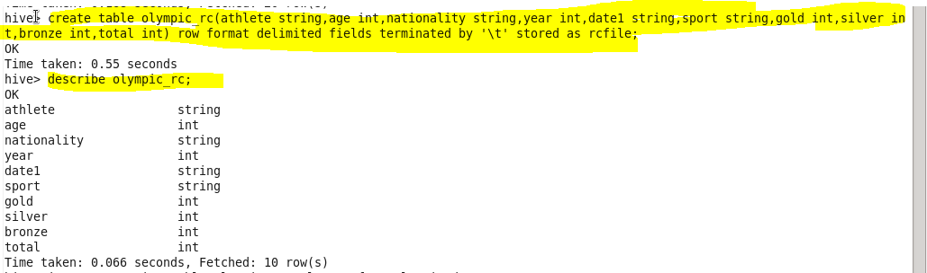

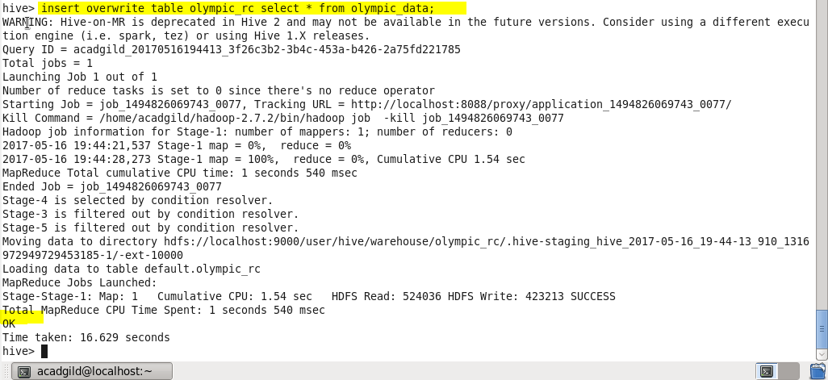

Showingresult

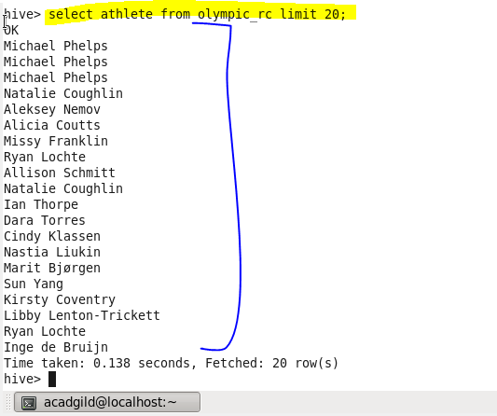

●->ORC FILE

->Creating table in orc file format.

->Inserting the data into created table.

->Displaying all the data using ‘select’ keyword.



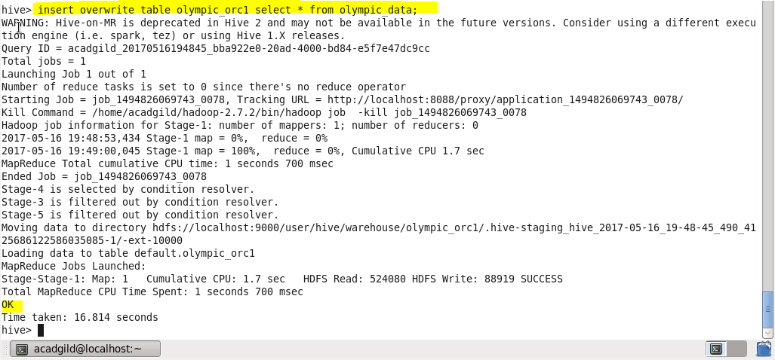

*Showing result:*

