**I am Having arry_table as shown below which I am going to read**

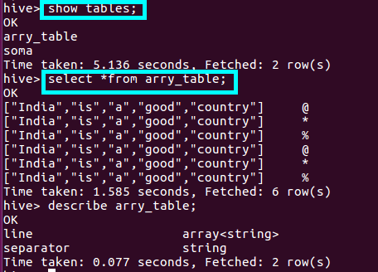

**JAVA CODE TO READ**

**1 :Defining a driver and the Class.forName(driver) method returns the Class object associated with the class or interface with the given string name, using the given class loader.**

**2: creating connection using driver.getconnection()**

**3: we are using createstatement() method to create a statement instance for sending SQL statements to the database. Here, Statement is an interface that represents an SQL statement.**

**4:** **in order to execute an SQL query, we should use executequery() method of the interface statement.Using Resultset to display the results of a querry**

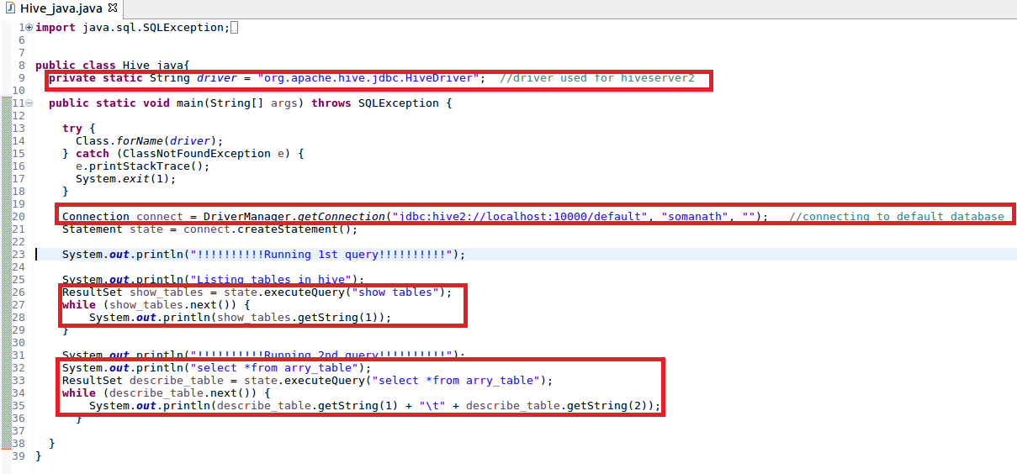

***O/P:-***

**We have successfully read data from Hive**

