*Create table customer :-*

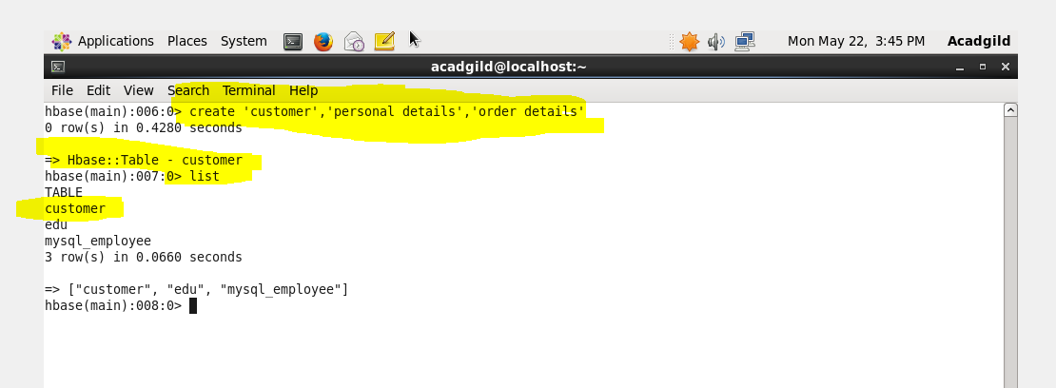

*Use put command:-.*

Personal details and order details as column families. Create a unique number as row key (ssn/Aadhar no.,etc)

Following values for personal details column family Name, age, city, state

Following values for order details column family Order no., order quantity, and order amount

*PERSONAL DETAILS*

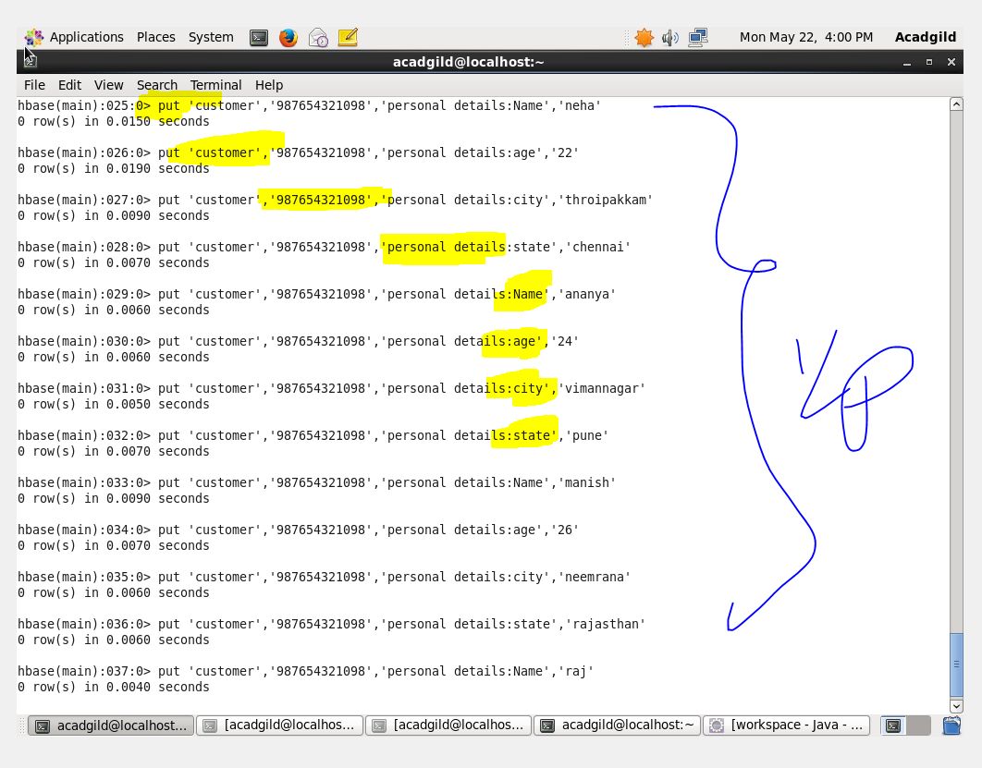

*ORDER DETAILS:-*

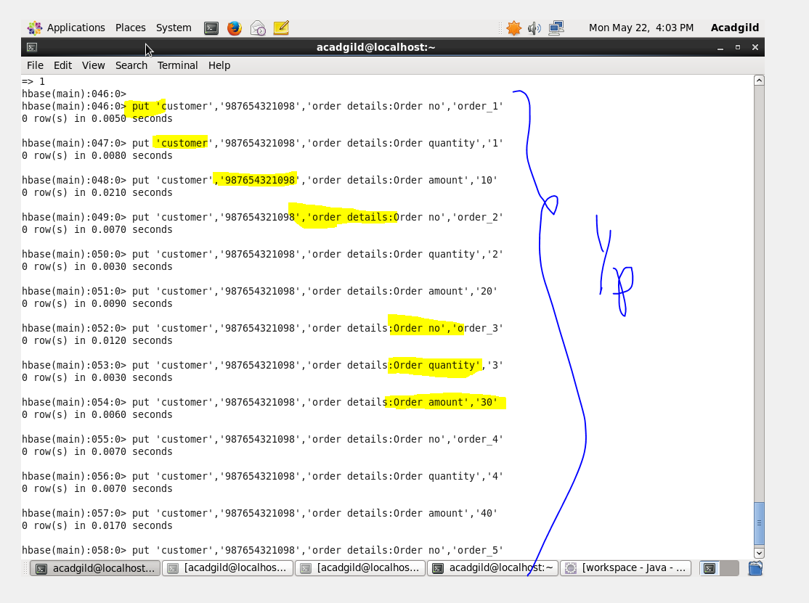

*Use get command:-*

*OUTPUT:-*

