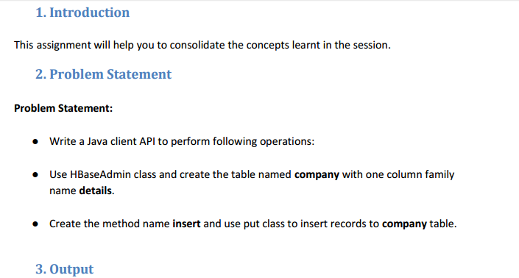

*CREATE A TABLE IN HBASE:-*

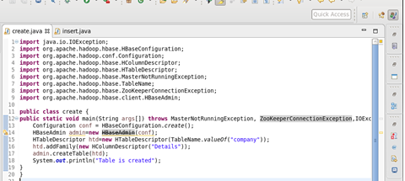

*TABLE IS CREATED IN HBASE :-*

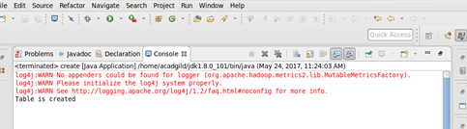

*SHOW THE TABLES IN HBASE:-*

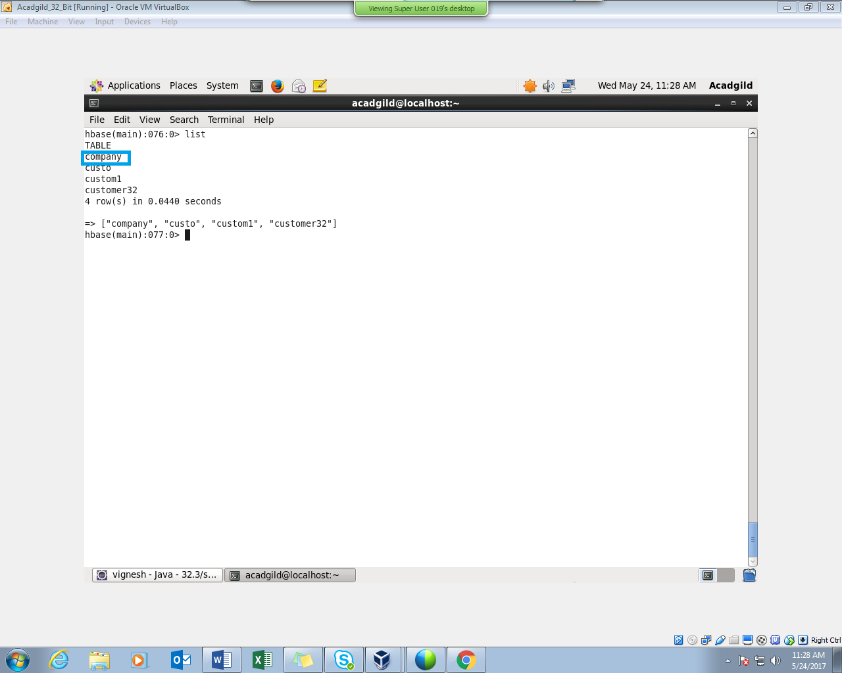

*INSERT DATA INTO THE TABLE COMPANY:-*

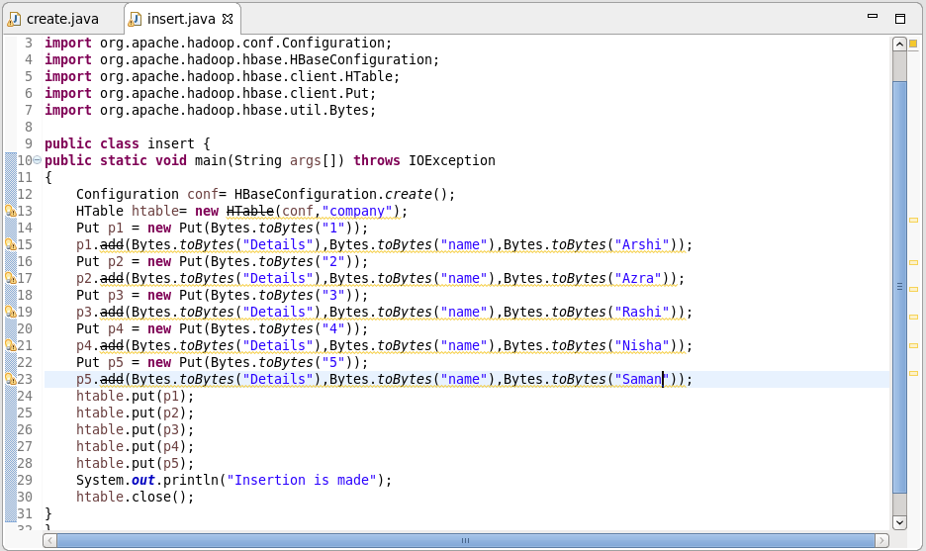

*RUNNING THE JAVA CODE IN ECLIPSE (RUN AS APPLICATION):-*

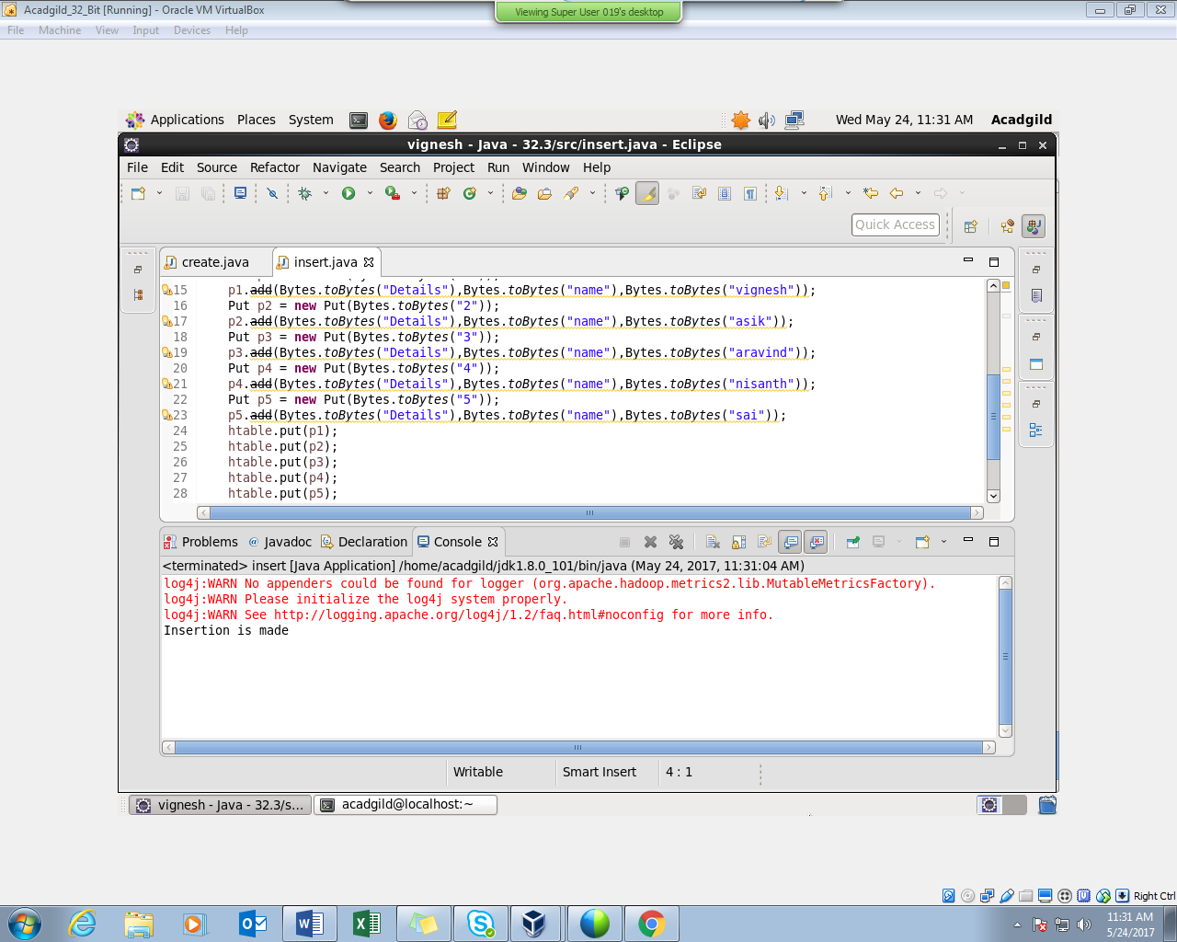

*INSERTION WAS SUCCESSFUL :-*

PERFORMING SCAN COMMAND :

