*Create table:-*

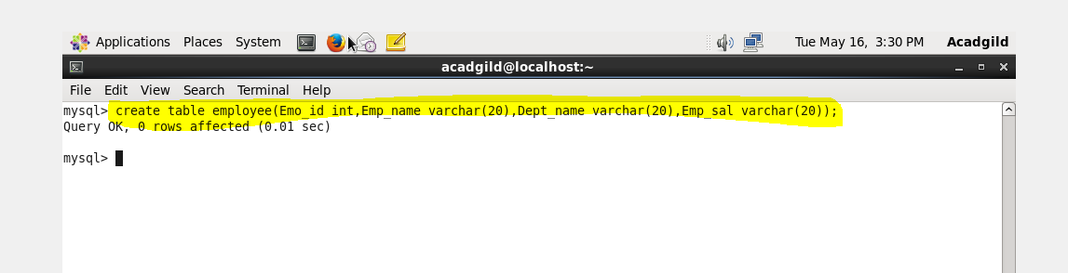

*Insert values :-*

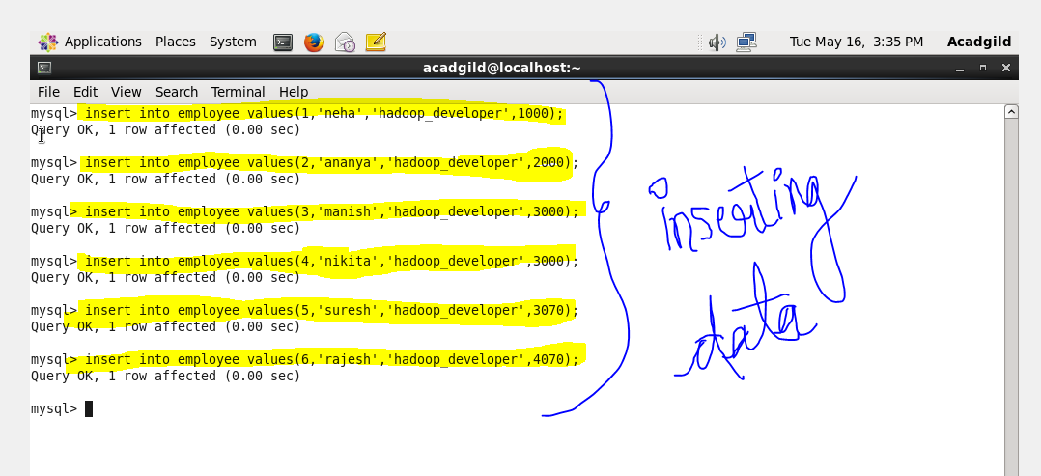

*Create a directory named sqoop:-*

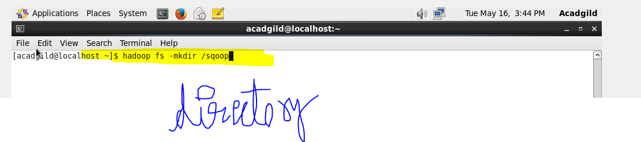

*At the browser:-*

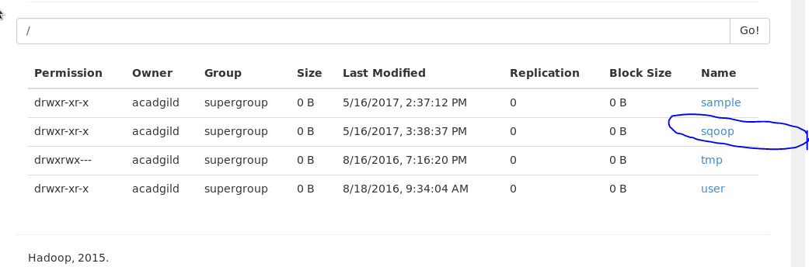

*Import the data from my sql to hdfs directory using sqoop:-*

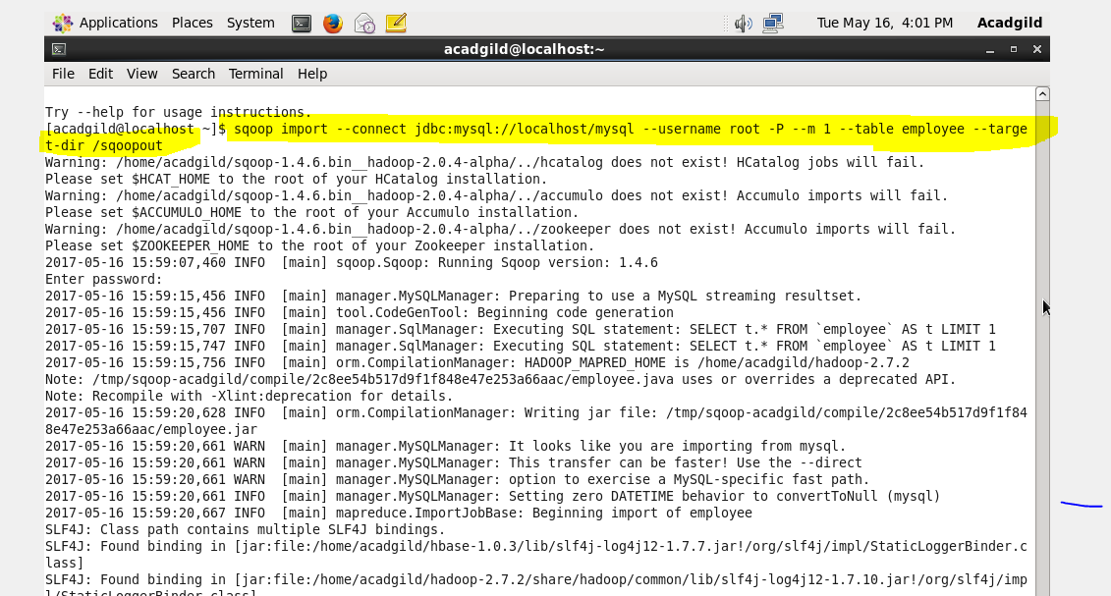

*Successfully imported:-*

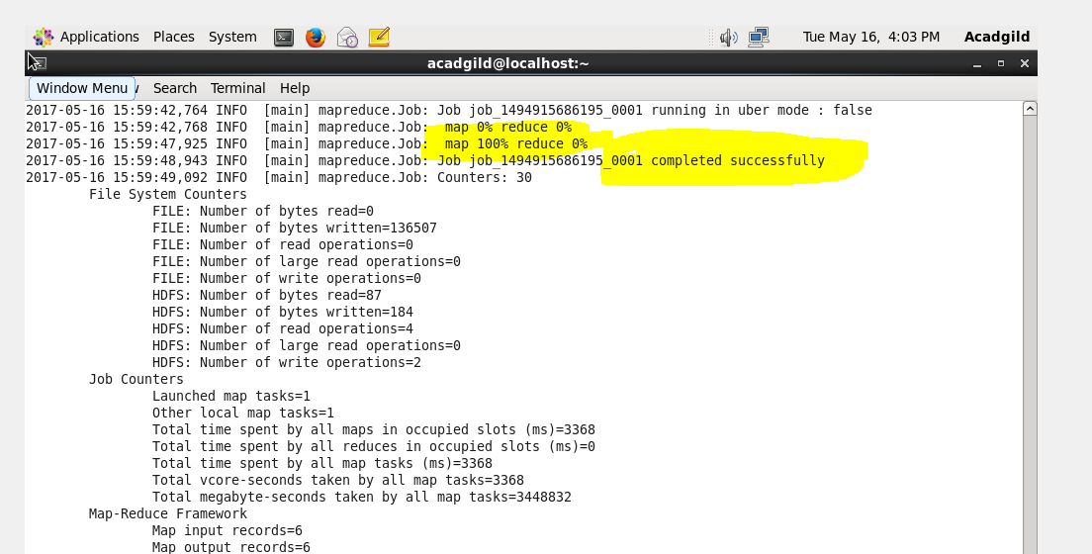

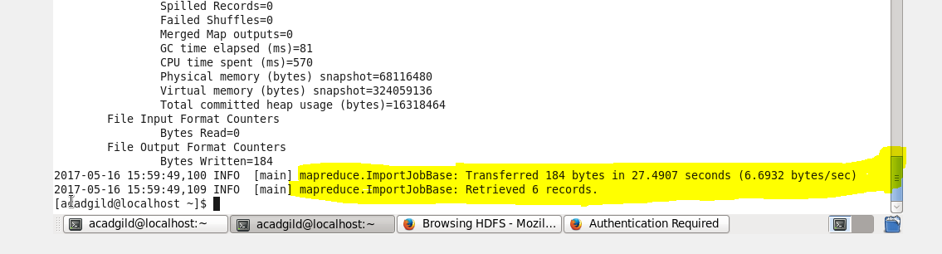

*Output :_*

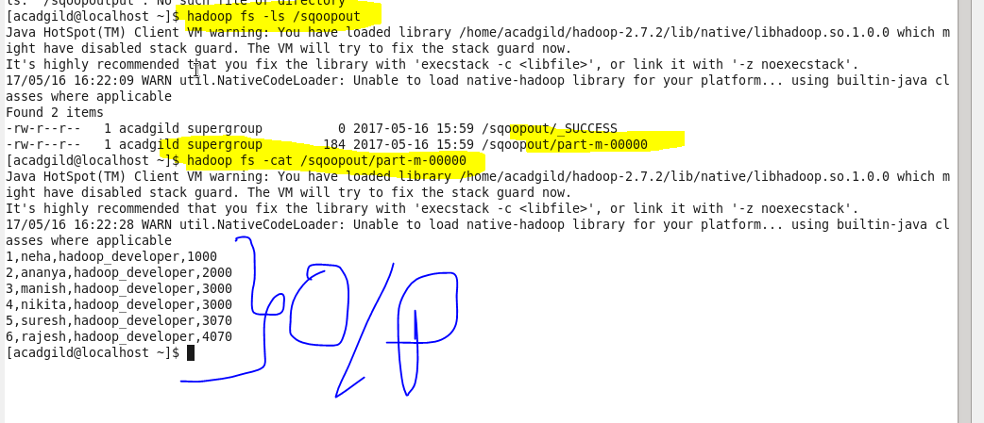

*Creating table employee2:-*

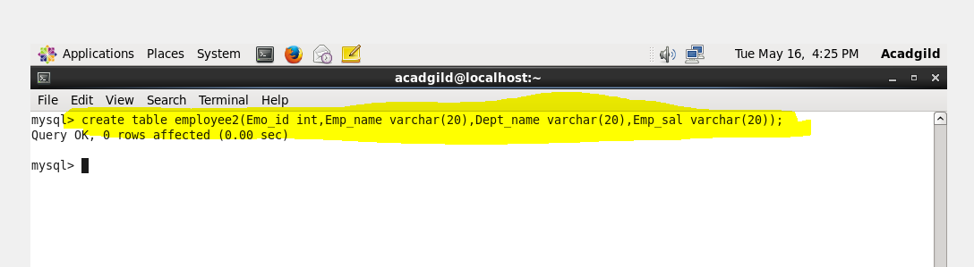

*Export data from hdfs to mysql:-*

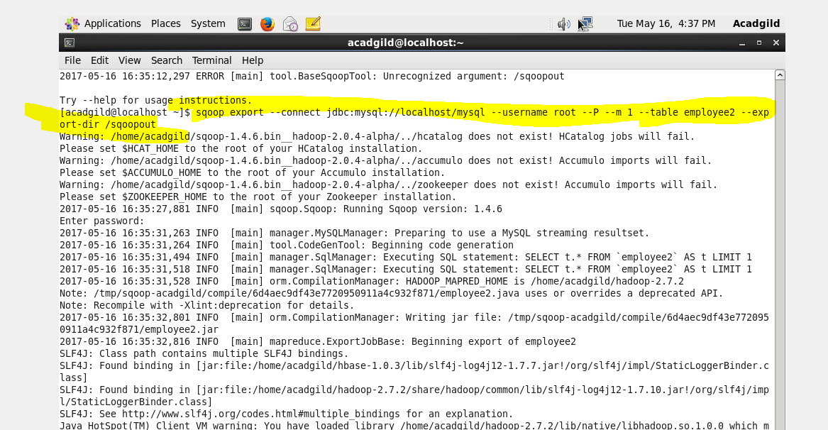

*Export successfully:-*

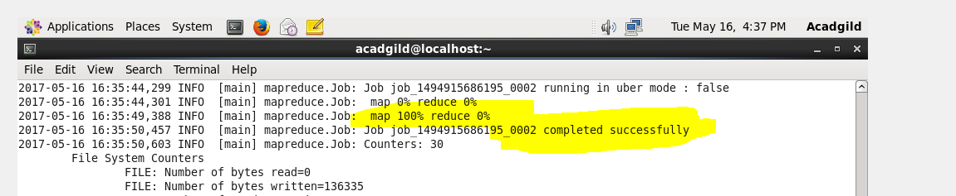

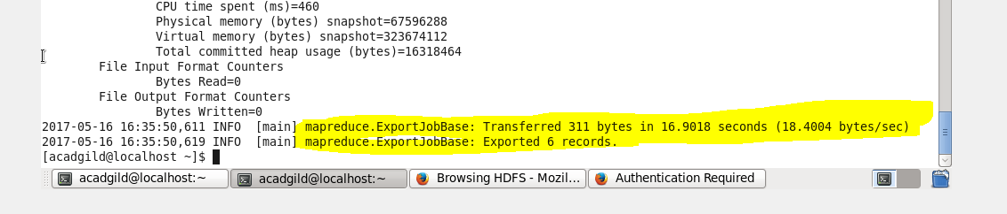

*Output :-*

