*Employee table:-*

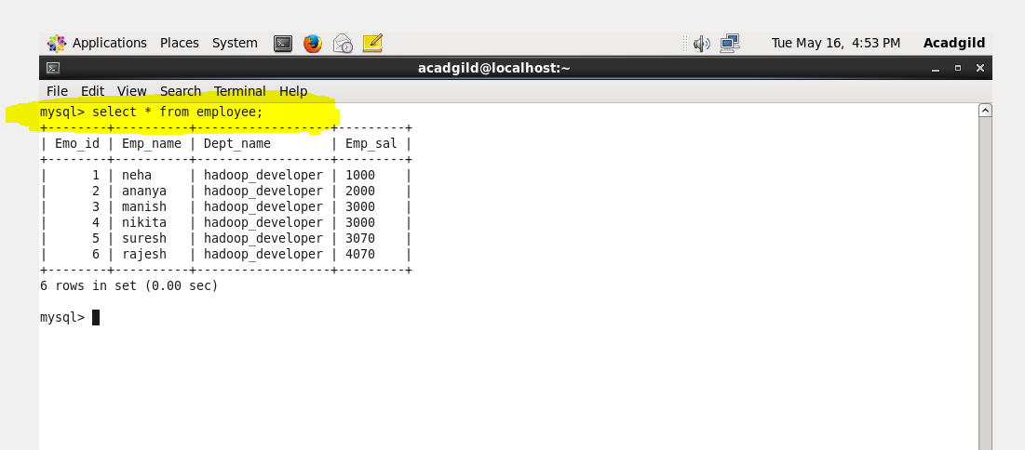

*Increment the rows :-*

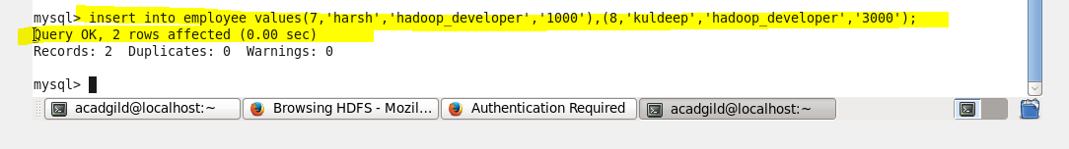

*O/P of incrementing rows in mysql:-*

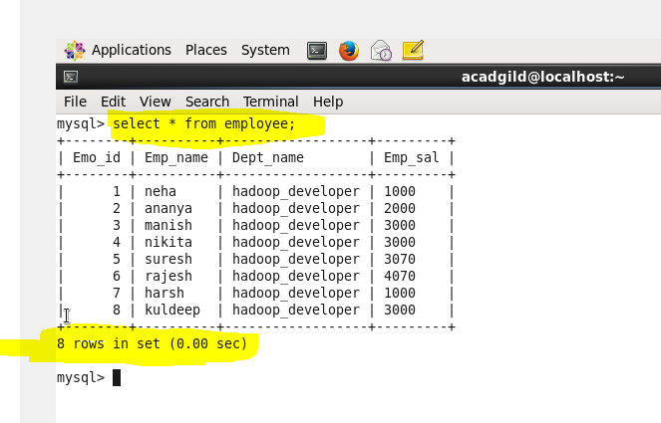

*Data already in hdfs:-*

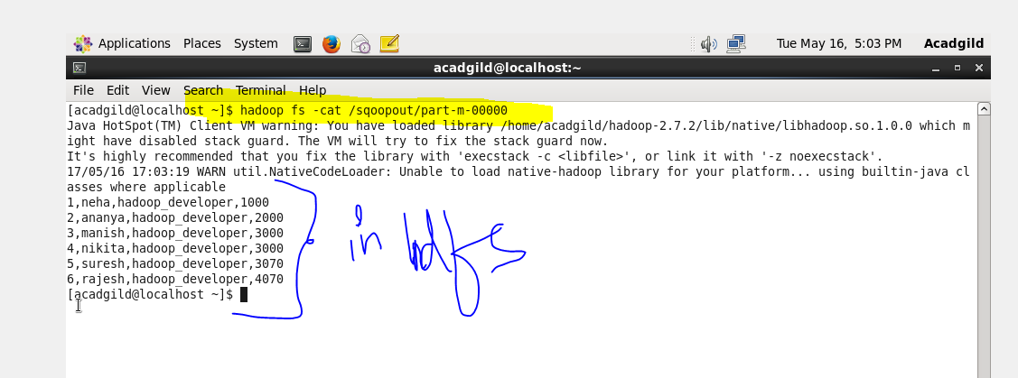

*Import data :-*

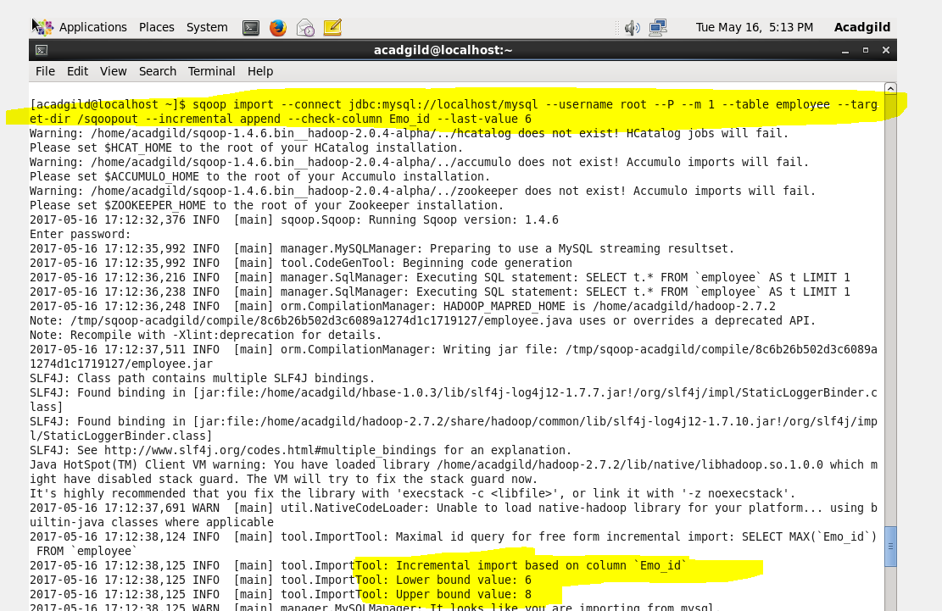

*Complete :-*

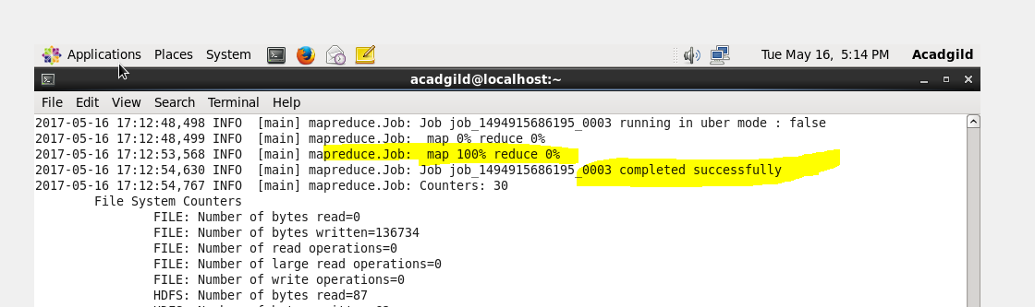

*Increment import complete:-*

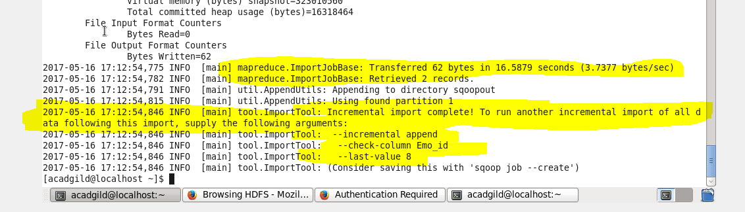

*O/P :-*

